

**Capstone Project Final Report**

**Project title: FPT Education Recruitment**

**Hanoi, September 3rd, 2020**

**Table of Contents**

**Chapter 1:** **Introduction 4**

**1.1. Purpose 4**

**1.2. Project information 4**

**1.3. The people 4**

***1.3.1. Supervisor 4***

***1.3.2. Team members 4***

**1.4. Background 4**

**1.5. Literature review of existing systems 5**

***1.5.1. The Samsung careers (SC) 5***

***1.5.2. VinAI Careers 6***

**1.6. The proposal system 7**

***1.6.1. System functions 7***

***1.6.2. Workflows 10***

***1.6.3. Out-of-scope functions 10***

***1.6.4. Tools and technique 10***

**Chapter 2:** **Project Plan 12**

**2.1. Purpose 12**

**2.2. Project overview 12**

***2.2.1. Channels 12***

***2.2.2. The proposed system 12***

***2.2.3. Boundaries of the system 12***

***2.2.4. Environment development 12***

**2.3. Project organization 13**

**2.4. Role and responsibilities 13**

**2.5. Software process model 15**

**2.6. Project management plan 15**

***2.6.1. Tasks 15***

***2.6.2. Meeting minutes 17***

**2.7. Conventions 18**

***2.7.1. Coding convention 18***

***2.7.2. Document convention 18***

**2.8. Risk management plan 19**

***2.8.1. Risk register 19***

***2.8.2. Probability – Impact matrix 20***

**Chapter 3:** **Software Requirement Specification 22**

**3.1. Purpose 22**

**3.2. System requirement specification 22**

***3.2.1. External interface requirements 22***

***3.2.2. System features 22***

***3.2.3. Use cases 28***

**3.3. Non-functional Requirement 120**

***3.3.1. Reliability 120***

***3.3.2. Security 120***

***3.3.3. Maintainability 121***

***3.3.4. Portability 121***

**3.4. Entity relationship diagram 121**

**Chapter 4:** **System Detailed Design 124**

**4.1. System Overview 124**

**4.2. System Architecture Design 124**

***4.2.1. Choice of System Architecture 124***

***4.2.2. Description of System Interface 125***

**4.3. Component Diagram 128**

**4.4. Detailed Description of Component 129**

***4.4.1. View 129***

***4.4.2. Controller 130***

***4.4.3. Model 131***

**4.5. Class Diagram 132**

***4.5.1. Class diagram 132***

***4.5.2. Models 145***

***4.5.3. DAO 160***

***4.5.4. Controller 173***

**4.6. Sequence Diagram 186**

**4.7. User Interface Design 231**

***4.7.1. Screen Images 231***

**4.8. Database Design 242**

**Chapter 5:** **Software Test Documentation 250**

**5.1. Purpose 250**

***5.1.1. Test approach 250***

**5.2. Test stages 251**

**5.3. Test type 251**

**5.4. Test plan 252**

***5.4.1. Features to be tested 252***

***5.4.2. Test process 255***

***5.4.3. Test schedule 255***

**5.5. Testing Tools and Environment 256**

***5.5.1. Testing Tools 256***

***5.5.2. Testing Environment 257***

**5.6. Test cases 257**

**5.7. Acceptance test 258**

**5.8. Test Report 262**

**Chapter 6:** **Software User’s Manual 263**

**6.1. Candidate 263**

**6.2. Admin 277**

**6.3. HR Staff 288**

# Introduction

## Purpose

This chapter provides an overview of the project including background information, a literature review of the existing system and raising a proposal for ideas of improvement.

## Project information

* Project name: FPT Education Recruitment System
* Project code: FERS
* Project group name: PID Team (*People - Idea - Dialogue*)
* Product type: Web Application
* Timeline: From 18th May 2020 to 3rd September 2020

## The people

### Supervisor

|  |  |  |  |  |
| --- | --- | --- | --- | --- |
|  | **Full name** | **Phone** | **E-mail** | **Title** |
| Supervisor | Phan Trường Lâm | 0913507828 | [lampt2@fe.edu.vn](mailto:lampt2@fpt.edu.vn) | Lecturer |

*Table 1.1 – Supervisor’s information*

### Team members

|  |  |  |  |  |  |
| --- | --- | --- | --- | --- | --- |
|  | **Full name** | **Student ID** | **Phone** | **E-mail** | **Role** |
| 1 | Đỗ Văn Tuấn | SE05339 | 0868455987 | [tuandvse05339@fpt.edu.vn](mailto:tuandvse05339@fpt.edu.vn) | Leader |
| 2 | Nguyễn Thái Bảo | SE05601 | 0353754567 | [baontse05601@fpt.edu.vn](mailto:baontse05601@fpt.edu.vn) | Member |
| 3 | Trần Quốc Đạt | SE05715 | 0888833324 | [dattqse05715@fpt.edu.vn](mailto:dattqse05715@fpt.edu.vn) | Member |
| 4 | Bùi Thanh Tùng | SE05661 | 0354442626 | [tungbtse05661@fpt.edu.vn](mailto:tungbtse05661@fpt.edu.vn) | Member |
| 5 | Đỗ Duy Luyện | SE04999 | 0383551655 | [luyenddse04999@fpt.edu.vn](mailto:luyenddse04999@fpt.edu.vn) | Member |

*Table 1.2 – Team member’s information*

## Background

FPT Corp is one of the largest companies in Viet Nam and FPT Education is a very important part of FPT Corp. FPT Education was founded in 1999. Since then, FPT Education has been growing with more than 50 thousands students at 28 training facilities in Ha Noi, Ho Chi Minh, Da Nang, Can Tho, Quy Nhon, Tay Nguyen.

In recent years, the number of pupils and students has increased every year, leading to the demand for teachers and staff to recruit also increased.

To recruit, the HR department uses the following recruitment channels:

* Website: *fpt.edu.vn/tuyen-dung*
* Word of mouth
* Use Vietnamworks services

Nowadays, FPT Education still doesn’t have a good enough recruitment system. They use a sub function in a news page fpt.edu.vn/tuyen-dung to public recruitment information. The function is very simple and there is not any process to recruit an employee.

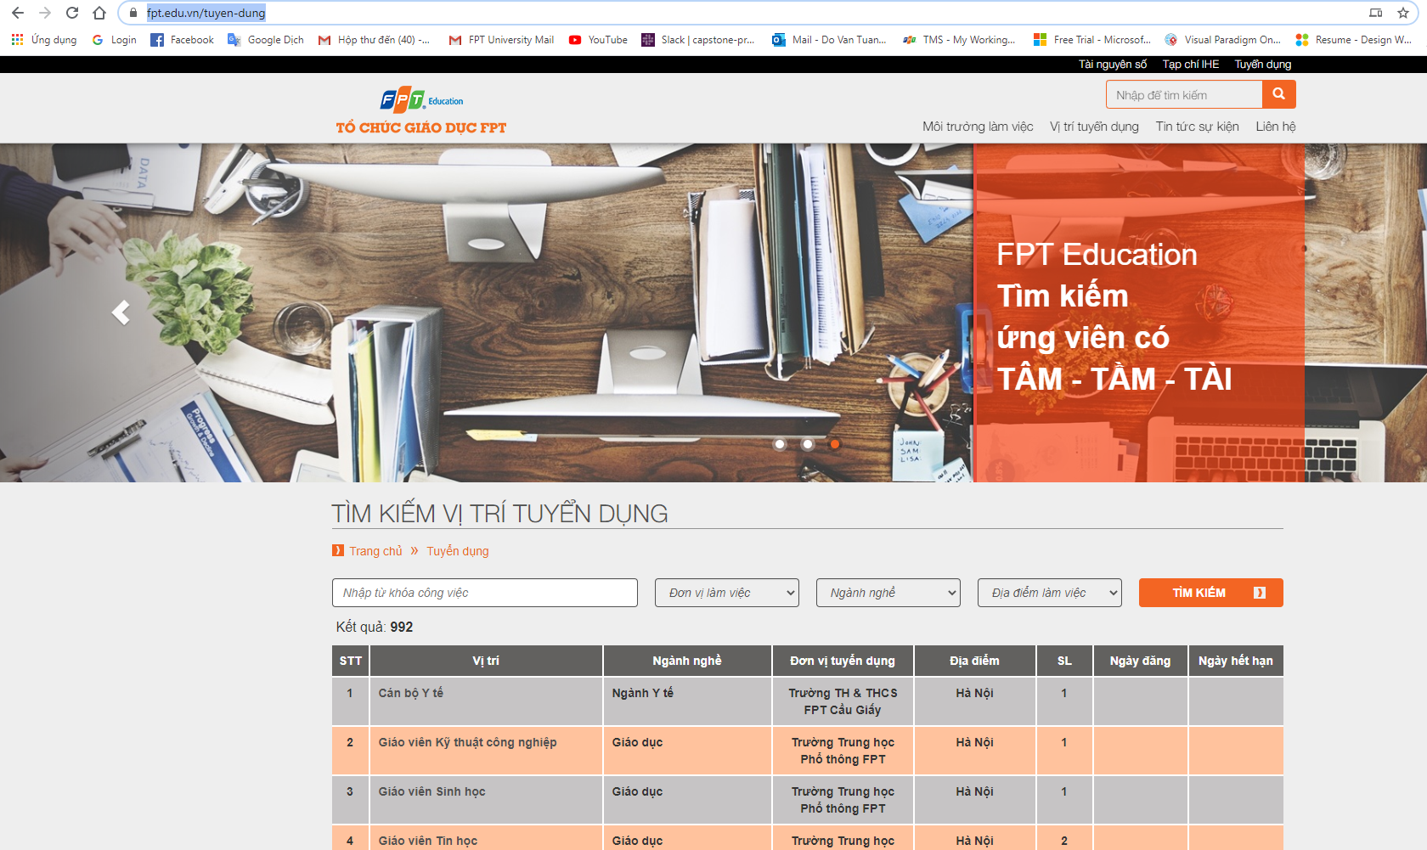

*Figure 1.1 FPT Education recruitment page*

## Literature review of existing systems

This section contains the overview of some existing applications that attempt to tackle limitations of traditional issuing, as well as their advantages..

### The Samsung careers (SC)

SC is a website for hiring people for Samsung’s organizations.

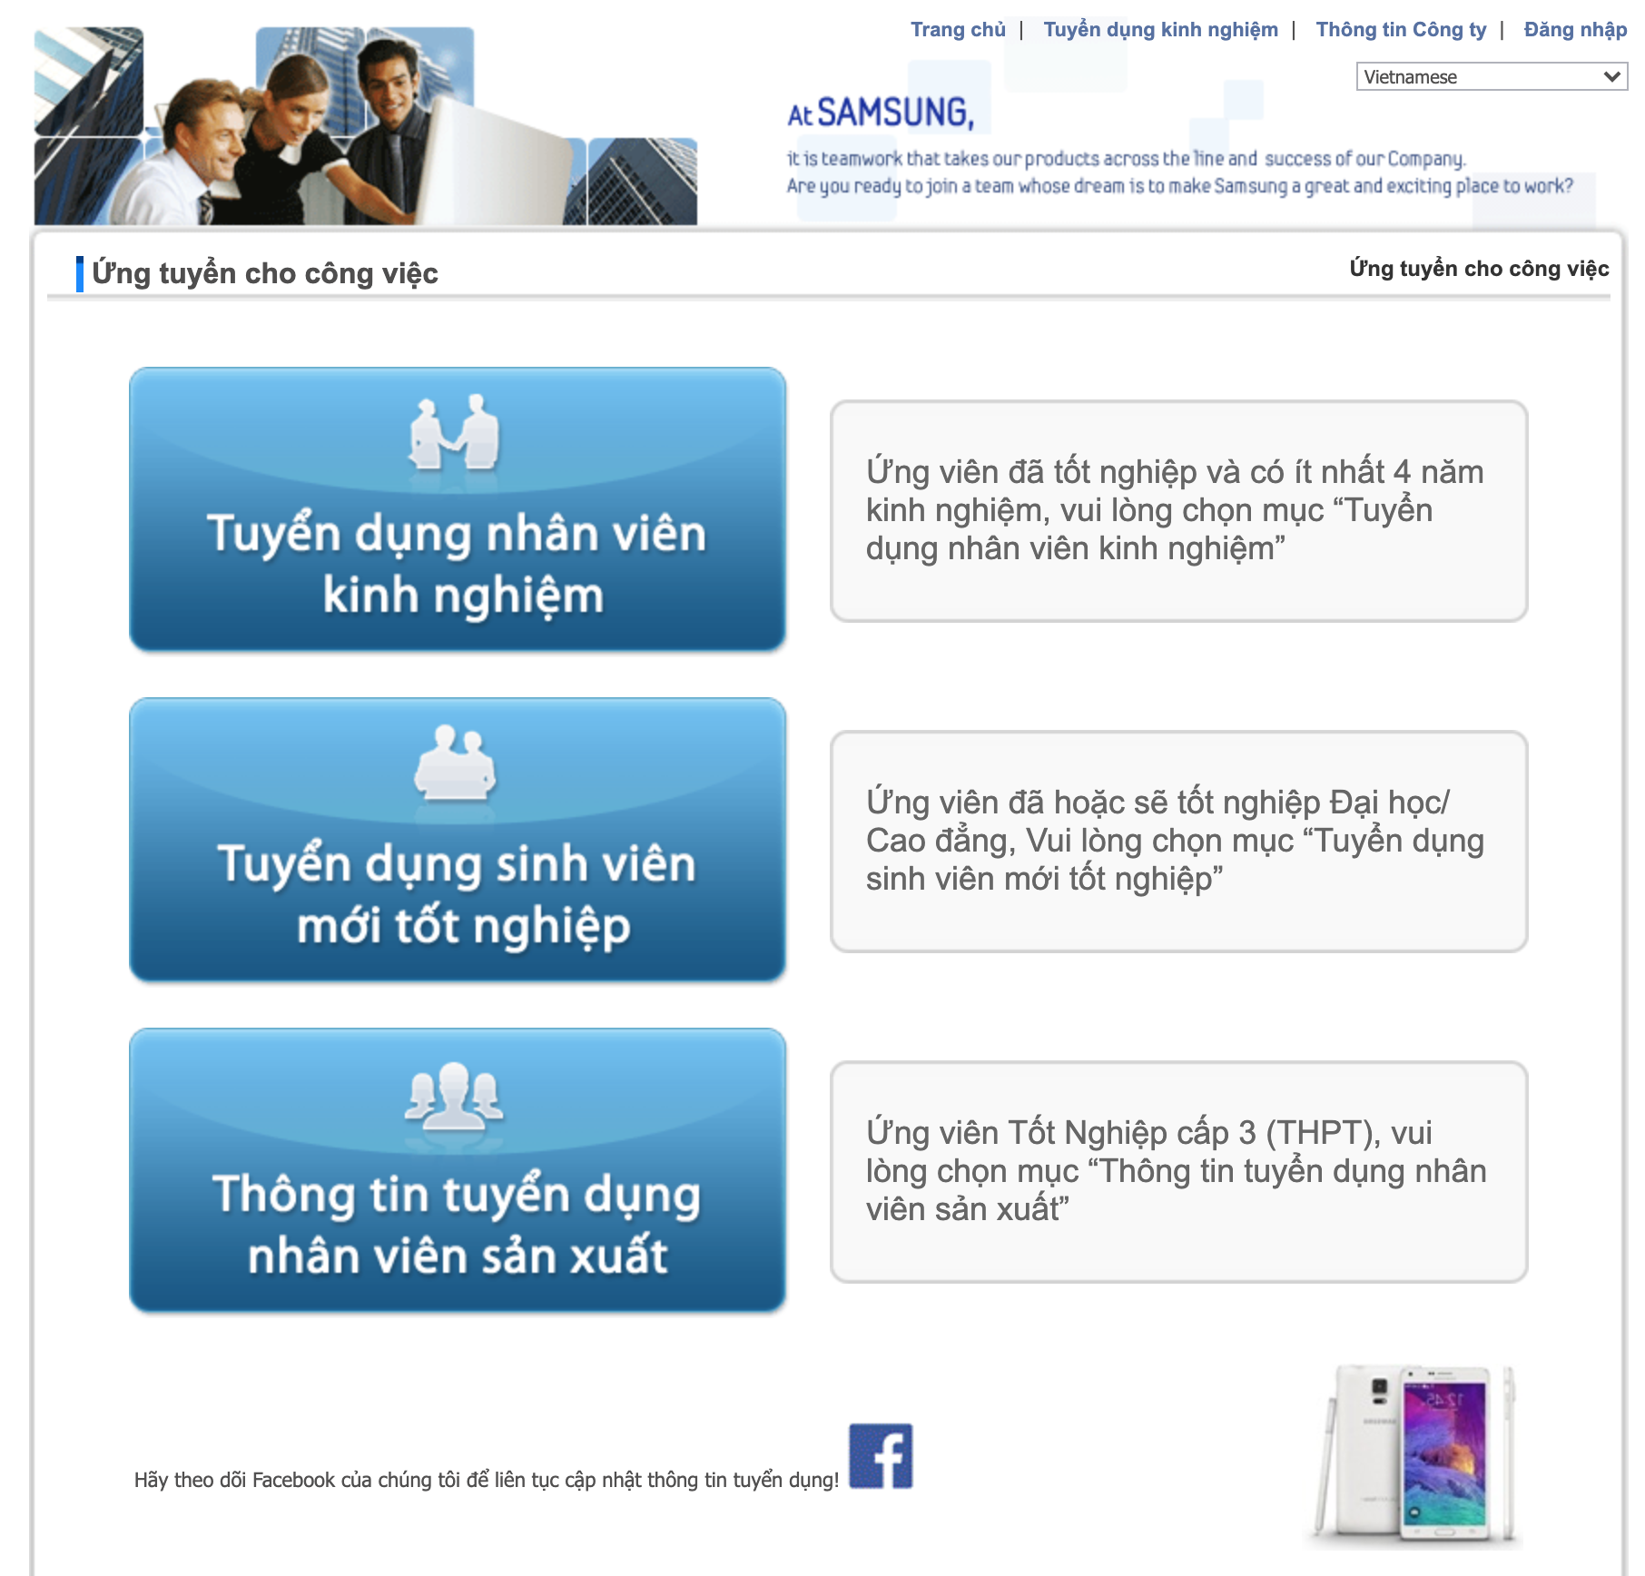

*Figure 1.2. SC homepage*

The advantages and of SC as follow:

|  |
| --- |
| **Advantages** |
| * Allow candidates to search and find jobs and view in detail. * Candidates can research more information about the company. |

*Table 1.3 – Advantages of SC*

### VinAI Careers

VinAI Research is a newly established research lab located in Hanoi, Vietnam. Funded by VinGroup, the largest enterprise in Vietnam by capitalization, their mission is to conduct high-impact research that pushes the knowledge frontier in AI and to accelerate applications of AI in Vietnam, the Asia Pacific region, and beyond.

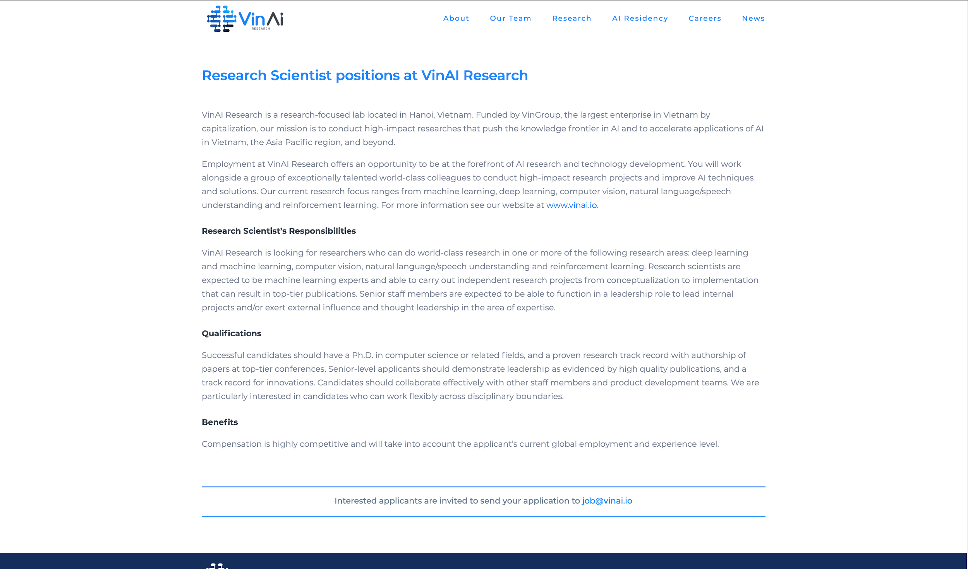

*Figure 1.3 – VinAI Careers homepage*

The pros of VinAI Careers are listed as below:

|  |
| --- |
| **Advantages** |
| * VinAI Careers shows jobs information in detail. * Jobs are sorted, candidates can focus easily. |

*Table 1.4 – Advantages of VinAI Careers*

## The proposal system

From those studies, our group came up with an idea: Build a professional recruiting website for the FPT Education system. The proposal is approved by FPT Edu HR Dept and Software Development Dept (App.FEHO)

### System functions

There are 3 types of users in FPT Education Recruitment System:

|  |  |
| --- | --- |
| **Type of User** | **Description** |
| Candidate | Users who find a job, they can view all information about organizations, recruitment of FPT Education System and apply to a job. |
| HR Staff | HR officers, they can manage all CVs that were uploaded, manage jobs, change status of CVs, export list of all CVs to excel file. |
| Super Admin | HR Manager, who has the most powerful rights in the system such as managing locations, accounts, units, careers, config emails, logs, quizzes, questions and question groups. |

*Table 1.5 – Types of users in the FPT Education Recruitment System*

FPT Education Recruitment System provides the following functions to the above users:

* System allows candidate to view all information about FPT Education and new career
* Candidate can search a career by keywords
* Candidate can apply for a job:
  + If candidate has a CV already, he/she can attach CV file (PDF) and submit to the system
  + If candidate doesn’t have a CV, he/she can create a basic CV and submit to the system
* After successfully uploading CV, the system will send email notification to candidates that their CVs are uploaded successfully
* If the candidate has not found a suitable job, he/she can leave contact information, HR will contact him/her to advise later.
* Candidates can do an entry test when they apply for a CV.
* HR staff can manage all CVs that were uploaded by candidates. The CV status is in one of the following 5 values: new, seen, pending, rejected, approved.
* HR staff can manage questions and can choose a quiz that a candidate needs to make sure he/she shares FPT Education’s philosophy.
* The status of CV is managed by HR staff.
* HR staff exports list CV to excel format file.
* The system supports multiple languages.
* Candidates can chat in real time with HR Staff.
* Website is good at Search Engine Optimization (SEO), evaluated by Lighthouse.[1]
* Super Admin is a person who has the most functionality in the system such as CRUD:
  + Location
  + Account
  + Unit
  + Career
  + Config email
  + Log
  + Quiz
  + Question
  + Question Group

#### HR Staff’s sitemap

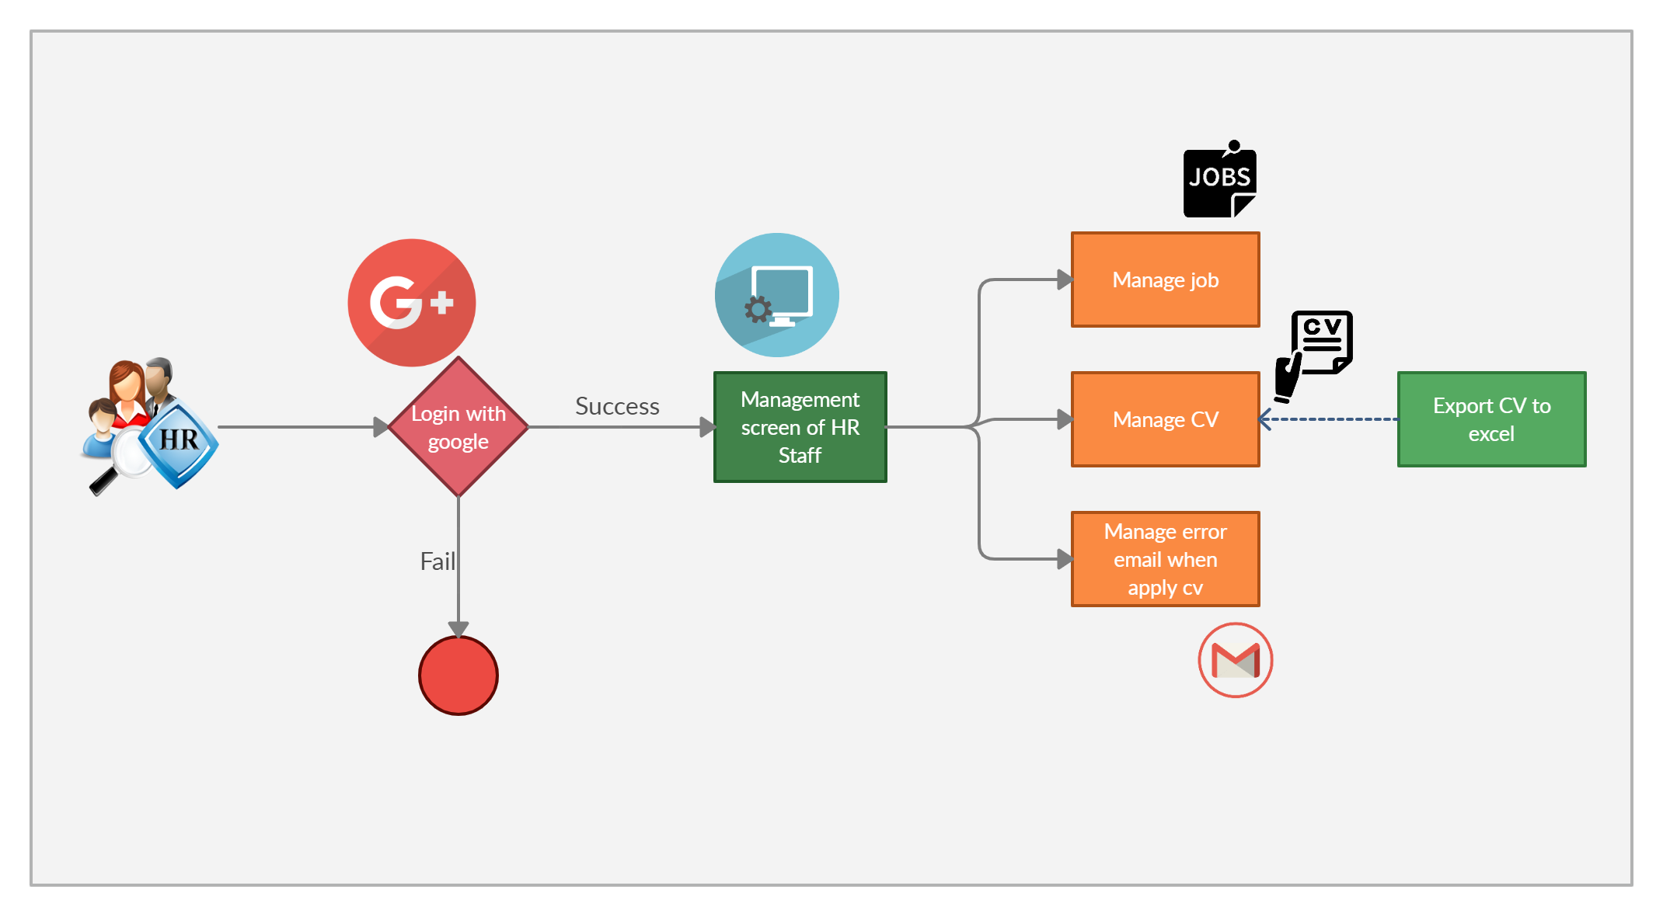

*Figure 1.4. HR Staff’s sitemap*

#### Super Admin’s sitemap

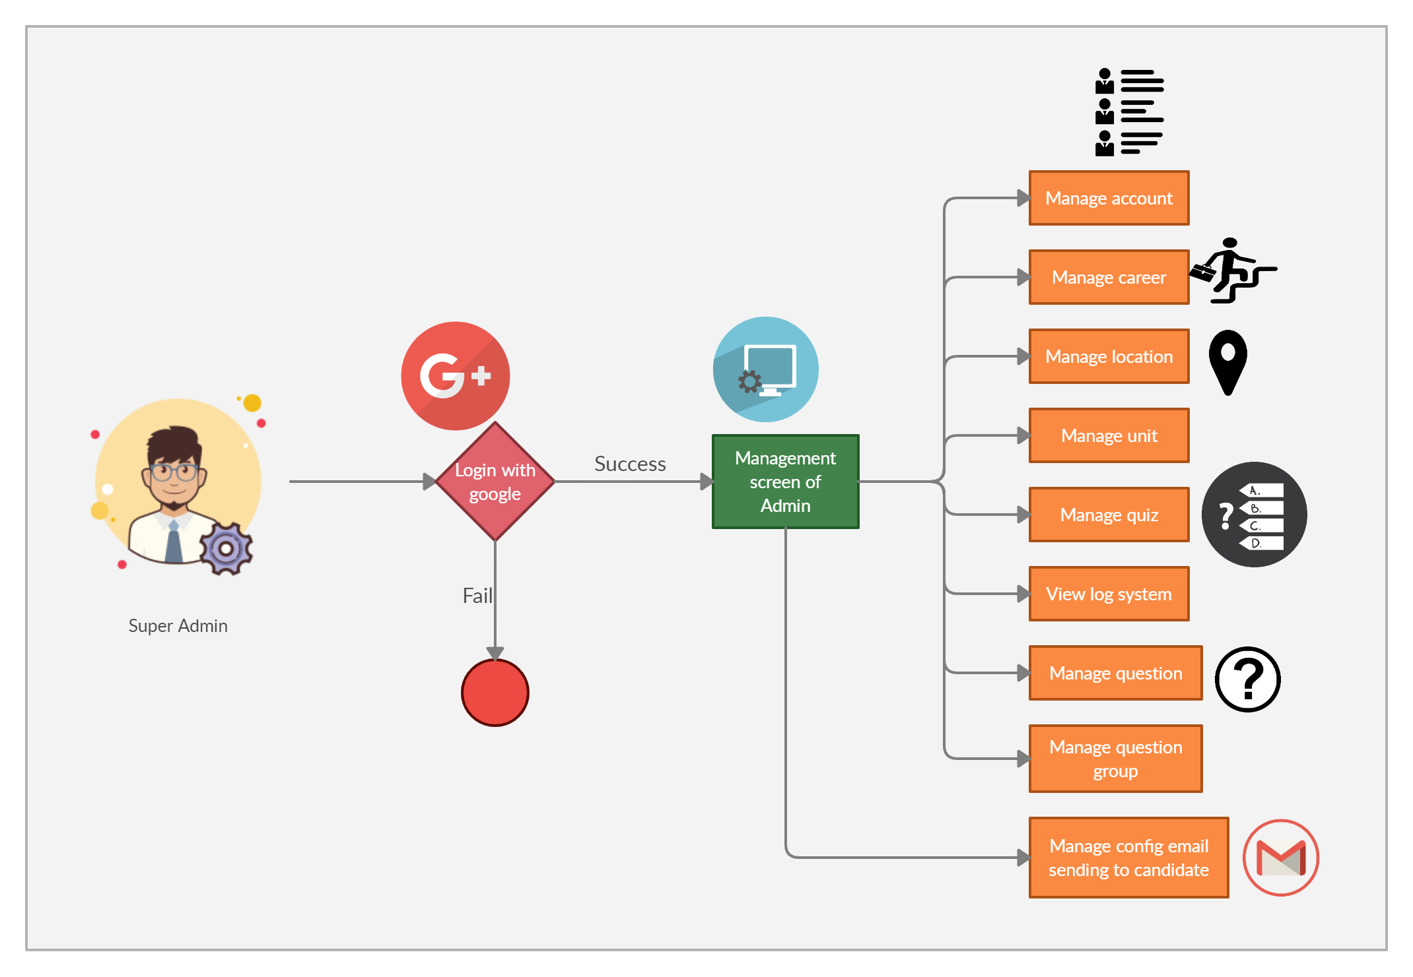

*Figure 1.5. Super Admin’s sitemap*

### Workflows

#### Apply job flow

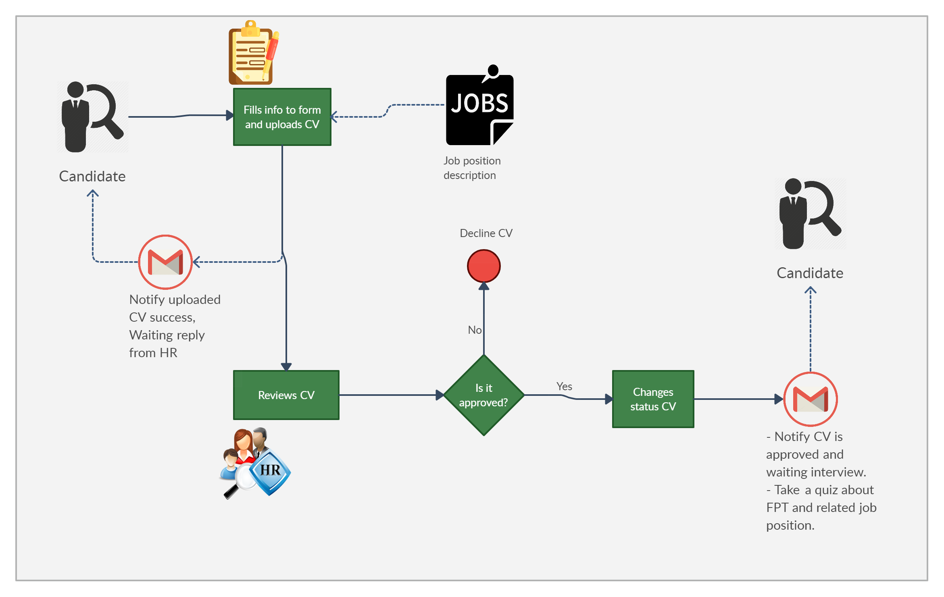

*Figure 1.6. Apply job flow*

### Out-of-scope functions

Due to the limitation of time, we will not implement some of the intended functions, although we are aware that they are also important and useful for users of the system:

* Support multiple languages
* Real time chat

### Tools and technique

|  |  |
| --- | --- |
| **Category** | **Tools & techniques** |
| Programming languages & runtime | C#, Javascript |
| Frameworks | .Net MVC 4.7 |
| Software architecture | MVC |
| Operating system | macOS 10.16 Catalina, Windows 10 |
| Version control | GitHub, Git 2.27.0 |
| IDE/Editors | Visual Studio 2017 |
| UML tools | Draw.io, Ashta |
| DBMS | SQL Server Management System 2012 |
| Project management tools | Pivotal Tracker, Microsoft Excel 2016 |
| Document tools | Microsoft Office 2016 |
| Process model | Agile Software Process Model |
| Development process | Continuous Integration & Continuous Delivery |
| Communication tools | Facebook, Gmail, Slack, Skype |
| Files management tools | Google Drive |
| Testing tools | Google Chrome |

*Table 1.6 – Tools & techniques used in project*

To solve the stated problems, the following tools and techniques are used:

* Using .Net MVC Framework[2] and SQL Server to code and build dynamic websites.
* Using Github[3] for managing source code.
* Using library SmtpClient and MailMessage[4] to automatically send email to candidates after successfully uploading a CV.

# Project Plan

## Purpose

This chapter provides an overview of the project plan, including software process model, project overview, project organization. Moreover, the document also details tools will be used, coding conventions, communication management.

## Project overview

### Channels

Currently, FPT education system implements the following recruitment channels:

* Website: [fpt.edu.vn/tuyen-dung](https://fpt.edu.vn/tuyen-dung)
* Social network:

Linkedin: [https://www.linkedin.com/company/fpt-education](https://www.linkedin.com/company/fpt-education/?fbclid=IwAR39GEoELUVWs8eSbrAiO8OE8CzoKNysQxtNqCuNjcyQGKgILS-hR5X5fTY)

* Advertisement :

Facebook: <https://www.facebook.com/educationfpt/>

Youtube: <https://www.youtube.com/user/FPTUniversityChannel>

### The proposed system

* We create a system to allow people to search and apply CV to remaining FPT Education’s jobs. Besides, candidates who are accepted on a job can do an entry test.
* Recruitment Staff can manage CVs, accounts, jobs and a few data at homepage on system.

### Boundaries of the system

* Allow candidates to view and search information about FPT Education system, recruitment jobs, recruitment process.
* Allows candidates to create, upload, edit CV to apply job
* Allows candidates to do a small quiz to learn more information about FPT Education
* Allows HR Staff to manage uploaded CV of candidate, add, edit, delete Job
* Allows System administrators to manage users, system config, manage location, manage units of FPT Education.

### Environment development

* ASP .NET MVC 5

## Project organization

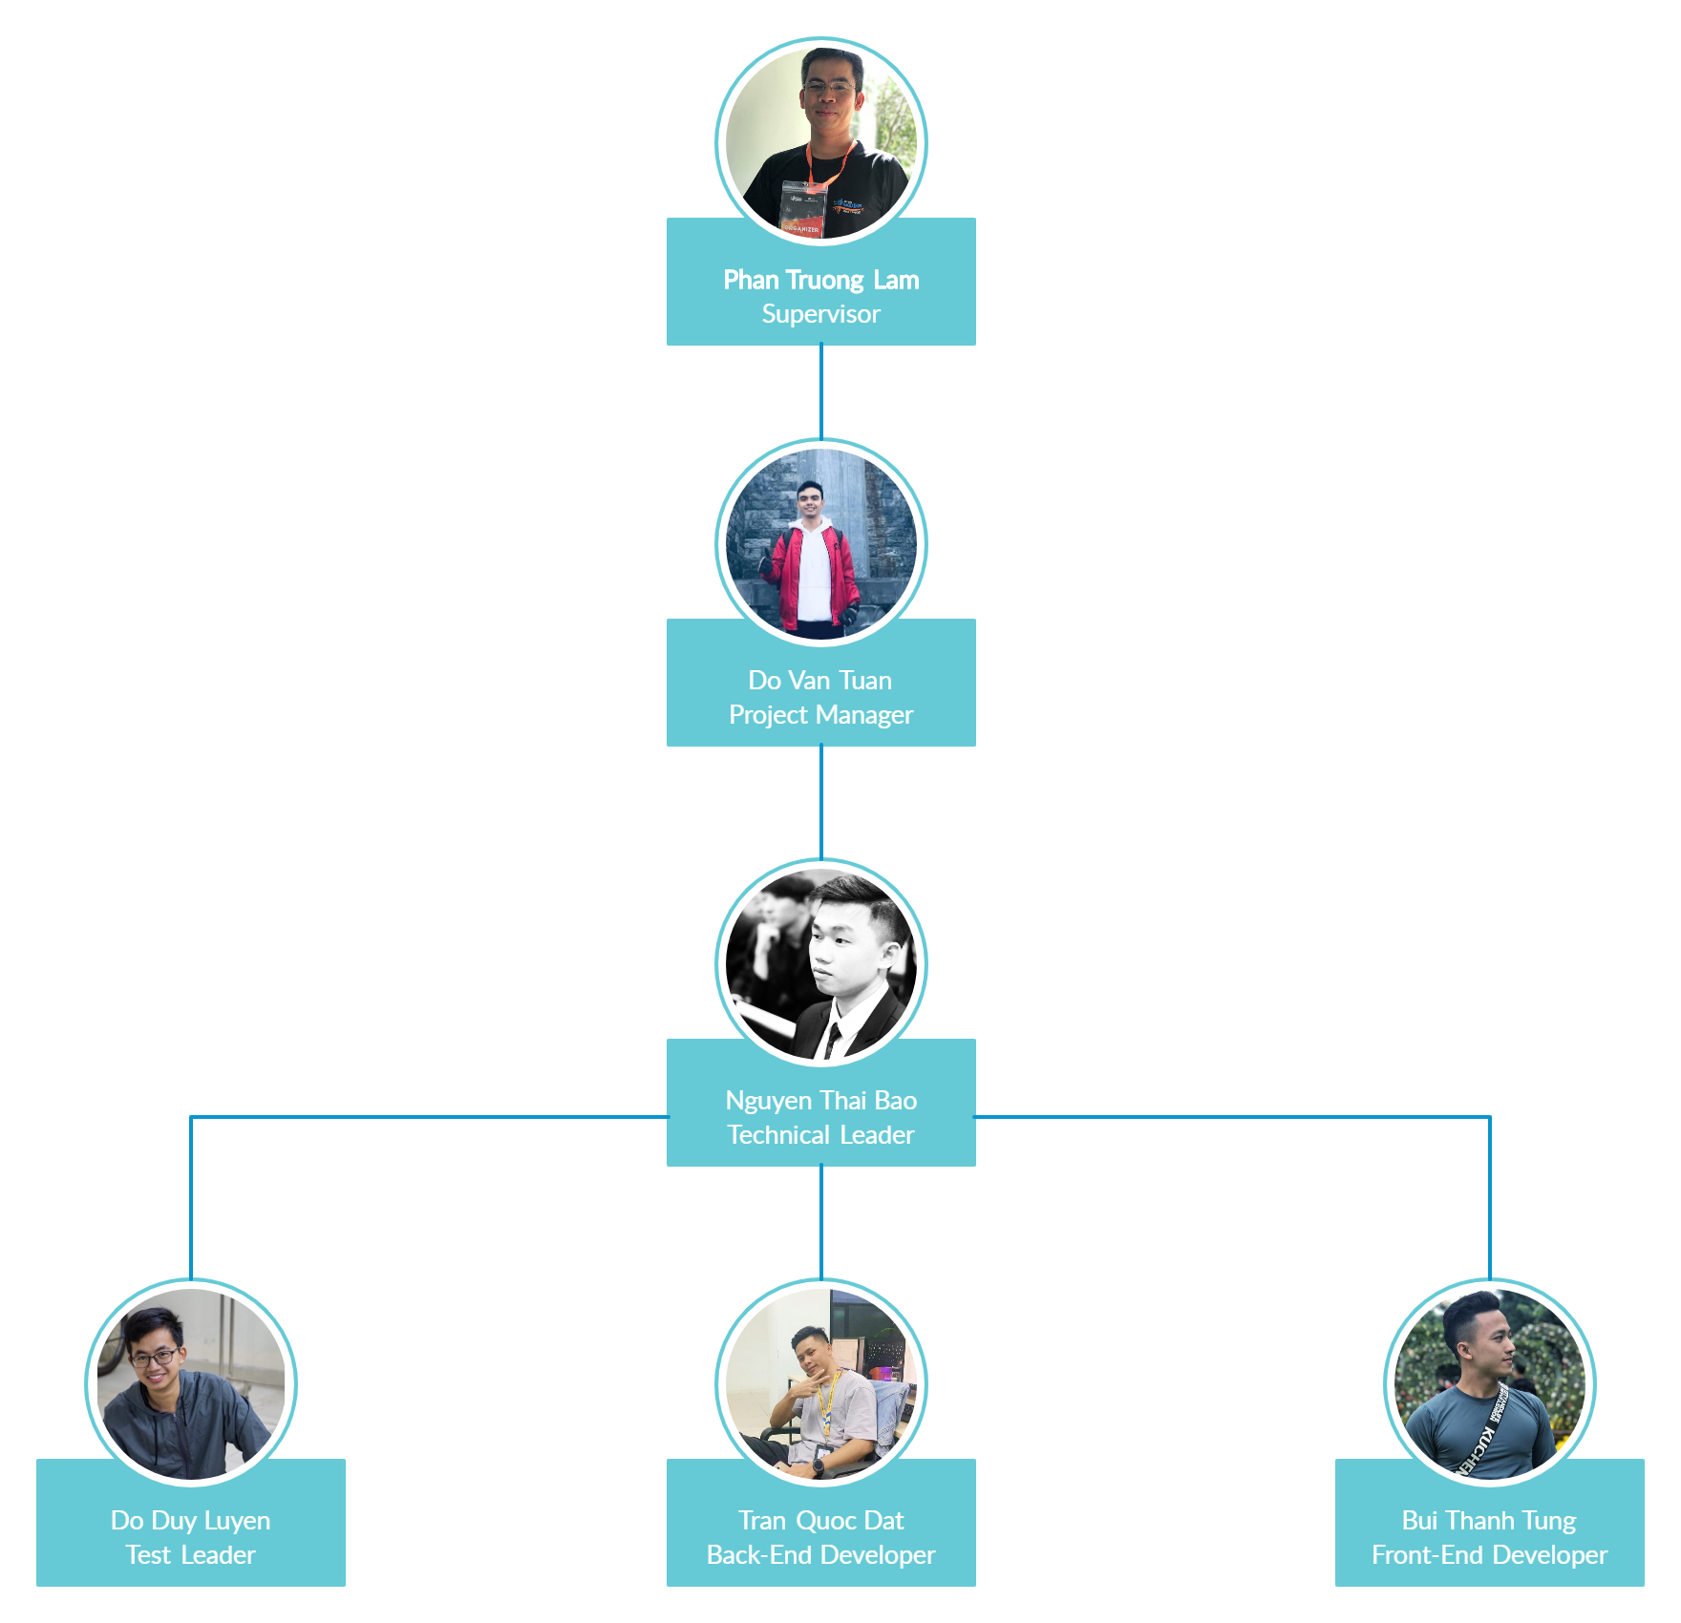

*Figure 2.1. Project organization chart*

## Role and responsibilities

Organization structure

|  |  |
| --- | --- |
| **Role** | **Responsibilities** |
| Project Manager | Planning, developing schedules, coordinating communication, generally responsible for keeping the team’s focus on the main goal. |
| Technical Leader | Responsible for choosing and deciding what technologies should be used, as well as for overseeing the work being done by other developers. |
| Quality Assurance Manager | Ensuring the product meets the certain standards of quality from requirements. |
| Test Leader | Responsible for test execution, including test set-up and test run, evaluation of test run and error recovery, defect logging and test results recording. |
| Developer | Involve in coding the product and reviewing code of other developers. |
| Designer | Involve in designing the product’s user interface. |
| Tester | Involve in testing the product. |

*Table 2.1 – Project organization structure*

Team member roles

|  |  |
| --- | --- |
| **Team Member** | **Role** |
| Pham Truong Lam | Supervisor |
| Do Van Tuan | Project Manager, Back-End Developer |
| Nguyen Thai Bao | Technical Leader, Developer, Quality Assurance Manager |
| Do Duy Luyen | Front-End Developer, Test Leader, Designer |
| Tran Quoc Dat | Back-End Developer |
| Bui Thanh Tung | Front-End Developer, Teser |

*Table 2.2 – Project role description*

## Software process model

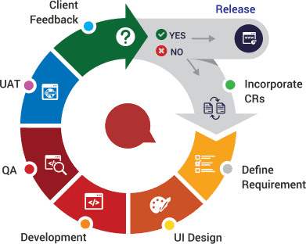

*Figure 2.2 – Agile software process model*

FPT Education Recruitment System project uses the Agile software process model.

Agile is a flexible software development methodology, which is a specific approach to software project management. It includes an integrated and interactive workflow to get products into the hands of users as quickly as possible. Agile model has the following advantages:

* Customer satisfaction by rapid, continuous delivery of useful software.
* People and interactions are emphasized rather than process and tools. Customers, developers and testers constantly interact with each other.
* Working software is delivered frequently (end of sprint).
* Face-to-face conversation is the best form of communication.
* Close, daily cooperation between customers and developers.
* Regular adaptation to changing circumstances.
* Even late changes in requirements are welcomed

## Project management plan

### Tasks

Refer to [Project management plan.xlsx](https://docs.google.com/spreadsheets/d/1ywuEWK_owP92odx_iZhE12ZZXCZRW3csHZBICMr2HCM) file for detail.

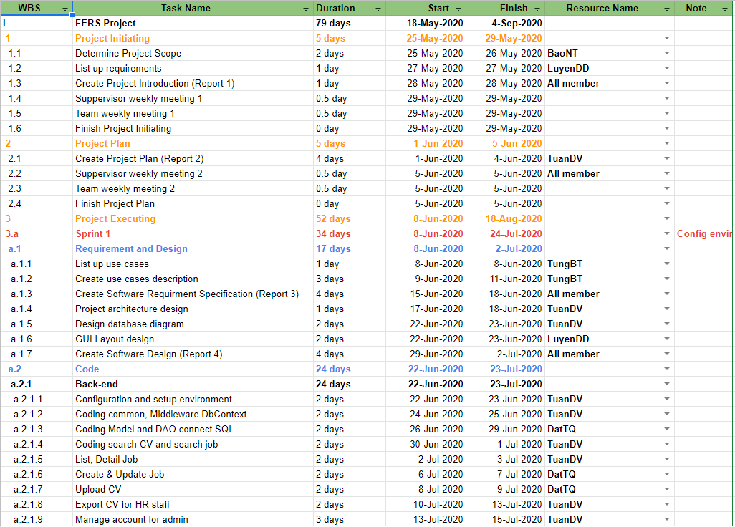

*Figure 2.3 – Project management plan*

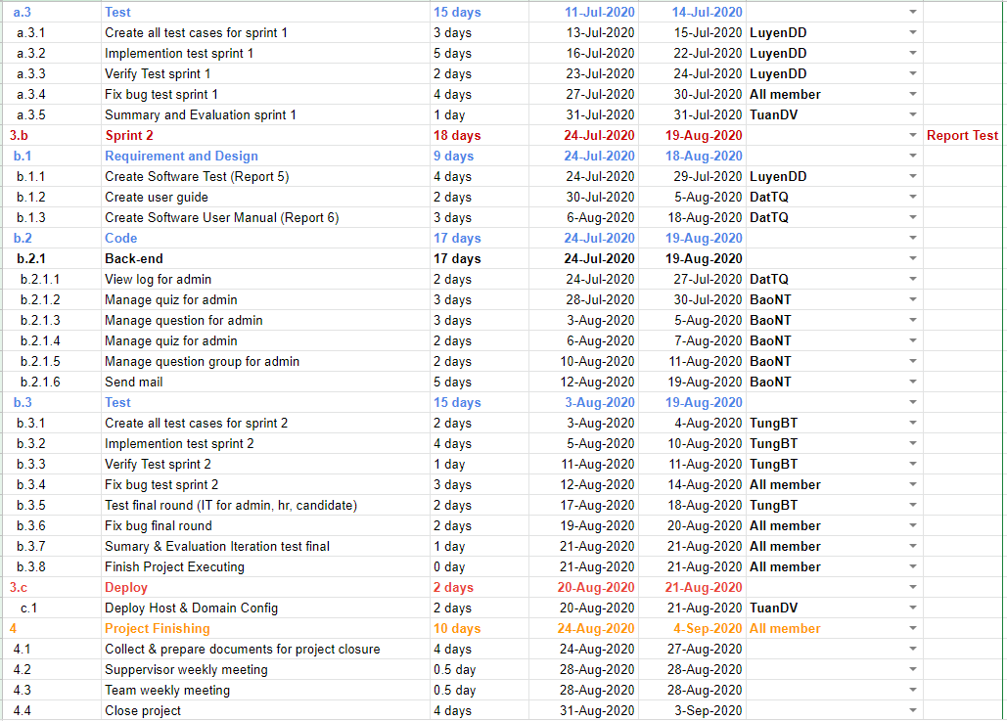

*Figure 2.4 – Project management plan*

### Meeting minutes

All meeting minutes is created for each meeting. The following template is used:

|  |  |  |  |  |  |
| --- | --- | --- | --- | --- | --- |
| **Meeting/Project Name:** | FPT Education Recruitment System | | | | |
| **Date of Meeting:** | 05/28/2020 | | Time: (Type) | 2 hours (Face-to-face) | |
| **Meeting Called by:** | TuanDV | | Location: | R107 – Alpha building | |
| **Note Taker:** | LuyenDD | | Time Keeper: | TungBT | |
| **1. Meeting Objective** | | | | | |
|  | | | | | |
| **2. Attendance** | | | | | |
| **Name** | **Roles** | **E-mail** | | | **Phone** |
| Do Van Tuan | Project Manager | [tuandvse05339@fpt.edu.vn](mailto:tuandvse05339@fpt.edu.vn) | | | 0868455987 |
| Do Duy Luyen | Developer | [luyenddse04999](mailto:luyenddse04999@fpt.edu.vn)[@fpt.edu.vn](mailto:quanghdse03459@fpt.edu.vn) | | | 0383551655 |
| Nguyen Thai Bao | Developer | [baontse05601](mailto:baontse05601@fpt.edu.vn)[@fpt.edu.vn](mailto:phanlhse04195@fpt.edu.vn) | | | 0353754567 |
| Tran Quoc Dat | Developer | [dattqse05715](mailto:dattqse05715@fpt.edu.vn)[@fpt.edu.vn](mailto:thanhpkse04131@fpt.edu.vn) | | | 0888833324 |
| Bui Thanh Tung | Tester | [tungbtse05661](mailto:tungbtse05661@fpt.edu.vn)[@fpt.edu.vn](mailto:tungtbse06187@fpt.edu.vn) | | | 0354442626 |
| **3. Tasks Done** | | | | | |
|  | | | | | |
| **4. To-Do Tasks** | | | | | |
|  | | | | | |
| **5. Difficulty** | | | | | |
|  | | | | | |

*Table 2.3. Meeting minute template*

## Conventions

### Coding convention

Coding and implementing the FERS uses StyleCop[5] analyzes C# source code to enforce a set of style and consistency rules with .Net on Visual Studio 2017.

### Document convention

* Font-family: Times New Roman
* Font size: 12pt
* Page header size: 20pt

## Risk management plan

### Risk register

|  |  |  |  |  |  |  |
| --- | --- | --- | --- | --- | --- | --- |
| **No** | **Name** | **Description** | **Probability** | **Impact** | **Prevention** | **Correction** |
| **R1** | Requirement changes | The scope may change; some requirements may be added | High | Medium | All member discuss carefully in the beginning of each iteration to define scope and requirements | Ensure resource allocation is modified correctly to adapt to new requirement |
| **R2** | Illness or absence of team members | The number of members decreases and not enough for work | Medium | Low | Members have to notify the team about the absence period and the plan of how to keep up with the work process. | Ensure that the absence of a member won’t affect others and always have plans to deal with this problem |
| **R3** | Conflict among team members | Team member disagree with others and refuse to work or work below their ability | Medium | High | Define clear tasks and unify the opinion before starting tasks | All members discuss to resolve the conflict. Voting. |
| **R4** | New technology | Require to study new technology to fulfill the requirement | Medium | Medium | Choosing technology based on member’s qualification. All team members must nurture by self-study. | When someone chooses a new technology, he/she has to explain to all team members about the decision. |
| **R5** | Team member distraction | Team members do not commit enough working time. | Medium | Medium | Choose member carefully | The PM reminds team members about the timeline. |
| **R6** | Internet connection is down | Internet connection is down and team members cannot submit work or merge code. | Low | Medium | All developers have to set up the isolated development environment and have an offline copy of the documentation. | Use alternative ways to connect to the internet, such as: using VPN or 4G. |
| **R7** | Lack of skill | Members lack the knowledge and skill to complete a particular task. | High | Medium | Form a team early, choose technology stack wisely and training before starting the project. | Member informs team about lack of skill, other team member support |
| **R8** | Library used in project is no longer supported | A library is no longer maintained. | Low | High | Choose a reputable library with active maintenance on GitHub. | Choose alternative libraries or code from scratch. |

*Table 2.4 - Risk register table*

### Probability – Impact matrix

|  |  |  |  |  |
| --- | --- | --- | --- | --- |
| **Probability** | High |  | **R1, R7** |  |
| Medium | **R2** | **R4, R5** | **R3** |
| Low |  | **R6** | **R8** |
|  | Low | Medium | High |
|  | **Impact** | | | |

*Table 2.5 - Risk probability - impact matrix*

# Software Requirement Specification

## Purpose

This chapter outlines functional and non-functional requirements of our system. It also provides some format constraints in common requirements and project success criteria. The content of this chapter is used as the basis for the work in the subsequent chapters.

## System requirement specification

### External interface requirements

#### User interfaces

* Standard user interface:
  1. Font-family: Montserrat
  2. Font-size: 16px
  3. Icon: Font Awesome 5
  4. Colors: The main color of this system is: #F36523
* Screen resolution: This system supports responsiveness for candidate’s screens: mobile, desktop, tablet, laptop.

#### Software interfaces

* Connecting to database: Microsoft SQL Server
* Transfer protocol: HTTPS, TCP/IP
* This system uses Simple Mail Transfer Protocol (SMTP) to automatically send email to the candidates.

#### Communications protocol

* HTTPS, HTTP

### System features

#### Use case diagram

**Actors:**

|  |  |
| --- | --- |
| **Actor** | **Description** |
| Super Admin | Human Resources Manager - who takes the highest responsibility in the system. Super Admin has powers in the following functions:   * Account management * Unit management * Location management * Career management * Email management * Quiz, question group and questions management * View system changes (View logs) |
| HR Staff | HR Staff who take responsibility related to the following functions:   * CV management * Job management * Failed sent email management |
| Candidate | People who visit the system and expect to apply for a job:   * View information about FPT Education, Jobs, Recruitment process of FPT Education * Apply for a job by create a CV or upload CV file * Take quiz about FPT Education after applying for a job |

*Table 3.1 Actors description*

Use case diagram:

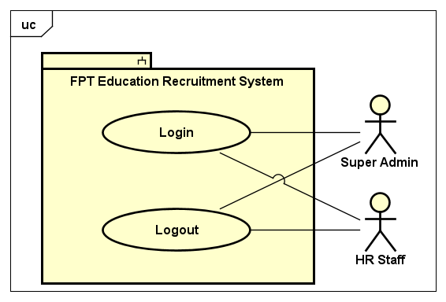

*Figure 3.1. Common use cases*

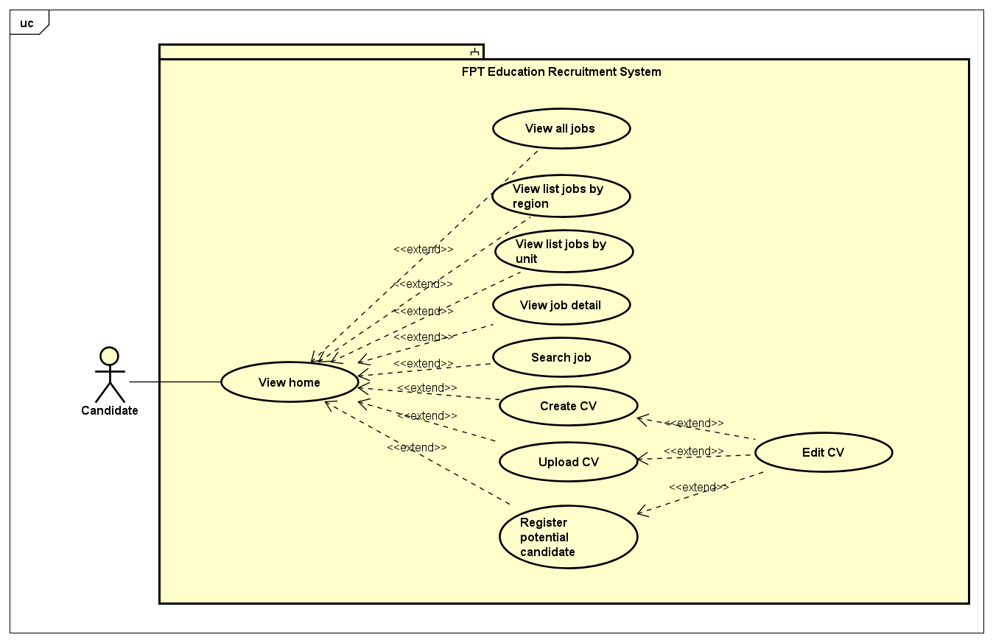

*Figure 3.2. Candidate's use cases*

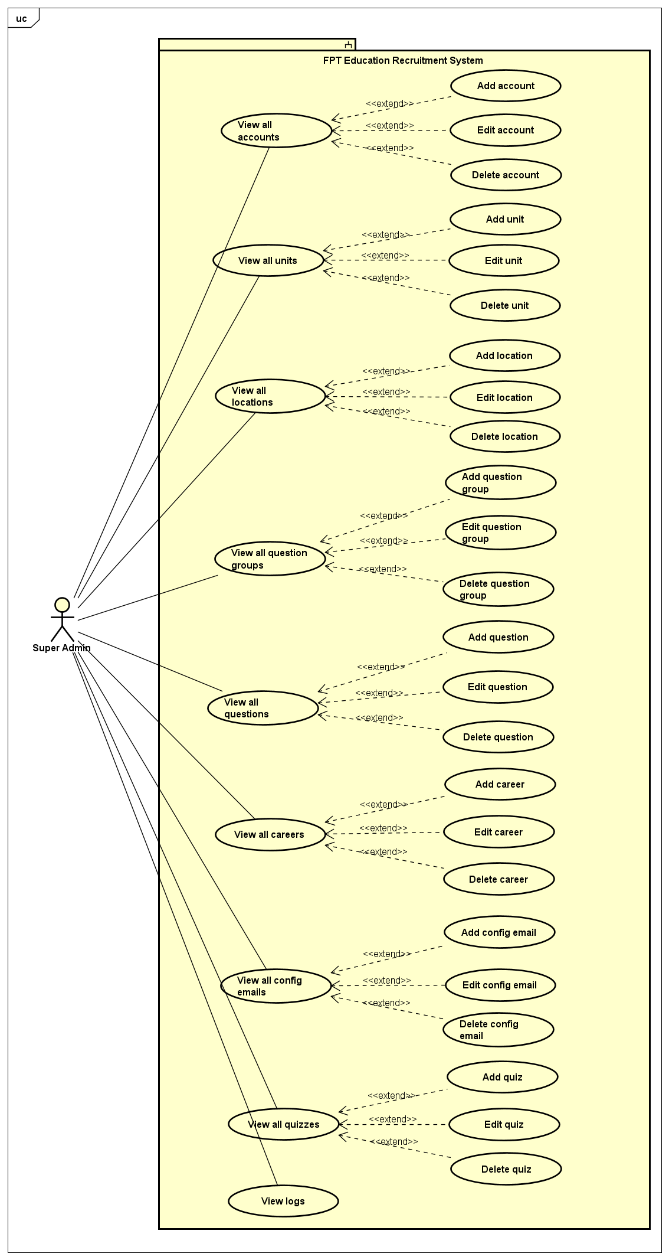

*Figure 3.3. Super Admin's use cases*

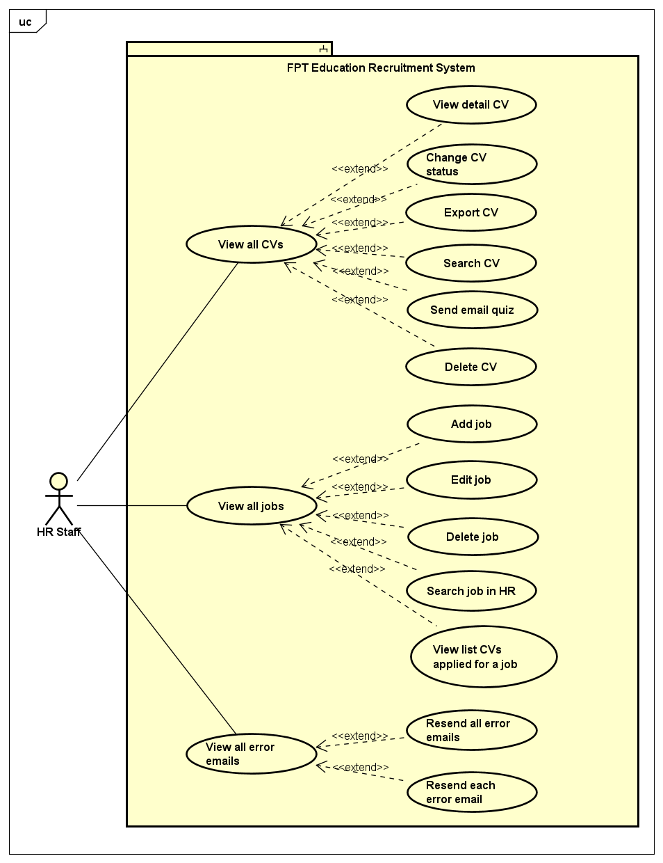

*Figure 3.4. HR Staff's use cases*

### Use cases

|  |  |  |  |
| --- | --- | --- | --- |
| **ID** | **Actor** | **Name** | **Description** |
| UC-01 | Candidate | View recruitment process | To view information about recruitment process of FPT Education |
| UC-02 | Candidate | View home | To view home page of FERS site |
| UC-03 | Candidate | View all jobs | To view all jobs which are in recruitment need |
| UC-04 | Candidate | View list jobs by region | To view list of jobs that are filtered by a region |
| UC-05 | Candidate | View list jobs by unit | To view all the jobs that an unit wants to recruit |
| UC-06 | Candidate | View job detail | To view detailed information about a job |
| UC-07 | Candidate | Search job | To search a job that candidate wants |
| UC-08 | Candidate | Create CV | To create a simple CV for job applications |
| UC-09 | Candidate | Upload CV | To upload CV when candidate has a CV already |
| UC-10 | Candidate | Register potential candidate | Leave information like a CV form when the candidate has not found the desired job on the system |
| UC-11 | Candidate | Edit CV | To edit information of a CV created/CV uploaded/Potential candidate registered |
| UC-12 | Candidate | Take quiz | To take an entry test about FPT Education |
| UC-13 | Super Admin | View all accounts | To view all accounts in the system, including HR Staff and Super Admin |
| UC-14 | Super Admin | Add account | To add a new account to the system |
| UC-15 | Super Admin | Edit account | To edit information of an account |
| UC-16 | Super Admin | Delete account | To remove an account |
| UC-17 | Super Admin | View all units | To view all units in FPT Education |
| UC-18 | Super Admin | Add unit | To add a new unit to FPT Education |
| UC-19 | Super Admin | Edit unit | To edit information of a unit |
| UC-20 | Super Admin | Delete unit | To delete a unit from FPT Education |
| UC-21 | Super Admin | View all locations | To view all working locations of FPT Education |
| UC-22 | Super Admin | Add location | To add a new working location into FPT Education |
| UC-23 | Super Admin | Edit location | To edit information about a location |
| UC-24 | Super Admin | Delete location | To delete a location |
| UC-25 | Super Admin | View all question groups | To view list of all question groups |
| UC-26 | Super Admin | Add question group | To add a new question group |
| UC-27 | Super Admin | Edit question group | To edit question group name |
| UC-28 | Super Admin | Delete question group | To delete a question group |
| UC-29 | Super Admin | View all questions | To view list of all questions for entry test |
| UC-30 | Super Admin | Add question | To add a new question to the system |
| UC-31 | Super Admin | Edit question | To edit content or the answers of the question |
| UC-32 | Super Admin | Delete question | To delete a question from the system |
| UC-33 | Super Admin | Search question | To search a question that Super Admin wants |
| UC-34 | Super Admin | View all quizzes | To view list of all quizzes that will be used for entry test |
| UC-35 | Super Admin | Add quiz | To add a new quiz |
| UC-36 | Super Admin | Edit quiz | To edit quiz name and the answers of the quiz |
| UC-37 | Super Admin | Delete quiz | To delete a quiz |
| UC-38 | Super Admin | View all careers | To view list of all careers at FPT Education |
| UC-39 | Super Admin | Add career | To add a new career |
| UC-40 | Super Admin | Edit career | To edit information about a career |
| UC-41 | Super Admin | Delete career | To delete a career from FPT Education |
| UC-42 | Super Admin | View all config emails | View all email address that will be used to send email to the candidate |
| UC-43 | Super Admin | Add config email | To add a new email address that will be used to send email to the candidate |
| UC-44 | Super Admin | Edit config email | To edit configuration information of the email |
| UC-45 | Super Admin | Delete config email | To delete an email |
| UC-46 | Super Admin | View logs | To view all system changes |
| UC-47 | Super Admin, Hr Staff | Login | To login to the system |
| UC-48 | Super Admin, Hr Staff | Logout | To logout to the system |
| UC-49 | HR Staff | View all CVs | To view list of all CVs that were applied to the system |
| UC-50 | HR Staff | View detail CV | To view detailed information about a CV |
| UC-51 | HR Staff | Change CV status | To change the status of the CV. There are five status: New, seen, pending, approved, rejected |
| UC-52 | HR Staff | Search CV | To search the CVs that HR Staff wants |
| UC-53 | HR Staff | Delete CV | To delete a CV |
| UC-54 | HR Staff | Send email quiz | To send an email to the candidate, including the access link to the quiz |
| UC-55 | HR Staff | Export CV | To export list of all CVs to PDF file |
| UC-56 | HR Staff | View all jobs | To view list of all recruitment jobs |
| UC-57 | HR Staff | Add job | To add a new recruitment job |
| UC-58 | HR Staff | Edit job | To edit information of a recruitment job |
| UC-59 | HR Staff | Delete job | To delete a recruitment job |
| UC-60 | HR Staff | Search job in HR | To search a job that HR Staff wants |
| UC-61 | HR Staff | View list CVs applied for a job | To view list of all CVs that applied for a job |
| UC-62 | HR Staff | View all error emails | To view list of all emails that are failed to send to the candidates |
| UC-63 | HR Staff | Resend all error email | To resend all error emails to the candidates |
| UC-64 | HR Staff | Resend each error email | To resend the error email to a certain candidate |

*Table 3.2. List of use cases*

#### Use case 01: View recruitment process

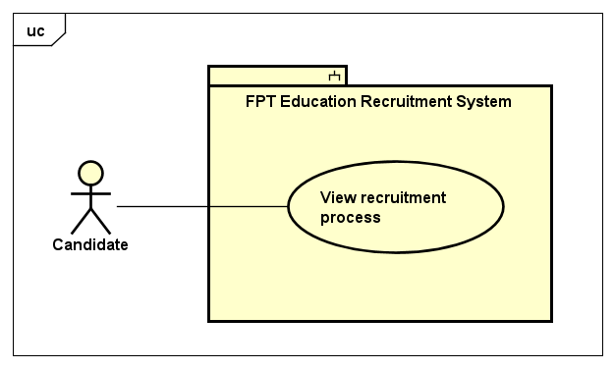

*Figure 3.5. View recruitment process*

|  |  |  |  |  |
| --- | --- | --- | --- | --- |
| **USE CASE-01 SPECIFICATION** | | | | |
| **Use-case No.** | <UC-01> | Use-case Version | | <1.0> |
| **Use-case Name** | View recruitment process | | | |
| **Author** | TungBT | | | |
| **Date** | 18/07/2020 | Priority | Low | |
| **Actor** | Candidate | | | |
| **Summary** | Candidate views information about recruitment process of FPT Education | | | |
| **Goal** | Display information about recruitment process | | | |
| **Triggers** | Candidate clicks on the link “Quy trình tuyển dụng” in the footer | | | |
| **Preconditions** | N/A | | | |
| **Post Conditions** | Candidate view information about recruitment process of FPT Education | | | |
| **Main Success Scenario** | | | | |
| |  |  |  | | --- | --- | --- | | Step | Actor Events | System Response | | 1 | Click on “Quy trình tuyển dụng” in the footer |  | | 2 |  | Redirect to recruitment process page | | | | | |
| **Alternative Scenario** | | | | |
| N/A | | | | |
| **Exceptions** | N/A | | | |
| **Business Rules** | N/A | | | |

#### Use case 02: View home



*Figure 3.6. View home use cases*

|  |  |  |  |  |
| --- | --- | --- | --- | --- |
| **USE CASE-02 SPECIFICATION** | | | | |
| **Use-case No.** | <UC-02> | Use-case Version | | <1.0> |
| **Use-case Name** | View home | | | |
| **Author** | TungBT | | | |
| **Date** | 18/07/2020 | Priority | High | |
| **Actor** | Candidate | | | |
| **Summary** | Candidate view information of home page | | | |
| **Goal** | Display information in home page | | | |
| **Triggers** | Candidate visit the website in the browser | | | |
| **Preconditions** | N/A | | | |
| **Post Conditions** | Candidate view information of home page | | | |
| **Main Success Scenario** | | | | |
| |  |  |  | | --- | --- | --- | | Step | Actor Events | System Response | | 1 | Visit the website in the browser by typing url “career.fpt.edu.vn” |  | | 2 |  | Connect successfully, system display home page | | | | | |
| **Alternative Scenario** | | | | |
| N/A | | | | |
| **Exceptions** | N/A | | | |
| **Business Rules** | N/A | | | |

#### Use case 03: View all jobs

|  |  |  |  |  |
| --- | --- | --- | --- | --- |
| **USE CASE-03 SPECIFICATION** | | | | |
| **Use-case No.** | <UC-03> | Use-case Version | | <1.0> |
| **Use-case Name** | View all jobs | | | |
| **Author** | TungBT | | | |
| **Date** | 18/07/2020 | Priority | Medium | |
| **Actor** | Candidate | | | |
| **Summary** | Candidate views list of all the jobs that are in need of recruitment | | | |
| **Goal** | Display list of all jobs that are in need of recruitment | | | |
| **Triggers** | Click on the link “Vị trí tuyển dụng” on the header | | | |
| **Preconditions** | N/A | | | |
| **Post Conditions** | View list of all jobs | | | |
| **Main Success Scenario** | | | | |
| |  |  |  | | --- | --- | --- | | Step | Actor Events | System Response | | 1 | Visit FERS website |  | | 2 |  | Display home page default | | 3 | User clicks on the link “Vị trí tuyển dụng” on the header |  | | 4 |  | Redirect to list job page and display all jobs | | | | | |
| **Alternative Scenario** | | | | |
| N/A | | | | |
| **Exceptions** | N/A | | | |
| **Business Rules** | N/A | | | |

#### Use case 04: View list jobs by region

|  |  |  |  |  |
| --- | --- | --- | --- | --- |
| **USE CASE-04 SPECIFICATION** | | | | |
| **Use-case No.** | <UC-04> | Use-case Version | | <1.0> |
| **Use-case Name** | View list jobs by region | | | |
| **Author** | TungBT | | | |
| **Date** | 18/07/2020 | Priority | Medium | |
| **Actor** | Candidate | | | |
| **Summary** | Candidate views list of all jobs filtered by a region | | | |
| **Goal** | View list jobs filtered by a region | | | |
| **Triggers** | Click button “Xem thêm” on a section job of a region | | | |
| **Preconditions** | N/A | | | |
| **Post Conditions** | View list jobs filtered by a region | | | |
| **Main Success Scenario** | | | | |
| |  |  |  | | --- | --- | --- | | Step | Actor Events | System Response | | 1 | Visit FERS website |  | | 2 |  | Display home page default | | 3 | Click button “Xem thêm” on a section job of a region |  | | 4 |  | Redirect to list job page and show list of jobs filtered by the region user clicked on | | | | | |
| **Alternative Scenario** | | | | |
| N/A | | | | |
| **Exceptions** | N/A | | | |
| **Business Rules** | N/A | | | |

#### Use case 05: View list jobs by unit

|  |  |  |  |  |
| --- | --- | --- | --- | --- |
| **USE CASE-05 SPECIFICATION** | | | | |
| **Use-case No.** | <UC-05> | Use-case Version | | <1.0> |
| **Use-case Name** | View list jobs by unit | | | |
| **Author** | TungBT | | | |
| **Date** | 18/07/2020 | Priority | Medium | |
| **Actor** | Candidate | | | |
| **Summary** | Candidate views list of all jobs filtered by an unit | | | |
| **Goal** | View list jobs filtered by an unit | | | |
| **Triggers** | Click on the unit link in the "Các vị trí tuyển dụng" section on the home page | | | |
| **Preconditions** | N/A | | | |
| **Post Conditions** | View list jobs filtered by an unit | | | |
| **Main Success Scenario** | | | | |
| |  |  |  | | --- | --- | --- | | Step | Actor Events | System Response | | 1 | Visit FERS website |  | | 2 |  | Display home page default | | 3 | Click on the unit link in the "Các vị trí tuyển dụng" section on the home page |  | | 4 |  | Redirect to list job page and show list of jobs filtered by the unit user clicked on | | | | | |
| **Alternative Scenario** | | | | |
| N/A | | | | |
| **Exceptions** | N/A | | | |
| **Business Rules** | N/A | | | |

#### Use case 06: View job detail

|  |  |  |  |  |
| --- | --- | --- | --- | --- |
| **USE CASE-06 SPECIFICATION** | | | | |
| **Use-case No.** | <UC-06> | Use-case Version | | <1.0> |
| **Use-case Name** | View job detail | | | |
| **Author** | TungBT | | | |
| **Date** | 18/07/2020 | Priority | Medium | |
| **Actor** | Candidate | | | |
| **Summary** | Candidate view detailed information about a job | | | |
| **Goal** | Display detailed information about a job | | | |
| **Triggers** | Candidate click on a job | | | |
| **Preconditions** | N/A | | | |
| **Post Conditions** | Candidate view detailed information about a job | | | |
| **Main Success Scenario** | | | | |
| |  |  |  | | --- | --- | --- | | Step | Actor Events | System Response | | 1 | Visit FERS website |  | | 2 |  | Display homepage | | 3 | Scroll down to top recruitment jobs section of a region, then clicks to a certain job |  | | 5 |  | Redirect to job detail page and display detailed information about the job | | | | | |
| Alternative Scenario | | | | |
| Alternative Scenario 1:   |  |  |  | | --- | --- | --- | | Step | Actor Events | System Response | | 1 | Visit FERS website |  | | 2 |  | Display homepage | | 3 | Click “Xem thêm” to see list job filtered by region |  | | 4 |  | Redirect to list job page and display list jobs filtered by region | | 5 | Click on a job |  | | 6 |  | Redirect to job detail page and display detailed information about the job |   Alternative Scenario 2:   |  |  |  | | --- | --- | --- | | Step | Actor Events | System Response | | 1 | Visit FERS website |  | | 2 |  | Display homepage | | 3 | Click “Vị trí tuyển dụng” on header |  | | 4 |  | Redirect to list all jobs page and display all jobs that are in recruitment need | | 5 | Click on a job |  | | 6 |  | Redirect to job detail page and display detailed information about the job | | | | | |
| **Exceptions** | N/A | | | |
| **Business Rules** | N/A | | | |

#### Use case 07: Search job

|  |  |  |  |  |
| --- | --- | --- | --- | --- |
| **USE CASE-07 SPECIFICATION** | | | | |
| **Use-case No.** | <UC-07> | Use-case Version | | <1.0> |
| **Use-case Name** | Search job | | | |
| **Author** | TungBT | | | |
| **Date** | 18/07/2020 | Priority | Medium | |
| **Actor** | Candidate | | | |
| **Summary** | Candidate find a job that he/she needs | | | |
| **Goal** | Display list of job filter by some input searching | | | |
| **Triggers** | Candidate chooses the options in filter menu (homepage) then click “Tìm kiếm” | | | |
| **Preconditions** | N/A | | | |
| **Post Conditions** | Candidate find a job that candidate needs | | | |
| **Main Success Scenario** | | | | |
| |  |  |  | | --- | --- | --- | | Step | Actor Events | System Response | | 1 | Visit FERS website |  | | 2 |  | Display homepage | | 3 | Fill in input fields on search menu include:  Keyword (text)  Unit (drop down list)  Career (drop down list)  Location (drop down list)  Then click button “Tìm kiếm” |  | | 4 |  | Redirect to list job page and display the jobs filtered by searching keywords | | | | | |
| Alternative Scenario | | | | |
| |  |  |  | | --- | --- | --- | | Step | Actor Events | System Response | | 1 | Visit FERS website |  | | 2 |  | Display homepage | | 4 | Click to the link “Vị trí tuyển dụng” on header |  | | 5 |  | Redirect to list job page and show list of all jobs | | 6 | Fill in input fields on search menu in list job page, including:  Keyword (text)  Unit (drop down list)  Career (drop down list)  Location (drop down list)  Then click button “Tìm kiếm” |  | | 7 |  | Display list of jobs that are filtered by keywords | | | | | |
| **Exceptions** | N/A | | | |
| **Business Rules** | All input fields must not be blank | | | |

#### Use case 08: Create CV

|  |  |  |  |  |
| --- | --- | --- | --- | --- |
| **USE CASE-08 SPECIFICATION** | | | | |
| **Use-case No.** | <UC-08> | Use-case Version | | <1.0> |
| **Use-case Name** | Create CV | | | |
| **Author** | TungBT | | | |
| **Date** | 18/07/2020 | Priority | High | |
| **Actor** | Candidate | | | |
| **Summary** | Candidate create a CV to apply job | | | |
| **Goal** | Create CV a basic CV | | | |
| **Triggers** | Candidate click “Chưa có CV” on modal dialog | | | |
| **Preconditions** | N/A | | | |
| **Post Conditions** | Candidate create a CV | | | |
| **Main Success Scenario** | | | | |
| |  |  |  | | --- | --- | --- | | Step | Actor Events | System Response | | 1 | Visit FERS website |  | | 2 |  | Display homepage | | 3 | Click “Ứng tuyển ngay” on a detail job |  | | 4 |  | Display the confirmation dialog to ask if the candidate has a CV yet, include 2 options:  “Chưa có CV”  “Đã có CV” | | 5 | Click “Chưa có CV” |  | | 6 |  | Display the create CV dialog | | 7 | Fill in the input fields then click “Nộp CV” |  | | 8 |  | Notice of success and redirect to homepage | | | | | |
| Alternative Scenario | | | | |
| |  |  |  | | --- | --- | --- | | Step | Actor Events | System Response | | 1 | Visit FERS website |  | | 2 |  | Display homepage | | 3 | Click “Xem thêm” to see list job filtered by region |  | | 4 |  | Move to list job page and display list jobs filtered by region | | 5 | Click on a job |  | | 6 |  | Move to job detail page and display detailed information about the job | | 7 | Click the button “Ứng tuyển ngay” on a detail job page |  | | 8 |  | Display the confirmation dialog to ask if the candidate has a CV yet, include 2 options:  “Chưa có CV”  “Đã có CV” | | 9 | Click “Chưa có CV” |  | | 10 |  | Display the create CV dialog | | 11 | Fill in the input fields then click “Nộp CV” |  | | 12 |  | Notice of success and redirect to homepage | | | | | |
| Exceptions | N/A | | | |
| Business Rules | All input fields that include (*) must not be blank  The maximum length of input text fields is 255  The maximum length of text area fields is 5000 | | | |

#### Use case 09: Upload CV

|  |  |  |  |  |
| --- | --- | --- | --- | --- |
| **USE CASE-09 SPECIFICATION** | | | | |
| **Use-case No.** | <UC-09> | Use-case Version | | <1.0> |
| **Use-case Name** | Upload CV | | | |
| **Author** | TungBT | | | |
| **Date** | 18/07/2020 | Priority | High | |
| **Actor** | Candidate | | | |
| **Summary** | Once the candidate has a CV, he can upload it to the system | | | |
| Goal | Upload CV to the system to apply a job | | | |
| Triggers | Candidate click “Upload CV” on modal dialog | | | |
| Preconditions | N/A | | | |
| Post Conditions | Upload CV to the system | | | |
| Main Success Scenario | | | | |
| |  |  |  | | --- | --- | --- | | Step | Actor Events | System Response | | 1 | Visit FERS website |  | | 2 |  | Display homepage | | 3 | Click “Ứng tuyển ngay” on a detail job |  | | 4 |  | Display the confirmation dialog to ask if the candidate has a CV yet, include 2 options:  “Chưa có CV”  “Đã có CV” | | 5 | Click “Chưa có CV” |  | | 6 |  | Show modal Upload CV | | 7 | Fill in the input fields then click “Nộp CV” |  | | 8 |  | Notice of successful CV upload | | | | | |
| Alternative Scenario | | | | |
| |  |  |  | | --- | --- | --- | | Step | Actor Events | System Response | | 1 | Visit FERS website |  | | 2 |  | Display homepage | | 3 | Click “Xem thêm” to see list job filtered by region |  | | 4 |  | Move to list job page and display list jobs filtered by region | | 5 | Click on a job |  | | 6 |  | Move to job detail page and display detailed information about the job | | 7 | Click “Ứng tuyển ngay” on a detail job |  | | 8 |  | Display the confirmation dialog to ask if the candidate has a CV yet, include 2 options:  “Chưa có CV”  “Đã có CV” | | 9 | Click “Chưa có CV” |  | | 10 |  | Show modal Upload CV | | 11 | Fill in the input fields then click “Nộp CV” |  | | 12 |  | Notice of successful CV upload | | | | | |
| **Exceptions** | Failed to upload CV file to server The system gives notification and asks the user to re-upload | | | |
| **Business Rules** | All input fields that include (*) must not be blank  The maximum length of input text fields is 255  The maximum length of text area fields is 5000  The maximum capacity of CV file is 4MB  CV file must be PDF | | | |

#### Use case 10: Register potential candidate

|  |  |  |  |  |
| --- | --- | --- | --- | --- |
| USE CASE-10 SPECIFICATION | | | | |
| Use-case No. | <UC-10> | Use-case Version | | <1.0> |
| Use-case Name | Register potential candidate | | | |
| Author | TungBT | | | |
| Date | 18/07/2020 | Priority | Low | |
| Actor | Candidate | | | |
| Summary | When the candidate has not found the desired job, but they intend to apply in the future, they can leave personal information for HR staff to advise them. | | | |
| Goal | Candidate register information | | | |
| Triggers | Candidate clicks on the button “Đăng ký” in Homepage | | | |
| Preconditions | N/A | | | |
| Post Conditions | Candidate submit form to send information to the system | | | |
| Main Success Scenario | | | | |
| |  |  |  | | --- | --- | --- | | Step | Actor Events | System Response | | 1 | Visit FERS website |  | | 2 |  | Display homepage | | 3 | Click on the button “Đăng ký” |  | | 4 |  | Display modal register potential candidate | | 5 | Fill in all input fields and click “Đăng ký” |  | | 6 |  | Notice of success and close dialog | | | | | |
| **Alternative Scenario** | | | | |
| |  |  |  | | --- | --- | --- | | Step | Actor Events | System Response | | 1 | Visit FERS website |  | | 2 |  | Display homepage | | 3 | Click the link “Gia nhập với chúng tôi” on the header |  | | 4 |  | Display modal register potential candidate | | 5 | Fill in all input fields and click “Đăng ký” |  | | 6 |  | Notice of success and close dialog | | | | | |
| **Exceptions** | N/A | | | |
| **Business Rules** | All input fields that include (*) must not be blank  The maximum length of input text fields is 255  The maximum length of text area fields is 5000 | | | |

#### Use case 11: Edit CV

|  |  |  |  |  |
| --- | --- | --- | --- | --- |
| **USE CASE-11 SPECIFICATION** | | | | |
| Use-case No. | <UC-11> | Use-case Version | | <1.0> |
| Use-case Name | Edit CV | | | |
| Author | TungBT | | | |
| Date | 18/07/2020 | Priority | Medium | |
| Actor | Candidate | | | |
| Summary | After successfully creating a simple CV on the system, an email will be sent to the candidate, including a link to the page where candidates can edit their CV. | | | |
| Goal | Edit the CV | | | |
| Triggers | N/A | | | |
| Preconditions | Candidates successfully submit their CV by creating it directly on the system | | | |
| Post Conditions | Edit the CV | | | |
| Main Success Scenario | | | | |
| |  |  |  | | --- | --- | --- | | Step | Actor Events | System Response | | 1 | Do a normal flow of one of the following use case:  UC-08: Create CV  UC-09: Upload CV  UC-10: Register potential candidate |  | | 2 |  | Send an email to the candidate, including a link to the page where candidates can edit their CV. | | 3 | Click the attach link on the email |  | | 4 |  | Redirect to edit CV page | | 5 | Edit information of the CV and click submit button |  | | 6 |  | Notice of success then display home page | | | | | |
| **Alternative Scenario** | | | | |
| N/A | | | | |
| **Exceptions** | N/A | | | |
| **Business Rules** | All input fields that include (*) must not be blank  The maximum length of input text fields is 255  The maximum length of text area fields is 5000 | | | |

#### Use case 12: Take quiz

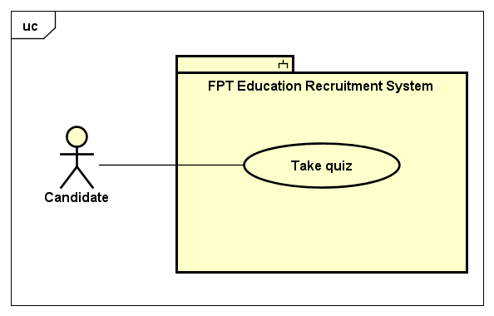

*Figure 3.7. Take quiz use case*

|  |  |  |  |  |
| --- | --- | --- | --- | --- |
| **USE CASE-12 SPECIFICATION** | | | | |
| **Use-case No.** | <UC-12> | Use-case Version | | <1.0> |
| **Use-case Name** | Take quiz | | | |
| **Author** | TungBT | | | |
| **Date** | 18/07/2020 | Priority | Medium | |
| **Actor** | Candidate | | | |
| **Summary** | Candidate received a document about FPT Education to learn about FE, then do a small quiz | | | |
| **Goal** | Help candidate to understand more about FPT Education | | | |
| **Triggers** | Clicks the link of quiz in email which were sent to candidate | | | |
| **Preconditions** | HR Staff clicks send email to the candidate to take quiz | | | |
| **Post Conditions** | Candidate do a small quiz about FPT Education | | | |
| **Main Success Scenario** | | | | |
| |  |  |  | | --- | --- | --- | | Step | Actor Events | System Response | | 1 | After HR Staff does normal flow of UC-54 (Send email quiz), Candidate will be received an email that includes link to the quiz  Candidate clicks to the link to the quiz |  | | 2 |  | Redirect to the quiz page | | 3 | After answer all questions, candidate click the button “Nộp bài” to submit the quiz |  | | 4 |  | Display success message: "Chúc mừng bạn đã hoàn thành bài kiểm tra !" | | | | | |
| **Alternative Scenario** | | | | |
| N/A | | | | |
| **Exceptions** | N/A | | | |
| **Business Rules** | Each question has one or more right answers  Time for a quiz is 40 minutes | | | |

#### Use case 13: View all accounts

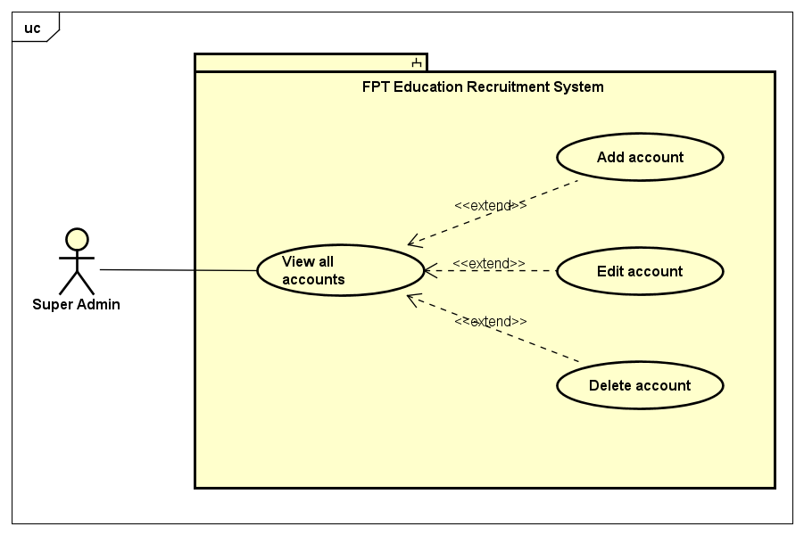

*Figure 3.8. Account management use cases*

|  |  |  |  |  |
| --- | --- | --- | --- | --- |
| **USE CASE-13 SPECIFICATION** | | | | |
| **Use-case No.** | <UC-13> | Use-case Version | | <1.0> |
| **Use-case Name** | View all accounts | | | |
| **Author** | TungBT | | | |
| **Date** | 18/07/2020 | Priority | Medium | |
| **Actor** | Super Admin | | | |
| **Summary** | Super Admin view all accounts in the system | | | |
| **Goal** | View all accounts in the system | | | |
| **Triggers** | Super Admin clicks tab “Quản lý tài khoản” on the sidebar of admin dashboard | | | |
| **Preconditions** | User has successfully logged in to the system as the Super Admin role | | | |
| **Post Conditions** | Super Admin views table of accounts | | | |
| **Main Success Scenario** | | | | |
| |  |  |  | | --- | --- | --- | | Step | Actor Events | System Response | | 1 | Login with Super Admin role |  | | 2 |  | Display admin dashboard with account management tab default | | | | | |
| **Alternative Scenario** | | | | |
| N/A | | | | |
| **Exceptions** | N/A | | | |
| **Business Rules** | N/A | | | |

#### Use case 14: Add account

|  |  |  |  |  |
| --- | --- | --- | --- | --- |
| **USE CASE-14 SPECIFICATION** | | | | |
| **Use-case No.** | <UC-14> | Use-case Version | | <1.0> |
| **Use-case Name** | Add account | | | |
| **Author** | TungBT | | | |
| **Date** | 18/07/2020 | Priority | Medium | |
| **Actor** | Super Admin | | | |
| **Summary** | Super Admin adds an account to the system | | | |
| **Goal** | Add a new account | | | |
| **Triggers** | Super Admin clicks “Tạo tài khoản mới” button on account management page | | | |
| **Preconditions** | User has successfully logged in to the system as the Super Admin role | | | |
| **Post Conditions** | Add a new account to the system | | | |
| **Main Success Scenario** | | | | |
| |  |  |  | | --- | --- | --- | | Step | Actor Events | System Response | | 1 | Login with Super Admin role |  | | 2 |  | Display account management page | | 3 | Click on “Tạo tài khoản mới” button |  | | 4 |  | Redirect to create account page | | 5 | Fill in all input fields and submit the form |  | | 6 |  | If creating successfully, the system will redirect to the account manage page and notify a success message  If creating error, the system will redirect to the error page and show message of the error | | | | | |
| **Alternative Scenario** | | | | |
| N/A | | | | |
| **Exceptions** | N/A | | | |
| **Business Rules** | Email must be valid type of email and not duplicate | | | |

#### Use case 15: Edit account

|  |  |  |  |  |
| --- | --- | --- | --- | --- |
| **USE CASE-15 SPECIFICATION** | | | | |
| **Use-case No.** | <UC-15> | Use-case Version | | <1.0> |
| **Use-case Name** | Edit account | | | |
| **Author** | TungBT | | | |
| **Date** | 18/07/2020 | Priority | Medium | |
| **Actor** | Super Admin | | | |
| **Summary** | User has successfully logged in to the system as the Super Admin role | | | |
| **Goal** | Edit an existing account | | | |
| **Triggers** | Super Admin clicks “Sửa” button on an account when view all accounts | | | |
| **Preconditions** | User has successfully logged in to the system as the Super Admin role | | | |
| **Post Conditions** | Edit information about the account | | | |
| **Main Success Scenario** | | | | |
| |  |  |  | | --- | --- | --- | | Step | Actor Events | System Response | | 1 | Do a normal flow of UC-13 |  | | 2 |  | Display all accounts of the system | | 3 | Click “Sửa” button on an account |  | | 4 |  | Display edit account page | | 5 | Edit information of the account and submit the form |  | | 6 |  | Notice of success and back to account management page | | | | | |
| **Alternative Scenario** | | | | |
| N/A | | | | |
| **Exceptions** | N/A | | | |
| **Business Rules** | Email must be valid type of email and not duplicate | | | |

#### Use case 16: Delete account

|  |  |  |  |  |
| --- | --- | --- | --- | --- |
| **USE CASE-16 SPECIFICATION** | | | | |
| **Use-case No.** | <UC-16> | Use-case Version | | <1.0> |
| **Use-case Name** | Delete account | | | |
| **Author** | TungBT | | | |
| **Date** | 18/07/2020 | Priority | Medium | |
| **Actor** | Super Admin | | | |
| **Summary** | Super Admin deletes an account in the system | | | |
| **Goal** | Delete an account | | | |
| **Triggers** | Super Admin clicks “Xoá” button on account management page | | | |
| **Preconditions** | User has successfully logged in to the system as the Super Admin role | | | |
| **Post Conditions** | Delete an account | | | |
| **Main Success Scenario** | | | | |
| |  |  |  | | --- | --- | --- | | Step | Actor Events | System Response | | 1 | Do a normal flow of UC-13 |  | | 2 |  | Display all accounts of the system | | 3 | Click “Xoá” button on an account |  | | 4 |  | Give a confirmation message | | 5 | Confirm to delete the account |  | | 6 |  | Delete the account then display account management page | | | | | |
| **Alternative Scenario** | | | | |
|  | | | | |
| **Exceptions** | N/A | | | |
| **Business Rules** | Super Admin can not delete account of himself | | | |

#### Use case 17: View all units

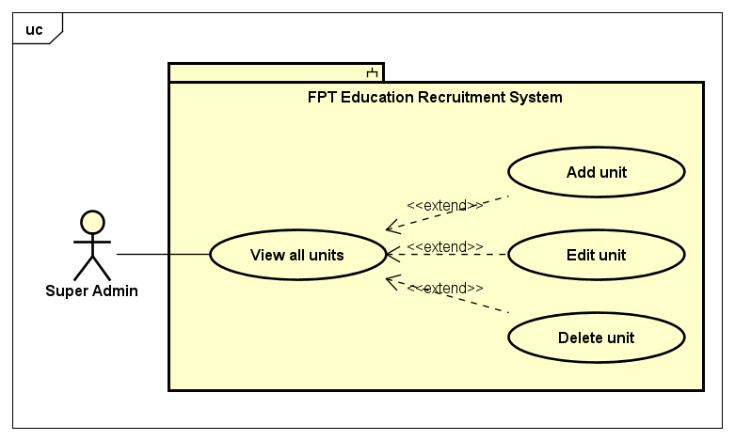

*Figure 3.9. Unit management use cases*

|  |  |  |  |  |
| --- | --- | --- | --- | --- |
| **USE CASE-17 SPECIFICATION** | | | | |
| **Use-case No.** | <UC-17> | Use-case Version | | <1.0> |
| **Use-case Name** | View all units | | | |
| **Author** | TungBT | | | |
| **Date** | 18/07/2020 | Priority | Medium | |
| **Actor** | Super Admin | | | |
| **Summary** | Super admin accesses the unit management page and views all units of the system | | | |
| **Goal** | View list of units in FPT Education system | | | |
| **Triggers** | User clicks the tab “Quản lý đơn vị” on the sidebar of admin dashboard | | | |
| **Preconditions** | User has successfully logged in to the system as the Super Admin role | | | |
| **Post Conditions** | View list of units in FPT Education system | | | |
| **Main Success Scenario** | | | | |
| |  |  |  | | --- | --- | --- | | Step | Actor Events | System Response | | 1 | User logins as Super Admin role |  | | 2 |  | Display Account management page by default | | 3 | Click on “Quản lý đơn vị” tab on the sidebar |  | | 4 |  | Display unit management page | | | | | |
| **Alternative Scenario** | | | | |
| N/A | | | | |
| **Exceptions** | N/A | | | |
| **Business Rules** | N/A | | | |

#### Use case 18: Add unit

|  |  |  |  |  |
| --- | --- | --- | --- | --- |
| **USE CASE-18 SPECIFICATION** | | | | |
| **Use-case No.** | <UC-18> | Use-case Version | | <1.0> |
| **Use-case Name** | Add unit | | | |
| **Author** | TungBT | | | |
| **Date** | 18/07/2020 | Priority | Low | |
| **Actor** | Super Admin | | | |
| **Summary** | Super Admin creates a new unit into FPT Education system | | | |
| **Goal** | Create a new unit | | | |
| **Triggers** | User clicks on “Thêm đơn vị làm việc” button on unit management page | | | |
| **Preconditions** | User has successfully logged in to the system as the Super Admin role | | | |
| **Post Conditions** | Create a new unit into the system | | | |
| **Main Success Scenario** | | | | |
| |  |  |  | | --- | --- | --- | | Step | Actor Events | System Response | | 1 | Do a normal flow of UC-17 and click on “Thêm đơn vị làm việc” button |  | | 2 |  | Display create an unit page | | 3 | Enter information in the input fields then click submit button |  | | 4 |  | Notice of success and redirect to unit management page | | | | | |
| **Alternative Scenario** | | | | |
| N/A | | | | |
| **Exceptions** | N/A | | | |
| **Business Rules** | Maximum size of image file is 4MB | | | |

#### Use case 19: Edit unit

|  |  |  |  |  |
| --- | --- | --- | --- | --- |
| **USE CASE-19 SPECIFICATION** | | | | |
| **Use-case No.** | <UC-19> | Use-case Version | | <1.0> |
| **Use-case Name** | Edit unit | | | |
| **Author** | TungBT | | | |
| **Date** | 18/07/2020 | Priority | Low | |
| **Actor** | Super Admin | | | |
| **Summary** | Super Admin edits information of an unit in FPT Education system | | | |
| **Goal** | Edit information of an unit | | | |
| **Triggers** | Click on “Sửa” button of an unit | | | |
| **Preconditions** | User has successfully logged in to the system as the Super Admin role | | | |
| **Post Conditions** | Edit an unit | | | |
| **Main Success Scenario** | | | | |
| |  |  |  | | --- | --- | --- | | Step | Actor Events | System Response | | 1 | Do a normal flow of UC-17 |  | | 2 |  | Display unit management page | | 3 | Click on “Sửa” button of an unit |  | | 4 |  | Display edit an unit page | | 5 | Edit information of the unit then submit form |  | | 6 |  | Notice of success then redirect to unit management page | | | | | |
| **Alternative Scenario** | | | | |
| N/A | | | | |
| **Exceptions** | N/A | | | |
| **Business Rules** | Maximum length of unit’s name is 255 | | | |

#### Use case 20: Delete unit

|  |  |  |  |  |
| --- | --- | --- | --- | --- |
| **USE CASE-20 SPECIFICATION** | | | | |
| **Use-case No.** | <UC-20> | Use-case Version | | <1.0> |
| **Use-case Name** | Delete unit | | | |
| **Author** | TungBT | | | |
| **Date** | 18/07/2020 | Priority | Low | |
| **Actor** | Super Admin | | | |
| **Summary** | Super Admin deletes an unit of FPT Education system | | | |
| **Goal** | Delete an unit | | | |
| **Triggers** | Click on “Xoá” button of an unit | | | |
| **Preconditions** | User has successfully logged in to the system as the Super Admin role | | | |
| **Post Conditions** | Delete an unit | | | |
| **Main Success Scenario** | | | | |
| |  |  |  | | --- | --- | --- | | Step | Actor Events | System Response | | 1 | Do a normal flow of UC-17 |  | | 2 |  | Display unit management page | | 3 | Click on “Xoá” button of an unit |  | | 4 |  | Give confirmation dialog box | | 5 | Confirm to delete the unit |  | | 6 |  | Delete the unit then display unit management page | | | | | |
| **Alternative Scenario** | | | | |
| N/A | | | | |
| **Exceptions** | N/A | | | |
| **Business Rules** | N/A | | | |

#### Use case 21: View all locations

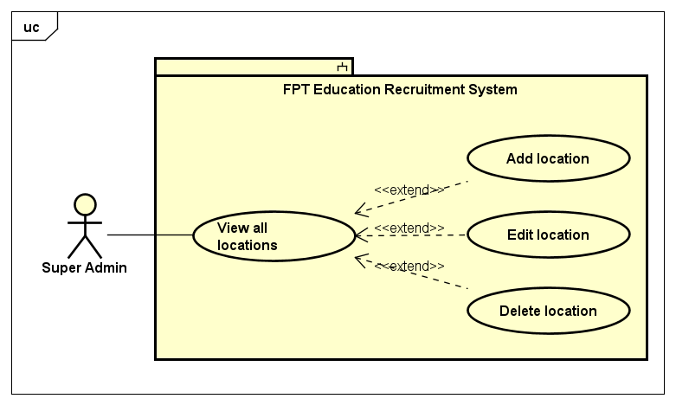

*Figure 3.10. Location management use cases*

|  |  |  |  |  |
| --- | --- | --- | --- | --- |
| **USE CASE-21 SPECIFICATION** | | | | |
| **Use-case No.** | <UC-21> | Use-case Version | | <1.0> |
| **Use-case Name** | View all locations | | | |
| **Author** | TungBT | | | |
| **Date** | 18/07/2020 | Priority | Medium | |
| **Actor** | Super Admin | | | |
| **Summary** | Super Admin views all locations of FPT Education system, these are provinces and cities of Vietnam | | | |
| **Goal** | View all locations of FPT Education system | | | |
| **Triggers** | User clicks the tab “Quản lý địa điểm” on the sidebar of admin dashboard | | | |
| **Preconditions** | User has successfully logged in to the system as the Super Admin role | | | |
| **Post Conditions** | View list of locations in FPT Education system | | | |
| **Main Success Scenario** | | | | |
| |  |  |  | | --- | --- | --- | | Step | Actor Events | System Response | | 1 | User logins as Super Admin role |  | | 2 |  | Display account management page by default | | 3 | Click on “Quản lý địa điểm” tab on the sidebar |  | | 4 |  | Display location management page | | | | | |
| **Alternative Scenario** | | | | |
| N/A | | | | |
| **Exceptions** | N/A | | | |
| **Business Rules** | N/A | | | |

#### Use case 22: Add location

|  |  |  |  |  |
| --- | --- | --- | --- | --- |
| **USE CASE-22 SPECIFICATION** | | | | |
| **Use-case No.** | <UC-22> | Use-case Version | | <1.0> |
| **Use-case Name** | Add location | | | |
| **Author** | TungBT | | | |
| **Date** | 18/07/2020 | Priority | Medium | |
| **Actor** | Super Admin | | | |
| **Summary** | Super Admin adds a new location into FPT Education system | | | |
| **Goal** | Add a new location | | | |
| **Triggers** | User clicks on “Thêm địa điểm mới” button on location management page | | | |
| **Preconditions** | User has successfully logged in to the system as the Super Admin role | | | |
| **Post Conditions** | Add a new location into the system | | | |
| **Main Success Scenario** | | | | |
| |  |  |  | | --- | --- | --- | | Step | Actor Events | System Response | | 1 | Do a normal flow of UC-21 and click on “Thêm địa điểm mới” button |  | | 2 |  | Display add a location page | | 3 | Fill information in the input fields then click submit button |  | | 4 |  | Notice of success and redirect to location management page | | | | | |
| **Alternative Scenario** | | | | |
| N/A | | | | |
| **Exceptions** | N/A | | | |
| **Business Rules** | Max length of the location name is 255 | | | |

#### Use case 23: Edit location

|  |  |  |  |  |
| --- | --- | --- | --- | --- |
| **USE CASE-23 SPECIFICATION** | | | | |
| **Use-case No.** | <UC-23> | Use-case Version | | <1.0> |
| **Use-case Name** | Edit location | | | |
| **Author** | TungBT | | | |
| **Date** | 18/07/2020 | Priority | Medium | |
| **Actor** | Super Admin | | | |
| **Summary** | Super Admin edits information of a location in FPT Education system | | | |
| **Goal** | Edit information of a location | | | |
| **Triggers** | Click on “Sửa” button of a location | | | |
| **Preconditions** | User has successfully logged in to the system as the Super Admin role | | | |
| **Post Conditions** | Edit a location | | | |
| **Main Success Scenario** | | | | |
| |  |  |  | | --- | --- | --- | | Step | Actor Events | System Response | | 1 | Do a normal flow of UC-21 |  | | 2 |  | Display location management page | | 3 | Click on “Sửa” button of a location |  | | 4 |  | Display edit location page | | 5 | Edit information of the location then submit form |  | | 6 |  | Notice of success then redirect to location management page | | | | | |
| **Alternative Scenario** | | | | |
| N/A | | | | |
| **Exceptions** | N/A | | | |
| **Business Rules** | Max length of unit name is 255 | | | |

#### Use case 24: Delete location

|  |  |  |  |  |
| --- | --- | --- | --- | --- |
| **USE CASE-24 SPECIFICATION** | | | | |
| **Use-case No.** | <UC-24> | Use-case Version | | <1.0> |
| **Use-case Name** | Delete location | | | |
| **Author** | TungBT | | | |
| **Date** | 18/07/2020 | Priority | Medium | |
| **Actor** | Super Admin | | | |
| **Summary** | Super Admin deletes a location of FPT Education system | | | |
| **Goal** | Delete a location | | | |
| **Triggers** | Click on “Xóa” button on a location | | | |
| Preconditions | User has successfully logged in to the system as the Super Admin role | | | |
| **Post Conditions** | Delete a location | | | |
| **Main Success Scenario** | | | | |
| |  |  |  | | --- | --- | --- | | Step | Actor Events | System Response | | 1 | Do a normal flow of UC-21 |  | | 2 |  | Display location management page | | 3 | Click on “Xóa” button on a location |  | | 4 |  | Give confirmation message | | 5 | Confirm to delete the location |  | | 6 |  | Delete the location then display location management page | | | | | |
| **Alternative Scenario** | | | | |
| N/A | | | | |
| **Exceptions** | N/A | | | |
| **Business Rules** | N/A | | | |

#### Use case 25: View all question groups

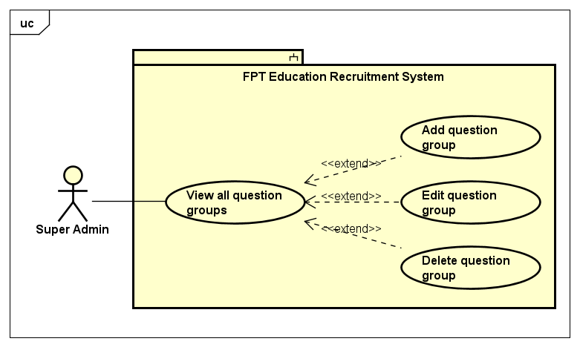

*Figure 3.11. Question group management use cases*

|  |  |  |  |  |
| --- | --- | --- | --- | --- |
| **USE CASE-25 SPECIFICATION** | | | | |
| **Use-case No.** | <UC-25> | Use-case Version | | <1.0> |
| **Use-case Name** | View all question groups | | | |
| **Author** | TungBT | | | |
| **Date** | 18/07/2020 | Priority | Low | |
| **Actor** | Super Admin | | | |
| **Summary** | Super Admin views all question groups in the system. The questions are divided into groups, each group corresponding to a different topic for easy management | | | |
| **Goal** | View all question groups | | | |
| **Triggers** | User clicks on the tab “Quản lý nhóm câu hỏi” on the sidebar of website | | | |
| **Preconditions** | User has successfully logged in to the system as the Super Admin role | | | |
| **Post Conditions** | View all question groups | | | |
| **Main Success Scenario** | | | | |
| |  |  |  | | --- | --- | --- | | Step | Actor Events | System Response | | 1 | User logins to the system as role of Super Admin |  | | 2 |  | Display account management page by default | | 3 | Click on the tab “Quản lý nhóm câu hỏi” on the sidebar |  | | 4 |  | Display list of question groups on question group management page | | | | | |
| **Alternative Scenario** | | | | |
| N/A | | | | |
| **Exceptions** | N/A | | | |
| **Business Rules** | N/A | | | |

#### Use case 26: Add question group

|  |  |  |  |  |
| --- | --- | --- | --- | --- |
| **USE CASE-26 SPECIFICATION** | | | | |
| **Use-case No.** | <UC-26> | Use-case Version | | <1.0> |
| **Use-case Name** | Add question group | | | |
| **Author** | TungBT | | | |
| **Date** | 18/07/2020 | Priority | Low | |
| **Actor** | Super Admin | | | |
| **Summary** | Super Admin adds a new question group | | | |
| **Goal** | Add a new question group | | | |
| **Triggers** | User clicks the button “Tạo nhóm mới” on question group management page | | | |
| **Preconditions** | User has successfully logged in to the system as the Super Admin role | | | |
| **Post Conditions** | Add a new question group | | | |
| **Main Success Scenario** | | | | |
| |  |  |  | | --- | --- | --- | | Step | Actor Events | System Response | | 1 | Do a normal flow of UC-25 |  | | 2 |  | Display question group management page | | 3 | Click on the button “Tạo nhóm mới” |  | | 4 |  | Display add question group page | | 5 | Enter name of the new question group and clicks “Tạo mới” |  | | 6 |  | Notice of success and display question group management page | | | | | |
| **Alternative Scenario** | | | | |
| N/A | | | | |
| **Exceptions** | N/A | | | |
| **Business Rules** | N/A | | | |

#### Use case 27: Edit question group

|  |  |  |  |  |
| --- | --- | --- | --- | --- |
| **USE CASE-27 SPECIFICATION** | | | | |
| **Use-case No.** | <UC-27> | Use-case Version | | <1.0> |
| **Use-case Name** | Edit question group | | | |
| **Author** | TungBT | | | |
| **Date** | 18/07/2020 | Priority | Low | |
| **Actor** | Super Admin | | | |
| **Summary** | Super Admin edit the name of a question group | | | |
| **Goal** | Edit a question group | | | |
| **Triggers** | User clicks button “Sửa” of a question group | | | |
| **Preconditions** | User has successfully logged in to the system as the Super Admin role | | | |
| **Post Conditions** | Edit a question group | | | |
| **Main Success Scenario** | | | | |
| |  |  |  | | --- | --- | --- | | Step | Actor Events | System Response | | 1 | Do a normal flow of UC-25 |  | | 2 |  | Display question group management page | | 3 | Click the button “Sửa” on a question group |  | | 4 |  | Display edit question group page | | 5 | Change the name of the question group then click button “Lưu” |  | | 6 |  | Notice of success and display question group management page | | | | | |
| **Alternative Scenario** | | | | |
| N/A | | | | |
| **Exceptions** | N/A | | | |
| **Business Rules** | Name of question group must not be blank  Max length of the name of question group is 255 | | | |

#### Use case 28: Delete question group

|  |  |  |  |  |
| --- | --- | --- | --- | --- |
| **USE CASE-28 SPECIFICATION** | | | | |
| **Use-case No.** | <UC-28> | Use-case Version | | <1.0> |
| **Use-case Name** | Delete question group | | | |
| **Author** | TungBT | | | |
| **Date** | 18/07/2020 | Priority | Low | |
| **Actor** | Super Admin | | | |
| **Summary** | Super Admin deletes a question group | | | |
| **Goal** | Delete a question group | | | |
| **Triggers** | User clicks button “Xóa” of a question group | | | |
| **Preconditions** | User has successfully logged in to the system as the Super Admin role | | | |
| **Post Conditions** | Delete a question group | | | |
| **Main Success Scenario** | | | | |
| |  |  |  | | --- | --- | --- | | Step | Actor Events | System Response | | 1 | Do a normal flow of UC-25 |  | | 2 |  | Display question group management page | | 3 | Click the button “Xóa” on a question group |  | | 4 |  | Pop up a confirmation dialog box | | 5 | Click OK to confirm delete |  | | 6 |  | The system notifies that the question group has been successfully deleted, then refresh page | | | | | |
| **Alternative Scenario** | | | | |
| N/A | | | | |
| **Exceptions** | N/A | | | |
| **Business Rules** | N/A | | | |

#### Use case 29: View all questions

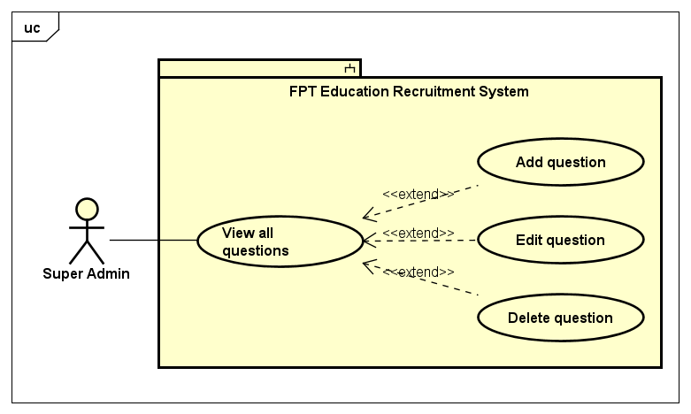

*Figure 3.12. Question management use cases*

|  |  |  |  |  |
| --- | --- | --- | --- | --- |
| **USE CASE-29 SPECIFICATION** | | | | |
| **Use-case No.** | <UC-29> | Use-case Version | | <1.0> |
| **Use-case Name** | View all questions | | | |
| **Author** | TungBT | | | |
| **Date** | 18/07/2020 | Priority | Medium | |
| **Actor** | Super Admin | | | |
| **Summary** | Super Admin views list of all questions in the system | | | |
| **Goal** | View all questions | | | |
| **Triggers** | Click tab “Quản lý câu hỏi” in the sidebar | | | |
| **Preconditions** | User has successfully logged in to the system as the Super Admin role | | | |
| **Post Conditions** | System show list of questions | | | |
| **Main Success Scenario** | | | | |
| |  |  |  | | --- | --- | --- | | Step | Actor Events | System Response | | 1 | User logins as role of Super Admin |  | | 2 |  | Display account management page by default | | 3 | Click on “Quản lý câu hỏi” tab on the sidebar |  | | 4 |  | Redirect to question management page, show list of all questions | | | | | |
| **Alternative Scenario** | | | | |
| N/A | | | | |
| **Exceptions** | N/A | | | |
| **Business Rules** | N/A | | | |

#### Use case 30: Add question

|  |  |  |  |  |
| --- | --- | --- | --- | --- |
| **USE CASE-30 SPECIFICATION** | | | | |
| **Use-case No.** | <UC-30> | Use-case Version | | <1.0> |
| **Use-case Name** | Add question | | | |
| **Author** | TungBT | | | |
| **Date** | 18/07/2020 | Priority | Medium | |
| **Actor** | Super Admin | | | |
| **Summary** | Super admin adds a new question into question bank | | | |
| **Goal** | Add a new question | | | |
| **Triggers** | User clicks on “Thêm câu hỏi mới” button on question management page | | | |
| **Preconditions** | User has successfully logged in to the system as the Super Admin role | | | |
| **Post Conditions** | Add a new question into question bank | | | |
| **Main Success Scenario** | | | | |
| |  |  |  | | --- | --- | --- | | Step | Actor Events | System Response | | 1 | Do a normal flow of UC-29 |  | | 2 |  | Display question management page | | 3 | Click on “Thêm câu hỏi mới” button |  | | 4 |  | Display add question page | | 5 | Enter information in the input fields then click submit button |  | | 6 |  | Notice of success and move to question management page | | | | | |
| **Alternative Scenario** | | | | |
|  | | | | |
| **Exceptions** | N/A | | | |
| **Business Rules** | Each question must have at least one correct answer  Max length of question name field is 255 | | | |

#### Use case 31: Edit question

|  |  |  |  |  |
| --- | --- | --- | --- | --- |
| **USE CASE-31 SPECIFICATION** | | | | |
| **Use-case No.** | <UC-31> | Use-case Version | | <1.0> |
| **Use-case Name** | Edit question | | | |
| **Author** | TungBT | | | |
| **Date** | 18/07/2020 | Priority | Medium | |
| **Actor** | Super Admin | | | |
| **Summary** | Super Admin edits a question in question bank | | | |
| **Goal** | Edit a question | | | |
| **Triggers** | Click on “Sửa” button of an question | | | |
| **Preconditions** | User has successfully logged in to the system as the Super Admin role | | | |
| **Post Conditions** | Edit a question | | | |
| **Main Success Scenario** | | | | |
| |  |  |  | | --- | --- | --- | | Step | Actor Events | System Response | | 1 | Do a normal flow of UC-29 |  | | 2 |  | Display list of question | | 3 | Click on “Sửa” button of a question |  | | 4 |  | Display edit question page | | 5 | Edit input fields and clicks submit button |  | | 6 |  | Notice of success and back to manage question page | | | | | |
| **Alternative Scenario** | | | | |
| N/A | | | | |
| **Exceptions** | N/A | | | |
| **Business Rules** | Each question can have one or more correct answers  Max length of question name field is 255 | | | |

#### Use case 32: Delete question

|  |  |  |  |  |
| --- | --- | --- | --- | --- |
| **USE CASE-32 SPECIFICATION** | | | | |
| **Use-case No.** | <UC-32> | Use-case Version | | <1.0> |
| **Use-case Name** | Delete question | | | |
| **Author** | TungBT | | | |
| **Date** | 18/07/2020 | Priority | Low | |
| **Actor** | Super Admin | | | |
| **Summary** | Super Admin deletes a question in question bank | | | |
| **Goal** | Delete a question | | | |
| **Triggers** | Click on “Xóa” button of a question | | | |
| **Preconditions** | User has successfully logged in to the system as the Super Admin role | | | |
| **Post Conditions** | Delete a question | | | |
| **Main Success Scenario** | | | | |
| |  |  |  | | --- | --- | --- | | Step | Actor Events | System Response | | 1 | Do a normal flow of UC-29 |  | | 2 |  | Display list of question | | 3 | Click on “Xóa” button of a question |  | | 4 |  | Give a confirmation dialog box | | 5 | Click OK to delete the question |  | | 6 |  | Delete successfully and refresh page | | | | | |
| **Alternative Scenario** | | | | |
| N/A | | | | |
| **Exceptions** | N/A | | | |
| **Business Rules** | N/A | | | |

#### Use case 33: Search question

|  |  |  |  |  |
| --- | --- | --- | --- | --- |
| **USE CASE-33 SPECIFICATION** | | | | |
| **Use-case No.** | <UC-33> | Use-case Version | | <1.0> |
| **Use-case Name** | Search question | | | |
| **Author** | TungBT | | | |
| **Date** | 18/07/2020 | Priority | Medium | |
| **Actor** | Super Admin | | | |
| **Summary** | Super Admin search for questions that he/she wants, searching keywords include:  Question name  Group question name | | | |
| **Goal** | Search a question | | | |
| **Triggers** | User enters the search keyword and/or chooses group on the search menu bar and then clicks button “Tìm kiếm” | | | |
| **Preconditions** | User has successfully logged in to the system as the Super Admin role | | | |
| **Post Conditions** | Search a question | | | |
| **Main Success Scenario** | | | | |
| |  |  |  | | --- | --- | --- | | Step | Actor Events | System Response | | 1 | Do a normal flow of UC-29 |  | | 2 |  | Display question management page | | 3 | Enter name of question into text field, select group question in drop down list then clicks the button “Tìm kiếm” |  | | 4 |  | Displays a list of suitable questions | | | | | |
| **Alternative Scenario** | | | | |
| N/A | | | | |
| **Exceptions** | N/A | | | |
| **Business Rules** | If all fields are blank, system will return all records  Max length of question name field is 255 | | | |

#### Use case 34: View all quizzes

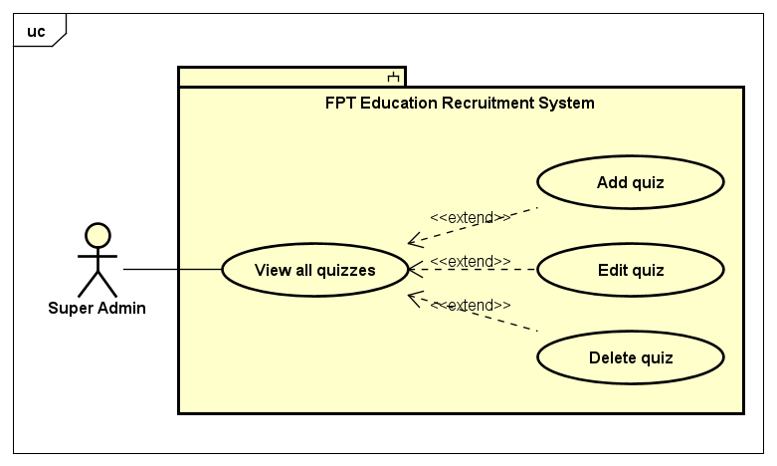

*Figure 3.13. Quiz management use cases*

|  |  |  |  |  |
| --- | --- | --- | --- | --- |
| **USE CASE-34 SPECIFICATION** | | | | |
| **Use-case No.** | <UC-34> | Use-case Version | | <1.0> |
| **Use-case Name** | View all quizzes | | | |
| **Author** | TungBT | | | |
| **Date** | 18/07/2020 | Priority | Low | |
| **Actor** | Super Admin | | | |
| **Summary** | Super Admin views list of all quizzes in the system | | | |
| **Goal** | View all quizzes | | | |
| **Triggers** | Click tab “Quản lý đề bài” in the sidebar | | | |
| **Preconditions** | User has successfully logged in to the system as the Super Admin role | | | |
| **Post Conditions** | System show list of quizzes | | | |
| **Main Success Scenario** | | | | |
| |  |  |  | | --- | --- | --- | | Step | Actor Events | System Response | | 1 | User logins as role of Super Admin |  | | 2 |  | Display account management page by default | | 3 | Click on “Quản lý đề bài” tab on the sidebar |  | | 4 |  | Display quiz management page, show list of all quizzes | | | | | |
| **Alternative Scenario** | | | | |
| N/A | | | | |
| **Exceptions** | N/A | | | |
| **Business Rules** | N/A | | | |

#### Use case 35: Add quiz

|  |  |  |  |  |
| --- | --- | --- | --- | --- |
| **USE CASE-35 SPECIFICATION** | | | | |
| **Use-case No.** | <UC-35> | Use-case Version | | <1.0> |
| **Use-case Name** | Add quiz | | | |
| **Author** | TungBT | | | |
| **Date** | 18/07/2020 | Priority | Low | |
| **Actor** | Super Admin | | | |
| **Summary** | Super admin adds a new quiz into quiz bank | | | |
| **Goal** | Add a new quiz | | | |
| **Triggers** | User clicks on “Tạo đề mới” button on quiz management page | | | |
| **Preconditions** | User has successfully logged in to the system as the Super Admin role | | | |
| **Post Conditions** | Add a new quiz into quiz bank | | | |
| **Main Success Scenario** | | | | |
| |  |  |  | | --- | --- | --- | | Step | Actor Events | System Response | | 1 | Do a normal flow of UC-34 |  | | 2 |  | Display quiz management page | | 3 | Click on “Tạo đề mới” button |  | | 4 |  | Display add quiz page | | 5 | Enter the name of the quiz, then check the questions user want in that quiz, finally click “Tạo mới” button |  | | 6 |  | Notice of success and move to quiz management page | | | | | |
| **Alternative Scenario** | | | | |
| N/A | | | | |
| **Exceptions** | N/A | | | |
| **Business Rules** | A Quiz must have name and contain at least 1 question  Max length of quiz name field is 255  Quiz name must not be blank | | | |

#### Use case 36: Edit quiz

|  |  |  |  |  |
| --- | --- | --- | --- | --- |
| **USE CASE-36 SPECIFICATION** | | | | |
| **Use-case No.** | <UC-36> | Use-case Version | | <1.0> |
| **Use-case Name** | Edit quiz | | | |
| **Author** | TungBT | | | |
| Date | 18/07/2020 | Priority | Low | |
| **Actor** | Super Admin | | | |
| **Summary** | Super Admin edit a quiz in quiz bank | | | |
| **Goal** | Edit a quiz | | | |
| **Triggers** | Click on “Sửa” button of a quiz | | | |
| **Preconditions** | User has successfully logged in to the system as the Super Admin role | | | |
| **Post Conditions** | Edit a quiz | | | |
| **Main Success Scenario** | | | | |
| |  |  |  | | --- | --- | --- | | Step | Actor Events | System Response | | 1 | Do a normal flow of UC-34 |  | | 2 |  | Display list of quizzes | | 3 | Click on “Sửa” button of a quiz |  | | 4 |  | Display edit quiz page | | 5 | Change the name of quiz, adds or removes questions of the the quiz, then clicks on submit button to complete editing |  | | 6 |  | Notice of success and back to manage quiz page | | | | | |
| **Alternative Scenario** | | | | |
| N/A | | | | |
| **Exceptions** | N/A | | | |
| **Business Rules** | A Quiz must have name and contain at least 1 question  Max length of quiz name field is 255  Quiz name must not be blank | | | |

#### Use case 37: Delete quiz

|  |  |  |  |  |
| --- | --- | --- | --- | --- |
| **USE CASE-37 SPECIFICATION** | | | | |
| **Use-case No.** | <UC-37> | Use-case Version | | <1.0> |
| **Use-case Name** | Delete quiz | | | |
| **Author** | TungBT | | | |
| **Date** | 18/07/2020 | Priority | Low | |
| **Actor** | Super Admin | | | |
| **Summary** | Super Admin deletes a quiz in quiz bank | | | |
| **Goal** | Delete a quiz | | | |
| **Triggers** | Click on “Xóa” button of a quiz | | | |
| **Preconditions** | User has successfully logged in to the system as the Super Admin role | | | |
| **Post Conditions** | Delete a quiz | | | |
| **Main Success Scenario** | | | | |
| |  |  |  | | --- | --- | --- | | Step | Actor Events | System Response | | 1 | Do a normal flow of UC-34 |  | | 2 |  | Display list of quizzes | | 3 | Click on “Xóa” button of a quiz |  | | 4 |  | Give a confirmation dialog box | | 5 | Click OK to delete the quiz |  | | 6 |  | Delete successfully and refresh page | | | | | |
| **Alternative Scenario** | | | | |
| N/A | | | | |
| **Exceptions** | N/A | | | |
| **Business Rules** | N/A | | | |

#### Use case 38: View all careers

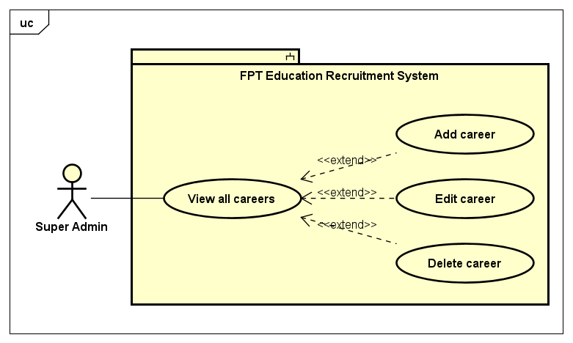

*Figure 3.14. Career management use cases*

|  |  |  |  |  |
| --- | --- | --- | --- | --- |
| **USE CASE-38 SPECIFICATION** | | | | |
| **Use-case No.** | <UC-38> | Use-case Version | | <1.0> |
| **Use-case Name** | View all careers | | | |
| **Author** | TungBT | | | |
| **Date** | 18/07/2020 | Priority | Low | |
| **Actor** | Super Admin | | | |
| **Summary** | Super Admin views list of all careers in the system | | | |
| **Goal** | View list of all careers | | | |
| **Triggers** | User clicks on the tab “Quản lý nghề nghiệp” on the sidebar | | | |
| **Preconditions** | User has successfully logged in to the system as the Super Admin role | | | |
| **Post Conditions** | View all careers | | | |
| **Main Success Scenario** | | | | |
| |  |  |  | | --- | --- | --- | | Step | Actor Events | System Response | | 1 | User logins the system as role of Super Admin |  | | 2 |  | Display admin homepage with account management tab default | | 3 | Click on “Quản lý nghề nghiệp” tab |  | | 4 |  | Display career management page | | | | | |
| **Alternative Scenario** | | | | |
| N/A | | | | |
| **Exceptions** | N/A | | | |
| **Business Rules** | N/A | | | |

#### Use case 39: Add career

|  |  |  |  |  |
| --- | --- | --- | --- | --- |
| **USE CASE-39 SPECIFICATION** | | | | |
| **Use-case No.** | <UC-39> | Use-case Version | | <1.0> |
| **Use-case Name** | Add career | | | |
| **Author** | TungBT | | | |
| **Date** | 18/07/2020 | Priority | Low | |
| **Actor** | Super Admin | | | |
| **Summary** | Super Admin adds a new career into the system | | | |
| **Goal** | Add a new career | | | |
| **Triggers** | User clicks on “Tạo nghề nghiệp mới” button on career management page | | | |
| **Preconditions** | User has successfully logged in to the system as the Super Admin role | | | |
| **Post Conditions** | Add a new career into the system | | | |
| **Main Success Scenario** | | | | |
| |  |  |  | | --- | --- | --- | | Step | Actor Events | System Response | | 1 | Do a normal flow of UC-38 |  | | 2 |  | Display career management page | | 3 | Click on “Tạo nghề nghiệp mới” button |  | | 4 |  | Display add career page | | 5 | Enter name of new career then click “Tạo mới” |  | | 6 |  | Notice of success, display career management page | | | | | |
| **Alternative Scenario** | | | | |
| N/A | | | | |
| **Exceptions** | N/A | | | |
| **Business Rules** | Career name must not be blank  Maximum length of career name is 255 | | | |

#### Use case 40: Edit career

|  |  |  |  |  |
| --- | --- | --- | --- | --- |
| **USE CASE-40 SPECIFICATION** | | | | |
| **Use-case No.** | <UC-40> | Use-case Version | | <1.0> |
| **Use-case Name** | Edit career | | | |
| **Author** | TungBT | | | |
| **Date** | 18/07/2020 | Priority | Low | |
| **Actor** | Super Admin | | | |
| **Summary** | Super Admin edits information of a career | | | |
| **Goal** | Edit information of a career | | | |
| **Triggers** | Click on “Sửa” button of a career | | | |
| **Preconditions** | User has successfully logged in to the system as the Super Admin role | | | |
| **Post Conditions** | Edit a career | | | |
| **Main Success Scenario** | | | | |
| |  |  |  | | --- | --- | --- | | Step | Actor Events | System Response | | 1 | Do a normal flow of UC-38 |  | | 2 |  | Display career management page | | 3 | Click on “Sửa” button of a career |  | | 4 |  | Display edit career page | | 5 | Change the name of career then clicks on “Lưu” button to complete editing |  | | 6 |  | Notice of success, display career management page | | | | | |
| **Alternative Scenario** | | | | |
| N/A | | | | |
| **Exceptions** | N/A | | | |
| **Business Rules** | N/A | | | |

#### Use case 41: Delete career

|  |  |  |  |  |
| --- | --- | --- | --- | --- |
| **USE CASE-41 SPECIFICATION** | | | | |
| **Use-case No.** | <UC-41> | Use-case Version | | <1.0> |
| **Use-case Name** | Delete career | | | |
| **Author** | TungBT | | | |
| **Date** | 18/07/2020 | Priority | Low | |
| **Actor** | Super Admin | | | |
| **Summary** | Super Admin deletes a career in the system | | | |
| **Goal** | Delete a career | | | |
| **Triggers** | Click on “Xóa” button of a career | | | |
| **Preconditions** | User has successfully logged in to the system as the Super Admin role | | | |
| **Post Conditions** | Delete a career | | | |
| **Main Success Scenario** | | | | |
| |  |  |  | | --- | --- | --- | | Step | Actor Events | System Response | | 1 | Do a normal flow of UC-38 |  | | 2 |  | Display career management page | | 3 | Click on “Xóa” button of a career |  | | 4 |  | Give a confirmation dialog box | | 5 | Click OK to delete the career |  | | 6 |  | Delete successfully and refresh page | | | | | |
| **Alternative Scenario** | | | | |
| N/A | | | | |
| **Exceptions** | N/A | | | |
| **Business Rules** | N/A | | | |

#### Use case 42: View all config emails

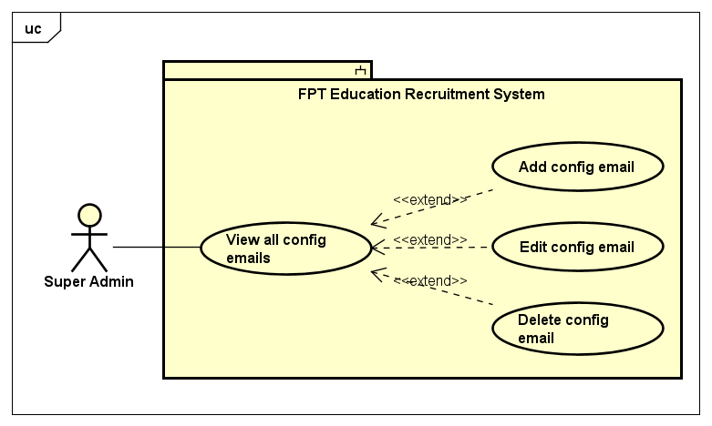

*Figure 3.15. Email management use cases*

|  |  |  |  |  |
| --- | --- | --- | --- | --- |
| **USE CASE-42 SPECIFICATION** | | | | |
| **Use-case No.** | <UC-42> | Use-case Version | | <1.0> |
| **Use-case Name** | View all config emails | | | |
| **Author** | TungBT | | | |
| **Date** | 18/07/2020 | Priority | Low | |
| **Actor** | Super Admin | | | |
| **Summary** | Super Admin views list of all config emails that will be used automatically to send emails for candidates | | | |
| **Goal** | View list of all config emails | | | |
| **Triggers** | Super Admin clicks tab “Quản lý gửi email” on the sidebar of admin page | | | |
| **Preconditions** | User has successfully logged in to the system as the Super Admin role | | | |
| **Post Conditions** | Super Admin views list of all config emails | | | |
| **Main Success Scenario** | | | | |
| |  |  |  | | --- | --- | --- | | Step | Actor Events | System Response | | 1 | User logins as Super Admin role |  | | 2 |  | Display account management page by default | | 3 | Click on “Quản lý gửi email” tab on the sidebar |  | | 4 |  | Display email management page | | | | | |
| **Alternative Scenario** | | | | |
| N/A | | | | |
| **Exceptions** | N/A | | | |
| **Business Rules** | N/A | | | |

#### Use case 43: Add config email

|  |  |  |  |  |
| --- | --- | --- | --- | --- |
| **USE CASE-43 SPECIFICATION** | | | | |
| **Use-case No.** | <UC-43> | Use-case Version | | <1.0> |
| **Use-case Name** | Add config email | | | |
| **Author** | TungBT | | | |
| **Date** | 18/07/2020 | Priority | Low | |
| **Actor** | Super Admin | | | |
| **Summary** | Super admin adds a new email into list of emails that will be used automatically to send emails for candidates | | | |
| **Goal** | Add a new email | | | |
| **Triggers** | User clicks on “Tạo tài khoản gửi email mới” button on email management page | | | |
| **Preconditions** | User has successfully logged in to the system as the Super Admin role | | | |
| **Post Conditions** | Add a new email | | | |
| **Main Success Scenario** | | | | |
| |  |  |  | | --- | --- | --- | | Step | Actor Events | System Response | | 1 | Do a normal flow of UC-42 |  | | 2 |  | Display config email management page | | 3 | Click on “Tạo tài khoản gửi email mới” button |  | | 4 |  | Display add config email page | | 5 | Enter information of a new config email includes:  Name of email  Password  Port number  Host  Is enable SSL  Is active  then click “Tạo mới” button |  | | 6 |  | Notice of success and display email management page | | | | | |
| **Alternative Scenario** | | | | |
| N/A | | | | |
| **Exceptions** | N/A | | | |
| **Business Rules** | Email, password, port, host must not be blank | | | |

#### Use case 44: Edit email

|  |  |  |  |  |
| --- | --- | --- | --- | --- |
| **USE CASE-44 SPECIFICATION** | | | | |
| **Use-case No.** | <UC-44> | Use-case Version | | <1.0> |
| **Use-case Name** | Edit config email | | | |
| **Author** | TungBT | | | |
| **Date** | 18/07/2020 | Priority | Low | |
| **Actor** | Super Admin | | | |
| **Summary** | Super Admin edits information of an email | | | |
| **Goal** | Edit information of a config email | | | |
| **Triggers** | Click on “Sửa” button of an email | | | |
| **Preconditions** | User has successfully logged in to the system as the Super Admin role | | | |
| **Post Conditions** | Edit an email | | | |
| **Main Success Scenario** | | | | |
| |  |  |  | | --- | --- | --- | | Step | Actor Events | System Response | | 1 | Do a normal flow of UC-42 |  | | 2 |  | Display email management page | | 3 | Click on “Sửa” button of an email |  | | 4 |  | Display edit email page | | 5 | Edit information of the email includes:  Name of email  Password  Port number  Host  Is enable SSL  Is active |  | | 6 | Click “Lưu” button |  | |  |  | Notice of success then display email management page | | | | | |
| **Alternative Scenario** | | | | |
| N/A | | | | |
| **Exceptions** | N/A | | | |
| **Business Rules** | Email, password, port, host must not be blank | | | |

#### Use case 45: Delete email

|  |  |  |  |  |
| --- | --- | --- | --- | --- |
| **USE CASE-45 SPECIFICATION** | | | | |
| **Use-case No.** | <UC-45> | Use-case Version | | <1.0> |
| **Use-case Name** | Delete config email | | | |
| **Author** | TungBT | | | |
| **Date** | 18/07/2020 | Priority | Low | |
| **Actor** | Super Admin | | | |
| **Summary** | Super Admin deletes an email | | | |
| **Goal** | Delete an email | | | |
| **Triggers** | Click on “Xóa” button on an email | | | |
| **Preconditions** | User has successfully logged in to the system as the Super Admin role | | | |
| **Post Conditions** | Delete an email | | | |
| **Main Success Scenario** | | | | |
| |  |  |  | | --- | --- | --- | | Step | Actor Events | System Response | | 1 | Do a normal flow of UC-42 |  | | 2 |  | Display email management page | | 3 | Click on “Xóa” button on an email |  | | 4 |  | Give confirmation dialog box | | 5 | Confirm to delete the email |  | | 6 |  | Delete the email then display email management page | | | | | |
| **Alternative Scenario** | | | | |
| N/A | | | | |
| **Exceptions** | N/A | | | |
| **Business Rules** | N/A | | | |

#### . Use case 46: View logs

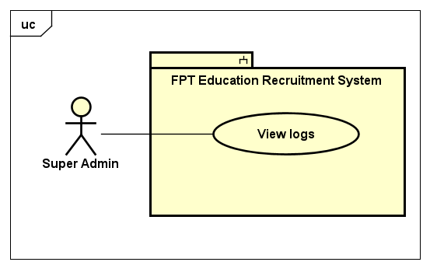

*Figure 3.16. View logs use case*

|  |  |  |  |  |
| --- | --- | --- | --- | --- |
| **USE CASE-46 SPECIFICATION** | | | | |
| **Use-case No.** | <UC-46> | Use-case Version | | <1.0> |
| **Use-case Name** | View logs | | | |
| **Author** | TungBT | | | |
| **Date** | 18/07/2020 | Priority | Medium | |
| **Actor** | Super Admin | | | |
| **Summary** | When any system changes take place (update accounts, add unit, ...), it is logged, the user can view the changes. | | | |
| **Goal** | View system changes | | | |
| **Triggers** | User clicks on “Quản lý log” tab on the sidebar | | | |
| **Preconditions** | User has successfully logged in to the system as the Super Admin role | | | |
| **Post Conditions** | View log about system changes | | | |
| **Main Success Scenario** | | | | |
| |  |  |  | | --- | --- | --- | | Step | Actor Events | System Response | | 1 | User logins to the system as role of Super Admin |  | | 2 |  | Display account management page by default | | 3 | Click on the tab “Quản lý log” |  | | 4 |  | Display view log page | | | | | |
| **Alternative Scenario** | | | | |
| N/A | | | | |
| **Exceptions** | N/A | | | |
| **Business Rules** | N/A | | | |

#### Use Case 47: Common use case



*Figure 3.17. Common use cases*

|  |  |  |  |  |
| --- | --- | --- | --- | --- |
| **USE CASE-47 SPECIFICATION** | | | | |
| **Use-case No.** | <UC-47> | Use-case Version | | <1.0> |
| **Use-case Name** | Login | | | |
| **Author** | TungBT | | | |
| **Date** | 18/07/2020 | Priority | High | |
| **Actor** | Super Admin, HR Staff | | | |
| **Summary** | User logins to FERS website as role of Super Admin or HR Staff | | | |
| **Goal** | Login to FERS website | | | |
| **Triggers** | Users access the link "[career.fpt.edu.vn](http://www.career.fpt.edu.vn/Admin/Login)[/Account/Login](http://www.career.fpt.edu.vn/Account/Login)" | | | |
| **Preconditions** | N/A | | | |
| **Post Conditions** | Login to FERS website | | | |
| **Main Success Scenario** | | | | |
| |  |  |  | | --- | --- | --- | | Step | Actor Events | System Response | | 1 | User accesses the link "[career.fpt.edu.vn/Account/Login](http://www.career.fpt.edu.vn/Account/Login)" |  | | 2 |  | Display login page | | 3 | Click on the button “Đăng nhập” |  | | 4 |  | Pop up Google Authentication dialog box, this dialog box will show list of emails account of user to login | | 5 | Click on the email that was registered on the system |  | | 6 |  | Display management page with functions depending on account role | | | | | |
| **Alternative Scenario** | | | | |
| N/A | | | | |
| **Exceptions** | N/A | | | |
| **Business Rules** | N/A | | | |

#### Use case 48: Logout

|  |  |  |  |  |
| --- | --- | --- | --- | --- |
| **USE CASE-48 SPECIFICATION** | | | | |
| **Use-case No.** | <UC-48> | Use-case Version | | <1.0> |
| **Use-case Name** | Logout | | | |
| **Author** | TungBT | | | |
| **Date** | 18/07/2020 | Priority | Low | |
| **Actor** | Super Admin / HR Staff | | | |
| **Summary** | User logs out of the system | | | |
| **Goal** | Log out of the system | | | |
| **Triggers** | User clicks on the button “Đăng xuất” | | | |
| **Preconditions** | User successfully logged into the system | | | |
| **Post Conditions** | Log out of the system | | | |
| **Main Success Scenario** | | | | |
| |  |  |  | | --- | --- | --- | | Step | Actor Events | System Response | | 1 | User click on the button “Đăng xuất” on the right top of page |  | | 2 |  | Log out the user from the system and move to the login page | | | | | |
| **Alternative Scenario** | | | | |
| N/A | | | | |
| **Exceptions** | N/A | | | |
| **Business Rules** | N/A | | | |

#### Use case 49: View all CVs

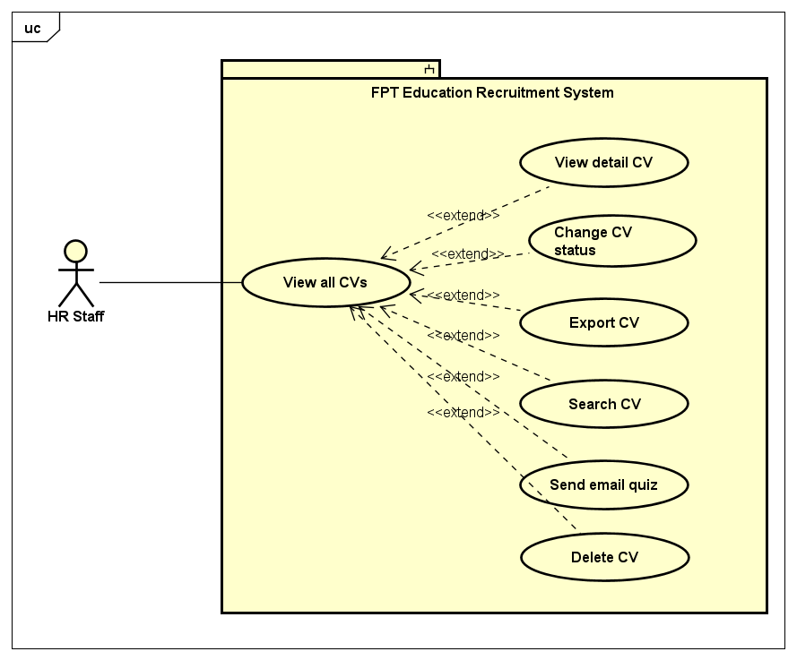

*Figure 3.18. CV management use cases*

|  |  |  |  |  |
| --- | --- | --- | --- | --- |
| **USE CASE-49 SPECIFICATION** | | | | |
| **Use-case No.** | <UC-49> | Use-case Version | | <1.0> |
| **Use-case Name** | View all CVs | | | |
| **Author** | TungBT | | | |
| **Date** | 18/07/2020 | Priority | Medium | |
| **Actor** | HR Staff | | | |
| **Summary** | HR Staff views list of all CVs that was submitted to the system | | | |
| **Goal** | View list of all CVs | | | |
| **Triggers** | Click on the tab “Quản lý CV” on the sidebar | | | |
| **Preconditions** | User has successfully logged in to the system as the HR Staff role | | | |
| **Post Conditions** | View list of all CVs | | | |
| **Main Success Scenario** | | | | |
| |  |  |  | | --- | --- | --- | | Step | Actor Events | System Response | | 1 | User logs in to the system as role of HR Staff |  | | 2 |  | Display job management page as default | | 3 | Click on the tab “Quản lý CV” on the sidebar of website |  | | 4 |  | Display CV management page | | | | | |
| **Alternative Scenario** | | | | |
| N/A | | | | |
| **Exceptions** | N/A | | | |
| **Business Rules** | N/A | | | |

#### Use case 50: View detail CV

|  |  |  |  |  |
| --- | --- | --- | --- | --- |
| **USE CASE-50 SPECIFICATION** | | | | |
| **Use-case No.** | <UC-50> | Use-case Version | | <1.0> |
| **Use-case Name** | View detail CV | | | |
| **Author** | TungBT | | | |
| **Date** | 18/07/2020 | Priority | Medium | |
| **Actor** | HR Staff | | | |
| **Summary** | HR Staff views detailed information about the candidate | | | |
| **Goal** | View detailed information about candidate | | | |
| **Triggers** | User clicks on the eye icon of a CV | | | |
| **Preconditions** | User has successfully logged in to the system as the HR Staff role | | | |
| **Post Conditions** | A dialog box will pop up and display information about CV | | | |
| **Main Success Scenario** | | | | |
| |  |  |  | | --- | --- | --- | | Step | Actor Events | System Response | | 1 | Do a normal flow of UC-49 |  | | 2 |  | Display CV management page | | 3 | Click on the eye icon of a CV |  | | 4 |  | Pop up a dialog box with detailed information about the CV | | | | | |
| **Alternative Scenario** | | | | |
| N/A | | | | |
| **Exceptions** | N/A | | | |
| **Business Rules** | N/A | | | |

#### Use case 51: Change CV status

|  |  |  |  |  |
| --- | --- | --- | --- | --- |
| **USE CASE-51 SPECIFICATION** | | | | |
| **Use-case No.** | <UC-51> | Use-case Version | | <1.0> |
| **Use-case Name** | Change CV status | | | |
| **Author** | TungBT | | | |
| **Date** | 18/07/2020 | Priority | High | |
| **Actor** | HR Staff | | | |
| **Summary** | CV is divided into groups with different statuses for easy management. HR Staff can change status of CV | | | |
| **Goal** | Change status of the CV | | | |
| **Triggers** | User clicks on the status options then change it to another option | | | |
| **Preconditions** | User has successfully logged in to the system as the HR Staff role | | | |
| **Post Conditions** | Change status of the CV | | | |
| **Main Success Scenario** | | | | |
| |  |  |  | | --- | --- | --- | | Step | Actor Events | System Response | | 1 | Do a normal flow of UC-49 |  | | 2 |  | Display CV management page | | 3 | Click on the status options of a CV |  | | 4 |  | Drop down a list of status | | 5 | Change the status of the CV to the state he/she wants. There are 5 states:  “Mới”  “Đã xem”  “Xem xét”  “Chấp nhận”  “Từ chối” |  | | 6 |  | The system notifies the successful status change, and simultaneously changes the color of the CV status | | | | | |
| **Alternative Scenario** | | | | |
| N/A | | | | |
| **Exceptions** | N/A | | | |
| **Business Rules** | It’s possible to change from current state to any other state | | | |

#### Use case 52: Search CV

|  |  |  |  |  |
| --- | --- | --- | --- | --- |
| **USE CASE-52 SPECIFICATION** | | | | |
| **Use-case No.** | <UC-52> | Use-case Version | | <1.0> |
| **Use-case Name** | Search CV | | | |
| **Author** | TungBT | | | |
| **Date** | 18/07/2020 | Priority | Medium | |
| **Actor** | HR Staff | | | |
| **Summary** | HR Staff search for a CV that he/she wants, searching keywords include:  Job title  Candidate name  Email  Start date  End date  CV status | | | |
| **Goal** | Search a CV | | | |
| **Triggers** | User enters the search keyword on the search menu bar and then clicks search button | | | |
| **Preconditions** | User has successfully logged in to the system as the HR Staff role | | | |
| **Post Conditions** | Search a CV | | | |
| **Main Success Scenario** | | | | |
| |  |  |  | | --- | --- | --- | | Step | Actor Events | System Response | | 1 | Do a normal flow of UC-49 |  | | 2 |  | Display CV management page | | 3 | Enter the search keywords and then click search button |  | | 4 |  | Display list of CV filtered by keyword search | | | | | |
| **Alternative Scenario** | | | | |
| N/A | | | | |
| **Exceptions** | N/A | | | |
| **Business Rules** | Maximum length of job title, email, candidate name field is 255 | | | |

#### Use case 53: Delete CV

|  |  |  |  |  |
| --- | --- | --- | --- | --- |
| **USE CASE-53 SPECIFICATION** | | | | |
| **Use-case No.** | <UC-53> | Use-case Version | | <1.0> |
| **Use-case Name** | Delete CV | | | |
| **Author** | TungBT | | | |
| **Date** | 18/07/2020 | Priority | Low | |
| **Actor** | HR Staff | | | |
| **Summary** | HR Staff deletes a CV of the candidate | | | |
| **Goal** | Delete a CV | | | |
| **Triggers** | Click on the button “Xóa” of a CV | | | |
| **Preconditions** | User has successfully logged in to the system as the HR Staff role | | | |
| **Post Conditions** | Delete a CV | | | |
| **Main Success Scenario** | | | | |
| |  |  |  | | --- | --- | --- | | Step | Actor Events | System Response | | 1 | Do a normal flow of UC-49 |  | | 2 |  | Display CV management page | | 3 | Click button “Xóa” on a CV |  | | 4 |  | Give confirmation message | | 5 | Click OK to confirm delete the CV |  | | 6 |  | Delete the CV then reload page | | | | | |
| **Alternative Scenario** | | | | |
| N/A | | | | |
| **Exceptions** | N/A | | | |
| **Business Rules** | N/A | | | |

#### Use case 54: Send email quiz

|  |  |  |  |  |
| --- | --- | --- | --- | --- |
| **USE CASE-54 SPECIFICATION** | | | | |
| **Use-case No.** | <UC-54> | Use-case Version | | <1.0> |
| **Use-case Name** | Send email quiz | | | |
| **Author** | TungBT | | | |
| **Date** | 18/07/2020 | Priority | Medium | |
| **Actor** | HR Staff | | | |
| **Summary** | After candidate submitted CV to the system, HR Staff can email the quiz link to candidates that they want | | | |
| **Goal** | Send an email that contains the link of quiz | | | |
| **Triggers** | Click on the button “Chưa gửi, gửi ngay” on CV management page | | | |
| **Preconditions** | User has successfully logged in to the system as the HR Staff role | | | |
| **Post Conditions** | Send an email that contains the link of quiz | | | |
| **Main Success Scenario** | | | | |
| |  |  |  | | --- | --- | --- | | Step | Actor Events | System Response | | 1 | Do a normal flow of UC-49 |  | | 2 |  | Display CV management page | | 3 | In the quiz score column, for candidates who have not taken the quiz, there is a button "Chưa gửi, gửi ngay". User clicks the button |  | | 4 |  | Send an email that contains the quiz link to candidate | | | | | |
| **Alternative Scenario** | | | | |
| N/A | | | | |
| **Exceptions** | The hosting provider does not allow sending emails or restrict sending mail | | | |
| **Business Rules** | N/A | | | |

#### Use case 55: Export CV

|  |  |  |  |  |
| --- | --- | --- | --- | --- |
| **USE CASE-55 SPECIFICATION** | | | | |
| **Use-case No.** | <UC-55> | Use-case Version | | <1.0> |
| **Use-case Name** | Export CV | | | |
| **Author** | TungBT | | | |
| **Date** | 18/07/2020 | Priority | Medium | |
| **Actor** | HR Staff | | | |
| **Summary** | When HR staff wants to export the CV list to an excel file for easy management, he/she just needs to click “Xuất ra Excel” button | | | |
| **Goal** | Export list of CV to excel file | | | |
| **Triggers** | User clicks on the button “Xuất ra Excel” | | | |
| **Preconditions** | User has successfully logged in to the system as the HR Staff role | | | |
| **Post Conditions** | Export list of CV to excel file | | | |
| **Main Success Scenario** | | | | |
| |  |  |  | | --- | --- | --- | | Step | Actor Events | System Response | | 1 | Do a normal flow of UC-49 |  | | 2 |  | Display CV management page | | 3 | Click on the button “Xuất ra Excel” |  | | 4 |  | Export the CV to excel file.  The excel file will be automatically downloaded on browser | | | | | |
| **Alternative Scenario** | | | | |
| N/A | | | | |
| **Exceptions** | N/A | | | |
| **Business Rules** | N/A | | | |

#### Use case 56: View all jobs

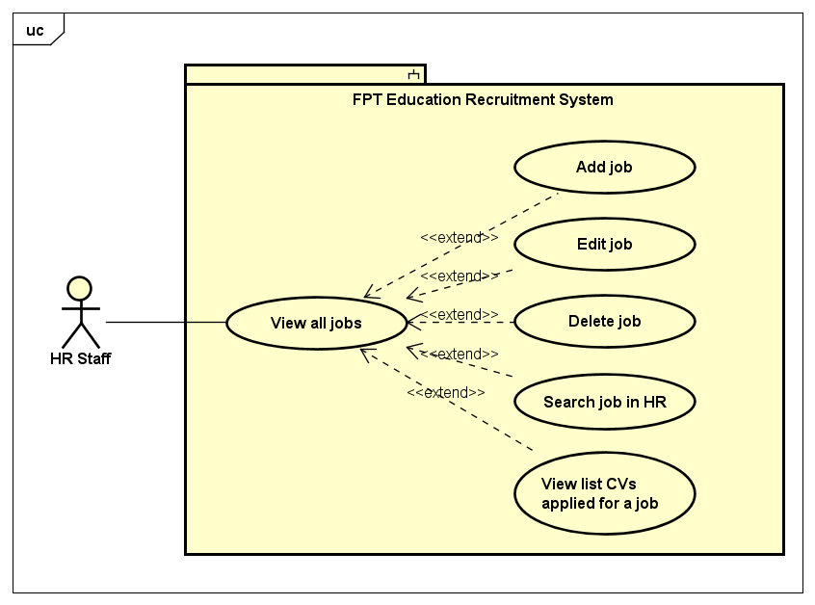

*Figure 3.19. Job management use cases*

|  |  |  |  |  |
| --- | --- | --- | --- | --- |
| **USE CASE-56 SPECIFICATION** | | | | |
| **Use-case No.** | <UC-56> | Use-case Version | | <1.0> |
| **Use-case Name** | View all jobs | | | |
| **Author** | DatTQ | | | |
| **Date** | 18/07/2020 | Priority | Medium | |
| **Actor** | HR Staff | | | |
| **Summary** | HR Staff views all jobs which are managed and based on the location of HR Staff can manage in the system. | | | |
| **Goal** | HR Staff views all jobs in the system | | | |
| **Triggers** | HR Staff click tab “Quản lý tin tuyển dụng” on the sidebar of HR Staff page | | | |
| **Preconditions** | User has successfully logged in to the system as the HR Staff role | | | |
| **Post Conditions** | View all job are managed by login HR Staff | | | |
| **Main Success Scenario** | | | | |
| |  |  |  | | --- | --- | --- | | Step | Actor Events | System Response | | 1 | User login as role of HR Staff |  | | 2 |  | Display HR Staff homepage with job management tab default | | | | | |
| **Alternative Scenario** | | | | |
| N/A | | | | |
| **Exceptions** | N/A | | | |
| **Business Rules** | N/A | | | |

#### Use case 57: Add job

|  |  |  |  |  |
| --- | --- | --- | --- | --- |
| **USE CASE-57 SPECIFICATION** | | | | |
| **Use-case No.** | <UC-57> | Use-case Version | | <1.0> |
| **Use-case Name** | Add job | | | |
| **Author** | DatTQ | | | |
| **Date** | 18/07/2020 | Priority | High | |
| **Actor** | HR Staff | | | |
| **Summary** | HR Staff add a job to the system | | | |
| **Goal** | Add new job | | | |
| **Triggers** | HR Staff click “Tạo việc mới” button on Job management page | | | |
| **Preconditions** | User has successfully logged in to the system as the HR Staff role | | | |
| **Post Conditions** | Add a new job to the system | | | |
| **Main Success Scenario** | | | | |
| |  |  |  | | --- | --- | --- | | Step | Actor Events | System Response | | 1 | Do a normal flow of UC-56 |  | | 2 |  | Display job management page | | 3 | Click “Tạo việc mới” button |  | | 4 |  | Display create job page | | 5 | Fill in all input fields then click “Tạo mới” |  | | 6 |  | Redirect to job manage page and notify success message | | | | | |
| **Alternative Scenario** | | | | |
| N/A | | | | |
| **Exceptions** | N/A | | | |
| **Business Rules** | Must fill all the input required | | | |

#### Use case 58: Edit job

|  |  |  |  |  |
| --- | --- | --- | --- | --- |
| **USE CASE-58 SPECIFICATION** | | | | |
| **Use-case No.** | <UC-58> | Use-case Version | | <1.0> |
| **Use-case Name** | Edit job | | | |
| **Author** | DatTQ | | | |
| **Date** | 18/07/2020 | Priority | Medium | |
| **Actor** | HR Staff | | | |
| **Summary** | HR Staff edits a job in the system | | | |
| **Goal** | Edit an existing job | | | |
| **Triggers** | Click “Sửa” button on an job when view all jobs | | | |
| **Preconditions** | User has successfully logged in to the system as the HR Staff role | | | |
| **Post Conditions** | Edit information about an job | | | |
| **Main Success Scenario** | | | | |
| |  |  |  | | --- | --- | --- | | Step | Actor Events | System Response | | 1 | Do a normal flow of UC-56 |  | | 2 |  | Display all jobs of the system | | 3 | Click “Sửa” button on a job |  | | 4 |  | Display edit job page | | 5 | Edit information of job and submit |  | | 6 |  | Notice of success and back to account management page. | | | | | |
| **Alternative Scenario** | | | | |
| N/A | | | | |
| **Exceptions** | N/A | | | |
| **Business Rules** | Must fill all the input required. | | | |

#### Use case 59: Delete job

|  |  |  |  |  |
| --- | --- | --- | --- | --- |
| **USE CASE-59 SPECIFICATION** | | | | |
| **Use-case No.** | <UC-59> | Use-case Version | | <1.0> |
| **Use-case Name** | Delete job | | | |
| **Author** | DatTQ | | | |
| **Date** | 18/07/2020 | Priority | Low | |
| **Actor** | HR Staff | | | |
| **Summary** | HR Staff deletes a job in the system | | | |
| **Goal** | Delete a job | | | |
| **Triggers** | HR Staff clicks “Xóa” button on Jobs management page | | | |
| **Preconditions** | User has successfully logged in to the system as the HR Staff role | | | |
| **Post Conditions** | Delete a job | | | |
| **Main Success Scenario** | | | | |
| |  |  |  | | --- | --- | --- | | Step | Actor Events | System Response | | 1 | Do a normal flow of UC-56 |  | | 2 |  | Display all jobs of the system | | 3 | Click “Xóa” button on an job |  | | 4 |  | Give confirmation message | | 5 | Confirm to delete the job |  | | 6 |  | Delete the job then reload page | | | | | |
| **Alternative Scenario** | | | | |
| N/A | | | | |
| **Exceptions** | N/A | | | |
| **Business Rules** | When HR Staff deletes a job which has CV applied, although the system doesn’t delete the job, the system will hide the job. | | | |

#### Use case 60: Search job in HR

|  |  |  |  |  |
| --- | --- | --- | --- | --- |
| **USE CASE-60 SPECIFICATION** | | | | |
| **Use-case No.** | <UC-60> | Use-case Version | | <1.0> |
| **Use-case Name** | Search Job In HR | | | |
| **Author** | DatTQ | | | |
| **Date** | 18/07/2020 | Priority | Medium | |
| **Actor** | HR Staff | | | |
| **Summary** | HR Staff find jobs that he/she needs,searching keywords include:  Job title  Unit  Career  Location | | | |
| **Goal** | Display list of jobs filter by some input searching | | | |
| **Triggers** | HR Staff choose the options in filter menu (Quản lý tin tuyển dụng) then click “Tìm kiếm” | | | |
| **Preconditions** | User has successfully logged in to the system as the HR Staff role | | | |
| **Post Conditions** | HR Staff find jobs that HR Staff needs | | | |
| **Main Success Scenario** | | | | |
| |  |  |  | | --- | --- | --- | | Step | Actor Events | System Response | | 1 | Do a normal flow of UC-56 |  | | 2 |  | Display job management page | | 3 | Enter the search keywords and then click “Tìm kiếm” button |  | | 4 |  | Display list of jobs filtered by keyword search | | | | | |
| **Alternative Scenario** | | | | |
| N/A | | | | |
| **Exceptions** | N/A | | | |
| **Business Rules** | Maximum length of job title name field is 255 | | | |

#### Use case 61: View list CVs applied for a job

|  |  |  |  |  |
| --- | --- | --- | --- | --- |
| **USE CASE-61 SPECIFICATION** | | | | |
| **Use-case No.** | <UC-61> | Use-case Version | | <1.0> |
| **Use-case Name** | View list CVs applied for a job | | | |
| **Author** | TungBT | | | |
| **Date** | 18/07/2020 | Priority | Medium | |
| **Actor** | HR Staff | | | |
| **Summary** | When HR Staffs view list of all the jobs that are currently recruiting, they can see the number of CVs applied for a job, when clicking on the link the system will redirect to a new page - a list of all CVs applied for the job | | | |
| **Goal** | View list of all CVs applied for a job | | | |
| **Triggers** | Click to the number of CV applied for a job on Job management page | | | |
| **Preconditions** | User has successfully logged in to the system as the HR Staff role | | | |
| **Post Conditions** | View list of all CVs applied for a job | | | |
| **Main Success Scenario** | | | | |
| |  |  |  | | --- | --- | --- | | Step | Actor Events | System Response | | 1 | Do a normal flow of UC-56, view all jobs |  | | 2 |  | Display job management page | | 3 | Click to the number of CV applied for a job |  | | 4 |  | Redirect to CV management page, show list of all CVs applied for the job user clicked to | | | | | |
| **Alternative Scenario** | | | | |
| N/A | | | | |
| **Exceptions** | N/A | | | |
| **Business Rules** | N/A | | | |

#### Use case 62: View all error emails

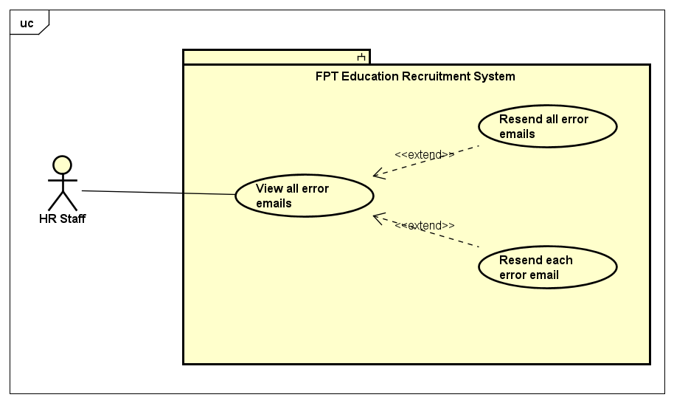

*Figure 3.20. Error email management use cases*

|  |  |  |  |  |
| --- | --- | --- | --- | --- |
| **USE CASE-62 SPECIFICATION** | | | | |
| **Use-case No.** | <UC-62> | Use-case Version | | <1.0> |
| **Use-case Name** | View all error emails | | | |
| **Author** | DatTQ | | | |
| **Date** | 18/07/2020 | Priority | Medium | |
| **Actor** | HR Staff | | | |
| **Summary** | FERS send an email to candidates, sometimes it can not be sent. HR Staff can review unsuccessful emails in the tab “Quản lý Email lỗi” | | | |
| **Goal** | HR Staff view list of error email | | | |
| **Triggers** | HR Staff click tab “Quản lý Email lỗi” on the sidebar of HR Staff page | | | |
| **Preconditions** | User has successfully logged in to the system as the HR Staff role | | | |
| **Post Conditions** | View all error email | | | |
| **Main Success Scenario** | | | | |
| |  |  |  | | --- | --- | --- | | Step | Actor Events | System Response | | 1 | User logins with HR Staff role |  | | 2 |  | Display job management page by default | | 3 | Click tab “Quản lý Email lỗi” on the sidebar |  | | 4 |  | Redirect to error email management page | | | | | |
| **Alternative Scenario** | | | | |
| N/A | | | | |
| **Exceptions** | N/A | | | |
| **Business Rules** | N/A | | | |

#### Use case 63: Resend all error emails

|  |  |  |  |  |
| --- | --- | --- | --- | --- |
| **USE CASE-63 SPECIFICATION** | | | | |
| **Use-case No.** | <UC-63> | Use-case Version | | <1.0> |
| **Use-case Name** | Resend all error email | | | |
| **Author** | DatTQ | | | |
| **Date** | 18/07/2020 | Priority | Medium | |
| **Actor** | HR Staff | | | |
| **Summary** | Resend all the failed emails at once | | | |
| **Goal** | Resend all error email to candidates | | | |
| **Triggers** | HR Staff click tab “Gửi lại những Email lỗi” on error email management page | | | |
| **Preconditions** | User has successfully logged in to the system as the HR Staff role | | | |
| **Post Conditions** | Resend all error email to candidates | | | |
| **Main Success Scenario** | | | | |
| |  |  |  | | --- | --- | --- | | Step | Actor Events | System Response | | 1 | Do a normal flow of UC-62 |  | | 2 |  | Display Email management page | | 3 | Click on the button “Gửi lại những Email lỗi” |  | | 4 |  | Resend all error email to the candidates | | | | | |
| **Alternative Scenario** | | | | |
| N/A | | | | |
| **Exceptions** | The hosting provider does not allow sending emails or restrict sending email | | | |
| Business Rules | N/A | | | |

#### Use case 64: Resend each error email

|  |  |  |  |  |
| --- | --- | --- | --- | --- |
| **USE CASE-64 SPECIFICATION** | | | | |
| **Use-case No.** | <UC-64> | Use-case Version | | <1.0> |
| **Use-case Name** | Resend each error email | | | |
| **Author** | DatTQ | | | |
| **Date** | 18/07/2020 | Priority | Low | |
| **Actor** | HR Staff | | | |
| **Summary** | After reviewing the failed emails, HR Staff can just click resend email to a person they specify, no need to resend all email at once | | | |
| **Goal** | Resend a certain error email | | | |
| **Triggers** | Click the button “Gửi lại” of an error email | | | |
| **Preconditions** | Successfully logged in to the system as the HR Staff role | | | |
| **Post Conditions** | Resend a certain error email | | | |
| **Main Success Scenario** | | | | |
| |  |  |  | | --- | --- | --- | | Step | Actor Events | System Response | | 1 | Do a normal flow of UC-62 |  | | 2 |  | Display email management page | | 3 | Click the button “Gửi lại” in an error email which HR Staff wants to resend |  | | 4 |  | Resend the email to candidate and notice of success | | | | | |
| **Alternative Scenario** | | | | |
| N/A | | | | |
| **Exceptions** | The hosting provider does not allow sending emails or restrict sending email | | | |
| **Business Rules** | N/A | | | |

## Non-functional Requirement

### Reliability

* All data entered by the user is validated before sending it to the server
* The system complies with business rules

### Security

* The system must use FPT Edu Google accounts (@fpt.edu.vn) to sign in.
* The system must use HTTPS to secure the information transferred between clients and servers.
* The system sends a quiz link via the candidate's email address and secured, authorized by a token generated by the system.
* The user authorization table is as follow:

|  |  |  |  |
| --- | --- | --- | --- |
| **Function** | **Super Admin** | **HR staff** | **Candidate** |
| Login | ✔ | ✔ |  |
| Logout | ✔ | ✔ |  |
| Manage accounts | ✔ |  |  |
| Manage quiz | ✔ |  |  |
| Manage careers | ✔ |  |  |
| Manage units | ✔ |  |  |
| Manage locations | ✔ |  |  |
| Manage questions | ✔ |  |  |
| Manage group question | ✔ |  |  |
| View log | ✔ |  |  |
| Manage configure email | ✔ |  |  |
| Manage CVs |  | ✔ |  |
| Manage Jobs |  | ✔ |  |
| Manage error email |  | ✔ |  |
| Apply job |  |  | ✔ |
| Take quiz |  |  | ✔ |

*Table 3.3. User authorization*

### Maintainability

This system using .NET MVC 5, with the following advantages to maintain:

* A main advantage of MVC is separation of concern. Separation of concern means we divide the application Model, Controller and View.
* We can easily maintain our application because of separation of concern.
* At the same time we can split many developers' work at a time. It will not affect one developer work to another developer work.
* It supports TTD (test-driven development).

### Portability

This system supports responsiveness for candidate actor’s views.

## Entity relationship diagram

This system has the following entities:

|  |  |  |
| --- | --- | --- |
| **No.** | **Entity** | **Description** |
| 1 | Role | Contains a role of the system: Super Admin and Hr Staff |
| 2 | Account | Contains an information of user |
| 3 | Location | Contains a province that have units of FPT Education there |
| 4 | Region | Existing a region in Vietnam as: “mien Bac, mien Trung, mien Nam, mien Tay” |
| 5 | Job | Contains a job that hr staff posted and candidate can apply |
| 6 | Career | Contains a career in FPT Education. Example: “Giao vien” |
| 7 | Unit | Contains a unit of FPT Education. Example: FPT University. |
| 8 | CV | Contains an information CV of candidate who applied job |
| 9 | QuestionGroup | Contains a question group of the system |
| 10 | Question | Contains a question for each group of questions |
| 11 | QuestionAnswer | Contains a possible answer for each question |
| 12 | Quiz | Contains a quiz of the system which can taken by candidates |
| 13 | QuizResult | Results of quiz done by candidates |

*Table 3.4. Entities description*

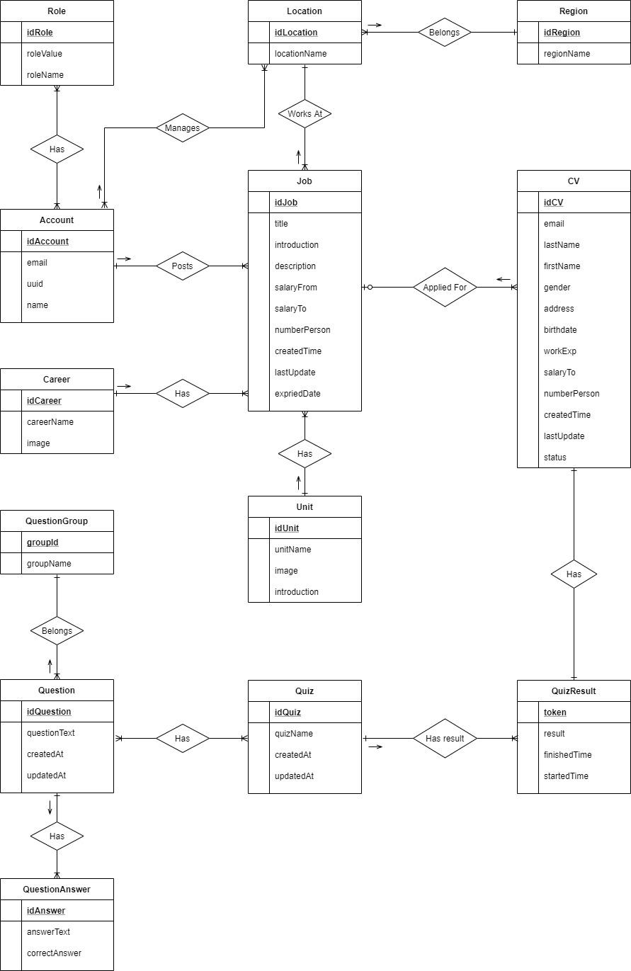

*Figure 3.21. Entity relationship diagram*

# System Detailed Design

## System Overview

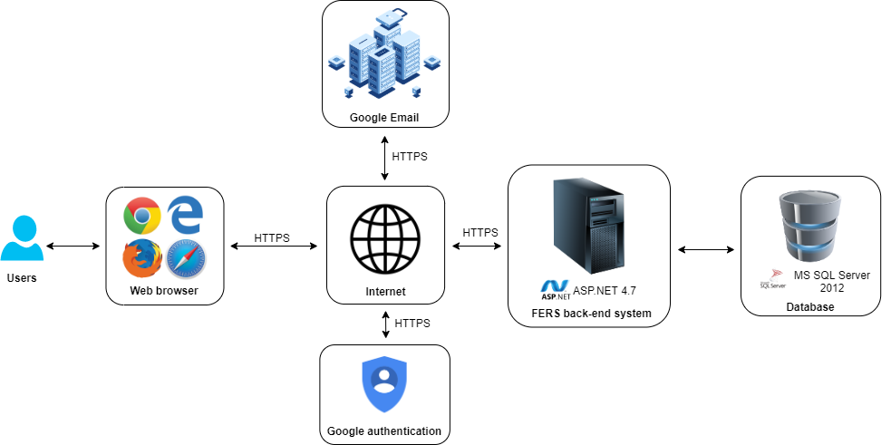

*Figure 4.1 - System overview*

## System Architecture Design

The FPT Recruitment System uses MVC pattern.

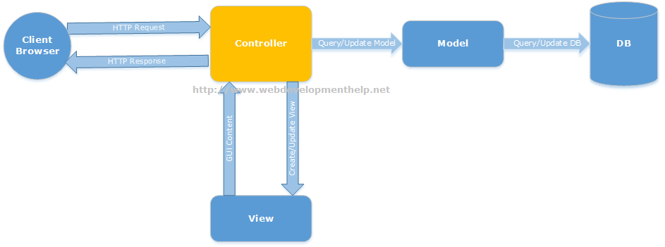

*Figure 4.2 – ASP.NET MVC Architecture*

### Choice of System Architecture

The Model-View-Controller (MVC) structure, which is the standard software development approach offered by most of the popular web frameworks, is clearly a layered architecture. Just above the database is the model layer, which often contains business logic and information about the types of data in the database. At the top is the view layer, which is often CSS, JavaScript, and HTML with dynamic embedded code. In the middle, you have the controller, which has various rules and methods for transforming the data moving between the view and the model.

### Description of System Interface

#### Database management system



*Figure 4.3 - Database management system*

Database management system is a software which is used to manage the database. SQL Server is a very popular commercial database which is used in different applications. DBMS provides an interface to perform various operations like database creation, storing data in it, updating data, creating a table in the database and a lot more. It provides protection and security to the database. In the case of multiple users, it also maintains data consistency.

#### Web browser



*Figure 4.4 - Browsers*

A web browser (commonly referred to as a browser) is a software application for accessing information on the World Wide Web. When a user requests a web page from a particular website, the web browser retrieves the necessary content from a web server and then displays the page on the user's device. A web browser is not the same thing as a search engine, though the two are often confused. For a user, a search engine is just a website that provides links to other websites. However, to connect to a website's server and display its web pages, a user must have a web browser installed. Web browsers are used on a range of devices, including desktops, laptops, tablets, and smartphones. . In 2019, an estimated 4.3 billion people used a browser.

#### Google authentication



*Figure 4.5 - Google authentication*

Google authentication is a service to help verifying email accounts by their access tokens - which will be returned from Google authentication service.

#### Simple Mail Transfer Protocol (SMTP)



*Figure 4.6 - Simple Mail Transfer Protocol*

The Simple Mail Transfer Protocol (SMTP) is a communication protocol for electronic mail transmission. As an Internet standard, SMTP was first defined in 1982 by RFC[6] 821, and updated in 2008 by RFC 5321 to Extended SMTP additions, which is the protocol variety in widespread use today. Mail servers and other message transfer agents use SMTP to send and receive mail messages. SMTP servers commonly use the Transmission Control Protocol on port number 25.

User-level email clients typically use SMTP only for sending messages to a mail server for relaying, and typically submit outgoing email to the mail server on port 587 or 465 as per RFC 8314. For retrieving messages, IMAP[7] and POP3[8] are standard, but proprietary servers also often implement proprietary protocols, e.g.

## Component Diagram

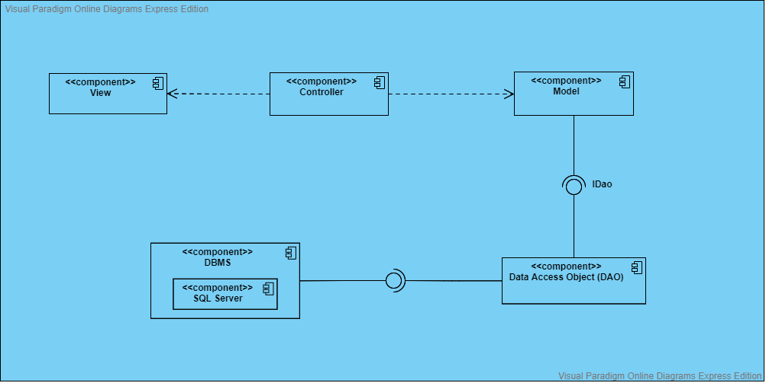

*Figure 4.7 - Component diagram*

## Detailed Description of Component

### View

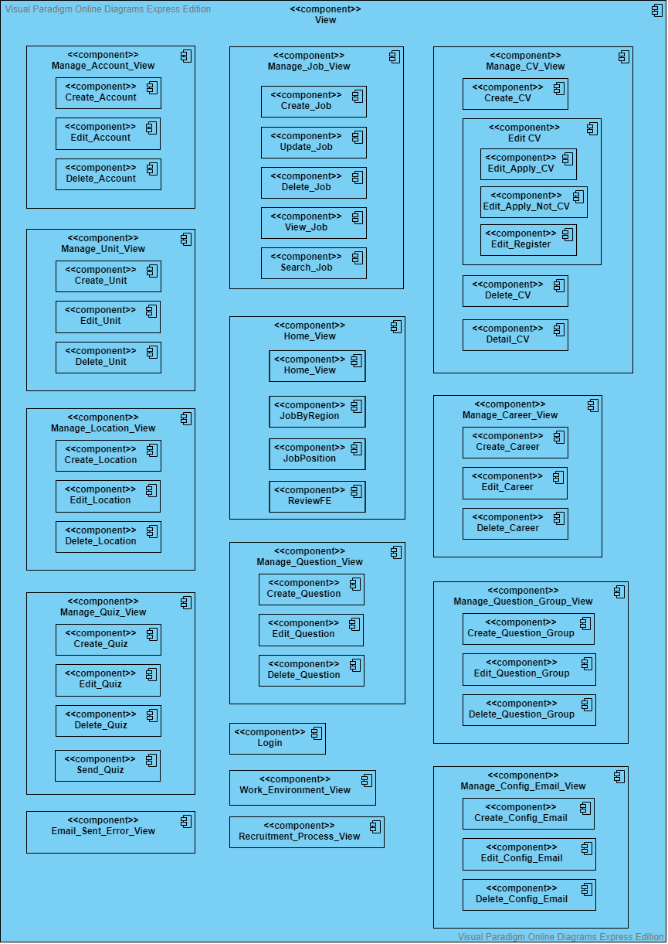

*Figure 4.8 - View*

### Controller

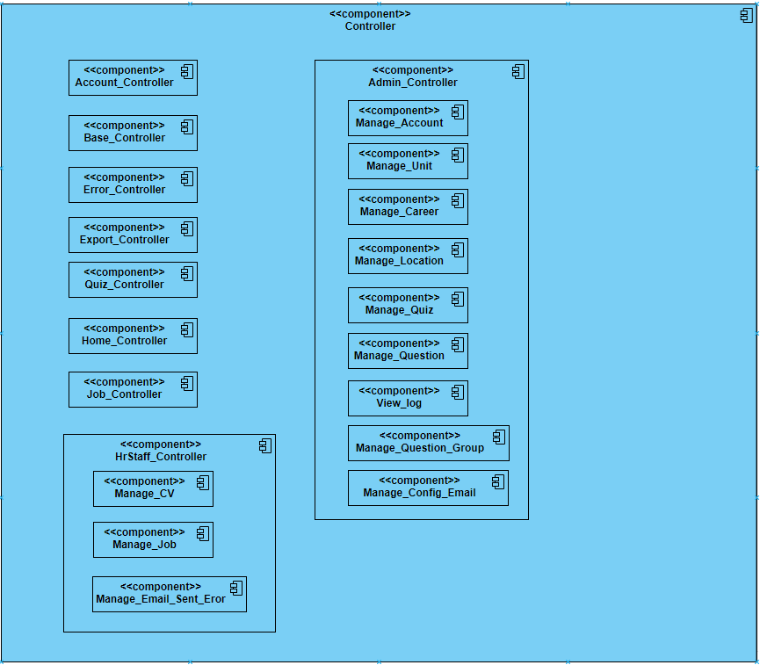

*Figure 4.9 - Controller*

### Model

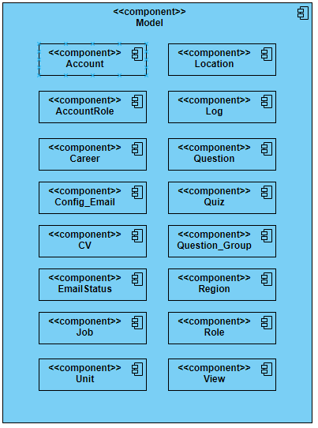

*Figure 4.10 - Model*

#### DAO

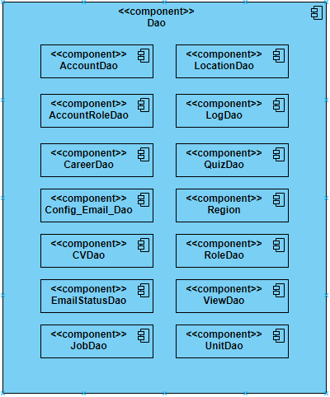

*Figure 4.11 - DAO*

## Class Diagram

### Class diagram

#### UC-01 (View recruitment process)

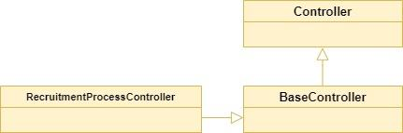

*Figure 4.12 - Class diagram for UC-01*

#### UC-02 (View home)

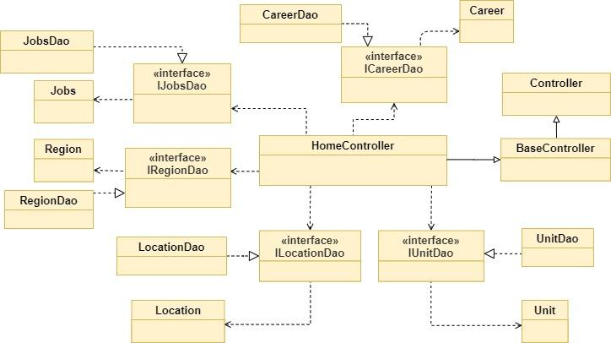

*Figure 4.13 - Class diagram for UC-02*

#### UC-03,04,05,06,07 (View all jobs - View list jobs by region - View list jobs by unit - View job detail - Search job)

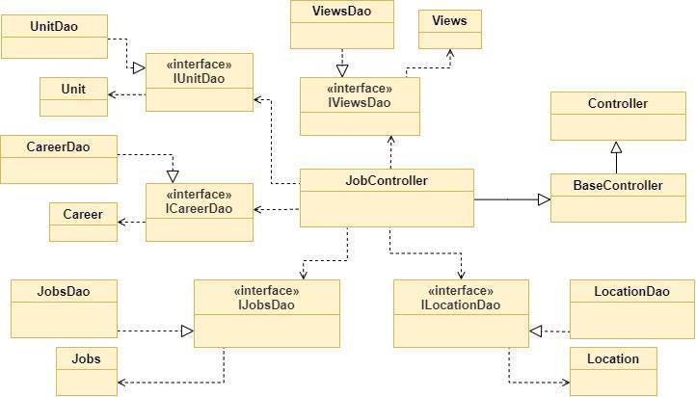

*Figure 4.14 - Class diagram for UC-03 to UC-07*

#### UC-08,09,10,11 (Create CV - Upload CV - Register potential candidate - Edit CV)

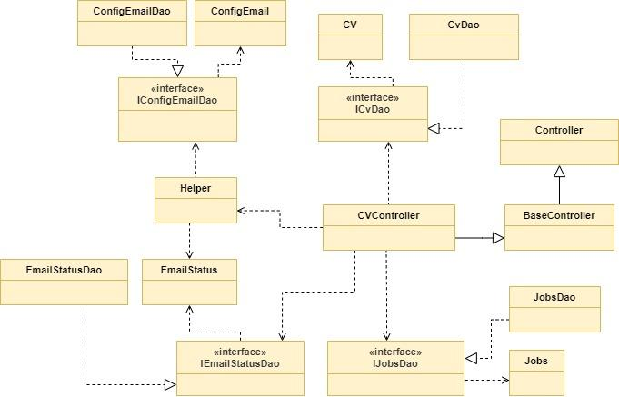

*Figure 4.15 - Class diagram for UC-8 to UC-11*

#### UC-12 (Take Quiz)

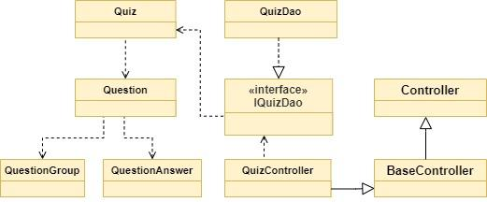

*Figure 4.16 - Class diagram for UC-12*

#### UC-13,14,15,16 (View all accounts – Add account – Edit account – Delete account)

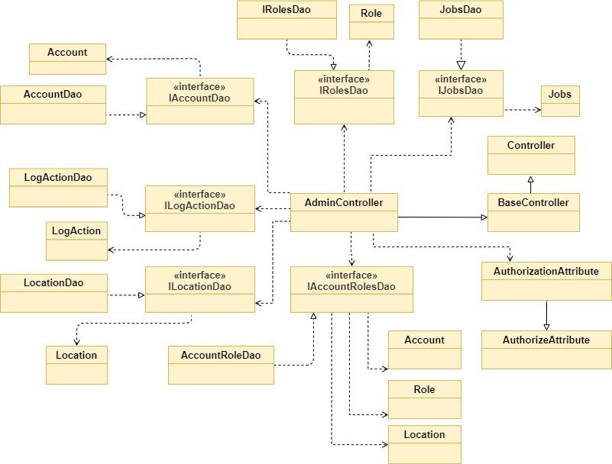

*Figure 4.17 – Class diagram for UC-13 to UC-16*

#### UC-17,18,19,20 (View all units – Add unit – Edit unit – Delete unit)

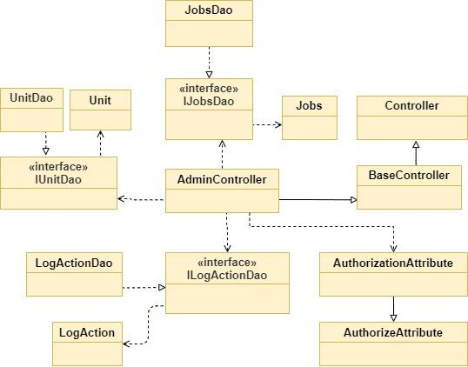

*Figure 4.18 – Class diagram for UC-17 to UC-20*

#### UC-21,22,23,24 (View all locations - Add location - Edit location - Delete location)

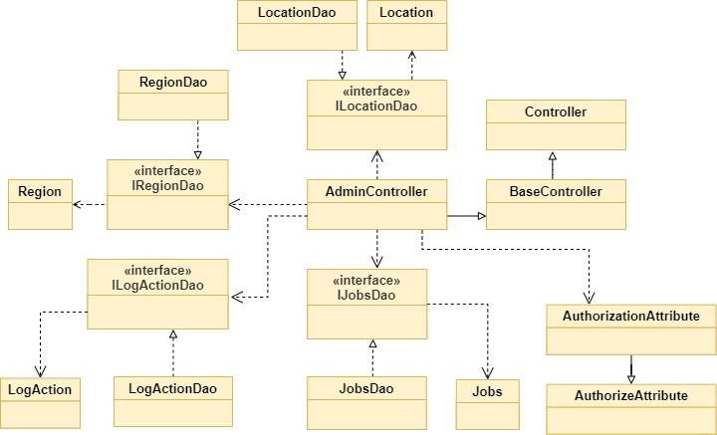

*Figure 4.19 - Class diagram for UC-21 to UC-24*

#### UC-25,26,27,28 (View all question groups - Add question groups - Edit question groups - Delete question groups)

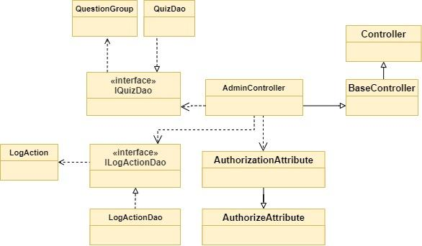

*Figure 4.20 - Class diagram for UC-25 to UC-28*

#### UC-29,30,31,32,33 (View all questions - Add question - Edit question - Delete question - Search question)

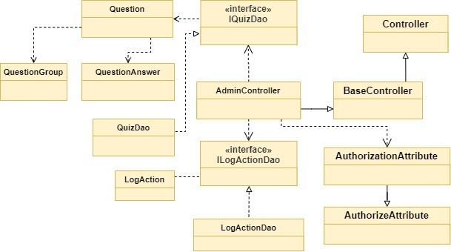

*Figure 4.21 - Class diagram for UC-29 to UC-33*

#### UC-34,35,36,37 (View all quizzes – Add quiz – Edit quiz – Delete quiz)

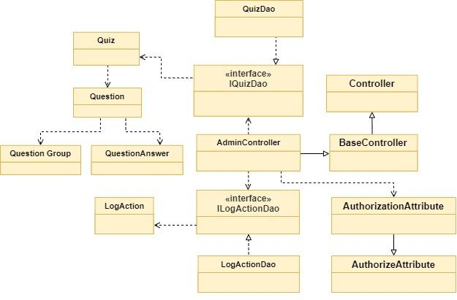

*Figure 4.22 – Class diagram for UC-34 to UC-37*

#### UC-38,39,40,41 (View all careers – Add career – Edit career – Delete career)

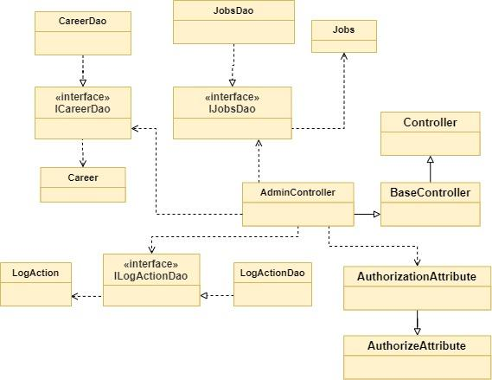

*Figure 4.23 – Class diagram for UC-38 to UC-41*

#### UC-42,43,44,45 (View all config emails - Add config email - Edit config email - Delete config email)

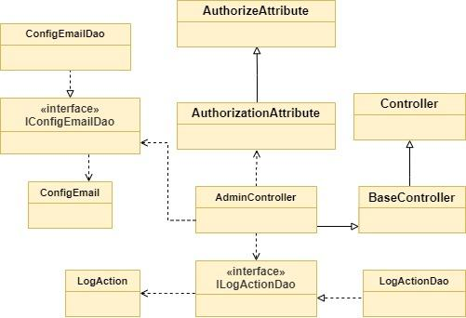

*Figure 4.24 - Class diagram for UC-42 to UC-45*

#### UC-46 (View log)

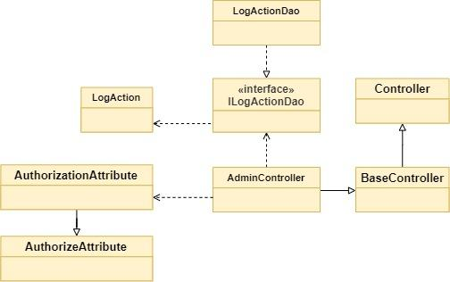

*Figure 4.25 – Class diagram for UC-46*

#### UC-47,48 (Login – Logout)

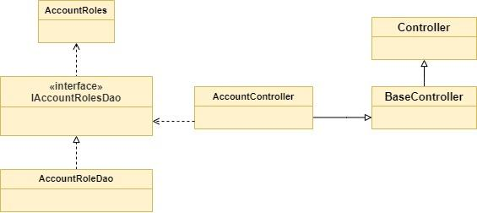

*Figure 4.26 – Class diagram for UC-47 to UC-48*

#### UC-49,50,51,52,53,54 (View all CVs - View detail CV - Change CV status - Search CV - Delete CV - Send email quiz)

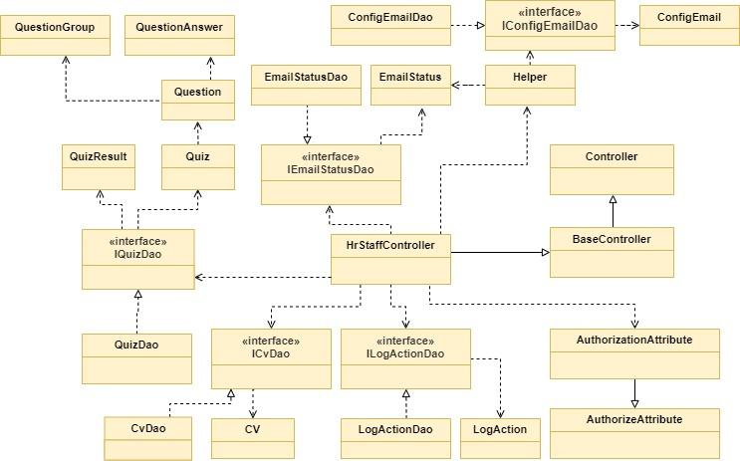

*Figure 4.27 - Class diagram for UC-49 to UC-54*

#### UC-55 (Export CV)

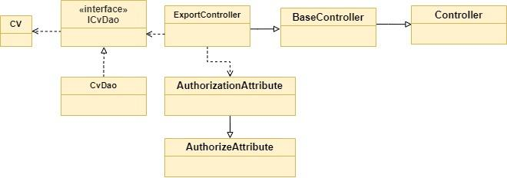

*Figure 4.28 – Class diagram for UC-55*

#### UC-56,57,58,59,60 (View all jobs – Add job – Edit job – Delete job – Search job in HR)

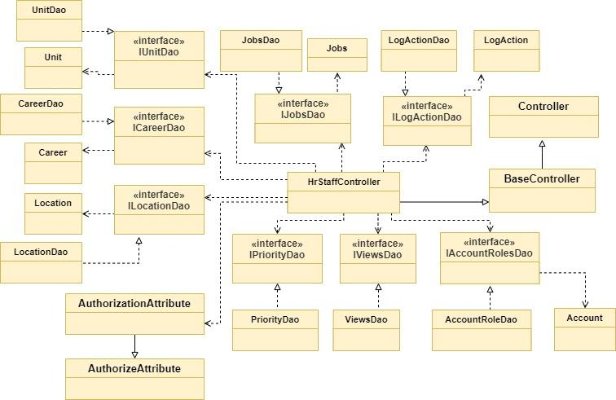

*Figure 4.29 – Class diagram for UC-56 to UC-60*

#### UC-61 (View list CVs applied for a job)

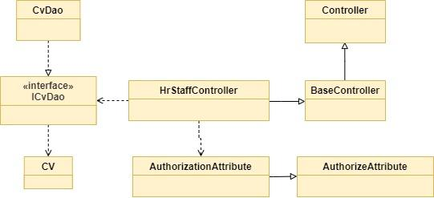

*Figure 4.30 - Class diagram for UC-61*

#### UC-62,63,64 (View all error emails - Resend all error email - Resend each error email)

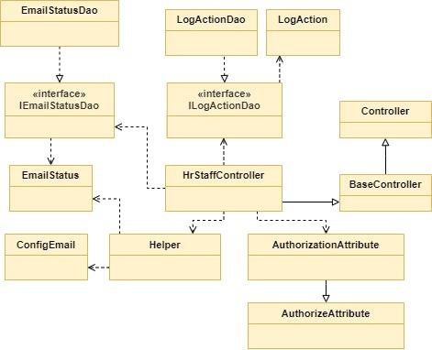

*Figure 4.31 - Class diagram for UC-62 to UC-64*

### Models

#### Account

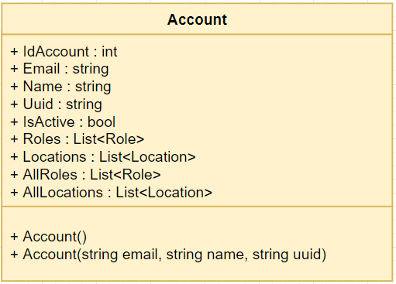

*Figure 4.32 - Account model*

Class specification

|  |  |  |  |
| --- | --- | --- | --- |
| **No** | **Attribute** | **Type** | **Description** |
| 01 | IdAccount | int | ID of account |
| 02 | Email | string | Email of account |
| 03 | Name | string | Name of account |
| 04 | Uuid | string | Using to manage account |
| 05 | IsActive | bool | To know an account is active or disable |
| 06 | Roles | List<Role> | All roles of login account manage |
| 07 | Locations | List<Location> | All locations of login account manage |
| 08 | Roles | List<Role> | All roles of system |
| 09 | Locations | List<Location> | All locations of system |

|  |  |  |
| --- | --- | --- |
| **No** | **Method** | **Description** |
| 01 | Account() | Default constructor |
| 02 | Account(string email, string name, string uuid) | Another constructor |

*Table 4.1: Account model*

#### AccountRoles

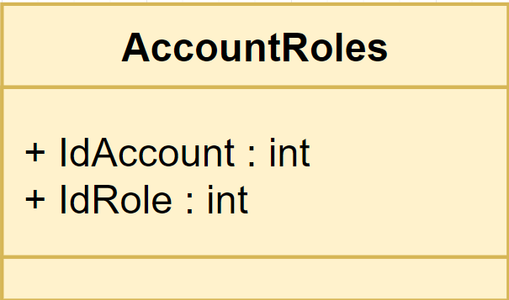

*Figure 4.33 - AccountRoles model*

Class specification

|  |  |  |  |
| --- | --- | --- | --- |
| **No** | **Attribute** | **Type** | **Description** |
| 01 | IdAccount | int | Id of account |
| 02 | IdRole | int | Id of role |

*Table 4.2: Account’s Role model*

#### Location

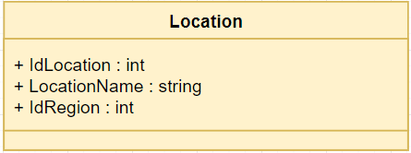

*Figure 4.34 - Location model*

Class specification

|  |  |  |  |
| --- | --- | --- | --- |
| **No** | **Attribute** | **Type** | **Description** |
| 01 | IdLocation | int | Id of location |
| 02 | LocationName | string | Name of location |
| 03 | IdRegion | int | Id of region |

*Table 4.3: Location model*

#### Career

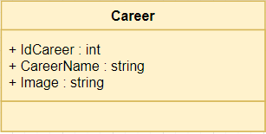

*Figure 4.35 - Career model*

Class specification

|  |  |  |  |
| --- | --- | --- | --- |
| **No** | **Attribute** | **Type** | **Description** |
| 01 | IdCareer | int | Id of career |
| 02 | CareerName | string | Name of career |
| 03 | Image | string | Name of image to represent the career |

*Table 4.4: Location model*

#### ConfigEmail

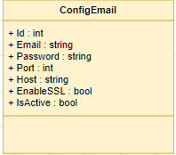

*Figure 4.36 - ConfigEmail model*

Class specification

|  |  |  |  |
| --- | --- | --- | --- |
| **No** | **Attribute** | **Type** | **Description** |
| 01 | Id | int | Id of config email |
| 02 | Email | string | Name of config email |
| 03 | Password | string | Password of config email |
| 04 | Port | int | Port to config send email |
| 05 | Host | string | Host to config send email |
| 06 | EnableSSL | bool | Set SSL is enable or not |
| 07 | IsActive | bool | Set config email is active or not |

*Table 4.5: ConfigEmail model*

#### CV

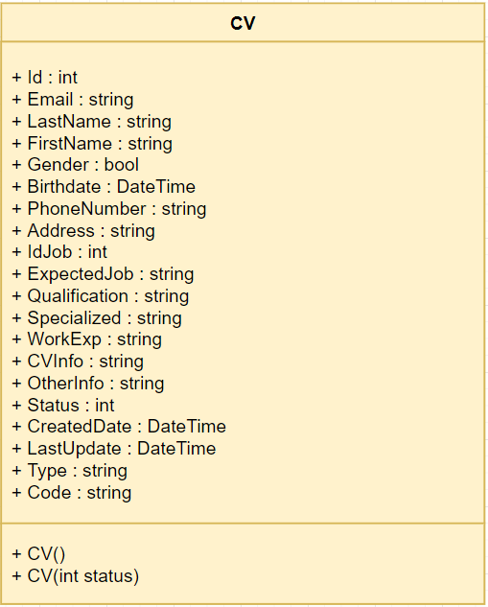

*Figure 4.37 - CV model*

Class specification

|  |  |  |  |
| --- | --- | --- | --- |
| **No** | **Attribute** | **Type** | **Description** |
| 01 | Id | int | Id of CV |
| 02 | Email | string | Email of candidate who send CV |
| 03 | LastName | string | Last name of candidate who send CV |
| 04 | FirstName | string | First name of candidate who send CV |
| 05 | Gender | bool | Gender of candidate who send CV |
| 06 | Birthdate | DateTime | Birthdate of candidate who send CV |
| 07 | PhoneNumber | string | Phone number of candidate who send CV |
| 08 | Address | string | Address of candidate who send CV |
| 09 | IdJob | int | Id of job candidate apply for |
| 10 | ExpectedJob | string | Expected job of candidate want to apply for |
| 11 | Qualification | string | Qualification of candidate who send CV |
| 12 | Specialized | string | Specialized of candidate who send CV |
| 13 | WorkExp | string | Work experience of candidate who send CV |
| 14 | CVInfo | string | CV of candidate |
| 15 | OtherInfo | string | Other information of candidate who send CV |
| 16 | Status | int | Status of CV :   * Status = 1 : “Mới” * Status = 2 : “Đã xem” * Status = 3 : “Cân nhắc” * Status = 4 : “Chấp nhận” * Else : “Từ chối” |
| 17 | CreatedDate | DateTime | Created time of CV when candidate sends CV |
| 18 | LastUpdate | DateTime | Last update time of CV when candidate edits CV |
| 19 | Type | string | Type of CV:   * Có CV * Không có CV * Đăng ký |
| 20 | Code | string | Code of CV to send link edit CV to candidate |

|  |  |  |
| --- | --- | --- |
| **No** | **Method** | **Description** |
| 01 | CV() | Default constructor |
| 02 | CV(int status) | Another constructor |

*Table 4.6: CV model*

#### EmailStatus

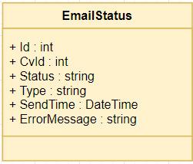

*Figure 4.38 - EmailStatus model*

Class specification

|  |  |  |  |
| --- | --- | --- | --- |
| **No** | **Attribute** | **Type** | **Description** |
| 01 | Id | int | Id of email status |
| 02 | CvId | int | Id of CV |
| 03 | Status | string | Status of email status   * SUCCESS : when send email success * FAIL : when fail to send email |
| 04 | Type | string | Type of email status   * RECEIVED : when candidate send CV * QUIZ : when HR staff send quiz |
| 05 | SendTime | DateTime | Time to send mail |
| 06 | ErrorMessage | string | Message of error when send fail |

*Table 4.7: EmailStatus model*

#### Job

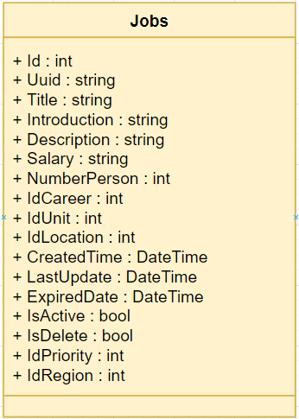

*Figure 4.39 - Jobs model*

Class specification

|  |  |  |  |
| --- | --- | --- | --- |
| **No** | **Attribute** | **Type** | **Description** |
| 01 | Id | int | Id of job |
| 02 | Uuid | string | Uuid of account of login user who create job |
| 03 | Title | string | Title of job |
| 04 | Introduction | string | Introduction of created job |
| 05 | Description | string | Description of created job |
| 06 | Salary | string | Salary of created job |
| 07 | NumberPerson | int | Number of candidates that HR staff want to recruit |
| 08 | IdCareer | int | Id of career (Type carrer of job) |
| 09 | IdUnit | int | Id of unit (Type unit of job) |
| 10 | IdLocation | int | Id of location (Location of job) |
| 11 | CreatedTime | DateTime | Time when job is created |
| 12 | LastUpdate | DateTime | Time of job when HR staff update |
| 13 | ExpiredDate | DateTime | Expiry time of job |
| 14 | IsActive | bool | To know job is showed or not |
| 15 | IsDelete | bool | To know job was deleted or not |
| 16 | IdPriority | int | Priority of created job |
| 17 | IdRegion | int | Region of created job |

*Table 4.8: Job model*

#### LogAction

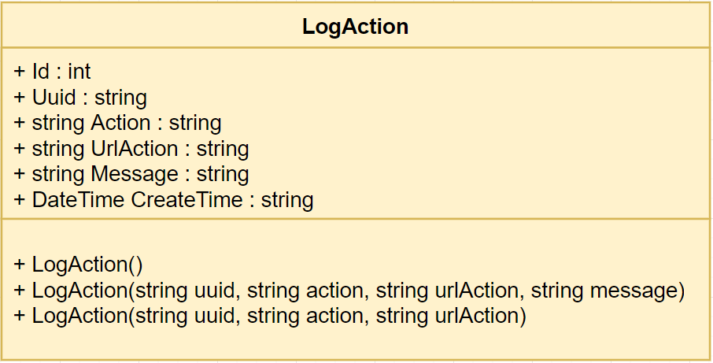

*Figure 4.40 - LogAction model*

Class specification

|  |  |  |  |
| --- | --- | --- | --- |
| **No** | **Attribute** | **Type** | **Description** |
| 01 | Id | int | Id of log action |
| 02 | Uuid | string | Uuid of account of login user who do action |
| 03 | Action | string | Name of action |
| 04 | UrlAction | string | Url of screen when user do action |
| 05 | Message | string | Description of action |
| 06 | CreateTime | DateTime | Time when user do action |

*Table 4.9: LogAction model*

#### Priority

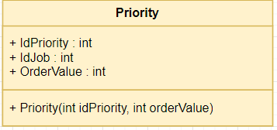

*Figure 4.41 - Priority model*

Class specification

|  |  |  |  |
| --- | --- | --- | --- |
| **No** | **Attribute** | **Type** | **Description** |
| 01 | Id | int | Id of priority |
| 02 | IdJob | string | Id of job which want to prioritize |
| 03 | OrderValue | int | Order value to prioritize, min is 1 and max is 3 |

*Table 4.10: Priority model*

#### Question

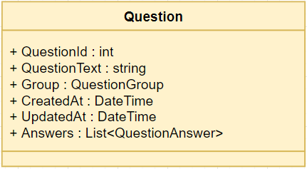

*Figure 4.42 - Question model*

Class specification

|  |  |  |  |
| --- | --- | --- | --- |
| **No** | **Attribute** | **Type** | **Description** |
| 01 | QuestionId | int | Id of question |
| 02 | QuestionText | string | Text of question |
| 03 | Group | QuestionGroup | Group of question |
| 04 | CreatedAt | DateTime | Time when question was created |
| 05 | UpdatedAt | DateTime | Time when question was updated |
| 06 | Answers | List<QuestionAnswer> | List answers of question |

*Table 4.11: Question model*

#### QuestionAnswer

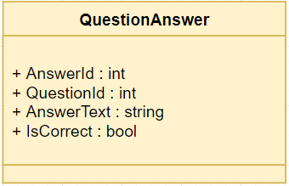

*Figure 4.43 - QuestionAnswer model*

Class specification

|  |  |  |  |
| --- | --- | --- | --- |
| **No** | **Attribute** | **Type** | **Description** |
| 01 | AnswerId | int | Id of answer |
| 02 | QuestionId | int | Id of question that answer belong to |
| 03 | AnswerText | string | Text of answer |
| 04 | IsCorrect | bool | To now this is correct answer or not |

*Table 4.12: QuestionAnswer model*

#### QuestionGroup

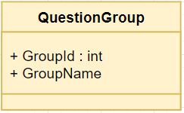

*Figure 4.44 - QuestionGroup model*

Class specification

|  |  |  |  |
| --- | --- | --- | --- |
| **No** | **Attribute** | **Type** | **Description** |
| 01 | GroupId | int | Id of group question |
| 02 | GroupName | int | Name of group question |

*Table 4.13: QuestionGroup model*

#### Quiz

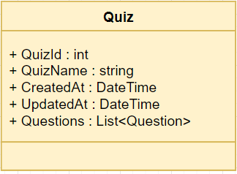

*Figure 4.45 - Quiz model*

Class specification

|  |  |  |  |
| --- | --- | --- | --- |
| **No** | **Attribute** | **Type** | **Description** |
| 01 | QuizId | int | Id of quiz |
| 02 | QuizName | string | Name of quiz |
| 03 | CreatedAt | DateTime | Time when quiz was created |
| 04 | UpdatedAt | DateTime | Time when quiz was updated |
| 05 | Questions | List<Question> | List questions of quiz |

*Table 4.14: Quiz model*

#### QuizResult

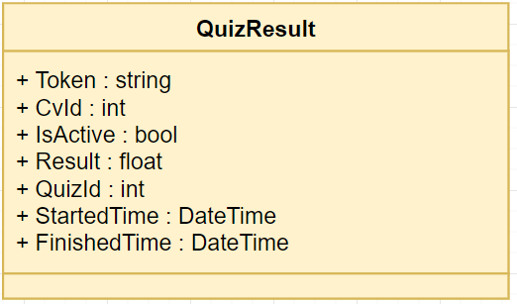

*Figure 4.46 - QuizResult model*

Class specification

|  |  |  |  |
| --- | --- | --- | --- |
| **No** | **Attribute** | **Type** | **Description** |
| 01 | Token | string | Token to distinguish between quizzes of candidate |
| 02 | CvId | int | Id of CV |
| 03 | IsActive | bool | To know candidate did quiz or not |
| 04 | Result | float | Scores of candidate after did quiz |
| 05 | QuizId | int | Id of quiz |
| 06 | StartedTime | DateTime | Time when candidate start to do quiz |
| 07 | FinishedTime | DateTime | Time when candidate finish the quiz |

*Table 4.14: QuizResult model*

#### Region

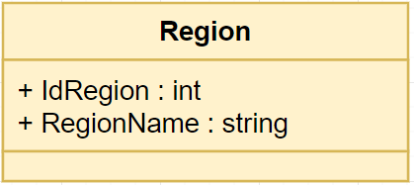

*Figure 4.47 - Region model*

Class specification

|  |  |  |  |
| --- | --- | --- | --- |
| **No** | **Attribute** | **Type** | **Description** |
| 01 | IdRegion | int | Id of region |
| 02 | RegionName | string | Name of region |

*Table 4.15: Region model*

#### Role

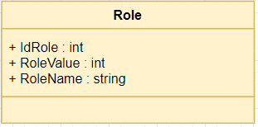

*Figure 4.48 - Role model*

Class specification

|  |  |  |  |
| --- | --- | --- | --- |
| **No** | **Attribute** | **Type** | **Description** |
| 01 | IdRole | int | Id of role |
| 02 | RoleValue | int | Value of role |
| 03 | RoleName | string | Name of role |

*Table 4.16: Role model*

#### Unit

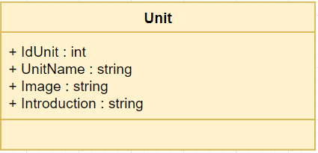

*Figure 4.49 - Unit model*

Class specification

|  |  |  |  |
| --- | --- | --- | --- |
| **No** | **Attribute** | **Type** | **Description** |
| 01 | IdUnit | int | Id of Unit |
| 02 | UnitName | string | Name of unit |
| 03 | Introduction | string | Introduce about unit |

*Table 4.17: Role model*

#### View

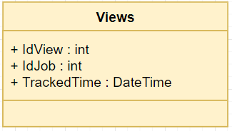

*Figure 4.50 - Views model*

Class specification

|  |  |  |  |
| --- | --- | --- | --- |
| **No** | **Attribute** | **Type** | **Description** |
| 01 | IdView | int | Id of view |
| 02 | IdJob | int | Id of job has candidate view |
| 03 | TrackedTime | DateTime | Time when candidate view job |

*Table 4.18: Role model*

### DAO

#### AccountDao

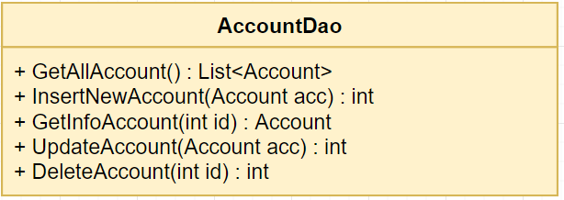

*Figure 4.51 - AccountDao*

Class specification

|  |  |  |
| --- | --- | --- |
| **No** | **Method** | **Description** |
| 01 | GetAllAccount() | Get all account in system |
| 02 | InsertNewAccount(Account acc) | Create a new account into system |
| 03 | GetInfoAccount(int id) | Get all information of an account |
| 04 | UpdateAccount(Account acc) | Edit information of an account |
| 05 | DeleteAccount(int id) | Delete an account in system |

*Table 4.19: AccountDao*

#### AccountRolesDao

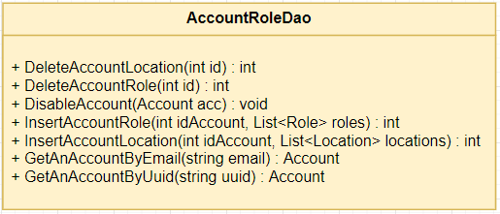

*Figure 4.52 - AccountRoleDao*

Class specification

|  |  |  |
| --- | --- | --- |
| **No** | **Method** | **Description** |
| 01 | DeleteAccountLocation(int id) | Delete locations of an account |
| 02 | DeleteAccountRole(int id) | Delete roles of an account |
| 03 | DisableAccount(Account acc) | Disable an account in system |
| 04 | InsertAccountRole(int idAccount, List<Role>) | Add roles for an account |
| 05 | InsertAccountLocation(int idAccount, List<Location>) | Add locations for an account |
| 06 | GetAnAccountByEmail(string email) | Get an account from system by email |
| 07 | GetAnAccountByUuid(string uuid) | Get an account from system by uuid |

*Table 4.20: AccountRoleDao*

#### CareerDao

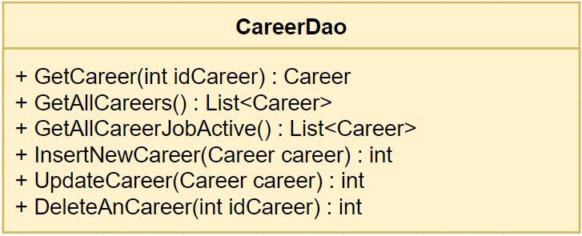

*Figure 4.53 - CareerDao*

Class specification

|  |  |  |
| --- | --- | --- |
| **No** | **Method** | **Description** |
| 01 | GetCareer(int idCareer) | Get information of a career |
| 02 | GetAllCareers() | Get all career in system |
| 03 | GetAllCareerJobActive() | Get all career of jobs which are active |
| 04 | InsertNewCareer(Career career) | Create a new career into system |
| 05 | UpdateCareer(Career career) | Update a career in system |
| 06 | DeleteAnCareer(int idCareer) | Delete a career in system |

*Table 4.21: CareerDao*

#### ConfigEmail

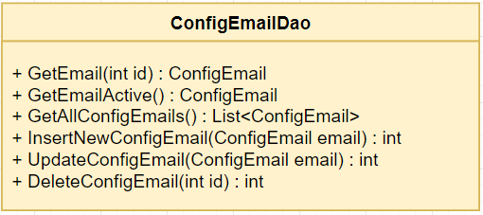

*Figure 4.54 - ConfigEmailDao*

Class specification

|  |  |  |
| --- | --- | --- |
| **No** | **Method** | **Description** |
| 01 | GetEmail(int id) | Get an email config in system |
| 02 | GetEmailActive() | Get an email config is active in system which is used to send email to candidate |
| 03 | GetAllConfigEmails() | Get all emails config in system |
| 04 | InsertNewConfigEmail(ConfigEmail email) | Create an new email config into system |
| 05 | UpdateConfigEmail(ConfigEmail email) | Edit an email config in system |
| 06 | DeleteConfigEmail(int id) | Delete an email config in system |

*Table 4.22: ConfigEmailDao*

#### CVDao

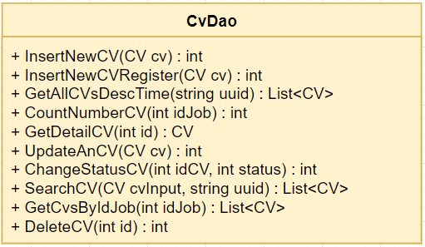

*Figure 4.55 - CVDao*

Class specification

|  |  |  |
| --- | --- | --- |
| **No** | **Method** | **Description** |
| 01 | InsertNewCV(CV cv) | Create a new CV when candidate apply job |
| 02 | InsertNewCVRegister(CV cv) | Create a new CV when candidate register potential candidate |
| 03 | GetAllCVsDescTime(string uuid) | Get all CV are managed by login account |
| 04 | CountNumberCV(int idJob) | Count number of CVs were apply for a job |
| 05 | GetDetailCV(int id) | Get detail of a CV |
| 06 | UpdateAnCV(CV cv) | Edit an CV |
| 07 | ChangeStatusCV(int idCV, int status) | Change status of CV   * Status = 1 : Mới * Status = 2 : Đã xem * Status = 3 : Cân nhắc * Status = 4 : Chấp nhận * Else : Từ chối |
| 08 | SearchCV(CV cvInput, string uuid) | Search CV base on information input |
| 09 | GetCvsByIdJob(int idJob, string uuid) | Get all CVs were applied for a job |
| 10 | DeleteCV(int id) | Delete a CV in system |

*Table 4.23: CVDao*

#### EmailStatusDao

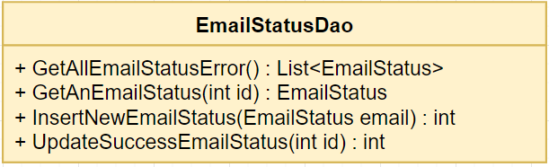

*Figure 4.56 – EmailStatusDao*

Class specification

|  |  |  |
| --- | --- | --- |
| **No** | **Method** | **Description** |
| 01 | GetAllEmailStatusError() | Get all emails which were error send to candidate |
| 02 | GetAnEmailStatus(int id) | Get an email was send in system |
| 03 | InsertNewEmailStatus(EmailStatus email) | Insert a new email when system send to candidate |
| 04 | UpdateSuccessEmailStatus(int id) | Update email was resent success in system |

*Table 4.24: EmailStatusDao*

#### JobsDao

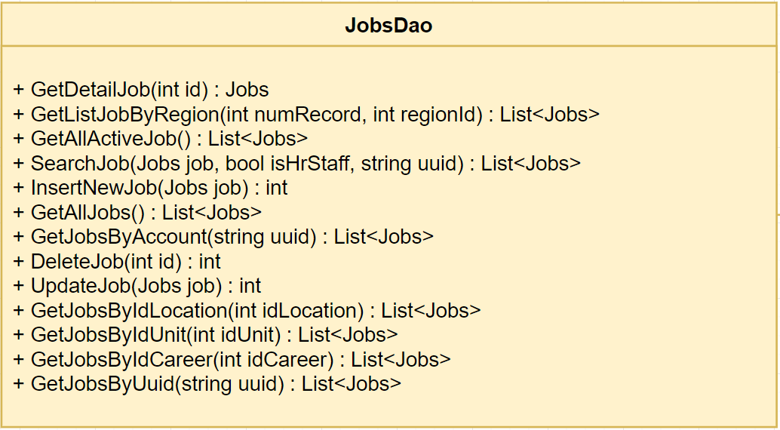

*Figure 4.57 – JobsDao*

Class specification

|  |  |  |
| --- | --- | --- |
| **No** | **Method** | **Description** |
| 01 | GetDetailJob(int id) | Get detail information of job |
| 02 | GetListJobByRegion(int numRecord, int regionId) | Get list job by a region |
| 03 | GetAllActiveJob() | Get all jobs is active in system |
| 04 | SearchJob(Jobs job, bool isHrStaff, string uuid) | Candidates search jobs with conditions of input, but HR staff just search jobs which are managed by HR staff and based on location. |
| 05 | InsertNewJob(Jobs job) | Create a new job into system |
| 06 | GetAllJobs() | Get all jobs in system |
| 07 | GetJobsByAccount(string uuid) | Get all job were created and managed by login account |
| 08 | GetJobsByUuid(string uuid) | Get all jobs were created by login account |
| 09 | DeleteJob(int id) | Delete a job in system |
| 10 | UpdateJob(Jobs job) | Edit a job in system |
| 11 | GetJobsByIdLocation(int idLocation) | Get all job of a location |
| 12 | GetJobsByIdUnit(int idUnit) | Get all jobs of an unit |
| 13 | GetJobsByIdCareer(int idCareer) | Get all jobs of a career |

*Table 4.25: JobsDao*

#### LocationDao

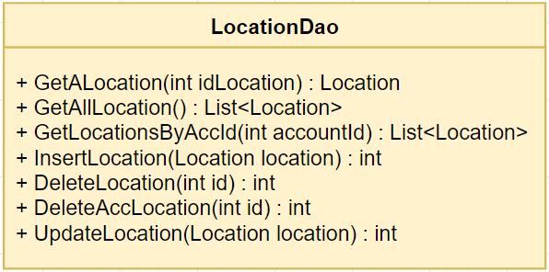

*Figure 4.58 - LocationDao*

Class specification

|  |  |  |
| --- | --- | --- |
| **No** | **Method** | **Description** |
| 01 | GetALocation(int idLocation) | Get information of a location in system |
| 02 | GetAllLocation() | Get all locations in system |
| 03 | GetLocationsByAccId(int accountId) | Get all locations are managed by an account |
| 04 | InsertLocation(Location location) | Create a location into system |
| 05 | DeleteLocation(int id) | Delete a location in system |
| 06 | DeleteAccLocation(int id) | Delete all account’s location management right |
| 07 | UpdateLocation(Location location) | Edit a location in system |

*Table 4.26: LocationDao*

#### LogActionDao

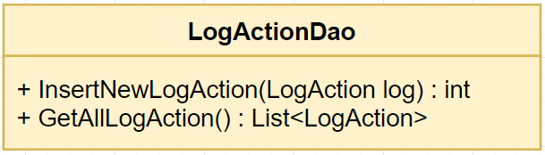

*Figure 4.59 - LogActionDao*

Class specification

|  |  |  |
| --- | --- | --- |
| **No** | **Method** | **Description** |
| 01 | InsertNewLogAction(LogAction log) | Create a new log action of an account |
| 02 | GetAllLogAction() | Get all logs were created in system |

*Table 4.27: LogActionDao*

#### PriorityDao

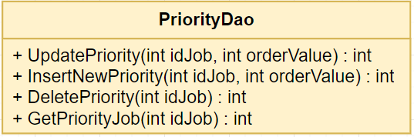

*Figure 4.60 - PriorityDao*

Class specification

|  |  |  |
| --- | --- | --- |
| **No** | **Method** | **Description** |
| 01 | UpdatePriority(int idJob, int orderValue) | Update order value priority of a job |
| 02 | InsertNewPriority(int idJob, int orderValue) | Create a order value priority of a job |
| 03 | DeletePriority(int idJob) | Delete order value priority of a job |
| 04 | GetPriorityJob(int idJob) | Get order value priority of a job |

*Table 4.27: PriorityDao*

#### QuizDao

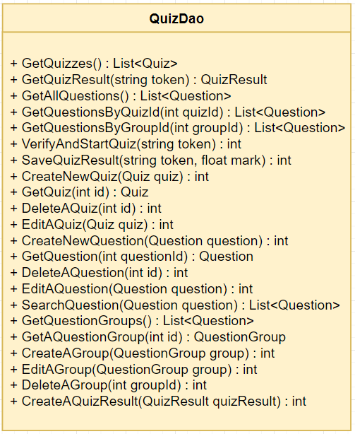

*Figure 4.61 – QuizDao*

Class specification

|  |  |  |
| --- | --- | --- |
| **No** | **Method** | **Description** |
| 01 | getQuizzes() | Get all quizzes in system |
| 02 | GetQuizResult(string token) | Get result of a quiz |
| 03 | GetAllQuestions() | Get all questions in system |
| 04 | GetQuestionsByQuizId(int quizId) | Get all questions of a quiz |
| 05 | GetQuestionsByGroupId(int groupId) | Get all questions of a group question |
| 06 | VerifyAndStartQuiz(string token) | Verify a result of a quiz to start this quiz |
| 07 | SaveQuizResult(string token, float mark) | Update result of quiz after finish |
| 08 | CreateAQuizResult(QuizResult quizResult) | Create result of a quiz |
| 09 | CreateNewQuiz(Quiz quiz) | Create a new quiz in system |
| 10 | GetQuiz(int id) | Get information of a quiz in system |
| 11 | DeleteAQuiz(int id) | Delete a quiz in system |
| 12 | EditAQuiz(Quiz quiz) | Edit a quiz in system |
| 13 | CreateNewQuestion(Question question) | Create a new question in system |
| 14 | GetQuestion(int questionId) | Get information of a question in system |
| 15 | DeleteAQuestion(int id) | Delete a question in system |
| 16 | EditAQuestion(Question question) | Edit a question in system |
| 17 | SearchQuestion(Question question) | Search question with input condition |
| 18 | GetQuestionGroups() | Get all question groups in system (include question in this group) |
| 19 | GetAQuestionGroup(int id) | Get information of a question group in system (include question in this group) |
| 20 | CreateAGroup(QuestionGroup group) | Create a group question in system |
| 21 | EditAGroup(QuestionGroup group) | Edit a group question in system |
| 22 | DeleteAGroup(int groupId) | Delete a group question in system |

*Table 4.28: QuizDao*

#### RegionDao

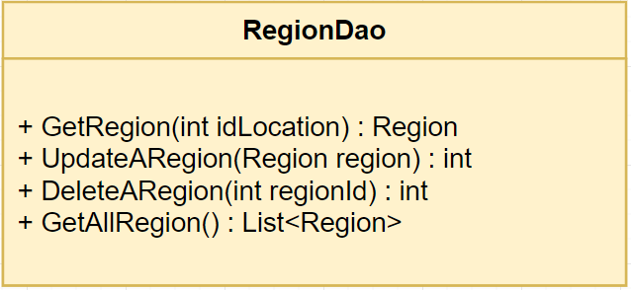

*Figure 4.62 - RegionDao*

Class specification

|  |  |  |
| --- | --- | --- |
| **No** | **Method** | **Description** |
| 01 | GetRegion(int idLocation) | Get region of a location |
| 02 | UpdateARegion(Region region) | Edit a region in system |
| 03 | DeleteARegion(int regionId) | Delete a region in system |
| 04 | GetAllRegion() | Get all regions in system |

*Table 4.29: RegionDao*

#### RolesDao

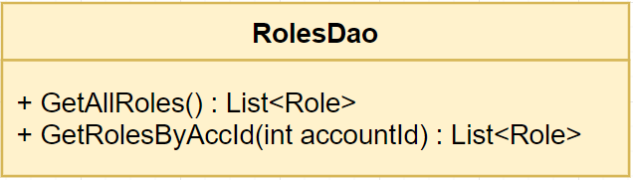

*Figure 4.63 - RolesDao*

Class specification

|  |  |  |
| --- | --- | --- |
| **No** | **Method** | **Description** |
| 01 | GetAllRoles() | Get all roles in system |
| 02 | GetRolesByAccId(int accountId) | Get all roles of an account in system |

*Table 4.30: RolesDao*

#### UnitDao

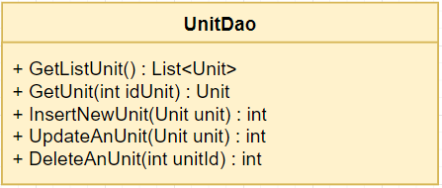

*Figure 4.64 - UnitDao*

Class specification

|  |  |  |
| --- | --- | --- |
| **No** | **Method** | **Description** |
| 01 | GetListUnit() | Get all units in system |
| 02 | GetUnit(int idUnit) | Get information of an unit in system |
| 03 | InsertNewUnit(Unit unit) | Create an new unit in system |
| 04 | UpdateAnUnit(Unit unit) | Edit an unit in system |
| 05 | DeleteAnUnit(int? unitId) | Delete an unit in system |

*Table 4.31: UnitDao*

#### ViewsDao

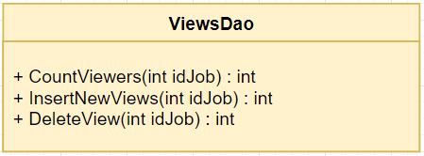

*Figure 4.65 - ViewsDao*

Class specification

|  |  |  |
| --- | --- | --- |
| **No** | **Method** | **Description** |
| 01 | CountViewers(int idJob) | Count number of viewer of a job |
| 02 | InsertNewViews(int idJob) | Insert of new view of a job |
| 03 | DeleteView(int idJob) | Delete all view of a job |

*Table 4.32: ViewsDao*

### Controller

#### BaseController

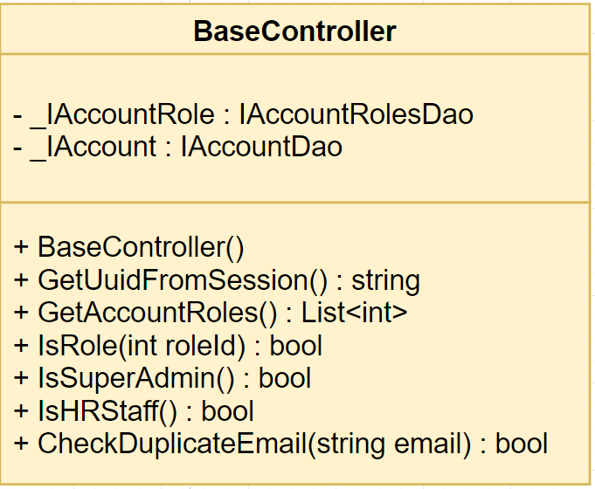

*Figure 4.66 - Base Controller*

Class specification

|  |  |  |
| --- | --- | --- |
| **No** | **Method** | **Description** |
| 01 | BaseController() | Default constructor |
| 02 | GetUuidFromSession() | Get uuid of login account from session |
| 03 | IsRole(int roleId) | Check an account has role or not |
| 04 | IsSupperAdmin() | Check an account is Super Admin or not |
| 05 | IsHRStaff() | Check an account is HR Staff or not |
| 07 | CheckDuplicateEmail(string email) | Check email of an account is exist or not |

*Table 4.33: Base Controller*

#### AccountController

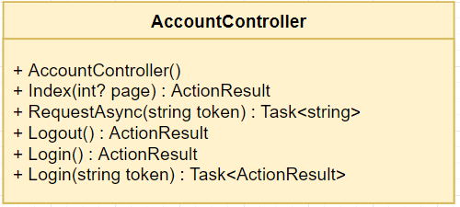

*Figure 4.67 - Account Controller*

Class specification

|  |  |  |
| --- | --- | --- |
| **No** | **Method** | **Description** |
| 01 | AccountController | Default constructor |
| 02 | Index() | If login account is Admin, then redirect to Admin page  If login account is HR staff, then redirect to HR staff page  If not login, redirect to login page |
| 03 | RequestAsync(string token) | Verify token with google |
| 04 | Logout() | Logout account from system |
| 05 | Login() | Redirect to login page |
| 07 | Login(string token) | Login account into system |

*Table 4.34: Account Controller*

#### AdminController

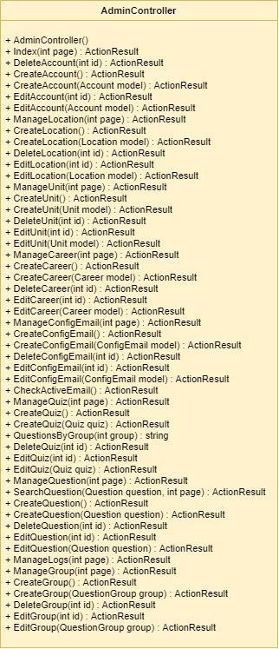

*Figure 4.68 - Admin Controller*

Class specification

|  |  |  |
| --- | --- | --- |
| **No** | **Method** | **Description** |
| 01 | AdminController() | Default constructor |
| 02 | Index(int page) | Get list accounts and return to list account manage page |
| 03 | DeleteAccount(int id) | Delete account from system |
| 04 | CreateAccount() | Check permission and return to create account page |
| 05 | CreateAccount(Account model) | Handle and verify to create an account into the system. If verify failed, return to create account page with submit information |
| 06 | EditAccount(int id) | Check permission, get account to edit and return to edit account page |
| 07 | EditAccount(Account model) | Handle and verify to edit an account in the system. If verify failed, return to edit account page with submit information |
| 08 | ManageLocation(int page) | Get list locations and return to location manage page |
| 09 | CreateLocation() | Check permission and return to create location page |
| 10 | CreateLocation(Location model) | Handle and verify to create a location into the system. If verify failed, return to create location page with submit information |
| 11 | DeleteLocation(int id) | Delete a location in system |
| 12 | EditLocation(int id) | Check permission and return to edit location page |
| 13 | EditLocation(Location model) | Handle and verify to edit a location in the system. If verify failed, return to edit location page with submit information |
| 14 | ManageUnit(int page) | Get list units and return to unit manage page |
| 15 | CreateUnit() | Check permission and return to create unit page |
| 16 | CreateUnit(Unit model) | Handle and verify to create a unit into the system. If verify failed, return to create unit page with submit information |
| 17 | DeleteUnit(int id) | Delete a unit in system |
| 18 | EditUnit(int id) | Check permission and return to edit unit page |
| 19 | EditUnit(Unit model) | Handle and verify to edit a unit in the system. If verify failed, return to edit unit page with submit information |
| 20 | ManageCareer(int page) | Get list careers and return to unit manage page |
| 21 | CreateCareer() | Check permission and return to create career page |
| 22 | CreateCareer(Career model) | Handle and verify to create a career into the system. If verify failed, return to create career page with submit information |
| 23 | DeleteCareer(int id) | Delete a career in system |
| 24 | EditCareer(int id) | Check permission and return to edit career page |
| 25 | EditCareer(Career model) | Handle and verify to edit a career in the system. If verify failed, return to edit career page with submit information |
| 26 | ManageConfigEmail(int page) | Get list config emails and return to config email manage page |
| 27 | CreateConfigEmail() | Check permission and return to create config email page |
| 28 | CreateConfigEmail(ConfigEmail model) | Handle and verify to create a config email into the system. If verify failed, return to create config email page with submit information |
| 29 | DeleteConfigEmail(int id) | Delete a config email in system |
| 30 | EditConfigEmail(int id) | Check permission and return to edit config email page |
| 31 | EditConfigEmail(ConfigEmail model) | Handle and verify to edit a config email in the system. If verify failed, return to edit config email page with submit information |
| 32 | CheckActiveEmail() | Check system has config email active or not |
| 33 | ManageQuiz(int page) | Get list quizzes and return to quiz manage page |
| 34 | CreateQuiz() | Check permission and return to create quiz page |
| 35 | CreateQuiz(Quiz quiz) | Handle and verify to create a quiz into the system. If verify failed, return to create quiz page with submit information |
| 36 | QuestionsByGroup(int group) | Return list questions of a group question |
| 37 | DeleteQuiz(int id) | Delete a quiz in system |
| 38 | EditQuiz(int id) | Check permission and return to edit quiz page |
| 39 | EditQuiz(Quiz quiz) | Handle and verify to edit a quiz in the system. If verify failed, return to edit quiz page with submit information |
| 40 | ManageQuestion(int page) | Get list questions and return to question manage page |
| 41 | SearchQuestion(String search, int group, int page) | Get list questions with condition of input and return to question manage page |
| 42 | CreateQuestion() | Check permission and return to create question page |
| 43 | CreateQuestion(Question question) | Handle and verify to create a question in the system. If verify failed, return to create question page with submit information |
| 44 | DeleteQuestion(int id) | Delete a question in system |
| 45 | EditQuestion(int id) | Check permission and return to edit question page |
| 46 | EditQuestion(Question question) | Handle and verify to edit a question in the system. If verify failed, return to edit question page with submit information |
| 47 | ManageLogs(int page) | Get list logs and return to log manage page |
| 48 | ManageGroup(int page) | Get list question group and return to question group manage page |
| 49 | CreateGroup() | Check permission and return to create question group page |
| 50 | CreateGroup(QuestionGroup group) | Handle and verify to create a question group in the system. If verify failed, return to create question group page with submit information |
| 51 | DeleteGroup(int id) | Delete a question group in system |
| 52 | EditGroup(int id) | Check permission and return to edit question group page |
| 53 | EditGroup(QuestionGroup group) | Handle and verify to edit a question group in the system. If verify failed, return to edit question group page with submit information |

*Table 4.35: Admin Controller*

#### CVController

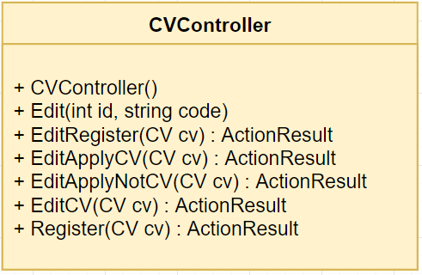

*Figure 4.69 - CV Controller*

Class specification

|  |  |  |
| --- | --- | --- |
| **No** | **Method** | **Description** |
| 01 | CVController() | Default constructor |
| 02 | Edit(int id, string code) | Check CV and type of CV to redirect to suitable edit page |
| 03 | EditRegister(CV cv) | Return to edit CV register page |
| 04 | EditApplyCV(CV cv) | Return to edit CV apply page which have CV file |
| 05 | EditApplyNotCV(CV cv) | Return to edit CV apply page which don’t have CV file |
| 06 | EditCV(CV cv) | Handle and verify to edit a CV in the system. If verify failed, return to edit CV page with submit information |
| 07 | Register(CV cv) | Handle to create a CV into the system. Then send mail to candidate to confirm about CV |

*Table 4.36: CV Controller*

#### ErrorController

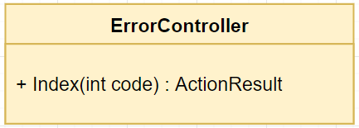

*Figure 4.70 - Error Controller*

Class specification

|  |  |  |
| --- | --- | --- |
| **No** | **Method** | **Description** |
| 01 | Index() | Return to error page with error message |

*Table 4.37: Error Controller*

#### ExportController

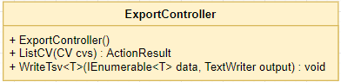

*Figure 4.71 - Export Controller*

Class specification

|  |  |  |
| --- | --- | --- |
| **No** | **Method** | **Description** |
| 01 | ExportController() | Default constructor |
| 02 | ListCV(CV cvs) | Handle to get list CVs to export |
| 03 | WriteTsv<T> | Handle to export list CVs to excel file |

*Table 4.38: Export Controller*

#### HomeController

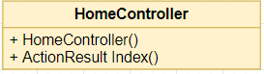

*Figure 4.72 - Home Controller*

Class specification

|  |  |  |
| --- | --- | --- |
| **No** | **Method** | **Description** |
| 01 | HomeController() | Default constructor |
| 02 | Index() | Return information of home |

*Table 4.39: Home Controller*

#### HrStaffController

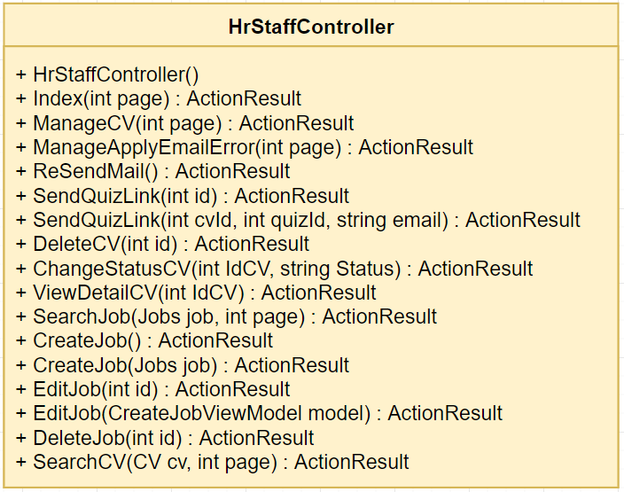

*Figure 4.73 - HrStaff Controller*

Class specification

|  |  |  |
| --- | --- | --- |
| **No** | **Method** | **Description** |
| 01 | HrStaffController() | Default constructor |
| 02 | Index(int page) | Get list jobs are managed by login account and return job manage page |
| 03 | ManageCV(int page) | Get list CVs are managed by login account and return CV manage page |
| 04 | ManageEmailError(int page) | Get list email which send error return error email manage page |
| 05 | ReSendMail(int id, string from) | Resend one error email or all error emails |
| 06 | SendQuizLink(int id) | Handle and verify to redirect to send quiz page |
| 07 | SendQuizLink(int cvId, int quizId, string email) | Handle and verify to send quiz to candidate, if verify failed, redirect to send quiz page with information submitted |
| 08 | DeleteCV(int id) | Delete a CV in system |
| 09 | ChangeStatusCV(int IdCV, string Status) | Change status of a CV |
| 10 | ViewDetailCV(int IdCV) | Get detail information of a CV and return to view detail CV page |
| 11 | SearchJob(Jobs job, int page) | Get list jobs with information of input and return to manage jobs page |
| 12 | CreateJob() | Check permission and redirect to create job page |
| 13 | CreateJob(Jobs job) | Handle and verify to create a job in system, if verify failed, redirect to create job page with information submitted |
| 14 | EditJob(int id) | Check permission, get information of job and redirect to edit job page |
| 15 | EditJob(CreateJobViewModel model) | Handle and verify to edit a job in system, if verify failed, redirect to edit job page with information submitted |
| 16 | DeleteJob(int id) | Check permission and delete a job in system |
| 17 | SearchCV(CV cv, int page) | Get list CVs with condition of input and return to manage CV page |

*Table 4.40: HrStaff Controller*

#### JobController

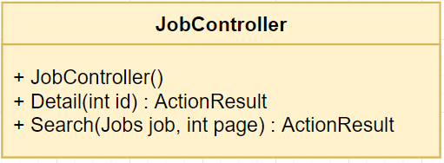

*Figure 4.74 - Job Controller*

Class specification

|  |  |  |
| --- | --- | --- |
| **No** | **Method** | **Description** |
| 01 | JobController() | Default constructor |
| 02 | Detail | Return information detail of a job and return to view detail job page |
| 03 | Search(Jobs job, int page) | Return list jobs with conditions search |

*Table 4.41: Job Controller*

#### QuizController

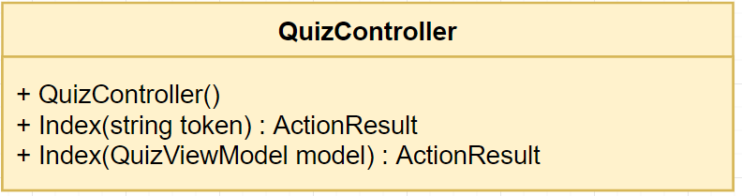

*Figure 4.75 - Quiz Controller*

Class specification

|  |  |  |
| --- | --- | --- |
| **No** | **Method** | **Description** |
| 01 | QuizController() | Default constructor |
| 02 | Index(string token) | Check if the quiz has been done or not. If not, start to do a quiz, if has been done, show message to candidate |
| 03 | Index(QuizViewModel model) | Handle to finish the quiz, get mark and show to candidate |

*Table 4.42: Quiz Controller*

#### RecruitmentProcessController

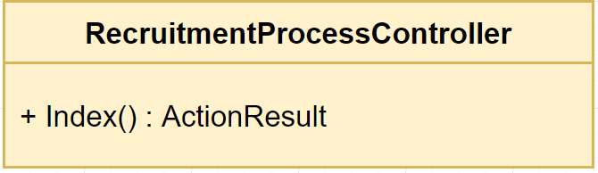

*Figure 4.76 - RecruitmentProcess Controller*

Class specification

|  |  |  |
| --- | --- | --- |
| **No** | **Method** | **Description** |
| 01 | Index() | Redirect to recruitment process page |

*Table 4.42: RecruitmentProcess Controller*

## Sequence Diagram

### UC-01 View recruitment process

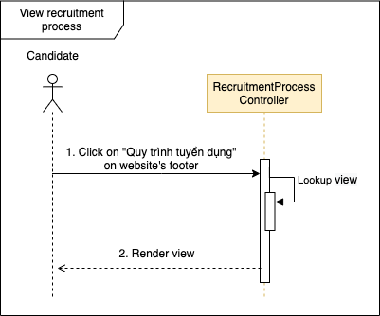

*Figure 4.77 - Sequence diagram for UC-01*

### UC-02 View home

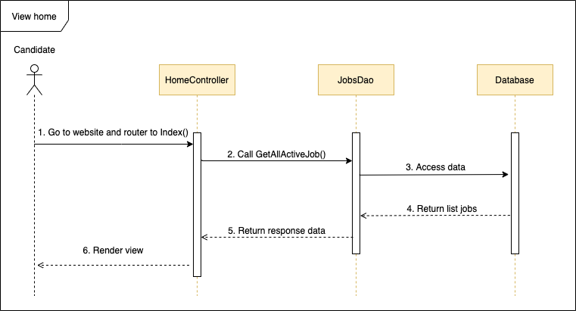

*Figure 4.78 - Sequence diagram for UC-02*

### UC-03 View all jobs

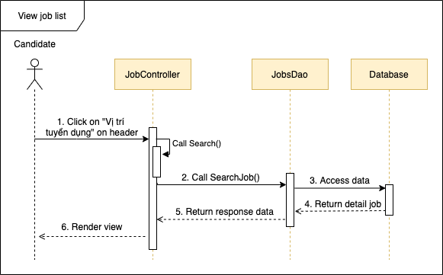

*Figure 4.79 - Sequence diagram for UC-03*

### UC-04 View list jobs by region

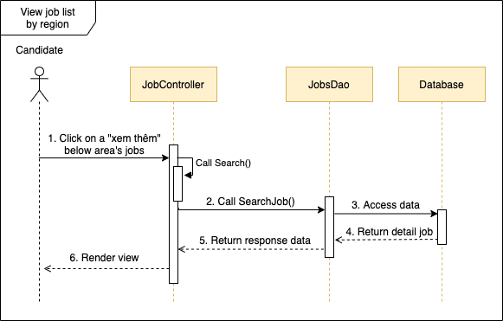

*Figure 4.80 - Sequence diagram for UC-04*

### UC-05 View list jobs by unit

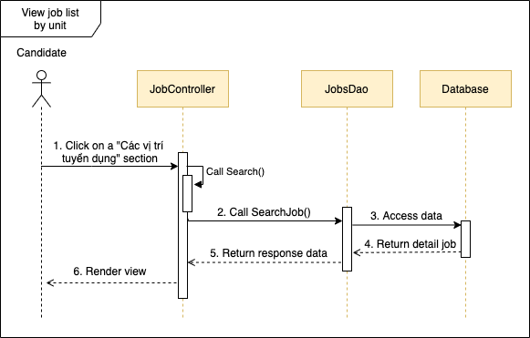

*Figure 4.81 - Sequence diagram for UC-05*

### UC-06 View job detail

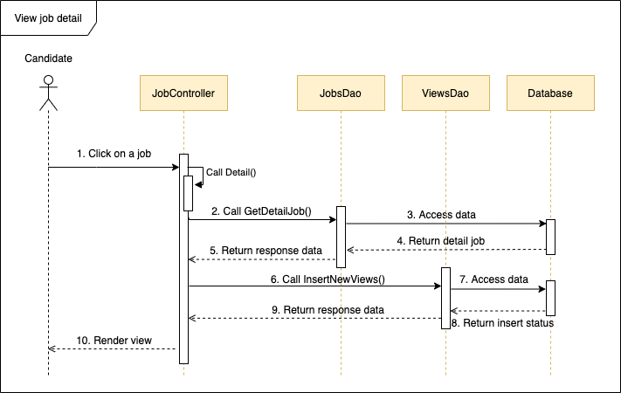

*Figure 4.82 - Sequence diagram for UC-06*

### UC-07 Search job

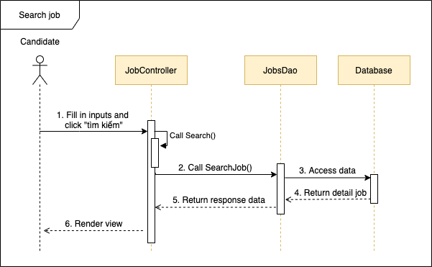

*Figure 4.83 - Sequence diagram for UC-07*

### UC-08 Create CV

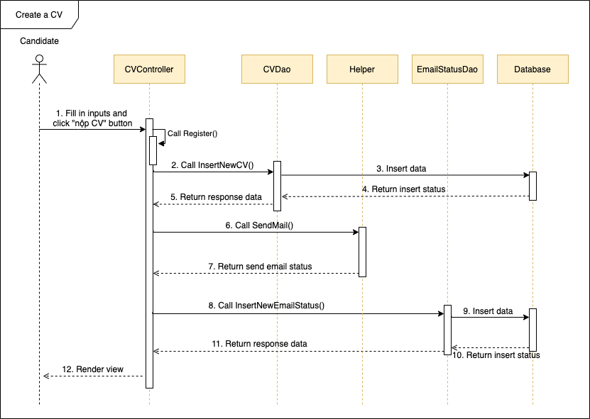

*Figure 4.84 - Sequence diagram for UC-08*

### UC-09 Upload CV

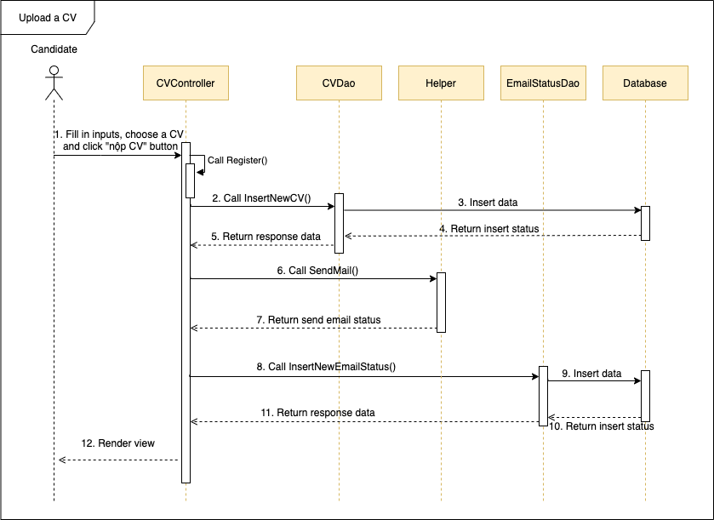

*Figure 4.85 - Sequence diagram for UC-09*

### UC-10 Register potential candidate

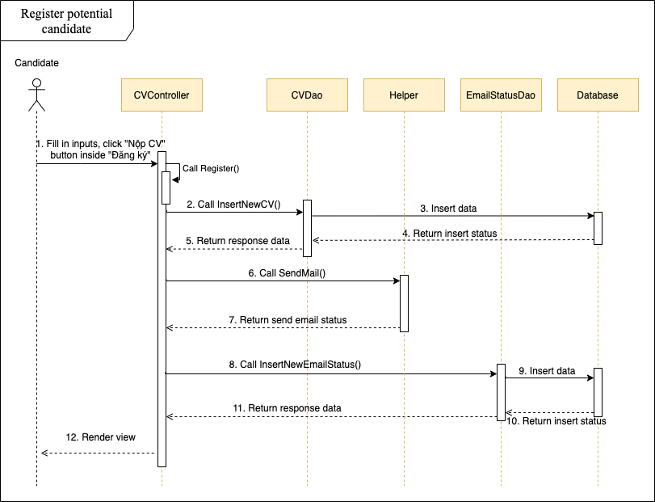

*Figure 4.86 - Sequence diagram for UC-10*

### UC-11 Edit CV

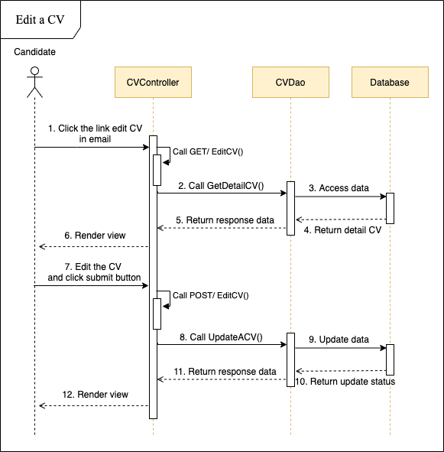

*Figure 4.87 - Sequence diagram for UC-11*

### UC-12 Take quiz

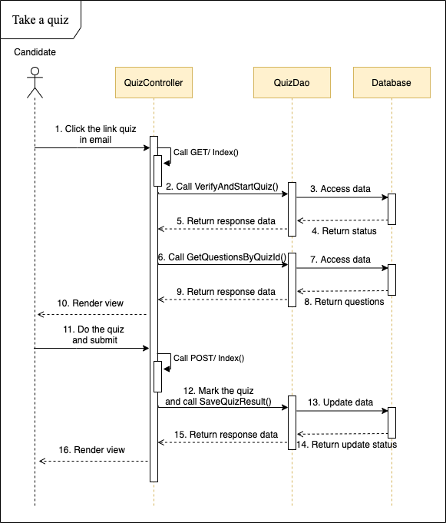

*Figure 4.88 - Sequence diagram for UC-12*

### UC-13 View all accounts

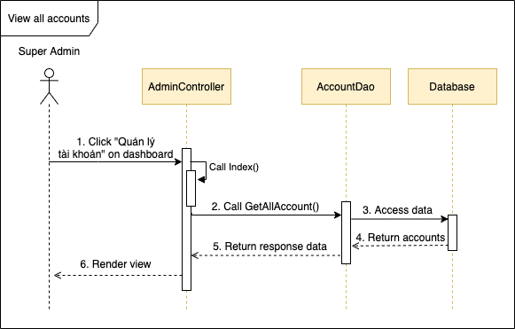

*Figure 4.89 - Sequence diagram for UC-13*

### UC-14 Add account

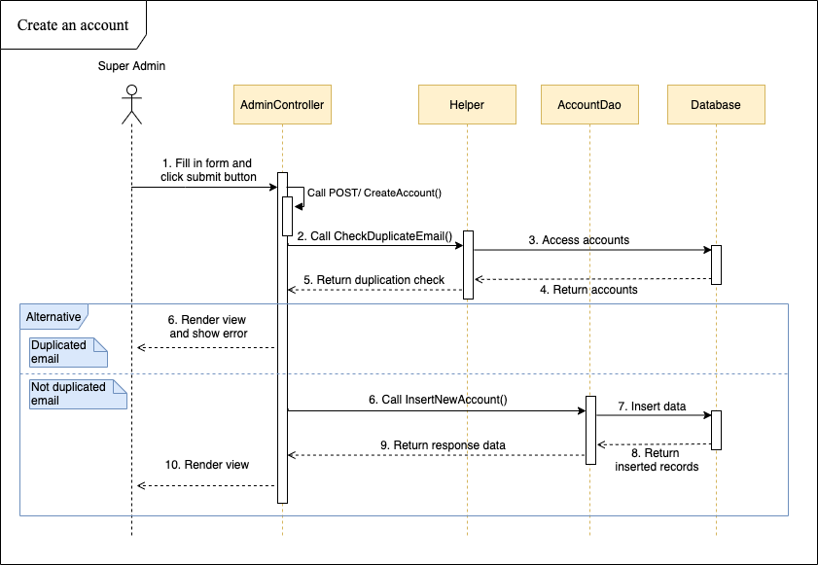

*Figure 4.90 - Sequence diagram for UC-14*

### UC-15 Edit account

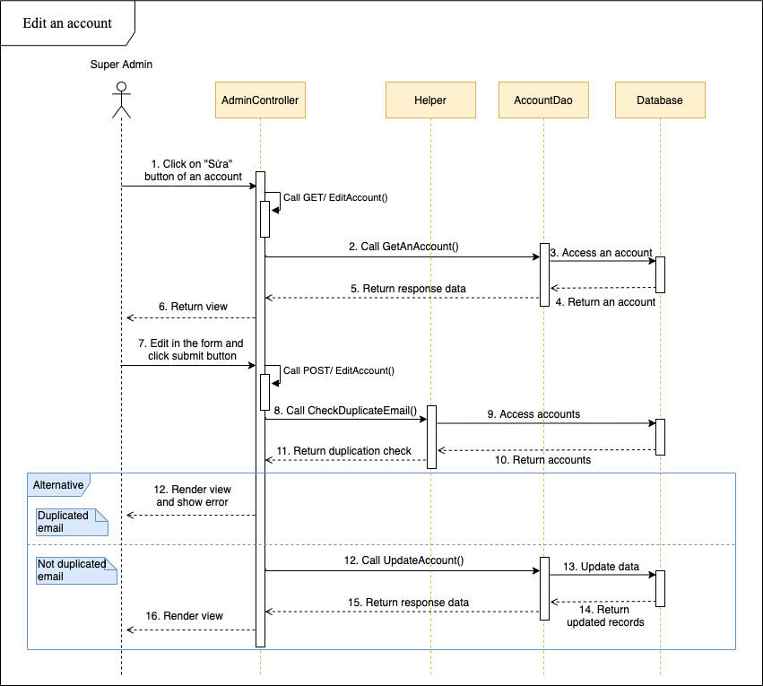

*Figure 4.91 - Sequence diagram for UC-15*

### UC-16 Delete account

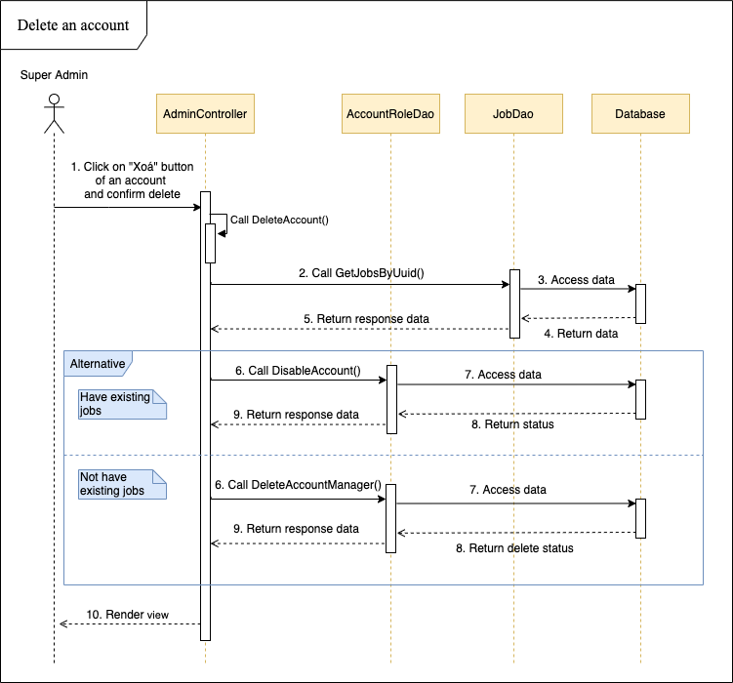

*Figure 4.92 - Sequence diagram for UC-16*

### UC-17 View all units

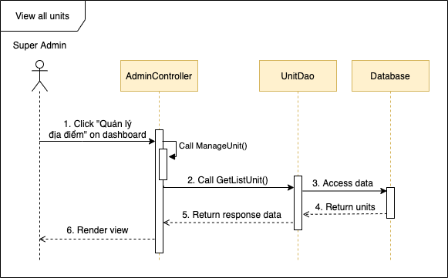

*Figure 4.93 - Sequence diagram for UC-17*

### UC-18 Add unit

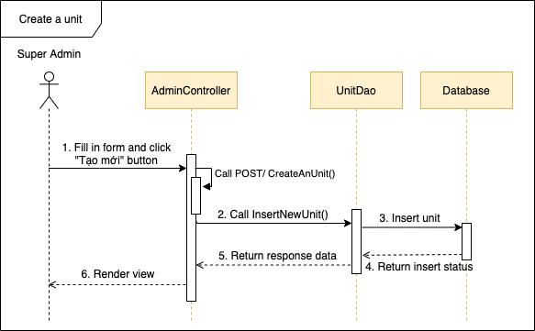

*Figure 4.94 - Sequence diagram for UC-18*

### UC-19 Edit unit

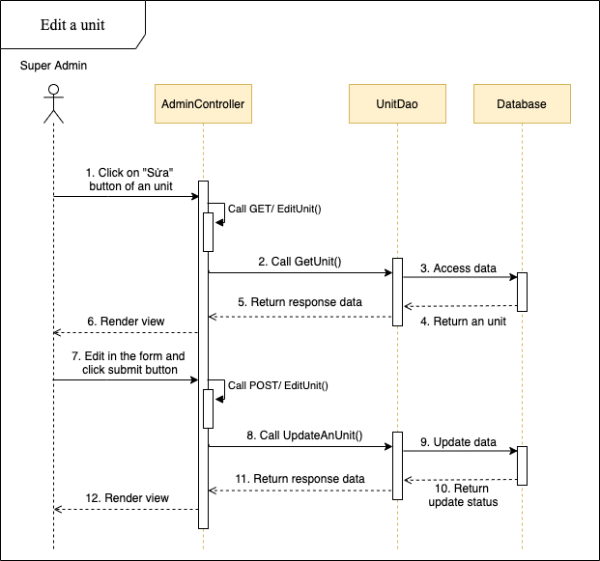

*Figure 4.95 - Sequence diagram for UC-19*

### UC-20 Delete unit

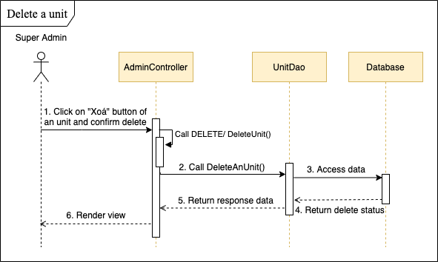

*Figure 4.96 - Sequence diagram for UC-20*

### UC-21 View all locations

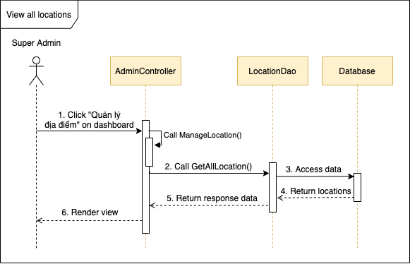

*Figure 4.97 - Sequence diagram for UC-21*

### UC-22 Add location

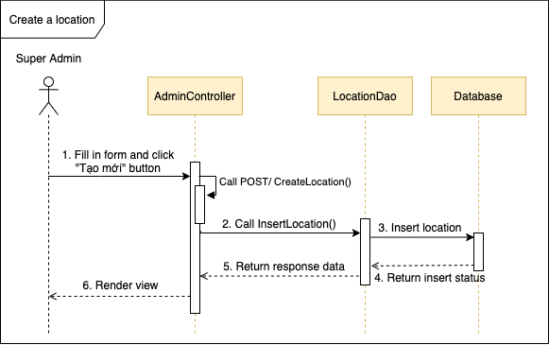

*Figure 4.98 - Sequence diagram for UC-22*

### UC-23 Edit location

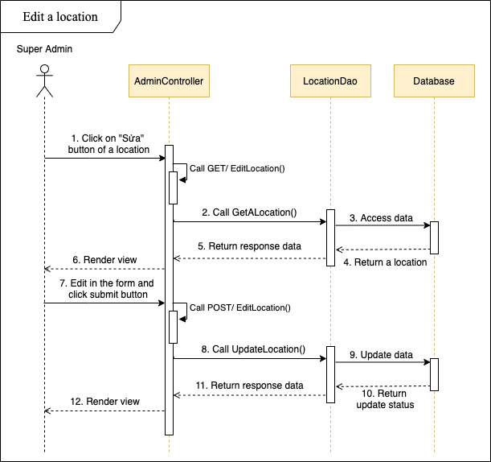

*Figure 4.99 - Sequence diagram for UC-23*

### UC-24 Delete location

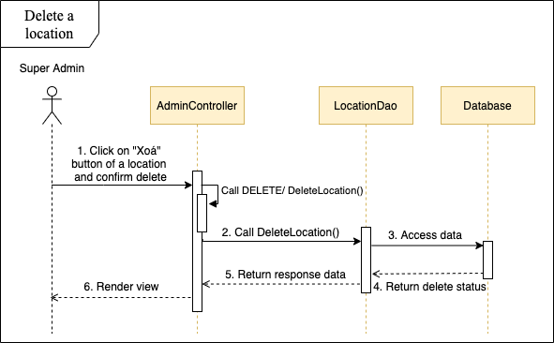

*Figure 4.100 - Sequence diagram for UC-24*

### UC-25 View all question groups

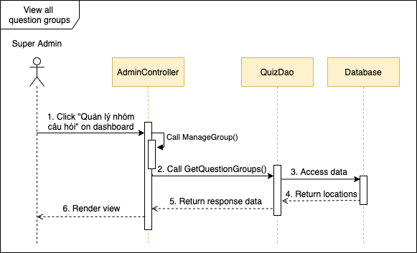

*Figure 4.101 - Sequence diagram for UC-25*

### UC-26 Add question groups

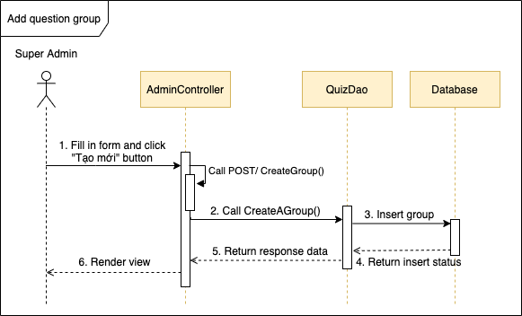

*Figure 4.102 - Sequence diagram for UC-26*

### UC-27 Edit question groups

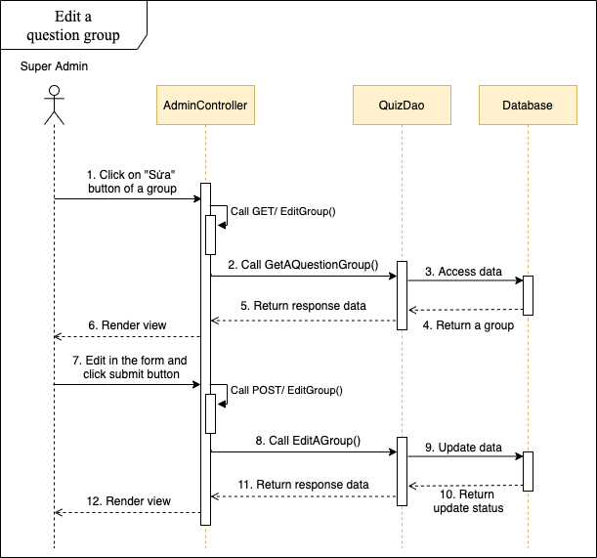

*Figure 4.103 - Sequence diagram for UC-27*

### UC-28 Delete question groups

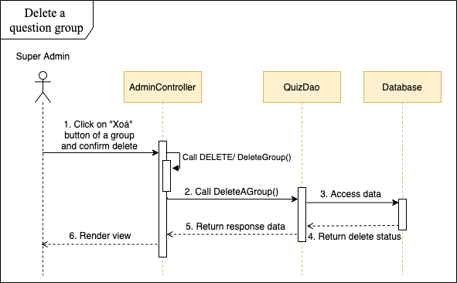

*Figure 4.104 - Sequence diagram for UC-28*

### UC-29 View all questions

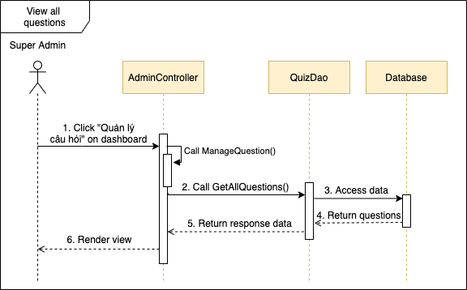

*Figure 4.105 - Sequence diagram for UC-29*

### UC-30 Add question

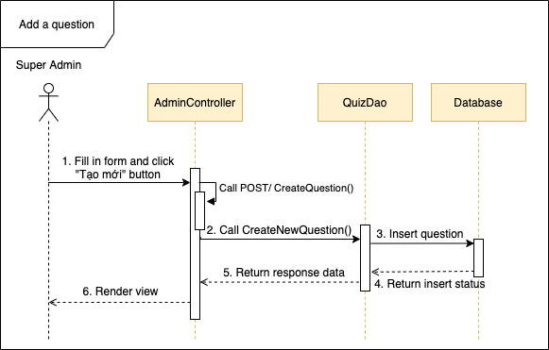

*Figure 4.106 - Sequence diagram for UC-30*

### UC-31 Edit question

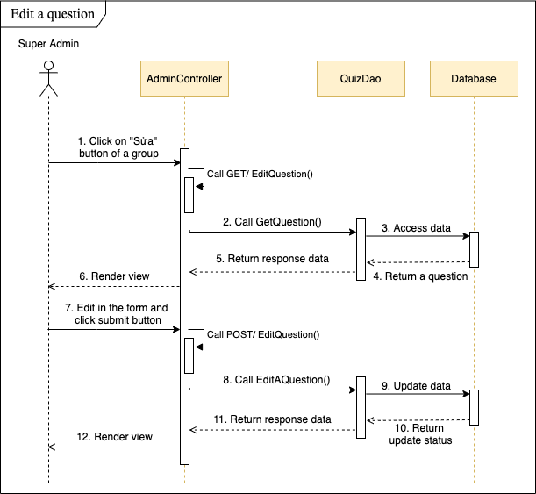

*Figure 4.107 - Sequence diagram for UC-31*

### UC-32 Delete question

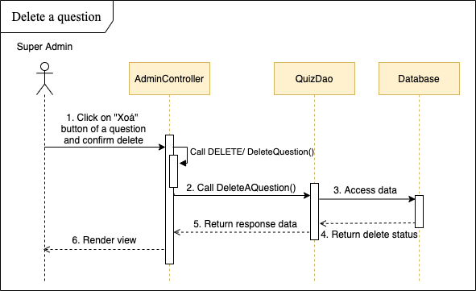

*Figure 4.108 - Sequence diagram for UC-32*

### UC-33 Search question

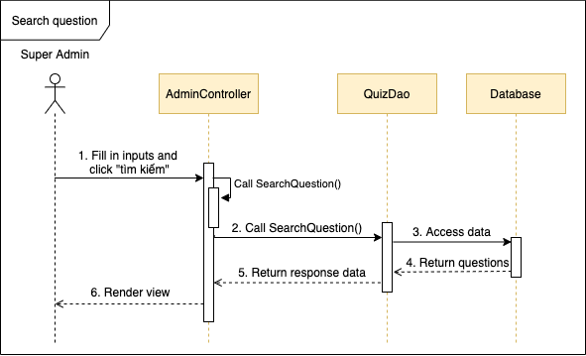

*Figure 4.109 - Sequence diagram for UC-33*

### UC-34 View all quizzes

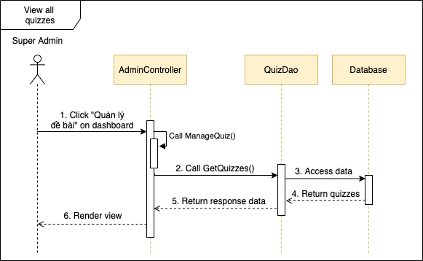

*Figure 4.110 - Sequence diagram for UC-34*

### UC-35 Add quiz

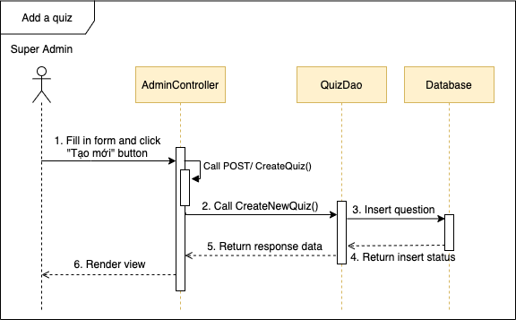

*Figure 4.111 - Sequence diagram for UC-35*

### UC-36 Edit quiz

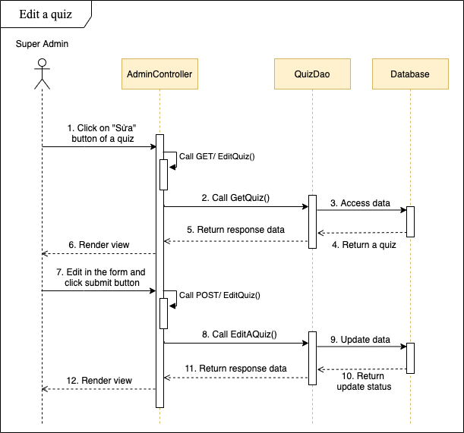

*Figure 4.112 - Sequence diagram for UC-36*

### UC-37 Delete quiz

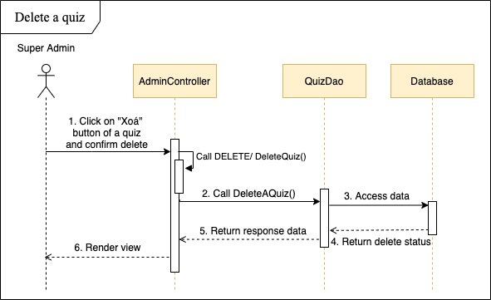

*Figure 4.113 - Sequence diagram for UC-37*

### UC-38 View all careers

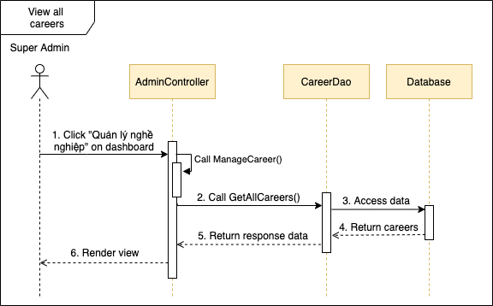

*Figure 4.114 - Sequence diagram for UC-38*

### UC-39 Add career

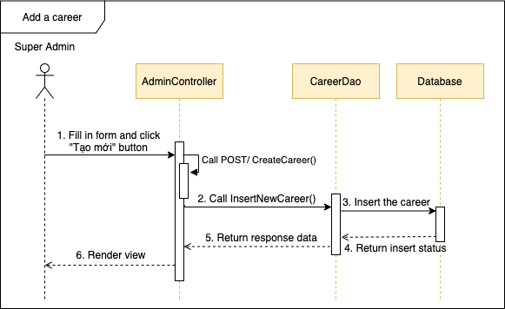

*Figure 4.115 - Sequence diagram for UC-39*

### UC-40 Edit career

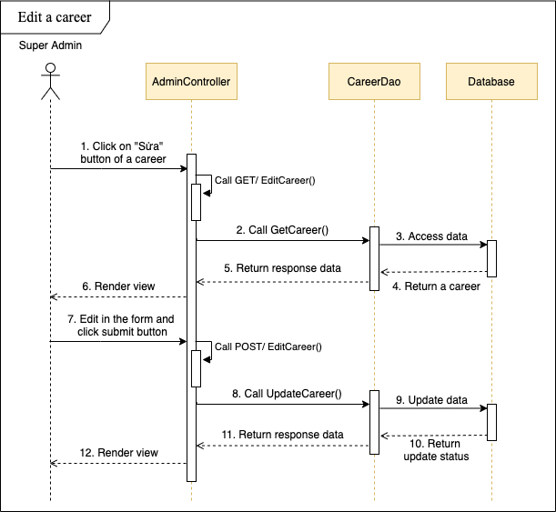

*Figure 4.116 - Sequence diagram for UC-40*

### UC-41 Delete career

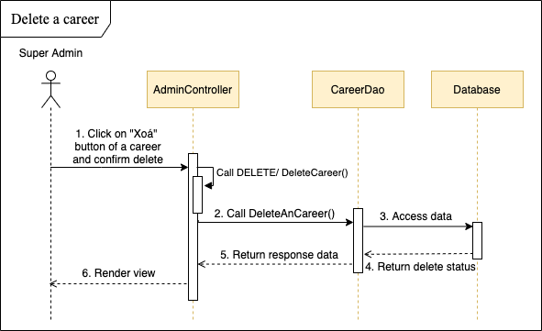

*Figure 4.117 - Sequence diagram for UC-41*

### UC-42 View all config emails

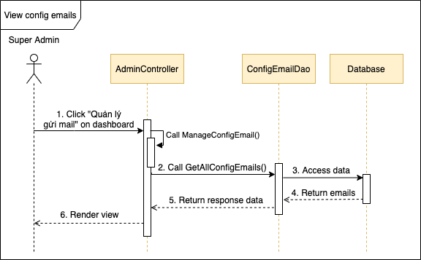

*Figure 4.118 - Sequence diagram for UC-42*

### UC-43 Add config email

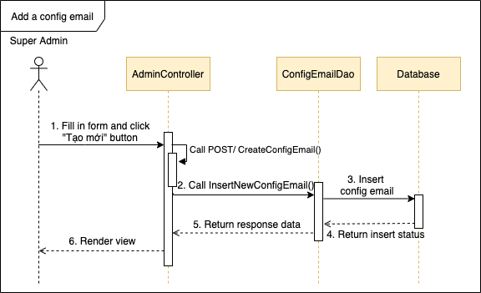

*Figure 4.119 - Sequence diagram for UC-43*

### UC-44 Edit config email

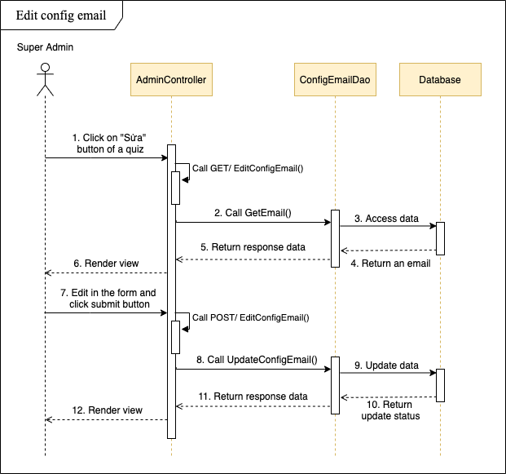

*Figure 4.120 - Sequence diagram for UC-44*

### UC-45 Delete config email

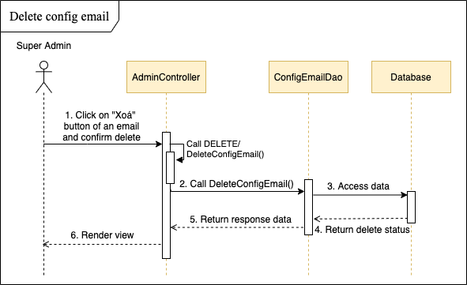

*Figure 4.121 - Sequence diagram for UC-45*

### UC-46 View log

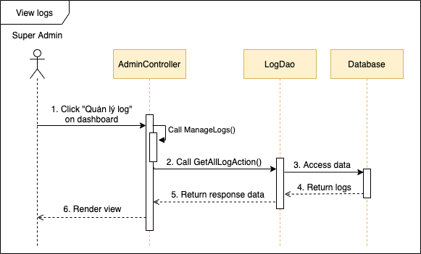

*Figure 4.122 - Sequence diagram for UC-46*

### UC-47 Login

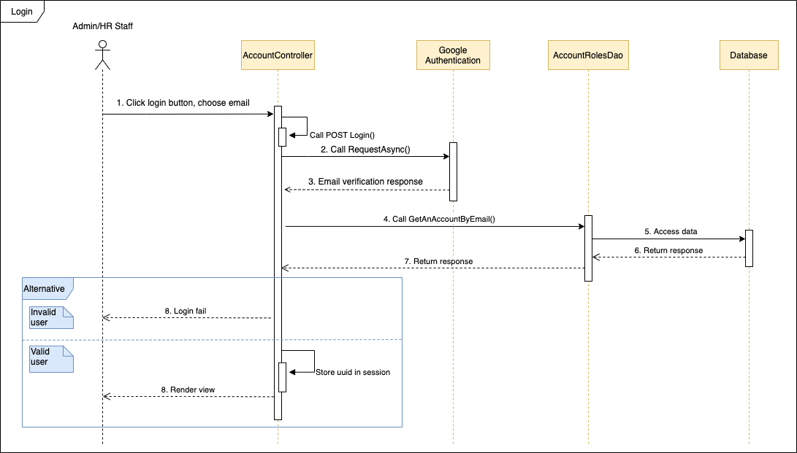

*Figure 4.123 - Sequence diagram for UC-47*

### UC-48 Logout

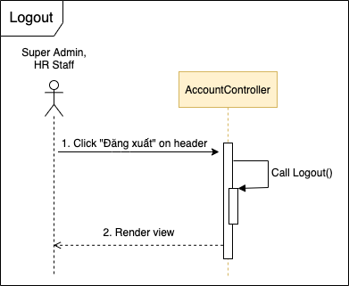

*Figure 4.124 - Sequence diagram for UC-48*

### UC-49 View all CVs

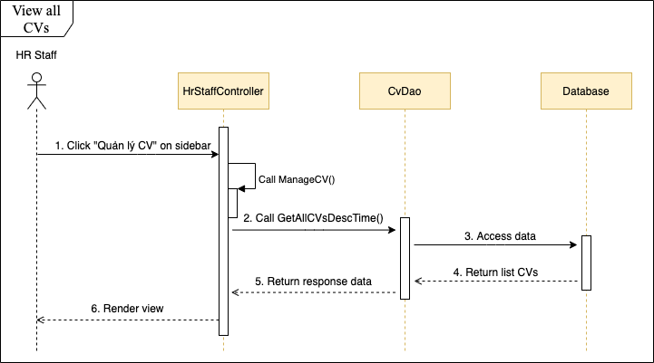

*Figure 4.125 - Sequence diagram for UC-49*

### UC-50 View detail CV

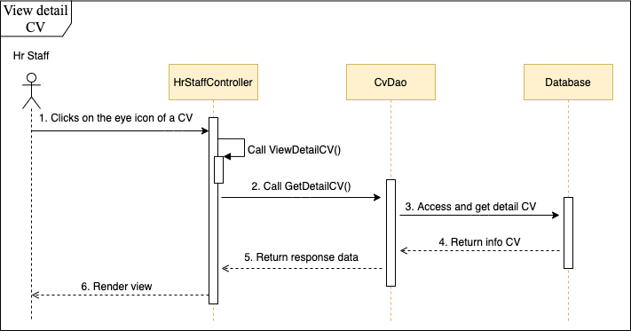

*Figure 4.126 - Sequence diagram for UC-50*

### UC-51 Change CV status

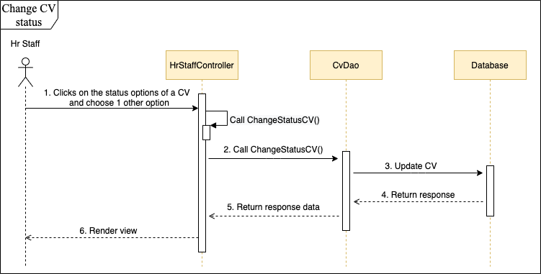

*Figure 4.127 - Sequence diagram for UC-51*

### UC-52 Search CV

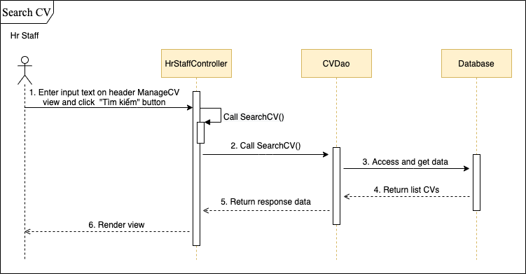

*Figure 4.128 - Sequence diagram for UC-52*

### UC-53 Delete CV

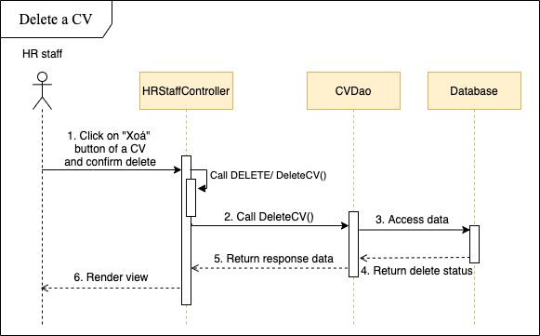

*Figure 4.129 - Sequence diagram for UC-53*

### UC-54 Send email quiz

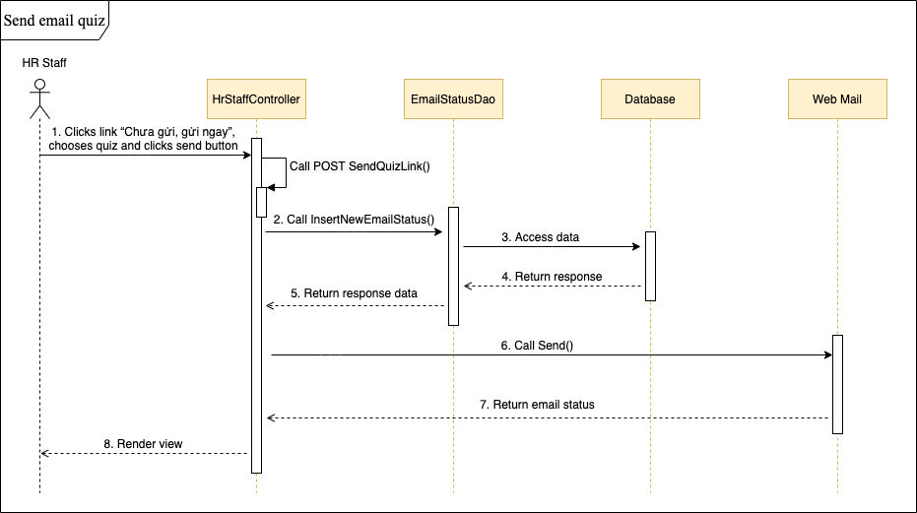

*Figure 4.130 - Sequence diagram for UC-54*

### UC-55 Export CV

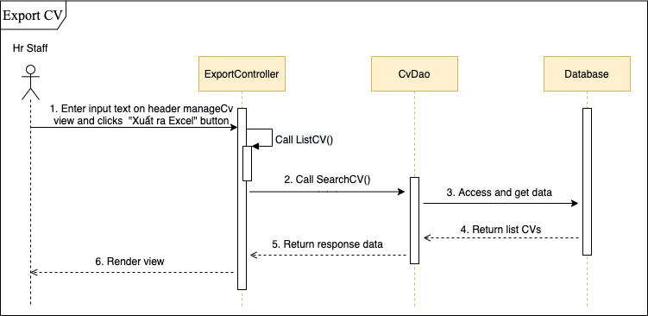

*Figure 4.131 - Sequence diagram for UC-55*

### UC-56 View all jobs

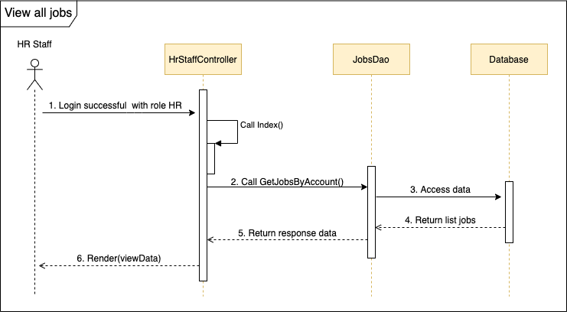

*Figure 4.132 - Sequence diagram for UC-56*

### UC-57 Add job

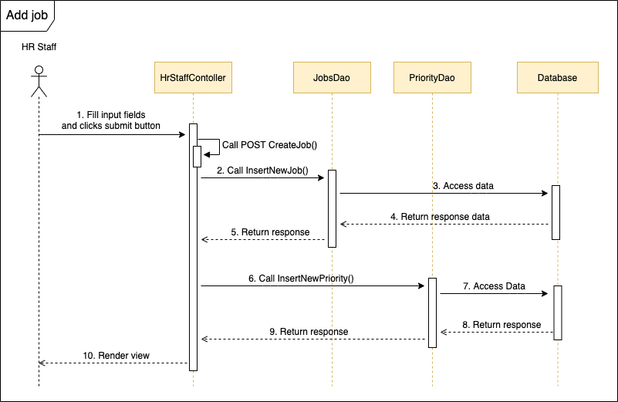

*Figure 4.133 - Sequence diagram for UC-57*

### UC-58 Edit job

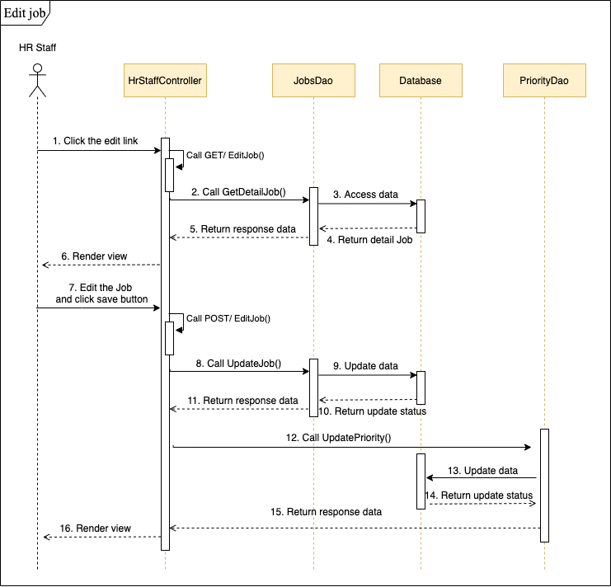

*Figure 4.134 - Sequence diagram for UC-58*

### UC-59 Delete job

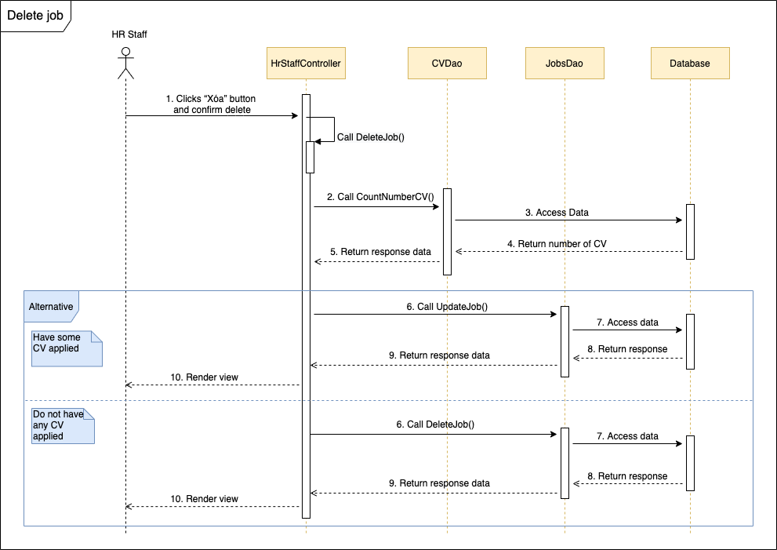

*Figure 4.135 - Sequence diagram for UC-59*

### UC-60 Search job in HR

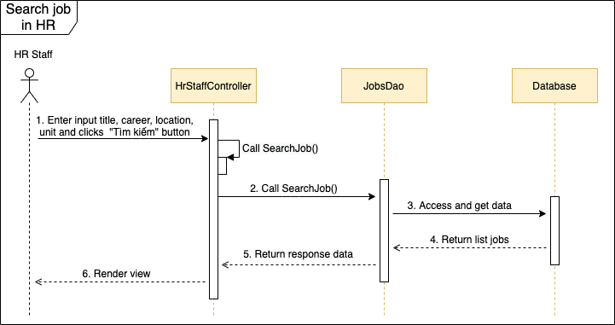

*Figure 4.136 - Sequence diagram for UC-60*

### UC-61 View list CVs applied for a job

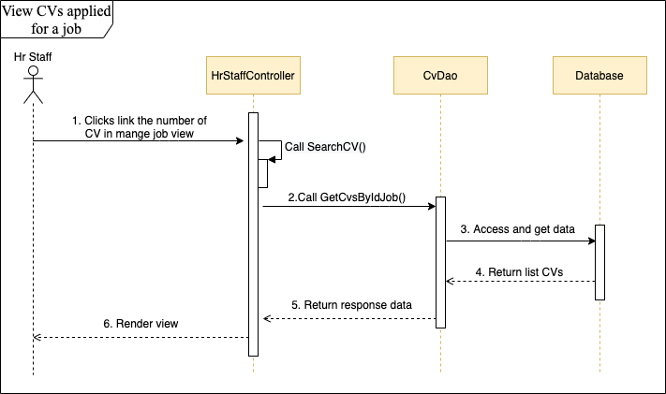

*Figure 4.137 - Sequence diagram for UC-61*

### UC-62 View all error emails

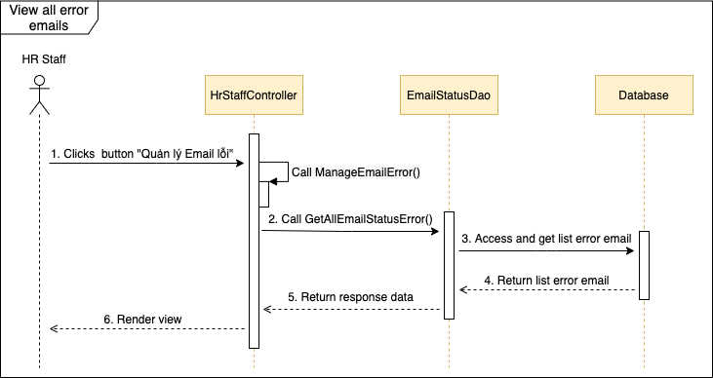

*Figure 4.138 - Sequence diagram for UC-62*

### UC-63 Resend all error email

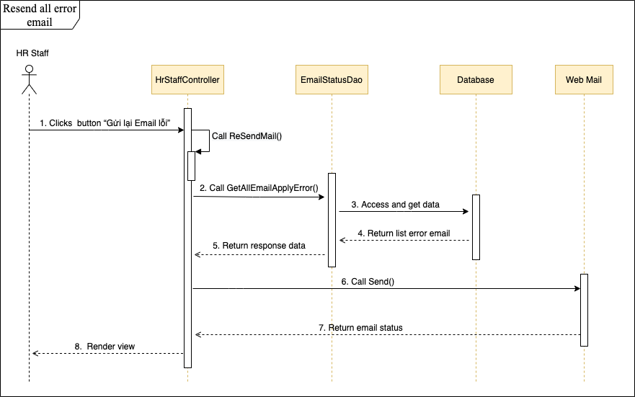

*Figure 4.139 - Sequence diagram for UC-63*

### UC-64 Resend each error email

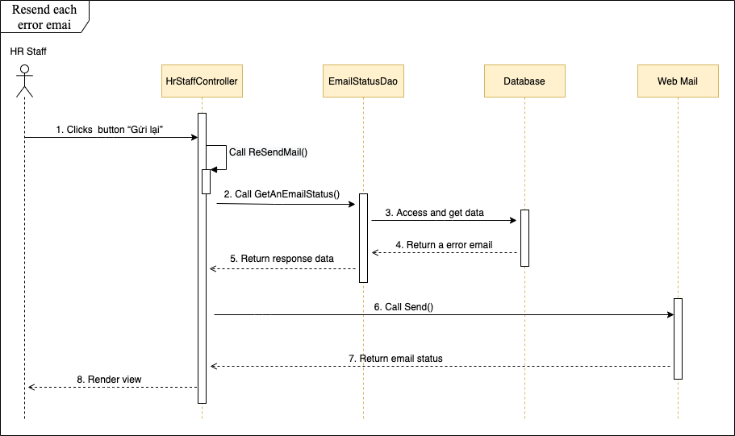

*Figure 4.140 - Sequence diagram for UC-64*

## User Interface Design

### Screen Images

#### Candidate

* + Homepage

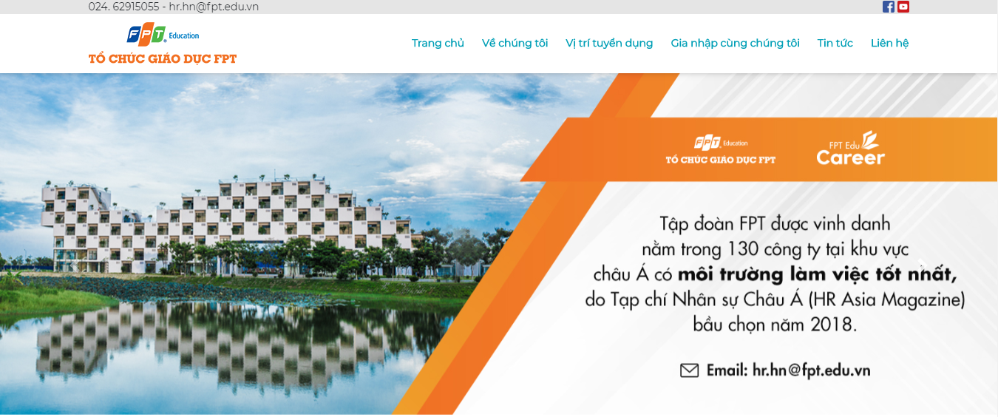

*Figure 4.141 - FERS’s banner*

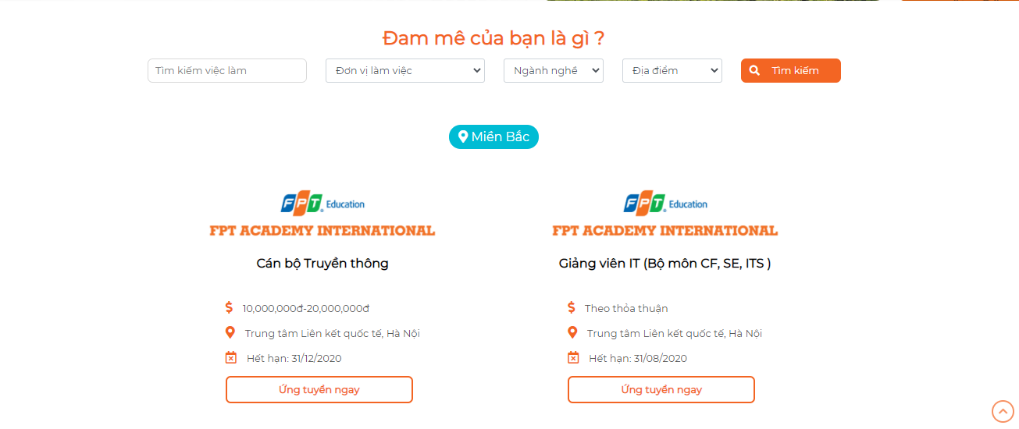

*Figure 4.142 - Search menu and recruitment jobs*

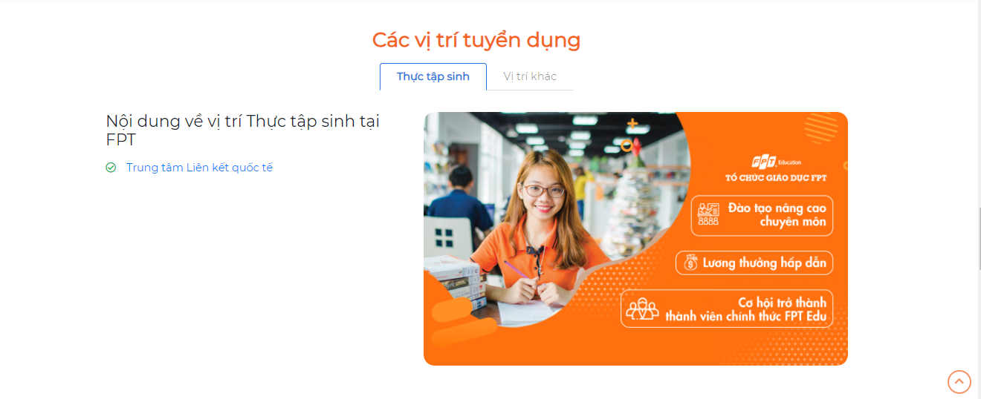

*Figure 4.143 - Recruitment positions*

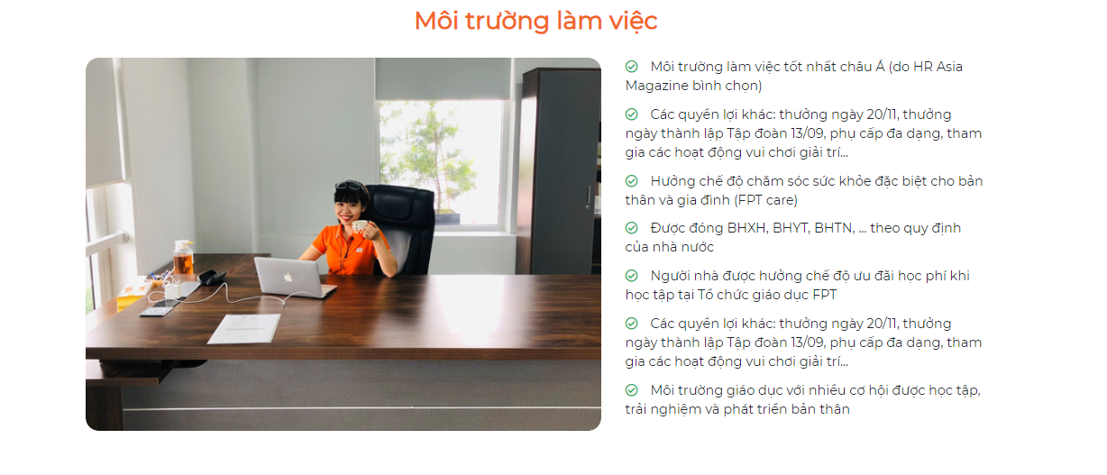

*Figure 4.144 - Working environment*

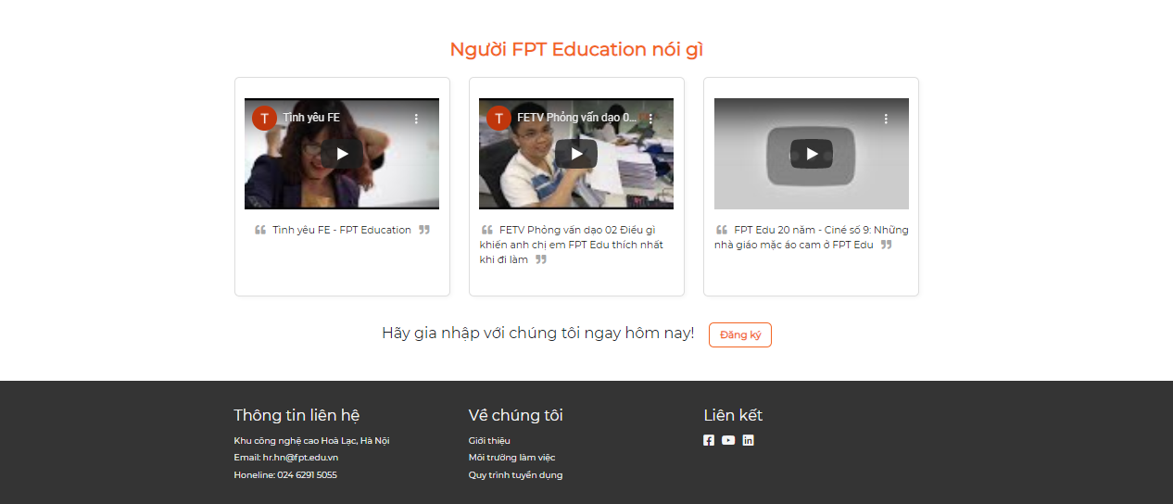

*Figure 4.145 - What FPT Education people say?*

* + Job list

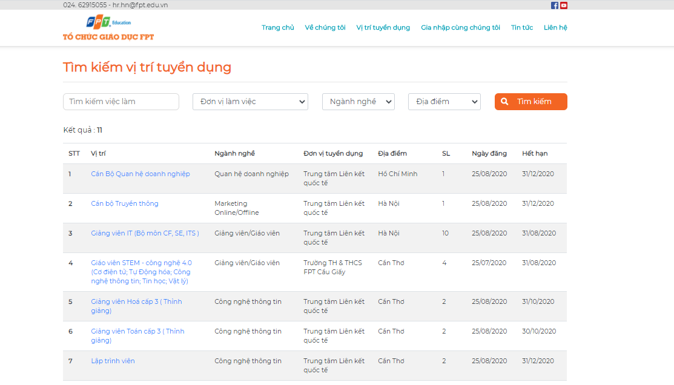

*Figure 4.146 - Job list*

* + Job detail

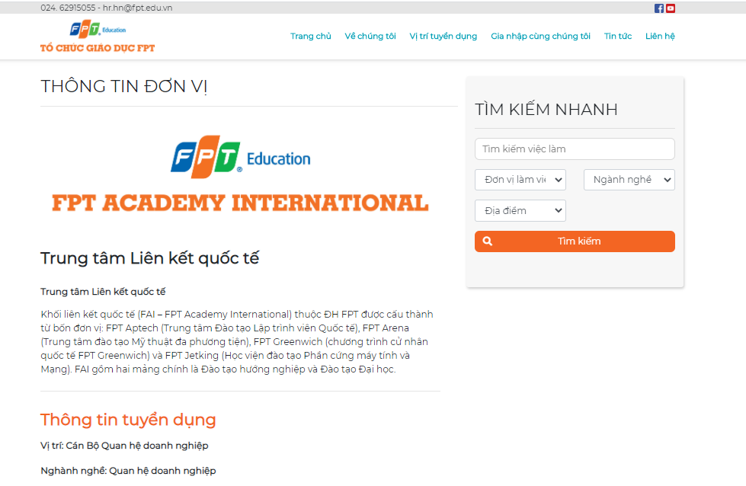

*Figure 4.147 - Job detail*

* + Recruitment process

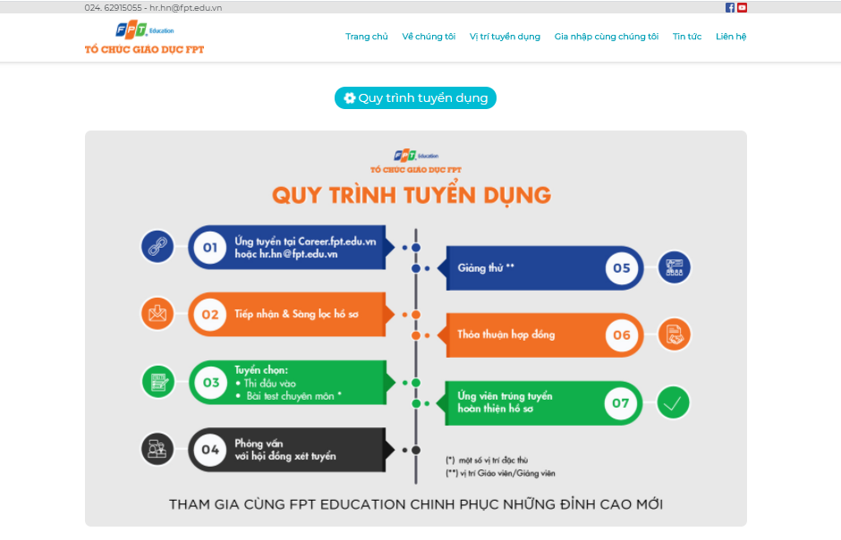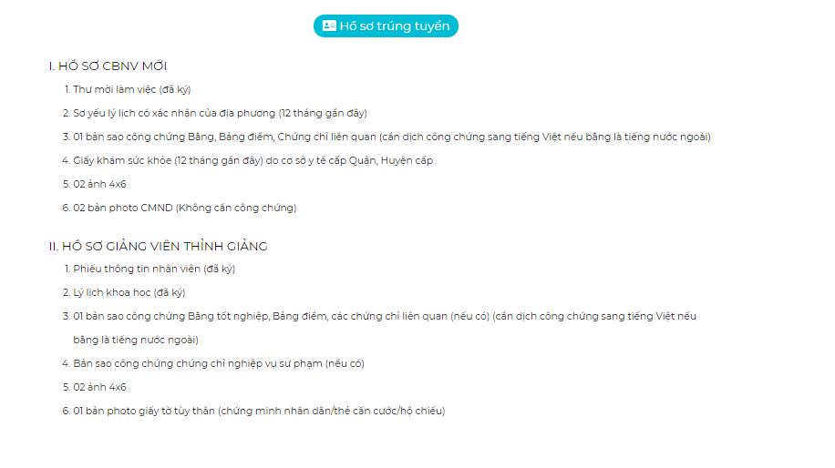

*Figure 4.148 - Recruitment process*

#### Admin

* + Account management screen

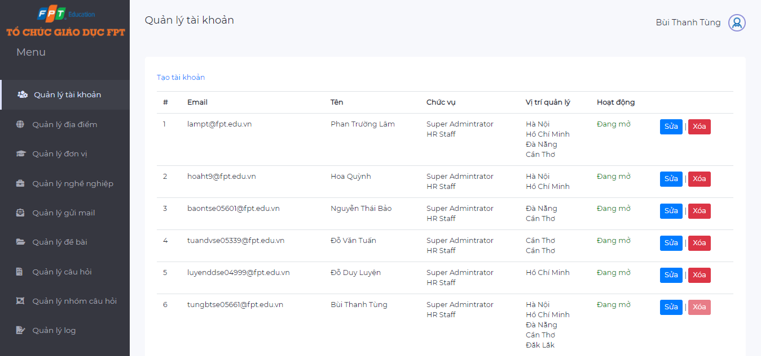

*Figure 4.149 - Account management screen*

* + Career management screen

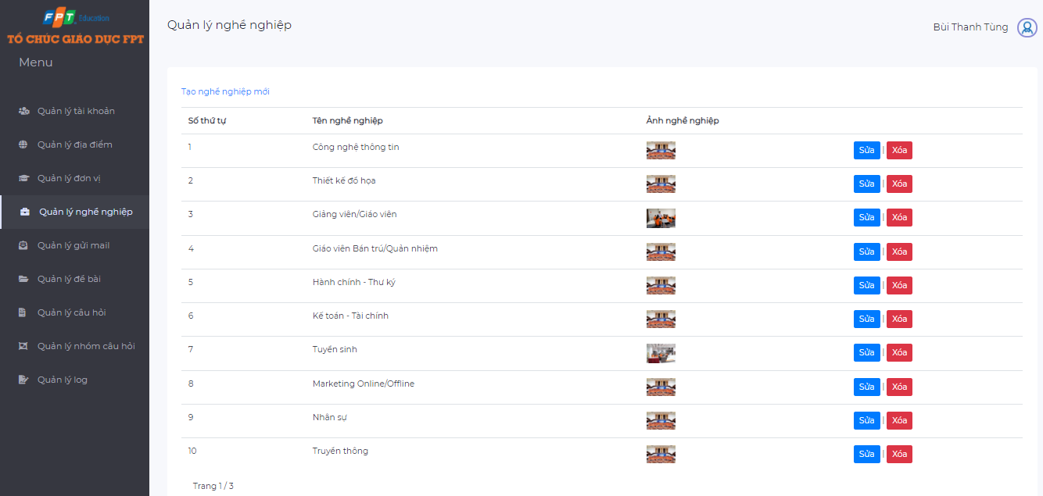

*Figure 4.150 - Career management screen*

* + Config email management screen

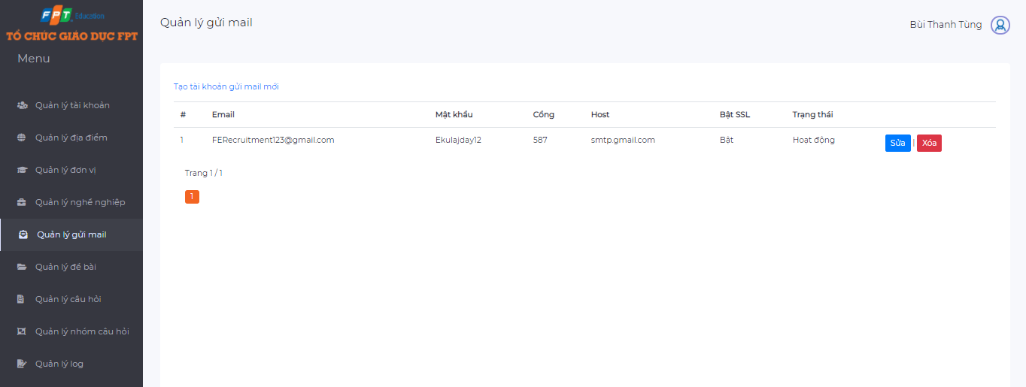

*Figure 4.151 - Config email management screen*

* + Location management screen

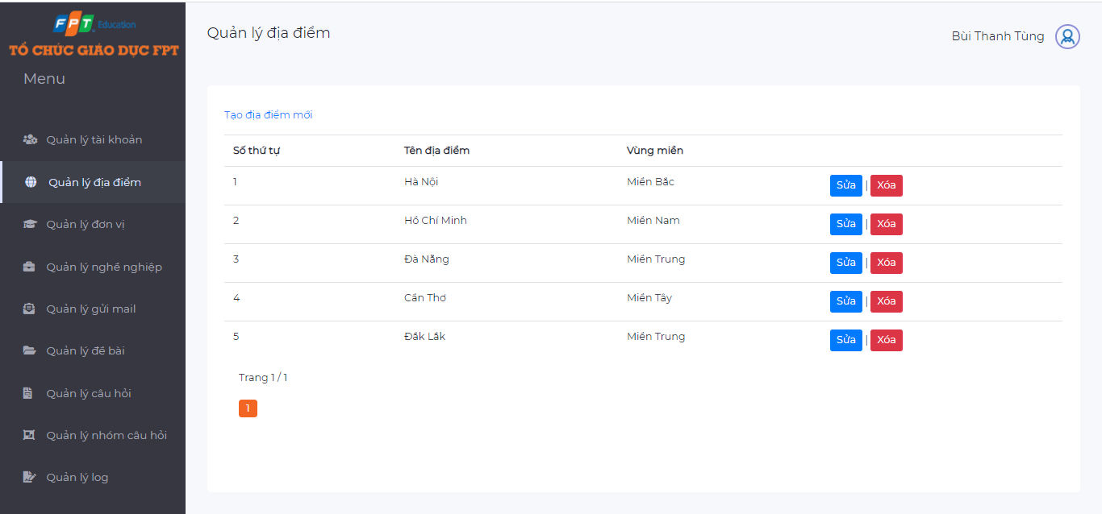

*Figure 4.152 - Location management screen*

* + Unit management screen

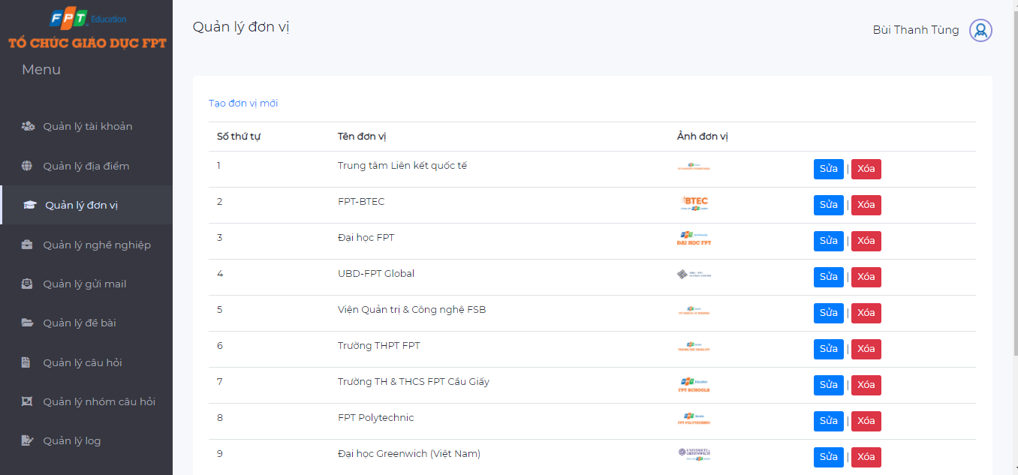

*Figure 4.153 - Unit management screen*

* + Question management screen

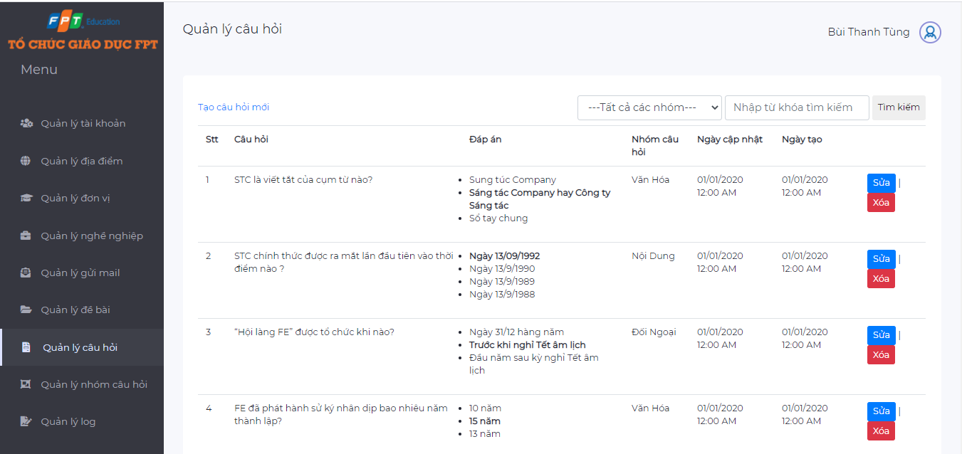

*Figure 4.154 - Question management screen*

* + Question group management screen

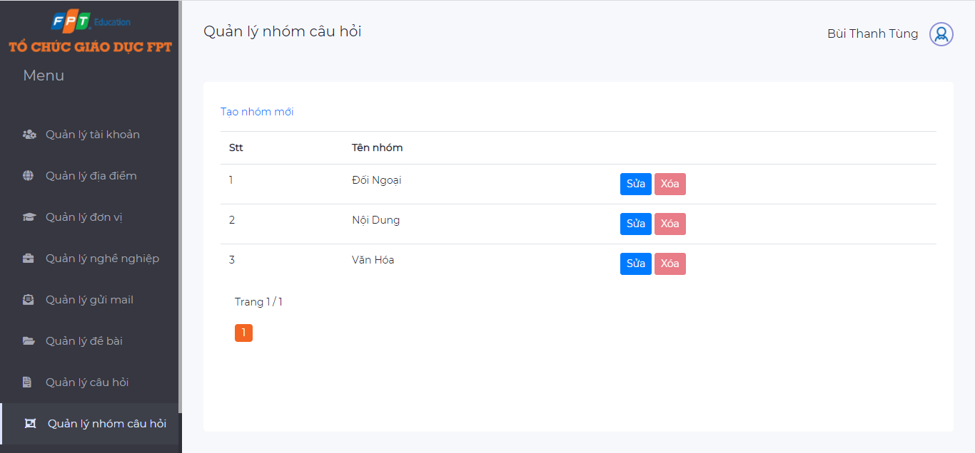

*Figure 4.155 - Question group management screen*

* + Quiz management screen

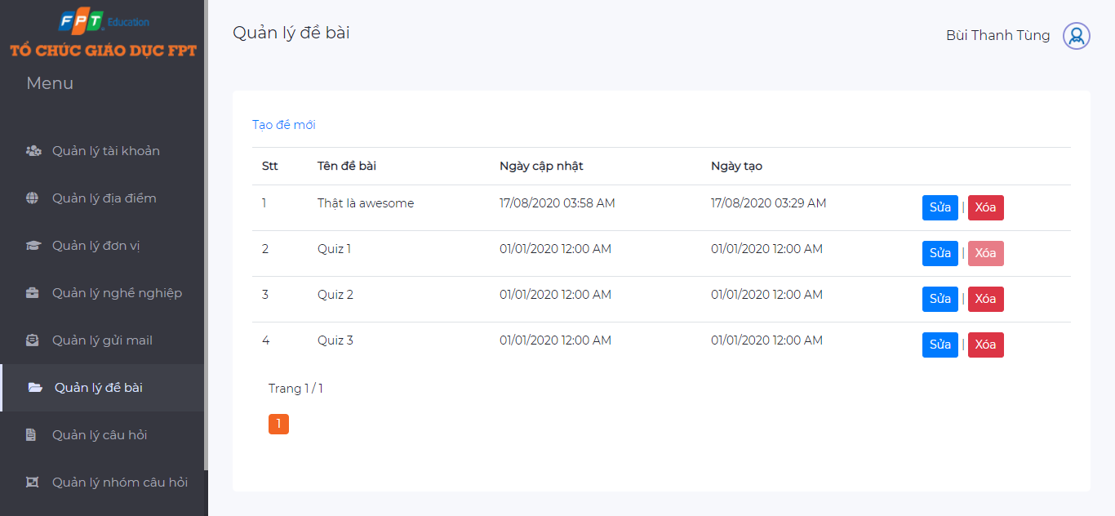

*Figure 4.156 - Quiz management screen*

* + Log management screen

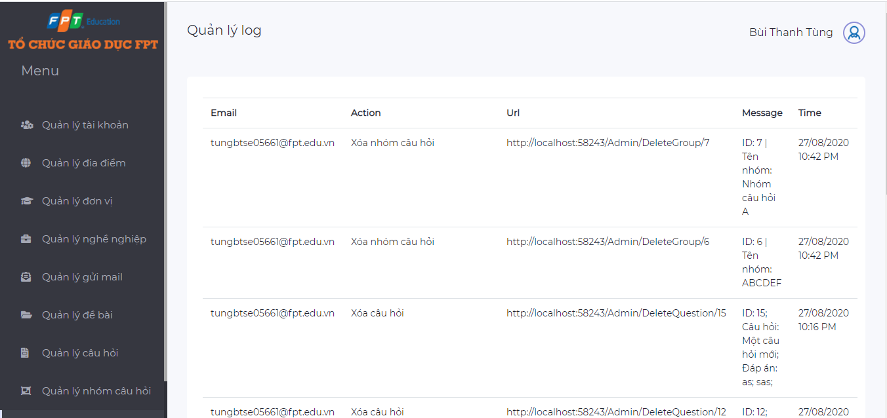

*Figure 4.157 - Log management screen*

#### HR Staff

* + Job management screen

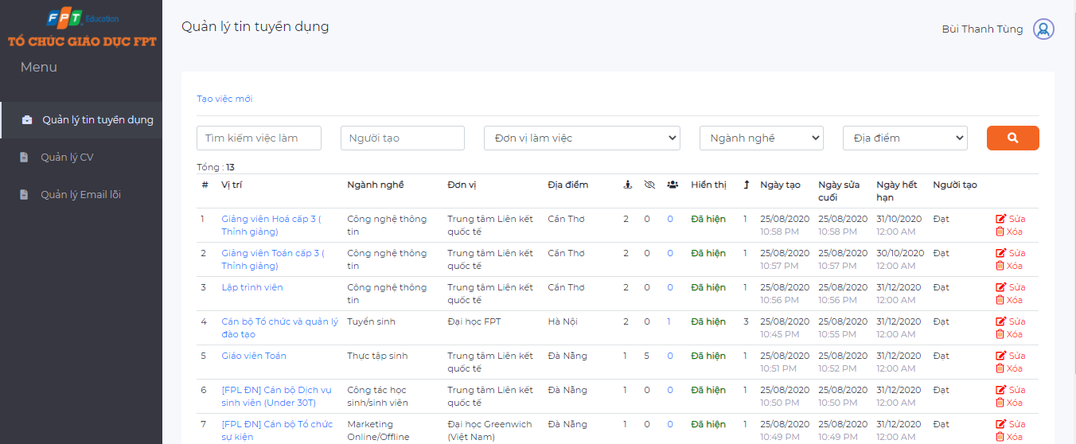

*Figure 4.158 - Job management screen*

* + CV management screen

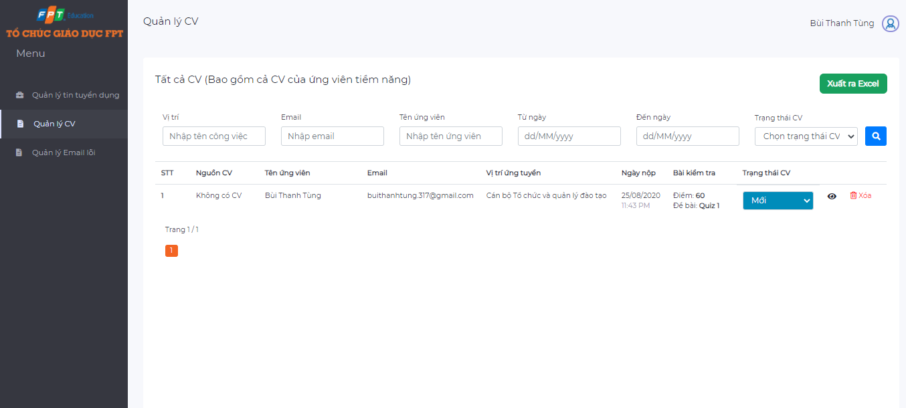

*Figure 4.159 - CV management screen*

* + Error email management screen

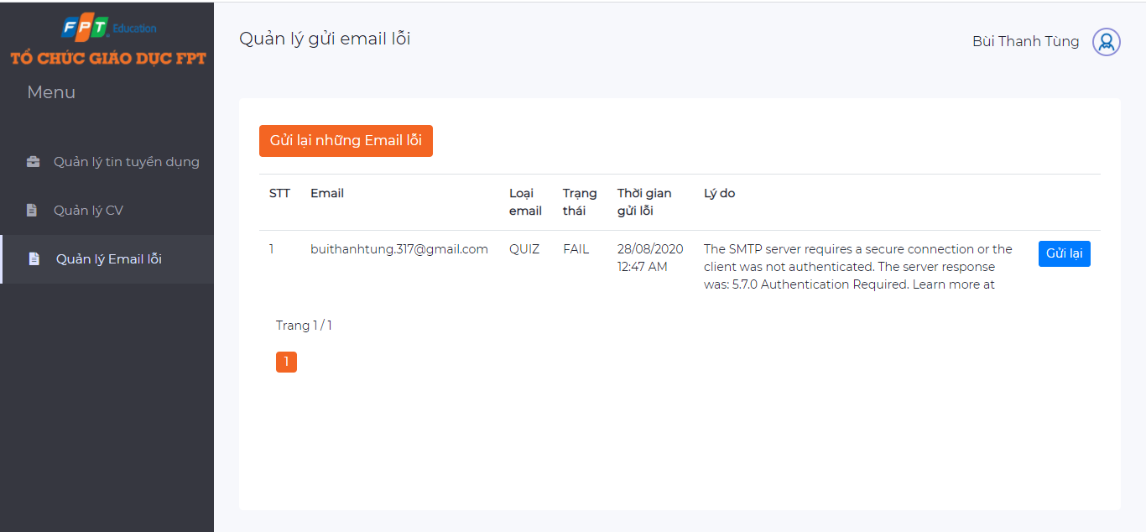

*Figure 4.160 - Error email management screen*

## Database Design

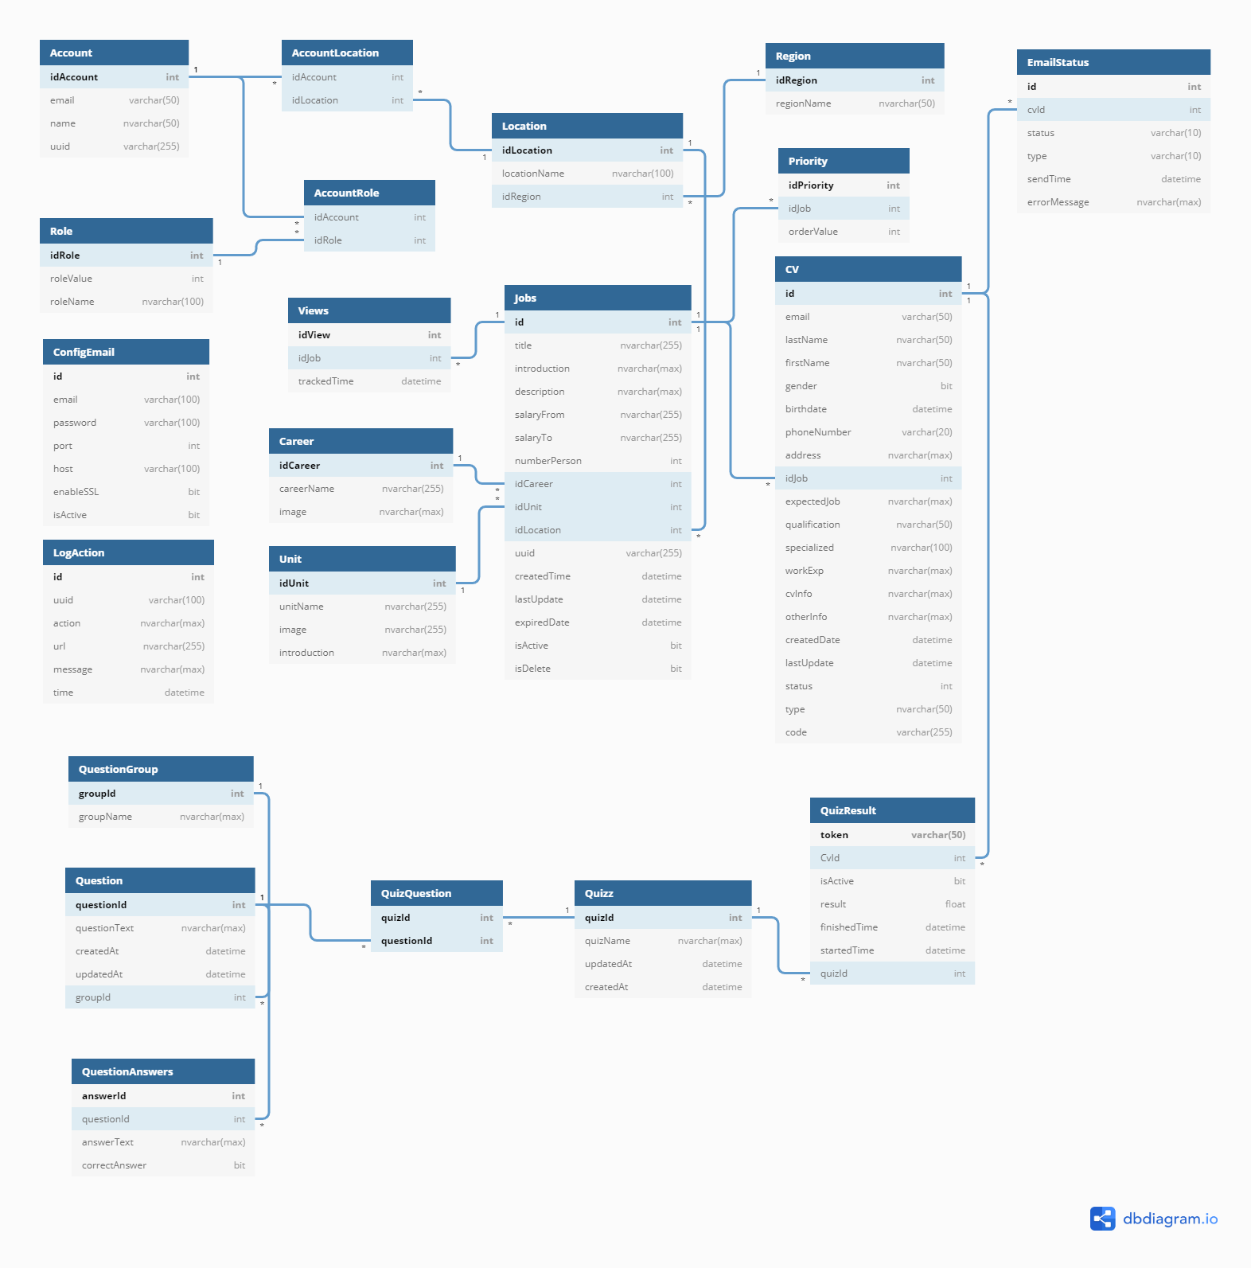

*Figure 4.161 - Database design*

### Account

* This table to store account related data
* Table structure

|  |  |  |  |  |  |  |  |
| --- | --- | --- | --- | --- | --- | --- | --- |
| **Field name** | **Type** | **Size** | **Unique** | **Not Null** | **PK** | **FK** | **Notes** |
| **idAccount** | int |  | ✓ | ✓ | ✓ |  |  |
| email | varchar | 50 |  | ✓ |  |  |  |
| name | varchar | 50 |  | ✓ |  |  |  |
| uuid | varchar | 255 |  | ✓ |  |  |  |
| isActive | bit |  |  |  |  |  |  |

*Table 4.43: Database Account*

### AccountRole

* This table to store information that tie between 2 tables Account and Role
* Table structure

|  |  |  |  |  |  |  |  |
| --- | --- | --- | --- | --- | --- | --- | --- |
| **Field name** | **Type** | **Size** | **Unique** | **Not Null** | **PK** | **FK** | **Notes** |
| idAccount | int |  |  | ✓ |  | ✓ | Fk: idAccount of Account |
| idRole | int |  |  | ✓ |  | ✓ | Fk: idRole of Role |

*Table 4.44: Database AccountRole*

### AccountLocation

* This table to store information that tie between 2 tables Account and Location
* Table structure

|  |  |  |  |  |  |  |  |
| --- | --- | --- | --- | --- | --- | --- | --- |
| **Field name** | **Type** | **Size** | **Unique** | **Not Null** | **PK** | **FK** | **Notes** |
| idAccount | int |  |  | ✓ |  | ✓ | Fk: idAccount of Account |
| idLocation | int |  |  | ✓ |  | ✓ | Fk: idLocation of Location |

*Table 4.45: Database AccountLocation*

### Career

* This table to store career related data
* Table structure

|  |  |  |  |  |  |  |  |
| --- | --- | --- | --- | --- | --- | --- | --- |
| **Field name** | **Type** | **Size** | **Unique** | **Not Null** | **PK** | **FK** | **Notes** |
| **idCareer** | int |  | ✓ | ✓ | ✓ |  |  |
| careerName | nvarchar | 255 |  | ✓ |  |  |  |
| image | nvarchar | Max |  |  |  |  |  |

*Table 4.46: Database Carrer*

### ConfigEmail

* This table to store config email related data
* Table structure

|  |  |  |  |  |  |  |  |
| --- | --- | --- | --- | --- | --- | --- | --- |
| **Field name** | **Type** | **Size** | **Unique** | **Not Null** | **PK** | **FK** | **Notes** |
| **id** | int |  | ✓ | ✓ | ✓ |  |  |
| email | varchar | 100 |  |  |  |  |  |
| password | varchar | 100 |  |  |  |  |  |
| port | int |  |  |  |  |  |  |
| host | varchar | 100 |  |  |  |  |  |
| enableSSL | bit |  |  |  |  |  |  |
| isActive | bit |  |  |  |  |  |  |

*Table 4.47: Database**ConfigEmail*

### CV

* This table to store CV related data
* Table structure

|  |  |  |  |  |  |  |  |
| --- | --- | --- | --- | --- | --- | --- | --- |
| **Field name** | **Type** | **Size** | **Unique** | **Not Null** | **PK** | **FK** | **Notes** |
| **id** | int |  | ✓ | ✓ | ✓ |  |  |
| email | varchar | 50 |  | ✓ |  |  |  |
| lastName | varchar | 50 |  | ✓ |  |  |  |
| fistName | varchar | 50 |  | ✓ |  |  |  |
| gender | bit |  |  | ✓ |  |  |  |
| birthdate | datetime |  |  | ✓ |  |  |  |
| phoneNumber | varchar | 20 |  | ✓ |  |  |  |
| address | nvarchar | Max |  | ✓ |  |  |  |
| idJob | int |  |  |  |  | ✓ |  |
| expectedJob | nvarchar | Max |  |  |  |  |  |
| qualification | nvarchar | 50 |  |  |  |  |  |
| specialized | nvarchar | 100 |  |  |  |  |  |
| workExp | nvarchar | Max |  |  |  |  |  |
| cvInfo | nvarchar | Max |  |  |  |  |  |
| createDate | datetime |  |  | ✓ |  |  |  |
| lastUpdate | datetime |  |  | ✓ |  |  |  |
| status | int |  |  | ✓ |  |  |  |
| type | nvarchar | 50 |  |  |  |  |  |
| code | varchar | 255 |  |  |  |  |  |

*Table 4.48: Database**CV*

### EmailStatus

* This table to store email status related data
* Table structure

|  |  |  |  |  |  |  |  |
| --- | --- | --- | --- | --- | --- | --- | --- |
| **Field name** | **Type** | **Size** | **Unique** | **Not Null** | **PK** | **FK** | **Notes** |
| **id** | int |  | ✓ | ✓ | ✓ |  |  |
| cvId | int |  |  |  |  | ✓ | Fk: id of CV |
| status | varchar | 10 |  |  |  |  |  |
| type | varchar | 10 |  |  |  |  |  |
| sendTime | datetime |  |  |  |  |  |  |
| errorMessage | nvarchar | Max |  |  |  |  |  |

*Table 4.49: Database**EmailStatus*

### Job

* This table to store job related data
* Table structure

|  |  |  |  |  |  |  |  |
| --- | --- | --- | --- | --- | --- | --- | --- |
| **Field name** | **Type** | **Size** | **Unique** | **Not Null** | **PK** | **FK** | **Notes** |
| **id** | int |  | ✓ | ✓ | ✓ |  |  |
| title | nvarchar | 255 |  | ✓ |  |  |  |
| introduction | nvarchar | Max |  | ✓ |  |  |  |
| description | nvarchar | Max |  | ✓ |  |  |  |
| salary | nvarchar | 255 |  | ✓ |  |  |  |
| numberPerson | int |  |  | ✓ |  |  |  |
| idCareer | int |  |  |  |  | ✓ | Fk: idCareer of Career |
| idUnit | int |  |  |  |  | ✓ | Fk: idUnit of Unit |
| idLocation | int |  |  |  |  | ✓ | Fk: idLocation of Location |
| uuid | varchar | 255 |  |  |  |  |  |
| createdTime | datetime |  |  | ✓ |  |  |  |
| lastUpdate | datetime |  |  | ✓ |  |  |  |
| expiredDate | datetime |  |  | ✓ |  |  |  |
| isActive | bit |  |  | ✓ |  |  |  |
| isDelete | bit |  |  | ✓ |  |  |  |

*Table 4.50: Database**Job*

### Location

* This table to store location related data
* Table structure

|  |  |  |  |  |  |  |  |
| --- | --- | --- | --- | --- | --- | --- | --- |
| **Field name** | **Type** | **Size** | **Unique** | **Not Null** | **PK** | **FK** | **Notes** |
| **idLocation** | int |  | ✓ | ✓ | ✓ |  |  |
| locationName | nvarchar | 100 |  |  | ✓ |  |  |
| idRegion | int |  |  |  |  | ✓ | Fk: idRegion of Region |

*Table 4.51: Database**Location*

### LogAction

* This table to store log action related data
* Table structure

|  |  |  |  |  |  |  |  |
| --- | --- | --- | --- | --- | --- | --- | --- |
| **Field name** | **Type** | **Size** | **Unique** | **Not Null** | **PK** | **FK** | **Notes** |
| **id** | int |  | ✓ | ✓ | ✓ |  |  |
| uuid | varchar | 100 |  |  |  |  |  |
| action | nvarchar | Max |  |  |  |  |  |
| url | nvarchar | 255 |  |  |  |  |  |
| message | nvarchar | Max |  |  |  |  |  |
| time | datetime |  |  |  |  |  |  |

*Table 4.52: Database**LogAction*

### Priority

* This table to store priority related data
* Table structure

|  |  |  |  |  |  |  |  |
| --- | --- | --- | --- | --- | --- | --- | --- |
| **Field name** | **Type** | **Size** | **Unique** | **Not Null** | **PK** | **FK** | **Notes** |
| **idPriority** | int |  | ✓ | ✓ | ✓ |  |  |
| idJob | int |  |  | ✓ |  |  | Fk: id of Job |
| orderValue | int |  |  | ✓ |  |  |  |

*Table 4.53: Database**Priority*

### Question

* This table to store question related data
* Table structure

|  |  |  |  |  |  |  |  |
| --- | --- | --- | --- | --- | --- | --- | --- |
| **Field name** | **Type** | **Size** | **Unique** | **Not Null** | **PK** | **FK** | **Notes** |
| **questionId** | int |  | ✓ | ✓ | ✓ |  |  |
| questionText | nvarchar | Max |  | ✓ |  |  |  |
| createdAt | datetime |  |  |  |  |  |  |
| updateAt | datetime |  |  |  |  |  |  |
| groupId | int |  |  |  |  | ✓ | Fk : groupId of QuestionGroup |

*Table 4.54: Database**Question*

### QuestionAnswer

* This table to store question answer related data
* Table structure

|  |  |  |  |  |  |  |  |
| --- | --- | --- | --- | --- | --- | --- | --- |
| **Field name** | **Type** | **Size** | **Unique** | **Not Null** | **PK** | **FK** | **Notes** |
| **answerId** | int |  | ✓ | ✓ | ✓ |  |  |
| questionId | int |  |  |  |  | ✓ | Fk: questionId of Question |
| answerText | nvarchar | Max |  | ✓ |  |  |  |
| correctAnswer | bit |  |  | ✓ |  |  |  |

*Table 4.55: Database**QuestionAnswer*

### QuestionGroup

* This table to store question group related data
* Table structure

|  |  |  |  |  |  |  |  |
| --- | --- | --- | --- | --- | --- | --- | --- |
| **Field name** | **Type** | **Size** | **Unique** | **Not Null** | **PK** | **FK** | **Notes** |
| **groupId** | int |  | ✓ | ✓ | ✓ |  |  |
| groupName | nvarchar | Max |  |  |  | ✓ | Fk: questionId of Question |

*Table 4.56: Database**QuestionGroup*

### Quiz

* This table to store quiz related data
* Table structure

|  |  |  |  |  |  |  |  |
| --- | --- | --- | --- | --- | --- | --- | --- |
| **Field name** | **Type** | **Size** | **Unique** | **Not Null** | **PK** | **FK** | **Notes** |
| **quizId** | int |  | ✓ | ✓ | ✓ |  |  |
| quizName | nvarchar | Max |  |  |  |  |  |
| updateAt | datetime |  |  |  |  |  |  |
| createAt | datetime |  |  |  |  |  |  |

*Table 4.57: Database**Quiz*

### QuizQuestion

* This table to store quiz question related data
* Table structure

|  |  |  |  |  |  |  |  |
| --- | --- | --- | --- | --- | --- | --- | --- |
| **Field name** | **Type** | **Size** | **Unique** | **Not Null** | **PK** | **FK** | **Notes** |
| quizId | int |  |  | ✓ |  | ✓ | Fk : quizId of Quiz |
| questionId | int |  |  | ✓ |  | ✓ | Fk : questionId of Question |

*Table 4.58: Database**QuizQuestion*

### QuizResult

* This table to store quiz result related data
* Table structure

|  |  |  |  |  |  |  |  |
| --- | --- | --- | --- | --- | --- | --- | --- |
| **Field name** | **Type** | **Size** | **Unique** | **Not Null** | **PK** | **FK** | **Notes** |
| **token** | varchar | 50 | ✓ | ✓ | ✓ |  |  |
| CvId | int |  |  |  |  | ✓ | Fk: id of CV |
| isActive | bit |  |  | ✓ |  |  |  |
| result | float |  |  |  |  |  |  |
| finishedTime | datetime |  |  |  |  |  |  |
| startedTime | datetime |  |  |  |  |  |  |
| quizId | int |  |  |  |  | ✓ | Fk: quizId of Quiz |

*Table 4.59: Database**QuizResult*

### Region

* This table to store region related data
* Table structure

|  |  |  |  |  |  |  |  |
| --- | --- | --- | --- | --- | --- | --- | --- |
| **Field name** | **Type** | **Size** | **Unique** | **Not Null** | **PK** | **FK** | **Notes** |
| **idRegion** | int |  | ✓ | ✓ | ✓ |  |  |
| regionName | nvarchar | 50 |  | ✓ |  |  |  |

*Table 4.60: Database**Region*

### Role

* This table to store role related data
* Table structure

|  |  |  |  |  |  |  |  |
| --- | --- | --- | --- | --- | --- | --- | --- |
| **Field name** | **Type** | **Size** | **Unique** | **Not Null** | **PK** | **FK** | **Notes** |
| **idRole** | int |  | ✓ | ✓ | ✓ |  |  |
| roleValue | int |  |  | ✓ |  |  |  |
| roleName | nvarchar | 100 |  | ✓ |  |  |  |

*Table 4.61: Database**Role*

### Unit

* This table to store unit related data
* Table structure

|  |  |  |  |  |  |  |  |
| --- | --- | --- | --- | --- | --- | --- | --- |
| **Field name** | **Type** | **Size** | **Unique** | **Not Null** | **PK** | **FK** | **Notes** |
| **idUnit** | int |  | ✓ | ✓ | ✓ |  |  |
| unitName | nvarchar | 255 |  |  |  |  |  |
| image | nvarchar | 255 |  |  |  |  |  |
| introduction | nvarchar | Max |  |  |  |  |  |

*Table 4.62: Database**Unit*

### View

* This table to store view related data
* Table structure

|  |  |  |  |  |  |  |  |
| --- | --- | --- | --- | --- | --- | --- | --- |
| **Field name** | **Type** | **Size** | **Unique** | **Not Null** | **PK** | **FK** | **Notes** |
| **idView** | int |  | ✓ | ✓ | ✓ |  |  |
| idJob | int |  |  | ✓ |  | ✓ | Fk: id of Job |
| trackedTime | datetime |  |  | ✓ |  |  |  |

*Table 4.63: Database**Viewe*

# Software Test Documentation

## Purpose

The primary purpose of this chapter is to detect and prevent defects which may be created by developers while developing the software and this may lead to software failures. On the other hand, another objective of this chapter is to provide information about the level of quality and to make sure that the end result meets the business and user requirements. It contains the following sections:

* Test approach
* Test stages
* Test type
* Test plan: Feature to be tested, Feature not to be tested, Test process, Test schedule, Testing tool and environment.
* Test cases
* Checklist
* Test report

### Test approach



*Figure 5.1 - V-Model*

Overall, we choose V-Model to implement the testing process. With V-Model, software development is separated into two appropriate phase’s groups: development and testing. In this model, the verification and validation will be done side by side. It emphasizes the strict process flow to develop a quality product. The errors occurring in any phase will be corrected in that phase. Proactive defect tracking defects, which are found at early stages even, may be in the development phase before application being tested.

## Test stages

In this project, there are 4 phases in the testing process: Unit testing, Integration testing, System testing and Acceptance testing.

|  |  |  |
| --- | --- | --- |
| **No.** | **Test Stages** | **Description** |
| 1 | Unit testing | The main aim of this endeavor is to determine whether the application functions as designed. In this phase, a unit can refer to a function, individual program or even a procedure. |
| 2 | Integration testing | Integration testing allows individuals the opportunity to combine all of the units within a program and test them as a group. This testing level is designed to find interface defects between the modules/functions. This is particularly beneficial because it determines how efficiently the units are running together. |
| 3 | System testing | System testing is the first level in which the complete application is tested as a whole. The goal at this level is to evaluate whether the system has complied with all of the outlined requirements and to see that it meets Quality Standards. |
| 4 | Acceptance testing | Acceptance testing (or User Acceptance Testing), is conducted to determine whether the system is ready for release. During this phase, the tester and some alpha test users will test the system to find out whether the application meets their business’ needs. |

*Table 5.1 – Testing stages*

## Test type

The test team has to test the following type:

* Unit test
* GUI test
* Function test
* Acceptance test

|  |  |  |  |  |
| --- | --- | --- | --- | --- |
| **Type of test** | **Stage of test** | | | |
| **Unit test** | **Integration test** | **System test** | **Acceptance test** |
| Unit test | x | x | x |  |
| GUI test |  |  | x | x |
| Function test | x | x | x | x |
| Acceptance test |  |  | x | x |

*Table 5.2 – Test type*

## Test plan

### Features to be tested

|  |  |
| --- | --- |
| **Actor** | **Feature** |
| Candidate | View recruitment process |
| View home |
| View all jobs |
| View list jobs by region |
| View list jobs by unit |
| View job detail |
| Search job |
| Create CV |
| Upload CV |
| Register potential candidate |
| Edit CV |
| Take quiz |
| HR Staff | Login |
| Logout |
| View all CVs |
| View detail CV |
| Change CV status |
| Search CV |
| Delete CV |
| Send email quiz |
| Export CV |
| View all jobs |
| Add job |
| Edit job |
| Delete job |
| Search job in HR |
| View list CVs applied for a job |
| View all error emails |
| Resend all error email |
| Resend each error email |
| Super Admin | Login |
| Logout |
| View all accounts |
| Add account |
| Edit account |
| Delete account |
| View all units |
| Add unit |
| Edit unit |
| Delete unit |
| View all locations |
| Add location |
| Edit location |
| Delete location |
| View all question groups |
| Add question group |
| Edit question group |
| Delete question group |
| View all questions |
| Add question |
| Edit question |
| Delete question |
| Search question |
| View all quizzes |
| Add quiz |
| Edit quiz |
| Delete quiz |
| View all careers |
| Add career |
| Edit career |
| Delete career |
| View all config emails |
| Add config email |
| Edit config email |
| Delete config email |
| View logs |

### Test process

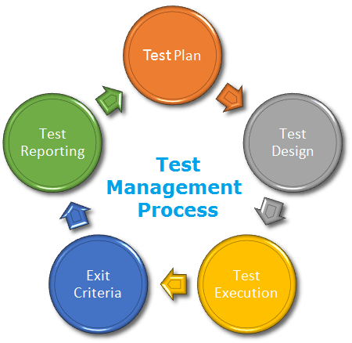

*Figure 5.2 - Test process*

* Test Planning use requirement specification test plans will make more detailed decisions about the overall approach of testing.
* Test Design design and create test cases.
* Test Execution execute test procedures using test execution tools, check actual results with expected results.
* Exit criteria defines when to stop testing based on time.
* Test reporting activities update Test Report and if there is an error then report error to developer.

### Test schedule

The table below describes the test schedule for the FERS Project:

|  |  |  |  |
| --- | --- | --- | --- |
| **Test Schedule** | **Start Date** | **End Date** | **Responsibilities** |
| Unit test | June 24, 2020 | August 19, 2020 | Developers |
| GUI test | June 26, 2020 | July 31, 2020 | Testers |
| Integration test | July 01, 2020 | August 10, 2020 | Testers |
| System test | July 21, 2020 | August 17, 2020 | Testers |
| Acceptance test | July 30, 2020 | August 31, 2020 | FPT HR Staffs |

*Table 5.3 – Test schedule*

## Testing Tools and Environment

### Testing Tools

* Chrome 84.0.4147.135 (64-bit) DevTools: To view logs, inspect elements, lighthouse.

*Figure 5.3 - Chrome dev tools*

* Google sheet: To manage test documents

*Figure 5.4 - Google sheet*

* Microsoft Visual Studio 17: To run unit tests and create/ update code unit tests.

*Figure 5.5 - Microsoft visual*

### Testing Environment

|  |  |  |
| --- | --- | --- |
| **Type of testing** | **Software** | **Hardware** |
| System test & Acceptance test & Test case | * Google Sheet. * Google Docs. * Google Chrome 84.0.4147.135 (64-bit) | Personal computer for developing with the minimum configuration:  - Laptop Asus  - 2.20GHz Intel Core i7  - RAM: 16GB |
| Unit test | * Microsoft Visual Studio 2017 | Personal computer for run testing with minimum configuration:   * Laptop Asus rog gl552vx * Core i7 6700HQ 2.6GHz * RAM: 8GB |

*Table 5.4 – Testing Environment*

## Test cases

Test cases have been managed on the [Test Case Sheet](https://docs.google.com/spreadsheets/d/197FWUa32-QykdtH1zgmdGq5hVTbtytHeO_tPqkG9wMI/edit?pli=1#gid=1250043366). Test case example:

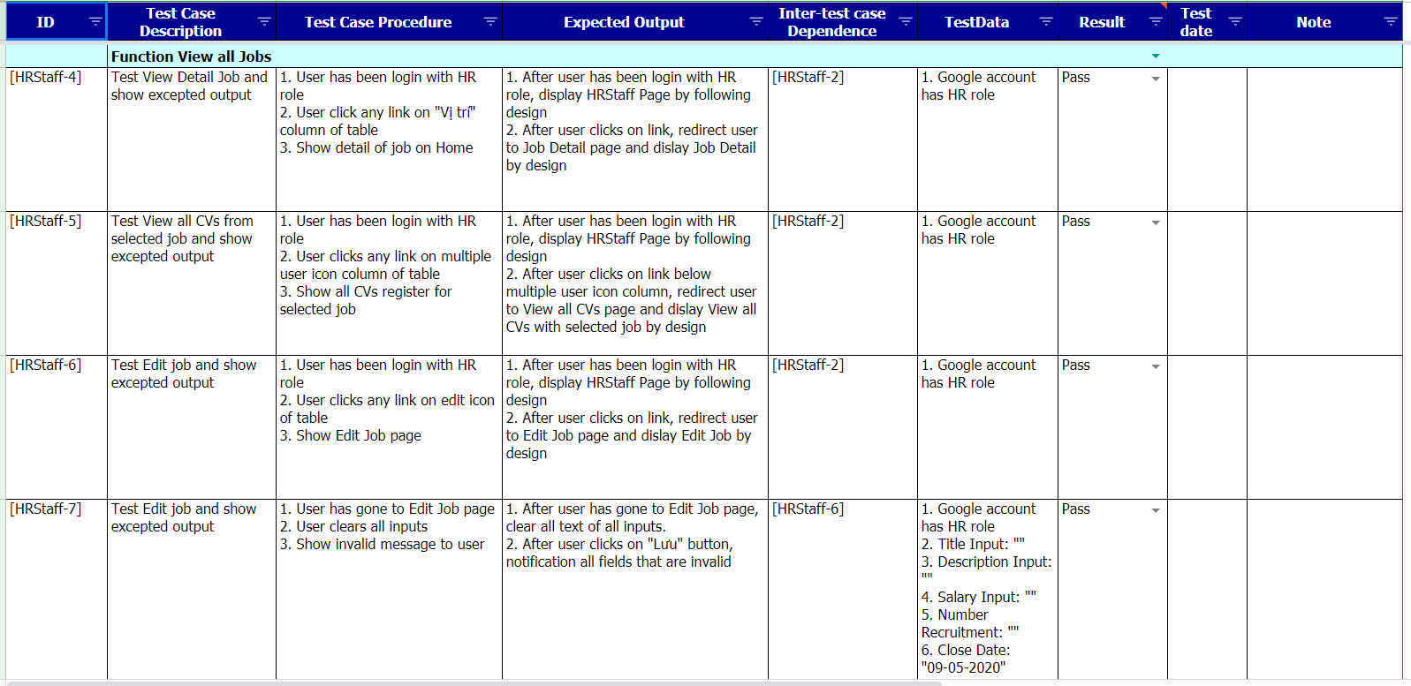  
*Figure 5.5 - Test case view all jobs*

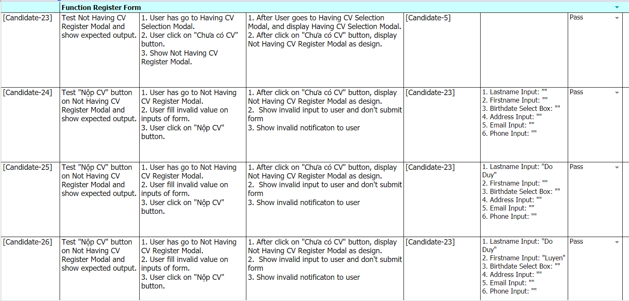

*Figure 5.6 - Test case register form*

## Acceptance test

* HR staff did an [acceptance test](https://docs.google.com/spreadsheets/d/1sIGlyMv5f2mLmO9ZZm__muP2ZmpWPnH41FqGgFeifEA/) to find out Web Application meet requirements:

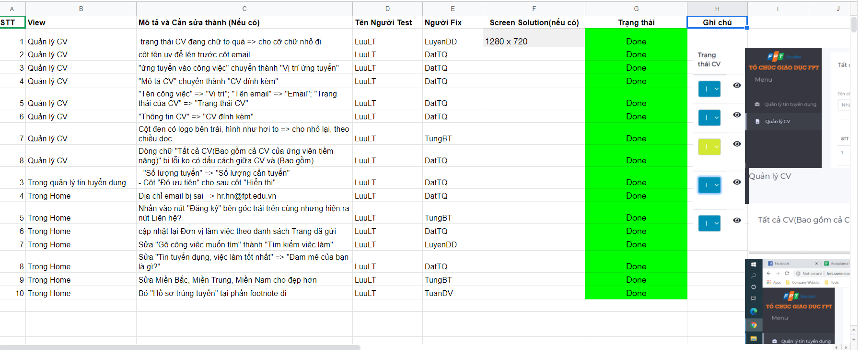

*Figure 5.7 - Acceptance test*

* The content of the checklist is shown in the table below:

|  |  |  |  |
| --- | --- | --- | --- |
| **ID** | **Checklists** | **Yes** | **No** |
| **General** | | | |
| **CL-01** | Functionality of buttons available on all pages. | √ |  |
| **CL-02** | Validation error messages are displayed properly below the field. | √ |  |
| **CL-03** | All numeric values are formatted properly. | √ |  |
| **CL-04** | All error messages are displayed using red color. | √ |  |
| **CL-05** | Delete functionality for any record on the page is asked for confirmation. | √ |  |
| **CL-06** | Text does not have grammatical and spelling errors. | √ |  |
| **CL-07** | Unavailable pages are redirected to the error page. | √ |  |
| **CL-08** | Navigation space is the same on all pages. | √ |  |
| **CL-09** | Feature buttons on all page displays with the right role of users. | √ |  |
| **CL-10** | All mandatory fields are validated and required. | √ |  |
| **CL-11** | All messages create/update/delete successfully using green color. | √ |  |
| **CL-12** | All messages create/update/delete failure using red color. | √ |  |
| **GUI and Usability** | | | |
| **CL-13** | Information is presented in the order that the user needs it. | √ |  |
| **CL-14** | All fields on page (e.g. text box, radio options, dropdown lists) should be aligned properly. | √ |  |
| **CL-15** | The text is easy to understand. Don't use slang, acronyms, and abbreviations. | √ |  |
| **CL-16** | Icons and images are designed to give impression and copyright. | √ |  |
| **CL-17** | The most important fields are located where they are easy to see. | √ |  |
| **CL-18** | Candidate’s screens have responsive for mobile, laptop, desktop devices | √ |  |
| **CL-19** | Candidate’s screen has header and footer on every single screen. | √ |  |
| **CL-20** | SuperAdmin/ HR Staff screen has menu on the left in each screen | √ |  |
| **CL-21** | Only enable scroll when screen overheight or overwidth | √ |  |
| **CL-22** | All image tags have an “alt” attribute to decorate an image when the image wasn't downloaded. | √ |  |
| **Database** | | | |
| **CL-23** | Values columns are not accepting null values. | √ |  |
| **CL-24** | Input date of birth cannot be greater than current date. | √ |  |
| **CL-25** | Null values are not allowed for Primary key columns. | √ |  |
| **CL-26** | Radio button options are saved correctly in the database with true/false. | √ |  |
| **CL-27** | Input data is not truncated. Field length shown to the user on page and in database schema should be the same. | √ |  |
| **CL-28** | Input numeric fields with minimum, maximum, and float values. | √ |  |
| **CL-29** | Input date is formatted dd/mm/yyyy | √ |  |
| **CL-30** | Database fields are designed with correct data type and data length. | √ |  |
| **CL-31** | Input field leading and trailing spaces are truncated before committing data to the database. | √ |  |
| **CL-32** | Fields of columns are unique then cannot duplicate. | √ |  |
| **Security** | | | |
| **CL-33** | Test login with google authenticator. | √ |  |
| **CL-34** | Do not save all information of the account logged, but only save uuid in session. | √ |  |

*Table 5.5 – Checklist*

## Test Report

* Test report has been manage on the [Test report sheet](https://docs.google.com/spreadsheets/d/197FWUa32-QykdtH1zgmdGq5hVTbtytHeO_tPqkG9wMI/edit#gid=1395313998)
* We used Google Lighthouse tools for measuring the quality of web pages, especially SEO:

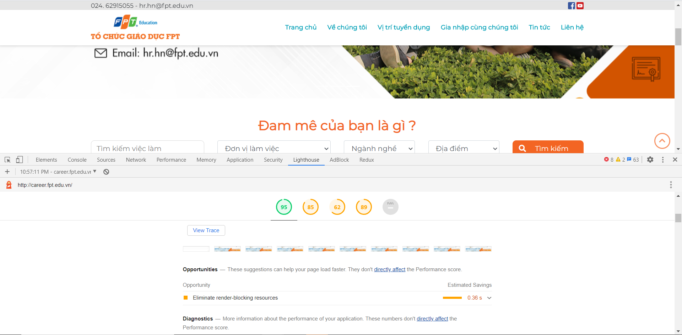*Figure 5.8 - Lighthouse tool’s result*

# Software User’s Manual

## Candidate

### Menu



*Figure 6.1. Header of homepage*

“Trang chủ”: Display home page of FERS.

“Về chúng tôi”: Give information about history of FPT Education.

“Vị trí tuyển dụng”: Redirect to list of all jobs that are in recruitment need at FPT education.

“Gia nhập cùng chúng tôi”: Popup a modal dialog for users to register potential candidates

“Tin tức”: Redirect to news page of FPT Education.

“Liên hệ”: Redirect to contact page of FPT Education.

### Search job

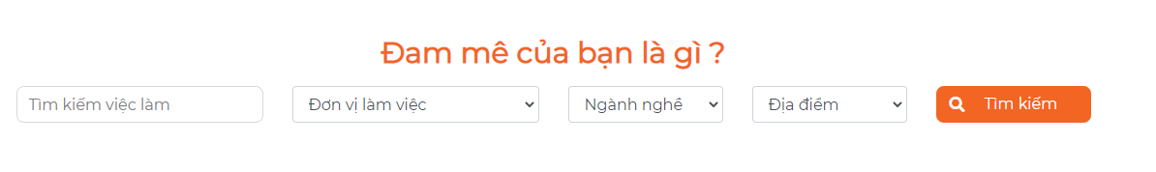

*Figure 6.2. Search bar*

Fill the condition you want to find and click the “Tìm kiếm” button. System will redirect to list jobs that are being recruited at FPT Education with the condition you want.

For example: Search job with title “Giáo viên STEM” and career “Giảng viên/Giáo viên” will return job based on condition search.

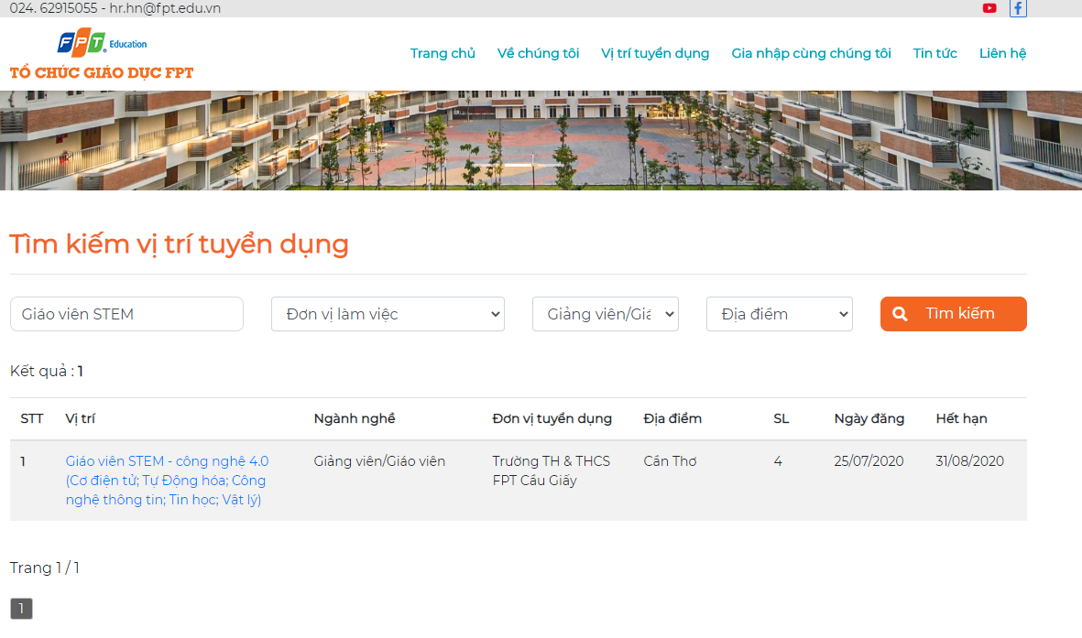

*Figure 6.3. List jobs page*

### List jobs

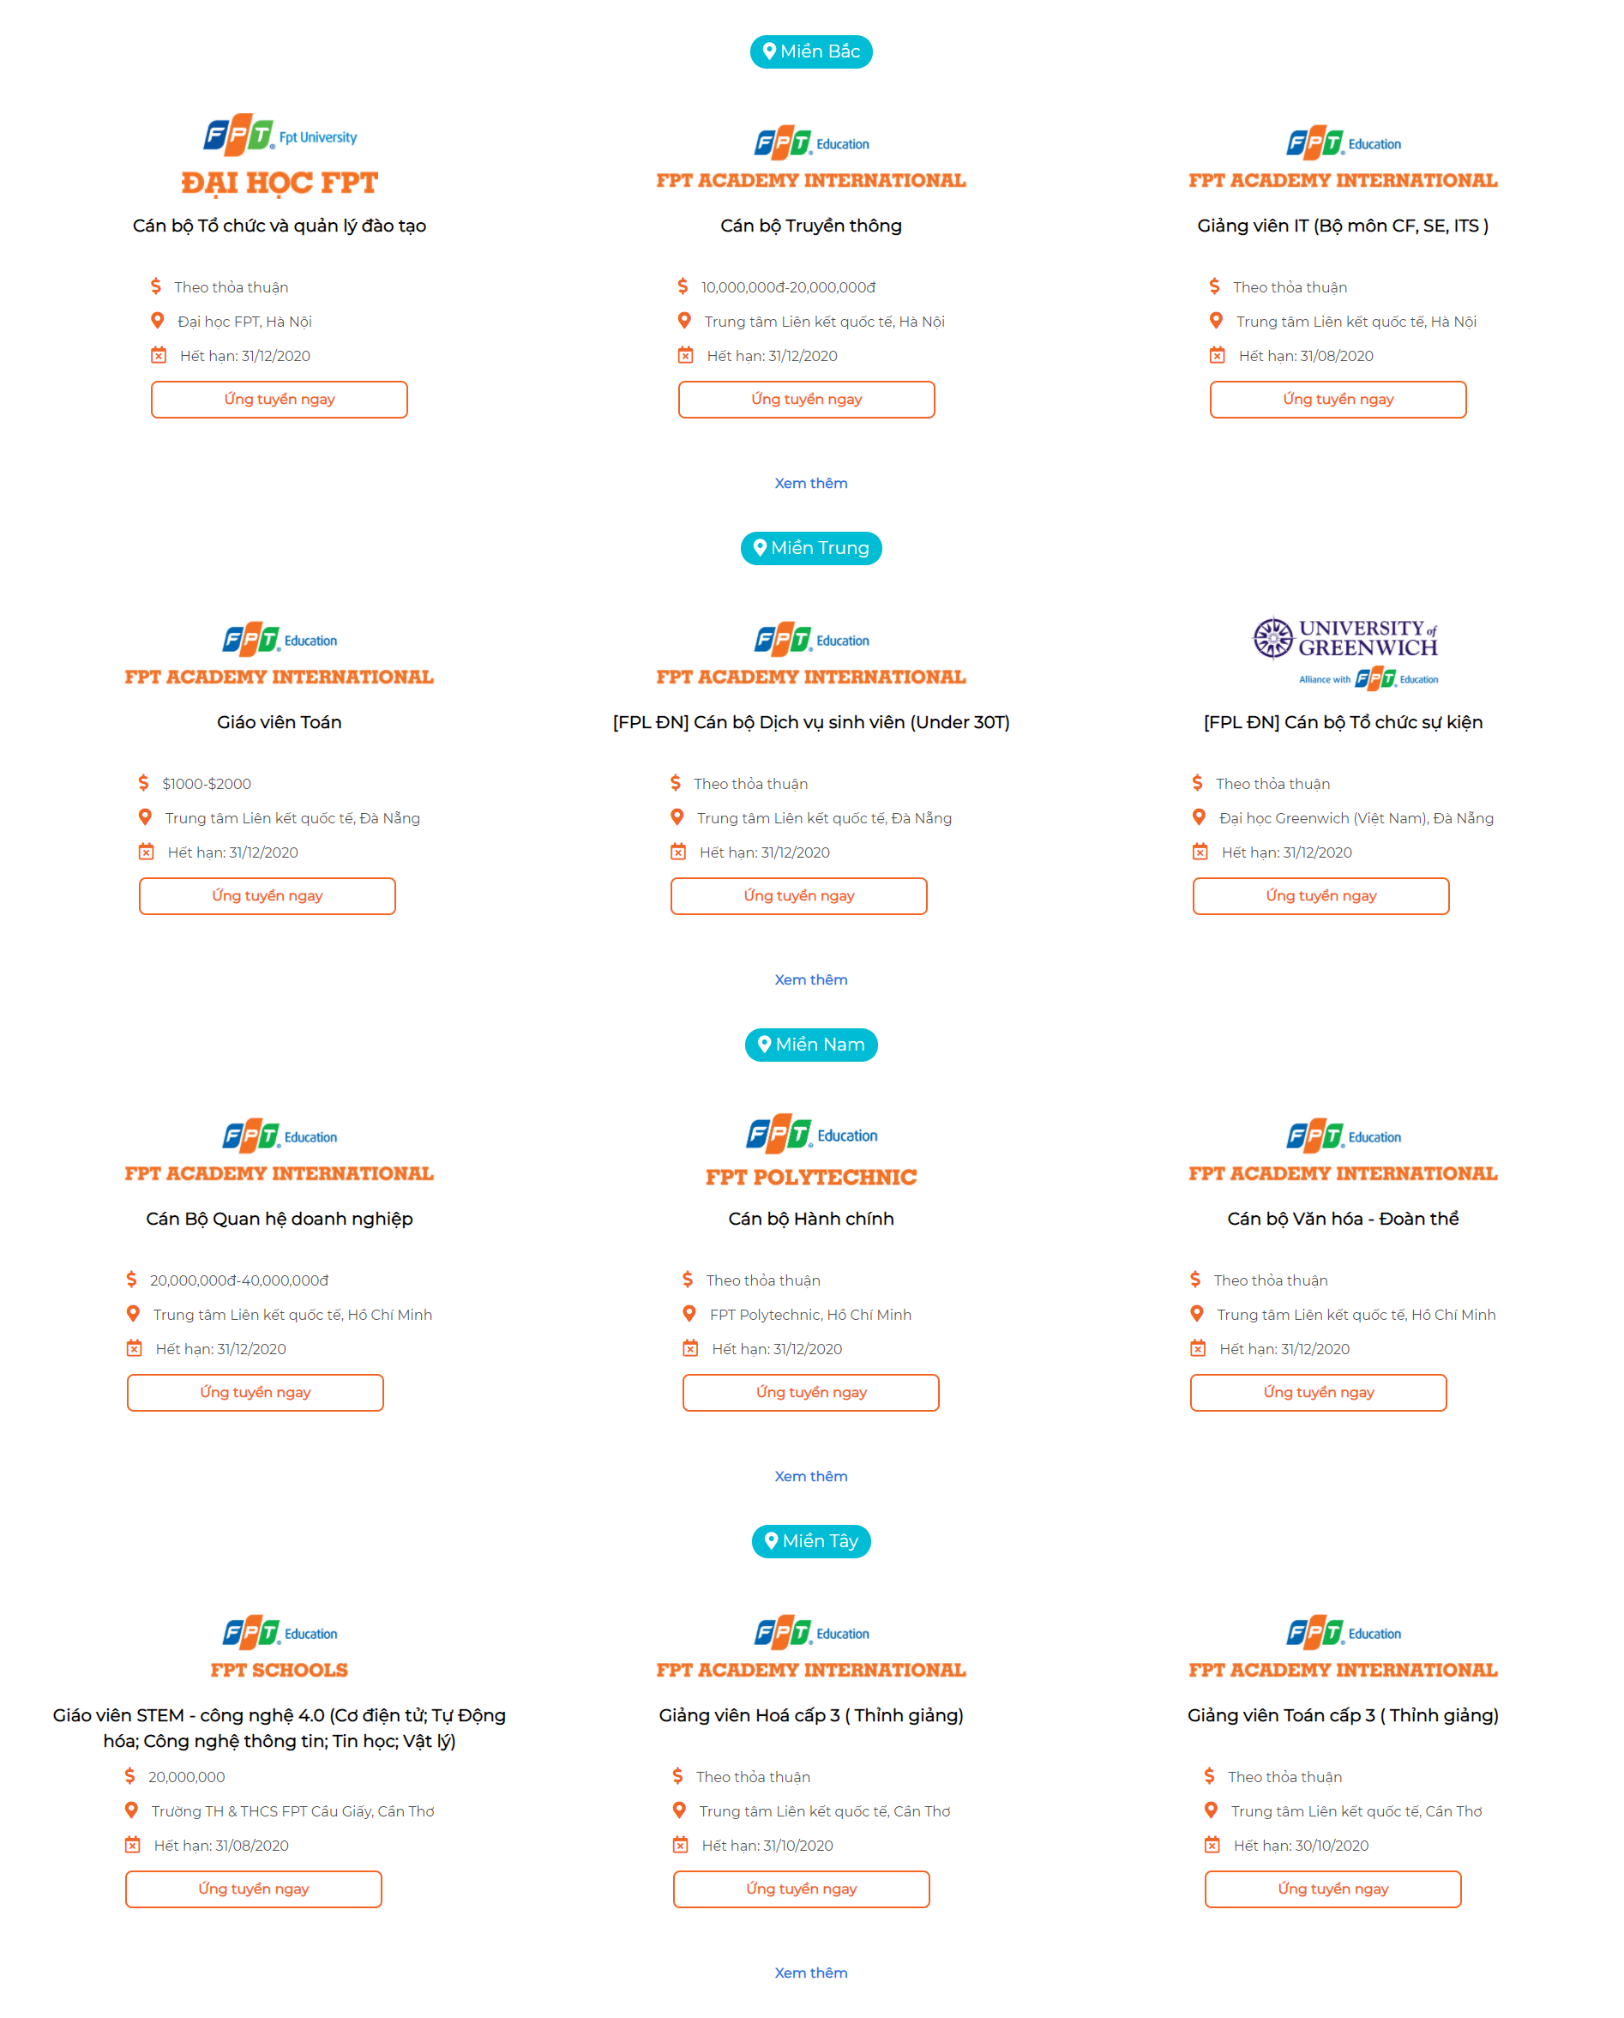

*Figure 6.4. Highlight jobs of regions*

That part displays jobs in each region on the home page, max is 3 jobs of each region. We have 4 regions in the system (Miền Bắc, Miền Trung, Miền Nam, Miền Tây). If you want to see more jobs in each region. Click the “Xem thêm” button, the system will redirect to a list of jobs in that region.

For example, I want to see all jobs of “Miền Bắc” region, I click “Xem thêm” of “Miền Bắc” region and the result is all jons of “Miền Bắc” (Having 3 jobs).

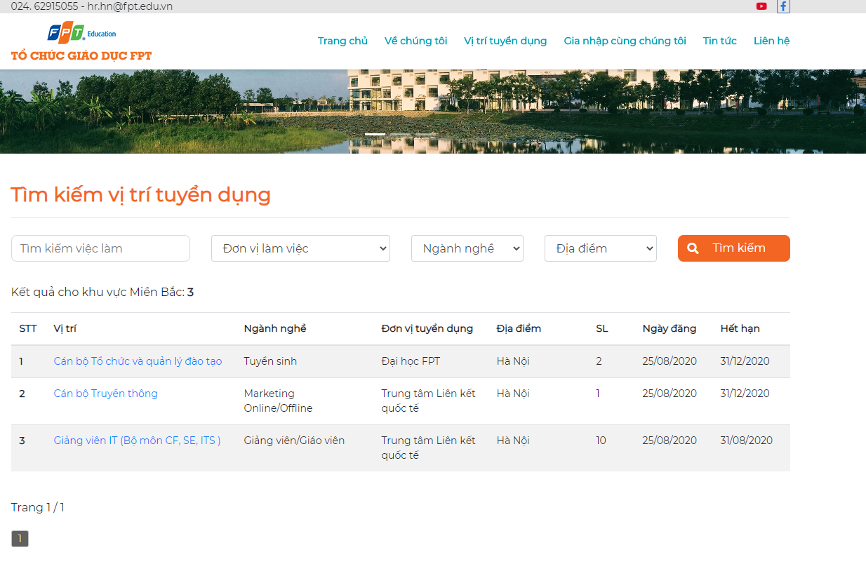

*Figure 6.5. Jobs displayed by a region*

### Job positions



*Figure 6.6. Hot job positions and recruitment units*

This part is a description of a tab which has jobs. We device into 4 tab : “Giảng viên/Giáo viên”, “Thực tập sinh”, “Tuyển sinh”, “Vị trí khác”. In each tab, we will show all units have jobs in that position. If we click to each unit, we will show all jobs in this unit.

For example, in tab “Giáo viên/Giảng viên”, we have two units have jobs about “Giáo viên/Giảng viên” : “Trường TH & THCS FPT Cầu Giấy” and “Trung tâm Liên kết quốc tế”. When I click to “Trường TH & THCS FPT Cầu Giấy”, the system will show all jobs in this unit.

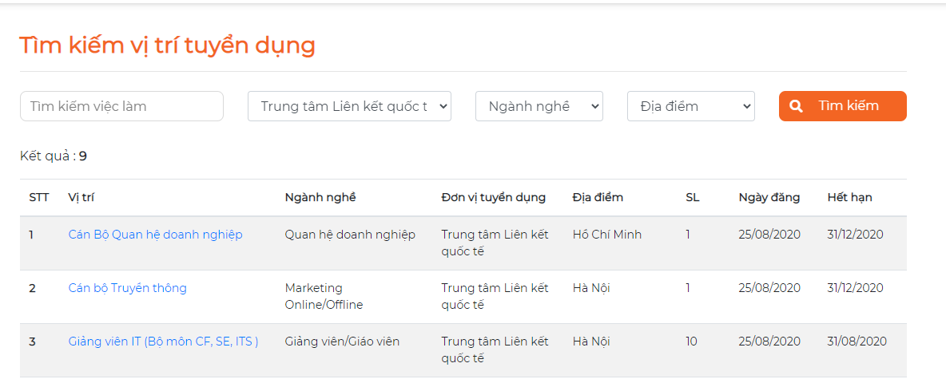

*Figure 6.7. List jobs of a unit*

### Working environment



*Figure 6.8. Information about working environment of FPT Education*

This part describes the working environment in FPT Education, if click to image, the system will redirect to a detail description page.

### What did FPT Education people say?

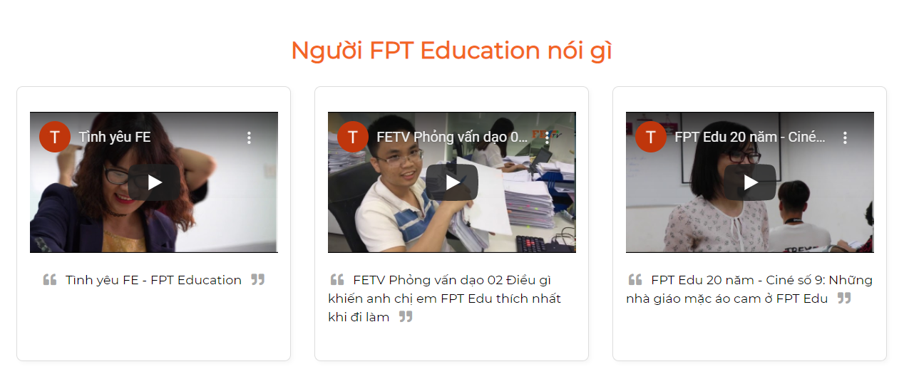

*Figure 6.9. Reviews about FPT Education*

This part gives some video about something that FPT Education people said. You can click each video to watch.

### Apply job

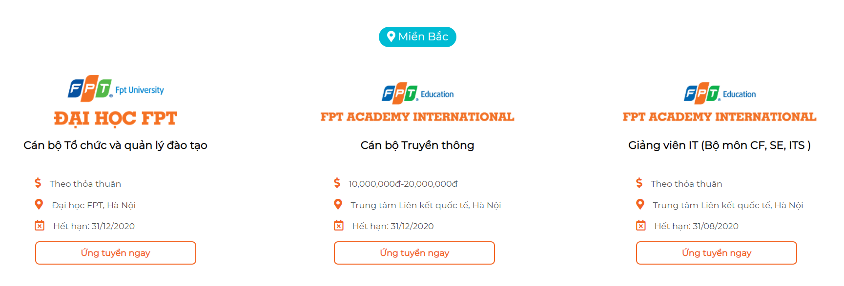

*Figure 6.10. List jobs of a region*

When you want to apply a job, you can click the “Ứng tuyển ngay” button of each job. The system will show a popup with 2 choices : “Có CV” and “Đã có CV”.

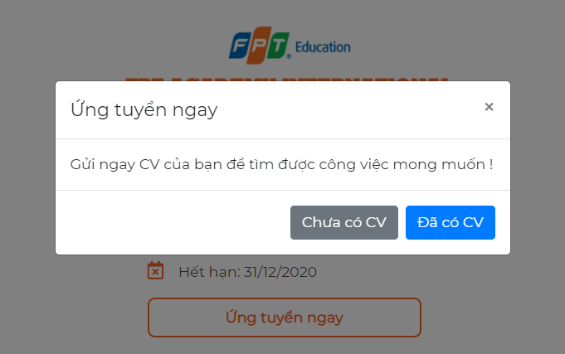

*Figure 6.11. Confirmation dialog box*

If you don’t have a CV, click the “Chưa có CV” button, the system will show a form suitable for you to fill in.

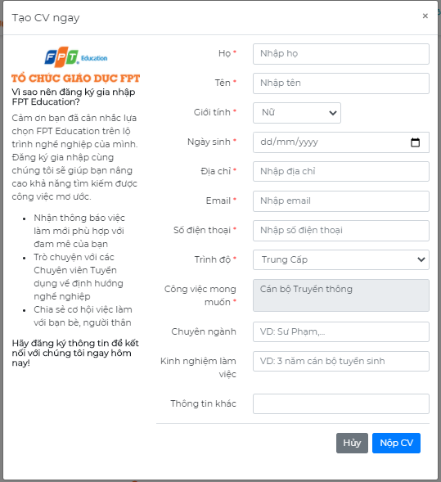

*Figure 6.12. Create CV modal dialog*

If you have a CV, click the “Đã có CV” button, the system will show a form suitable for you to fill in.

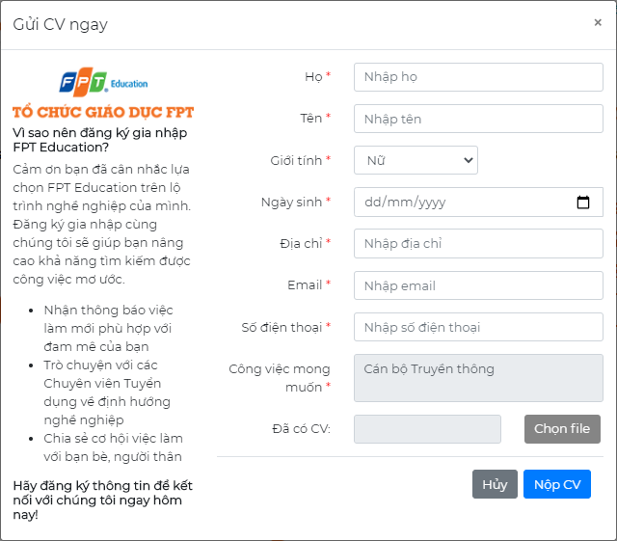

*Figure 6.13. Upload CV modal dialog*

Fields validation :

* With field have red symbol (*), you cannot leave it blank.
* In the field “Ngày sinh”, you must choose a date that is less than or equal to the current date.
* Phone number max length is 11 number.
* If you upload a CV file, the size of the file must be less than or equal 4MB.

Then, click the “Nộp CV” button to submit the form and the system will send a email to you to confirm about receiving your CV.

If you don’t want to apply for a job but are still in contact with the recruitment system, you can register a CV to the system with your expected job by click “Gia nhập cùng chúng tôi” in menu tab or click the “Đăng ký” button in the bottom of page. The system will show a form for you to register.

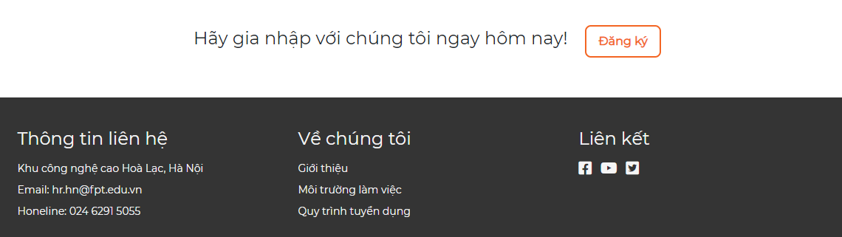

*Figure 6.14. Register potential candidate*

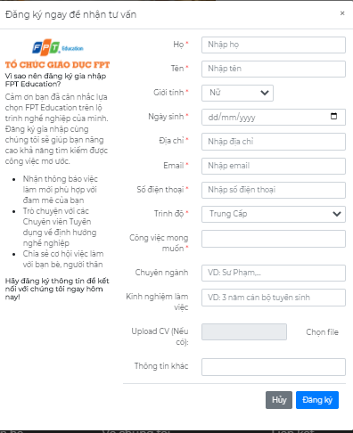

*Figure 6.15. Register potential candidate modal dialog*

Fields validation :

* With field have red symbol (*), you cannot leave it blank.
* In the field “Ngày sinh”, you must choose a date that is less than or equal to the current date.
* Phone number max length is 11 number.
* If you upload a CV file, the size of the file must be less than or equal 4MB.

Then, click the “Đăng ký” button to submit the form and the system will send an email to you to confirm about receiving your CV.

### Recruitment Process

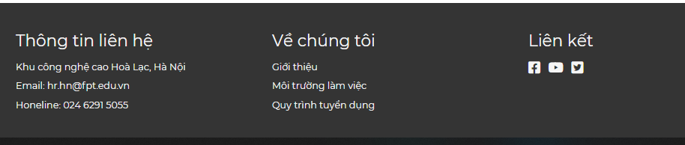

*Figure 6.16. Footer of FERS site*

When you click to “Quy trình tuyển dụng” on the footer, the system will redirect to recruitment process. This page have two part:

* Recruitment process: An image of the job recruitment process and steps at FPT Education
* Profile: Required documents and procedures if you are admitted to FPT Education





*Figure 6.17. Recruitment process page*

### Edit CV

After successfully applying/registering potential candidates for a job, candidates will receive an email with a link allowing them to edit their CV.

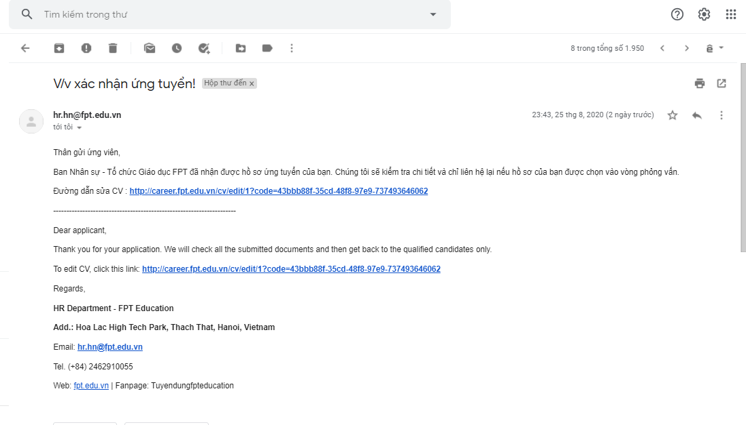

*Figure 6.18. Email notification of successful application*

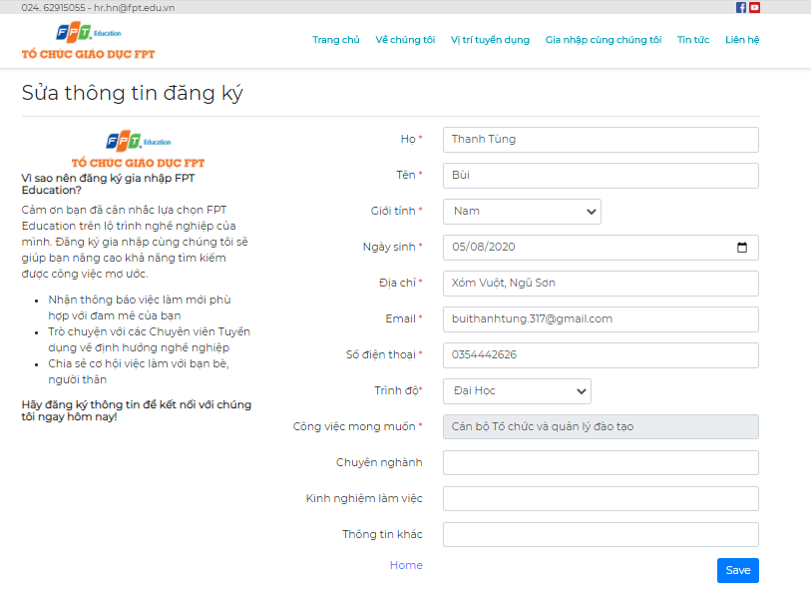

*Figure 6.19. Edit CV page*

### Take quiz

After applying for a job successfully, Candidate’s CV will be stored in the system. Once HR Staff click the send link quiz for the candidate, an email will be sent to the candidate, including the link of the quiz.

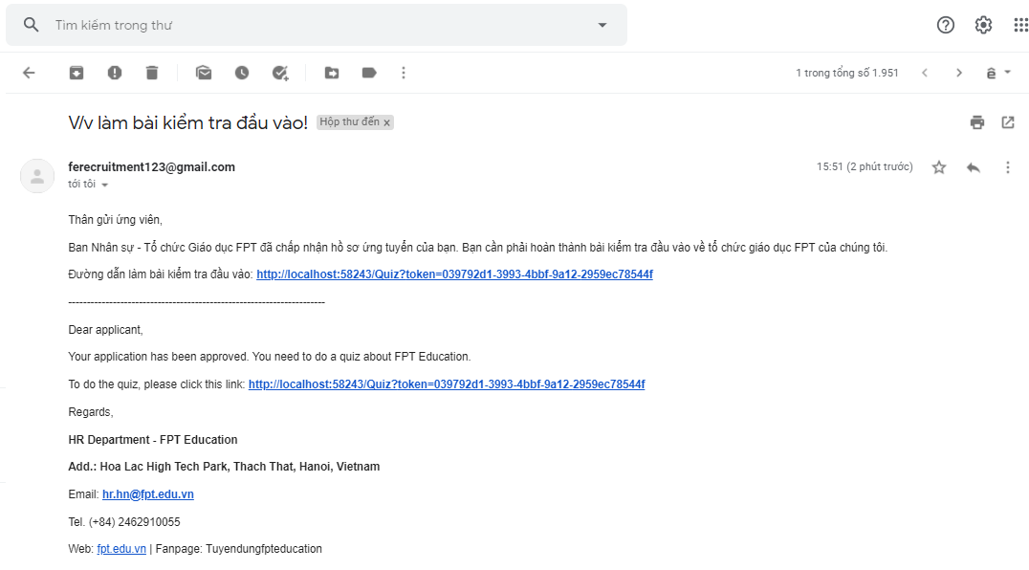

*Figure 6.20. Email quiz link*

Candidate will have 40 minutes to complete the quiz

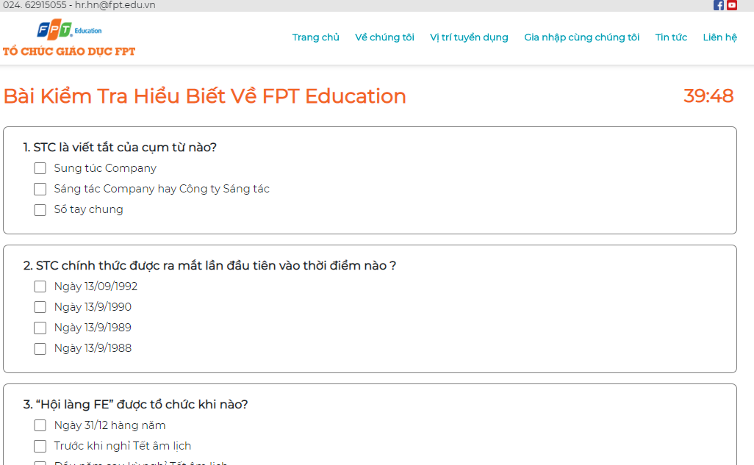

*Figure 6.21. Take quiz page*

### Login

Go to url : career.fpt.edu.vnAccount/Login to go to the login page. Click the “Đăng nhập” button and select your email to login the system. After login success,

* If you have the role “HR Staff”, the system will redirect to the HR manager page.
* If you have role “Admin” or both role “Admin” and “HR Staff”, the system will redirect to the admin manage page.

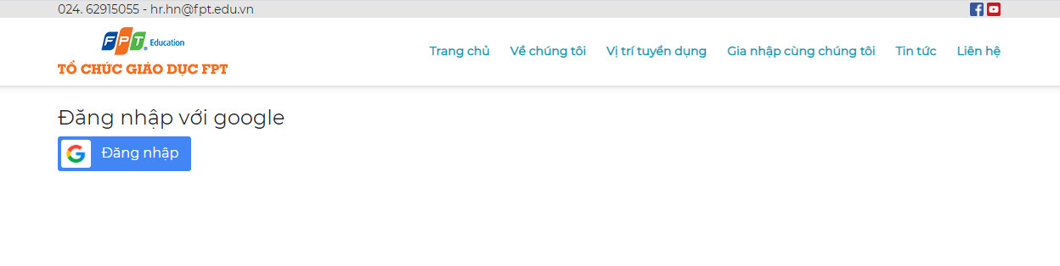

*Figure 6.22. Login page*

## Admin

Description all about function of Admin

### Account management

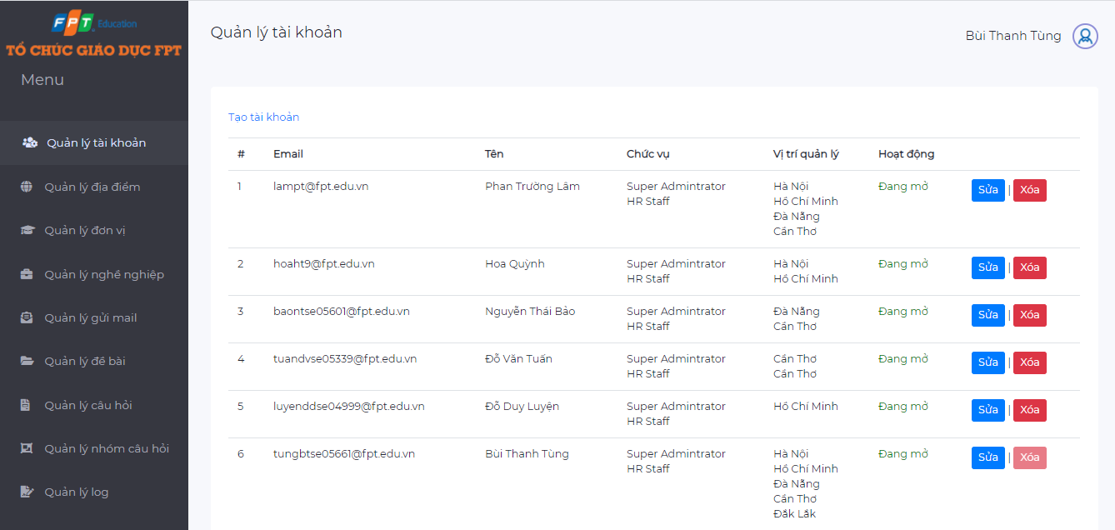

*Figure 6.23. Account management page*

This is the account management page. This page shows all accounts in the system.

* If you want to create a new account, click “Tạo tài khoản”.
* If you want to edit an account, click the “Sửa” button.
* If you want to delete an account, click the “Xóa” button.

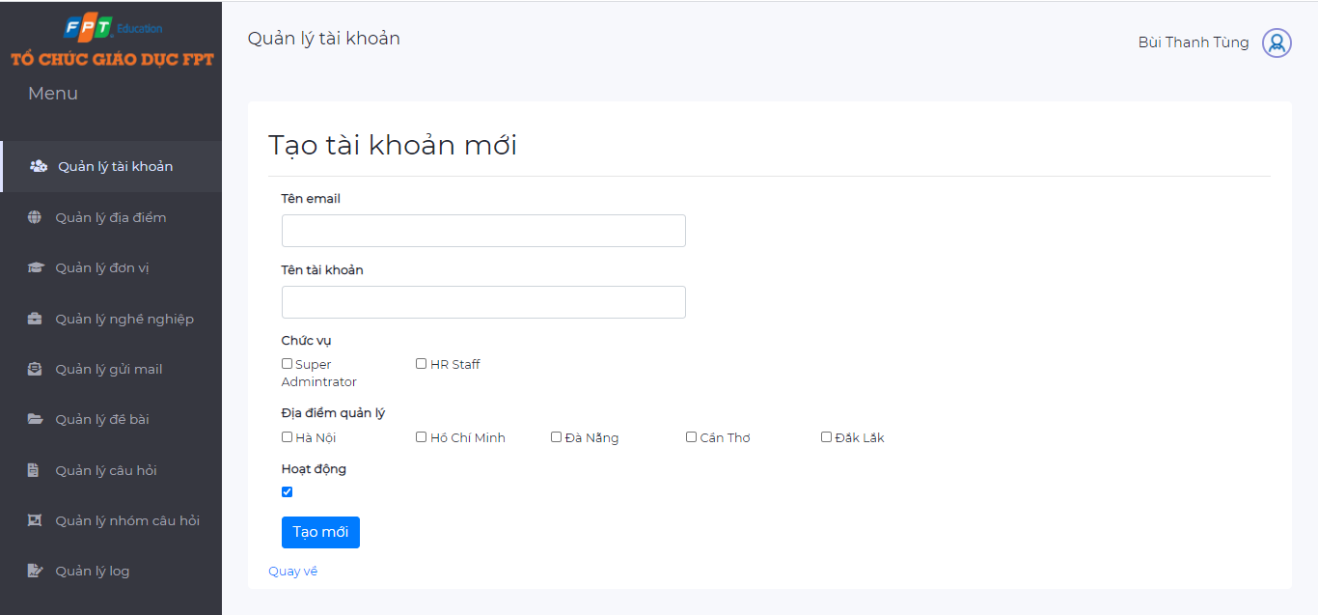

*Figure 6.24. Add account page*

* When user want to add a new account, they have to full fill the following information:
  + “Tên email”: email of the account
  + “Tên tài khoản”: Display name of the account
  + “Chức vụ”: Role of account, there are two role of accounts: Super Administrator and HR Staff.
  + “Địa điểm quản lý”: All working locations of FPT Education. The user only has management rights related to the specified locations
  + “Hoạt động”: Enable or disable the account?
* Similarly, with the edit account page, the user must also fill in the information as above

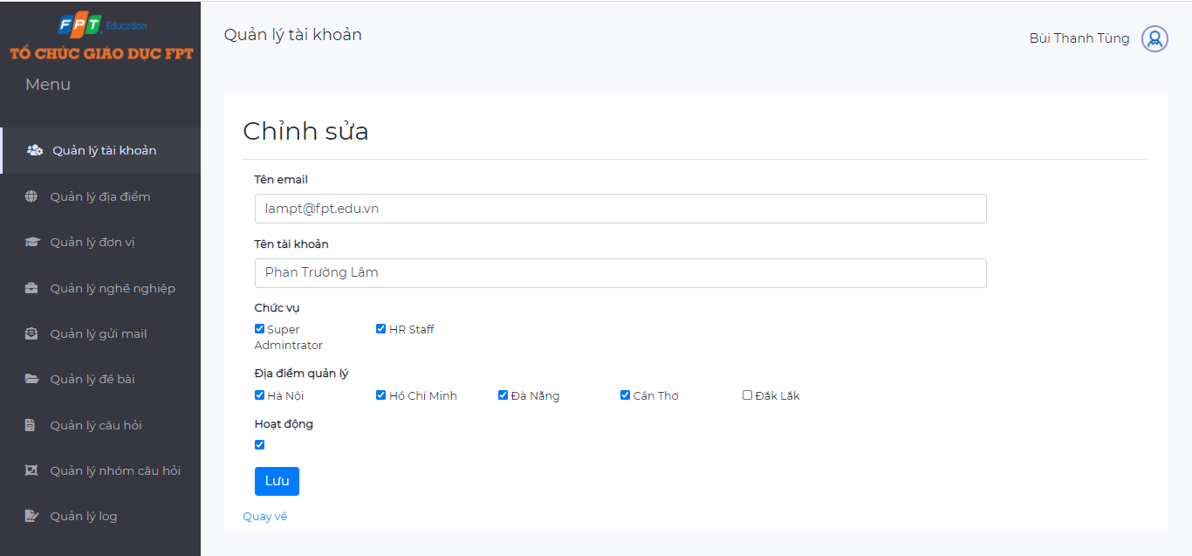

*Figure 6.25. Edit account page*

When the user wants to remove an account from the system, they can click the button “Xóa” on an account. A confirmation dialog will popup, if the user clicks OK - the account will be removed from the system.

### Location management



*Figure 6.26. Location management page*

This is a location management page. This page shows a list of all working locations of FPT Education.

* Click “Tạo địa điểm mới” to add a new location into FPT Education
* Click “Sửa” to edit a location
* Click “Xóa” to delete a location

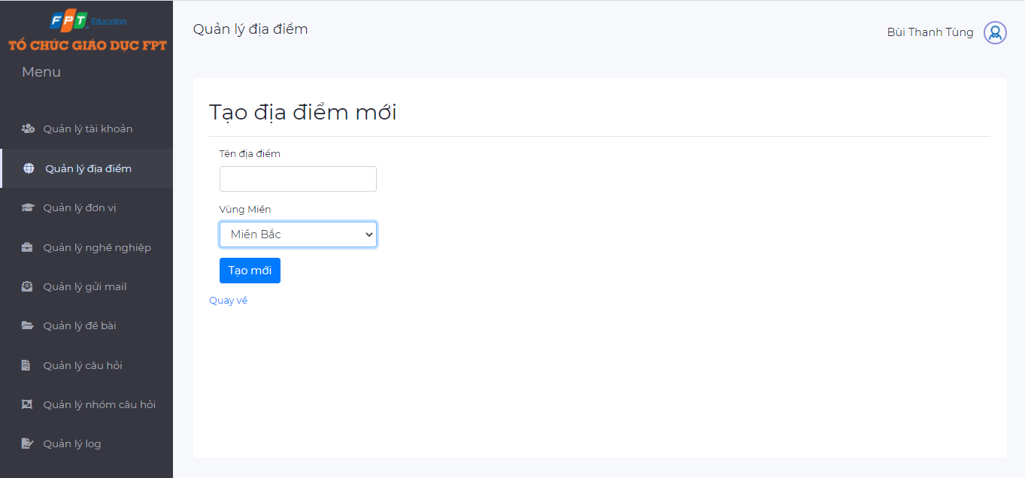

*Figure 6.27. Add location page*

* When adding a new location, user must full fill the following information:
  + “Tên địa điểm”: Name of the location
  + “Vùng miền”: Region of the location
* When editing the location, the user can change the name and region of the location.
* When deleting the location, a modal dialog will popup to make sure that the user really wants to delete the location.

### Unit management



*Figure 6.28. Unit management page*

This is the unit management page. This page shows a list of all working units of FPT Education.

* Click “Tạo đơn vị mới” to add a new unit into FPT Education
* Click “Sửa” to edit a unit
* Click “Xóa” to delete a unit

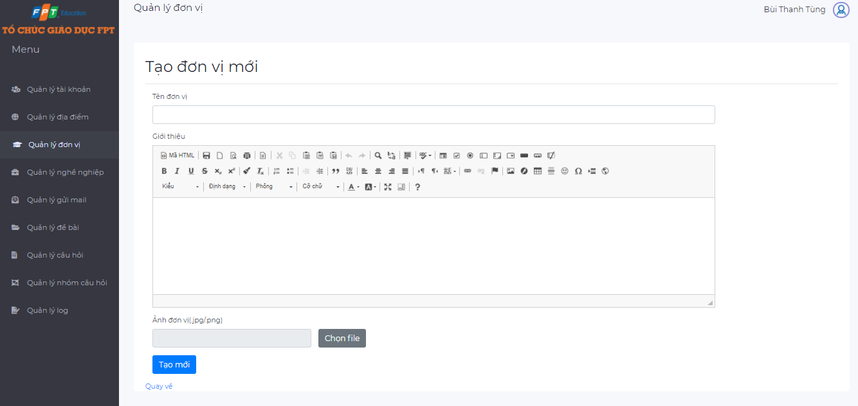

*Figure 6.29. Add unit page*

* When adding a new unit , user must full fill the following information:
  + “Tên đơn vị”: Name of the unit
  + “Giới thiệu”: Description about the unit
  + “Ảnh đơn vị”: A photo of the unit (must be JPG or PNG format file and below 4MB size)
* When editing the unit, the user can change the above information (unit name, description, image).
* When deleting the unit, a modal dialog will popup to make sure that the user really wants to delete the unit.

### Career management



*Figure 6.30. Career management page*

This is a career management page. This page shows a list of all careers of FPT Education.

* Click “Tạo nghề nghiệp mới” to add a new career into FPT Education
* Click “Sửa” to edit a career
* Click “Xóa” to delete a career

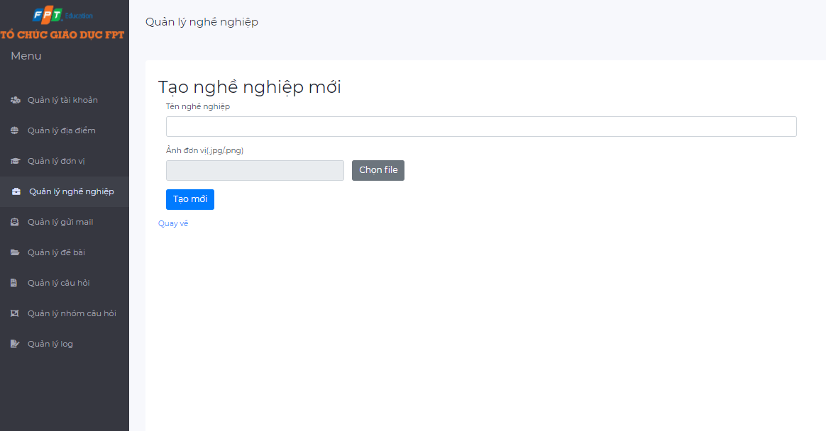

*Figure 6.31. Add career page*

* When adding a new career, user must full fill the following information:
  + “Tên nghề nghiệp”: Name of the career
  + “Ảnh nghề nghiệp”: A photo of the career (must be JPG or PNG format file and below 4MB size)
* When editing the career, the user can change the above information (career name, image).
* When deleting the career, a modal dialog will popup to make sure that the user really wants to delete the career.

### Config email management



*Figure 6.32. Config email management page*

This is the config email management page. This page shows a list of all emails which are used to automatically send to the candidates .

* Click “Tạo tài khoản gửi email mới” to add a new email
* Click “Sửa” to edit an email
* Click “Xóa” to delete an email

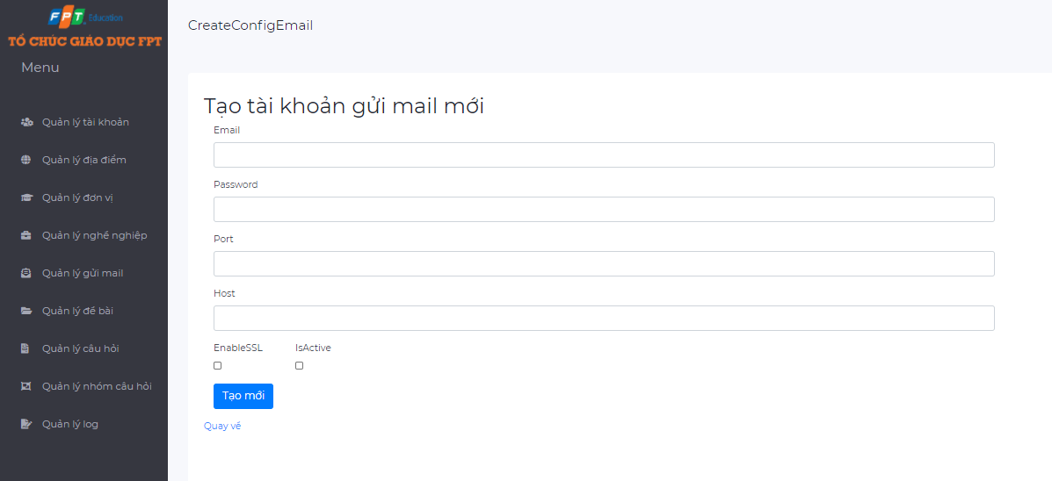

*Figure 6.33. Add a new email*

* When adding a new email, user must full fill the following information:
  + “Email”: The email address
  + “Password”: The password of the email address
  + “Port”:
  + “Host”:
  + “EnableSSL”:
  + “IsActive”: When this option is checked, the email is able to be used. Note that only one email is enabled at a time.
* When editing the email, the user can change the above information (email address, password, port number, host, enableSSL, isActive).
* When deleting the email, a modal dialog will popup to make sure that the user really wants to delete the email.

### Question management

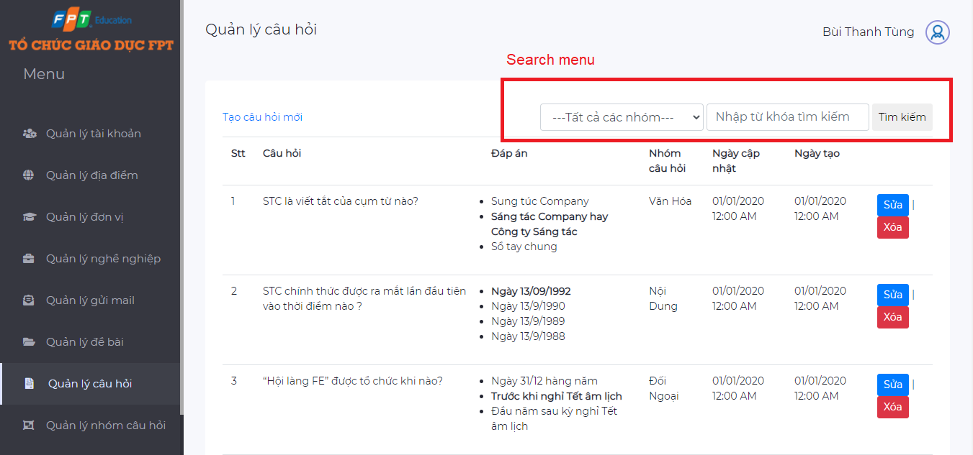

*Figure 6.34. Question management page*

The above is an interface of the question management page, including a list of all questions and search menu.

* Click “Tạo câu hỏi mới” to add a new question
* Click “Sửa” to edit a question
* Click “Xóa” to delete a question

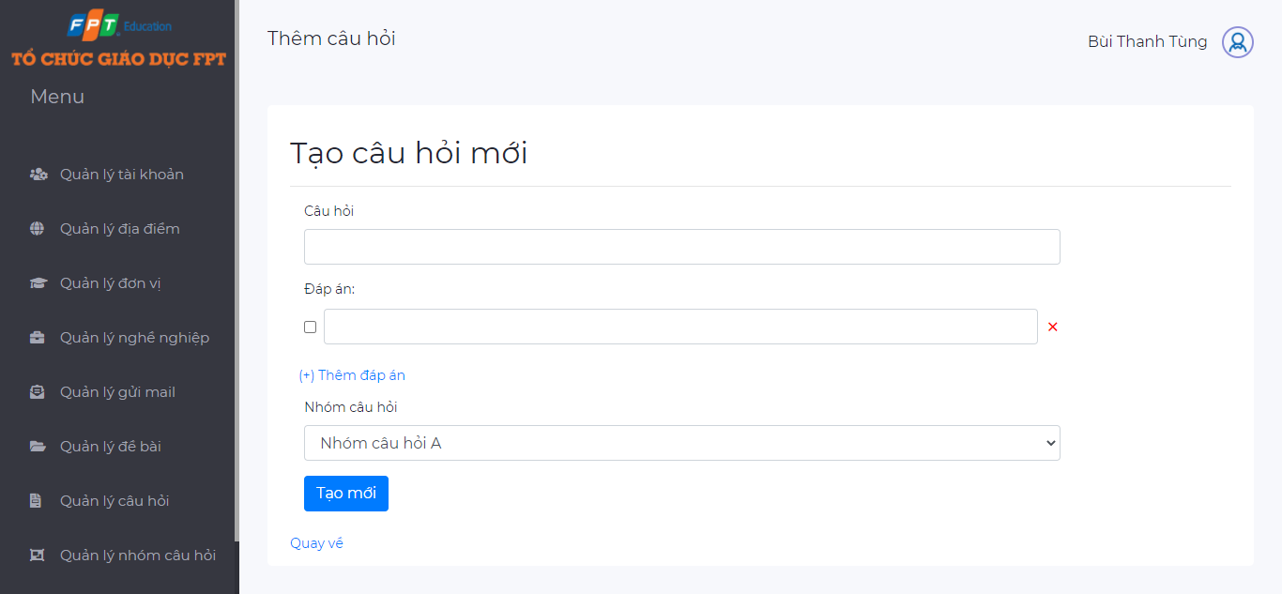

*Figure 6.35. Add question page*

* When adding a new question, user must full fill the following information:
  + “Câu hỏi”: Content of the question
  + “Đáp án”: Answers of the question. A question has one or more answers
  + User can add a new answer by clicking the button “Thêm đáp án”
  + “Nhóm câu hỏi”: The questions in the system are divided into groups to easily classify candidates
* When editing the question, the user can change the above information (question name, answers, question group)
* When deleting the question, a modal dialog will popup to make sure that the user really wants to delete it.

### Question group management



*Figure 6.36. Question group management page*

As mentioned above, the questions in the system will be divided into groups to easily manage the question bank and classify candidates when doing tests.

* Click “Tạo nhóm mới” to add a new question group
* Click “Sửa” to edit a question group
* Click “Xóa” to delete a question group

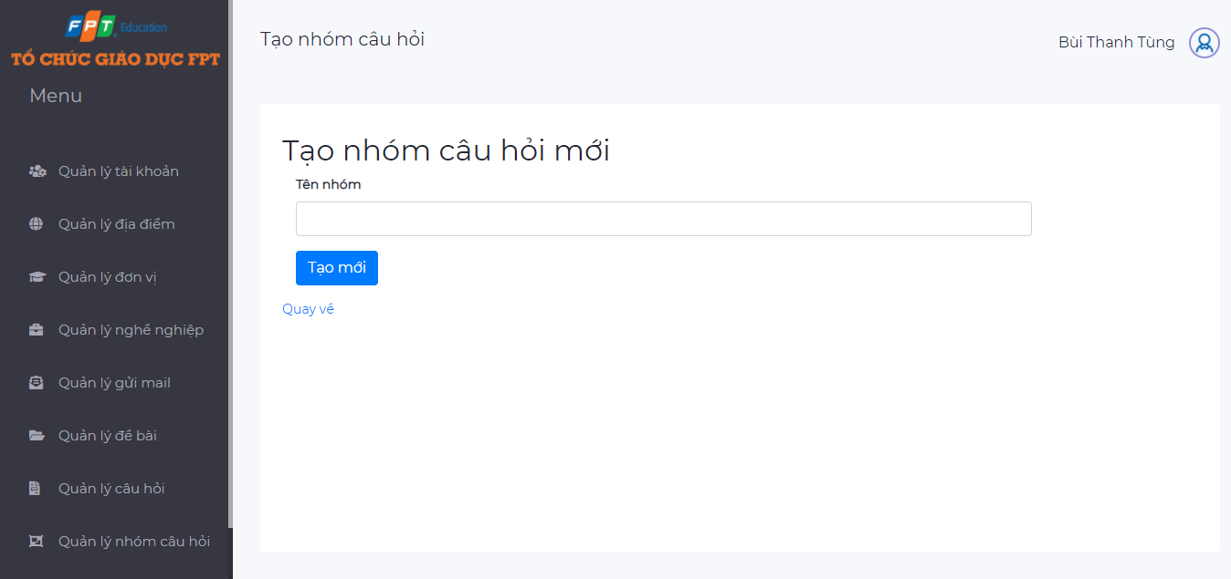

*Figure 6.37. Add question group page*

* When adding a new question group, user must full fill the following information:
  + “Tên nhóm”: The question group name
* User can also edit the name of question group
* Note: When creating a new question group, by default this question group has no questions, but once a question is added to this group, it cannot be deleted.1.3.8. Quiz management



*Figure 6.38. Quiz management page*

Quiz is a collection of questions that will be selected by Super Admin.

* Click “Tạo đề bài mới” to add a new quiz
* Click “Sửa” to edit a quiz
* Click “Xóa” to delete a quiz

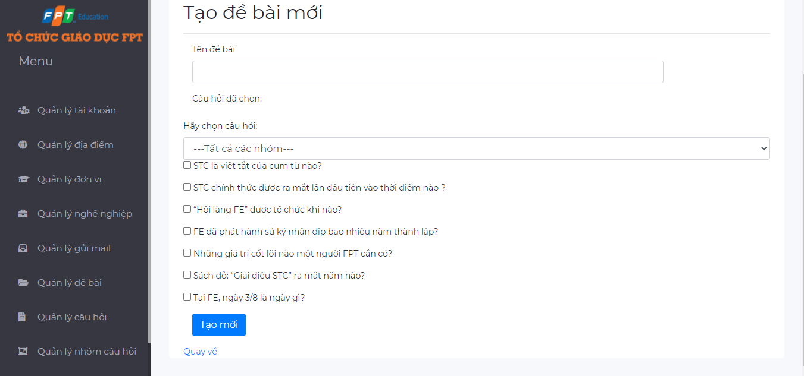

*Figure 6.39. Add quiz page*

* When adding a new quiz, user must full fill the following information:
  + “Tên đề bài”: The quiz name
  + Questions: Users select the questions by clicking the check box. The list of questions can be displayed all or filtered by question group
* User can also edit the name of quiz or the questions of the quiz
* When deleting a quiz, there is one thing to note that, it is not possible to delete the quizzes for which the candidate has already taken.

### Log management



*Figure 6.40. Log management page*

When there are changes made to the system, the change history is logged and displayed in the log page.

For example: When a HR Staff deletes a question in question bank, this action is logged including information like: who took the action, type of action, url, message of action, datetime of action.

## HR Staff

### Job management



*Figure 6.41. Job management page*

The above is job management page, display all information about jobs that are in recruitment need

* “Vị trí”: Position of recruitment job
* “Ngành nghề”: The major involve to the job
* “Đơn vị”: The unit
* “Địa điểm”: Working location
* “Số lượng cần tuyển”: Number of recruitment required
* “Lượt xem”: Number of clicks on job details
* “Số lượng CV đã ứng tuyển”: Number of CV applied to the job, user can click this to see list of all CVs that applied for this job
* “Hiển thị”: Are the jobs currently displayed?
* “Độ ưu tiên”: There are 3 priority levels (1, 2 and 3). The higher the priority level, the first displayed job on the homepage
* “Ngày tạo”: The created date
* “Ngày sửa cuối”: Datetime of last modified
* “Người tạo”: Who created this job

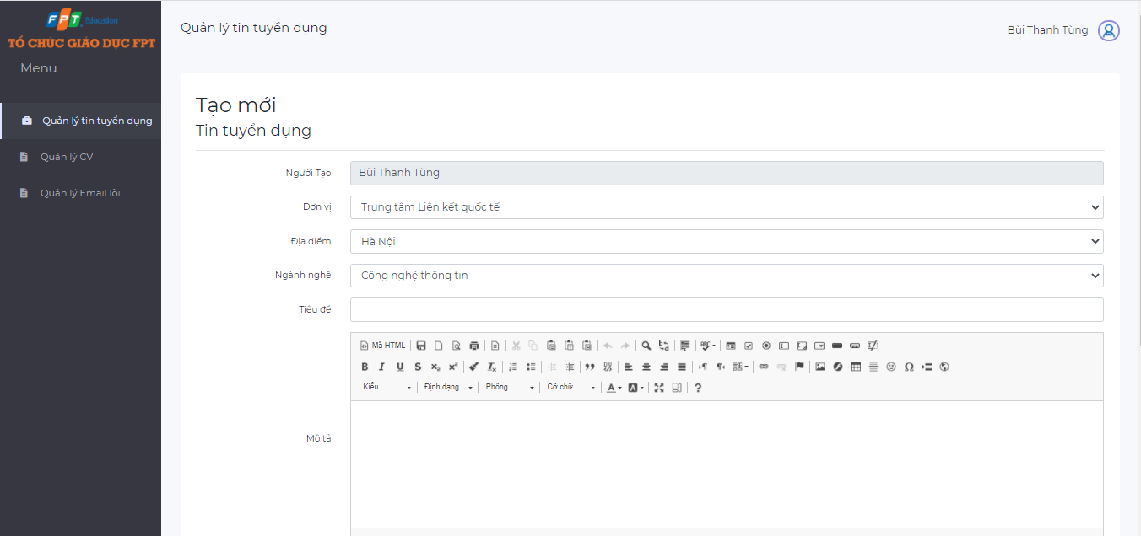

*Figure 6.42. Create job page*

When adding or editing the job, user must full fill the following information:

* “Đơn vị”: working unit
* “Địa điểm”: working location
* “Ngành nghề”: major of the job
* “Tiêu đề”: title of the job
* “Mô tả”: description about the job
* “Mức lương”: amount of salary
* “Số lượng”: number to be recruited
* “Ngày tạo”: created date
* “Ngày đóng”: close date
* “Độ ưu tiên”: priority level (1, 2, 3)
* “Hiển thị”: enable this option to show job, when you disable this option, the job will not display at candidate side.

### CV management



*Figure 6.43. CV management page*

The above is CV management page, show list of all CVs that was submitted to the system

* Click the eye icon to view detailed information about CV
* Search a CV by job position, email, candidate name, date, status of CV
* Change status of CV, there are five status of CV:
  + New
  + Seen
  + Pending
  + Approve
  + Reject
* Send link quiz for candidates

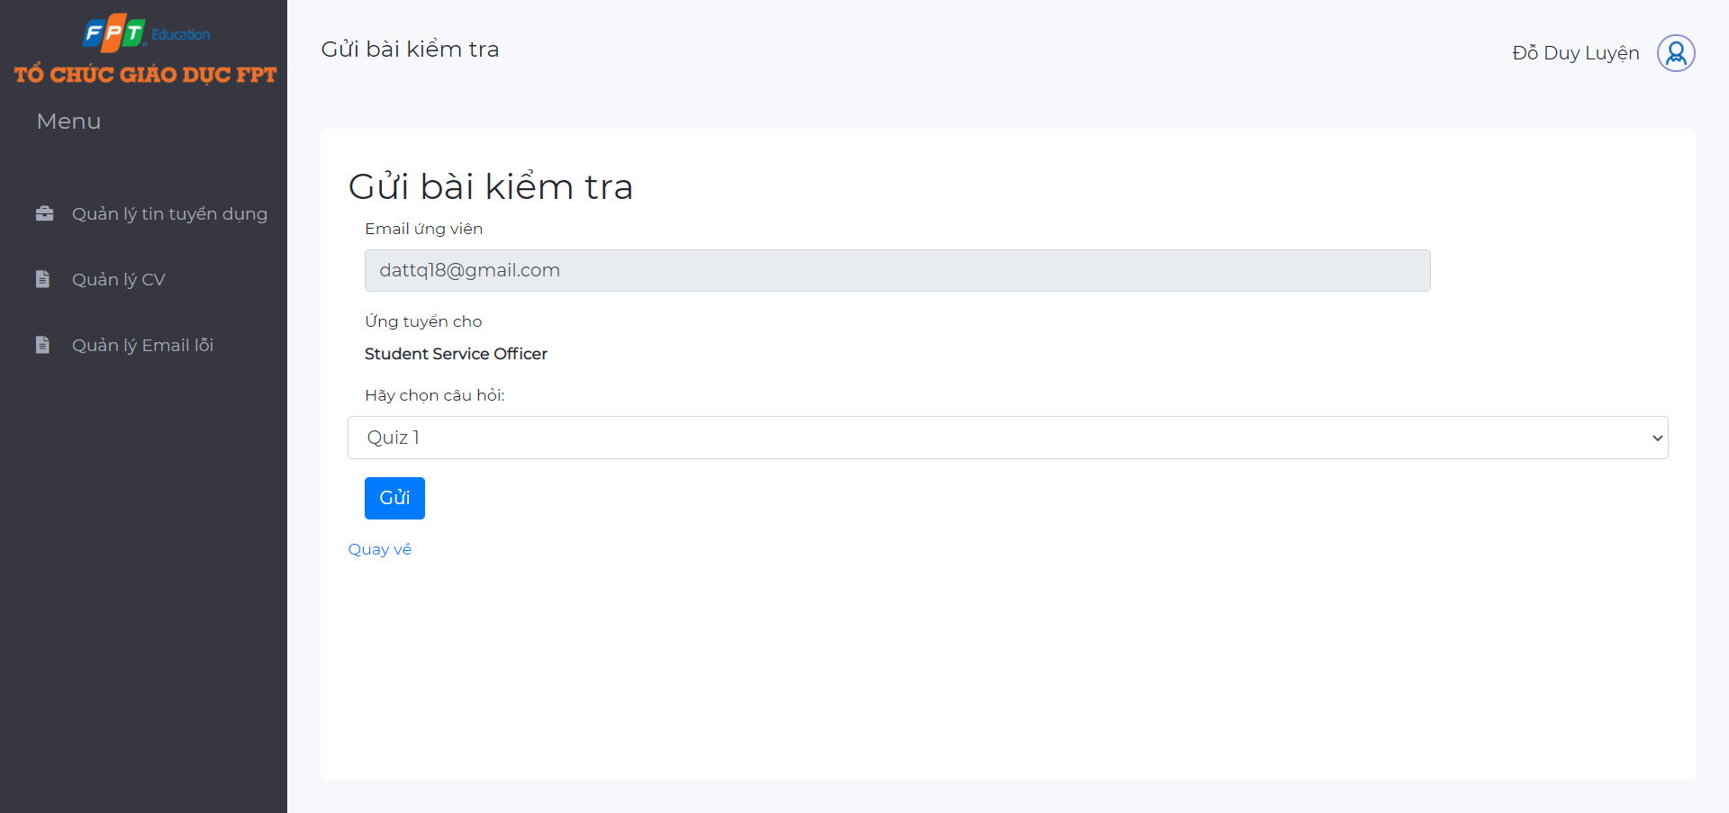

*Figure 6.44. Send email quiz page*

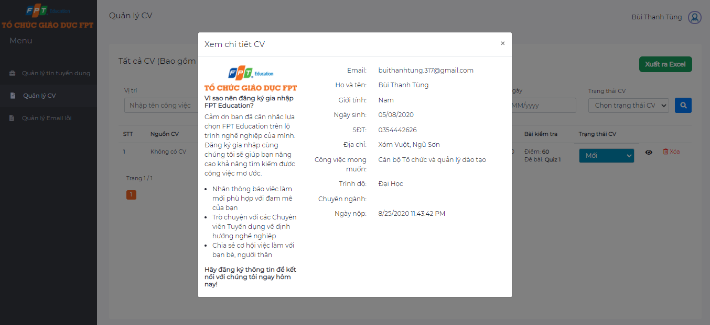

*Figure 6.45. Detail CV*

### Error email management

**

*Figure 6.46. Error email management page*

When sending emails to candidates, the email may not reach the candidate's inbox due to some error, such as the access network does not allow sending mail, lost internet connection, ..... These emails are not lost but are saved in the system and displayed on the error email management page.

*Note: In case the email cannot be sent, the user should check the connection, local network and email configuration in the management error screen of Admin .*

HR Staff can select a certain error email to resend by clicking the button “Gửi lại”. Can also resend all the error emails by clicking “Gửi lại những Email lỗi”

1. Lighthouse: <https://developers.google.com/web/tools/lighthouse>
2. .Net MVC Framework: <https://dotnet.microsoft.com/apps/aspnet/mvc>
3. Github : <https://github.com/marketplace/category/continuous-integration>
4. SmtpClient and MailMessage : <https://docs.microsoft.com/en-us/dotnet/api/system.net.mail.mailmessage>
5. StyleCop: <https://en.wikipedia.org/wiki/StyleCop>
6. RFC: <https://en.wikipedia.org/wiki/Request_for_Comments>
7. IMAP: <https://en.wikipedia.org/wiki/Internet_Message_Access_Protocol>
8. POP3: <https://en.wikipedia.org/wiki/Post_Office_Protocol>